# Magento生成订单onepagecheckout相关rest接口插件开发

按标准magento插件开发

本插件适用于一般magento登录用户，每个用户要有独立session，都能操作

提供已完成的登录及购物车功能rest接口作为参考，开发以此为参考和规范

主要功能要求，以下接口都是已登录用户使用，返回的都是该登录用户的信息

1.用户查看，更改个人信息;

2.用户查看与变更地址;

3.客户通过该接口完成将购物车内容变成订单并付款，即onepagecheckout的主要流程，

4.用户查看按条件过滤的订单。

现已完成接口

* 登录
* 获取购物车数量
* 获取购物车内容商品内容，相关选项，价格等
* 加入购物车
* 更新购物车内容（调整数量，删除等）
* 取购物车中总金额及优惠券使用情况
* 在购物车里使用和取消coupon优惠券

具体要补充

请参考 Magento API – SOAP/Rest

<https://www.magentocommerce.com/api/soap/customer/customer.html>

<https://www.magentocommerce.com/api/soap/customer/customerAddress/customerAddress.html>

<https://www.magentocommerce.com/api/soap/checkout/checkout.html>

<https://www.magentocommerce.com/api/soap/sales/sales.html>

## 1. Mage_Customer

只针对已登录用户，已登录用户返回本人信息，未登录的返回false

restconnect/customer/info

restconnect/customer/update

以下的命名规则相同

**Methods**:

* [customer.info](https://www.magentocommerce.com/api/soap/customer/customer.info.html) - Retrieve the customer data
* [customer.update](https://www.magentocommerce.com/api/soap/customer/customer.update.html) - Update the customer data

#### 2.Customer Address

Restconnect/Customer/addressList

* [customer_address.list](https://www.magentocommerce.com/api/soap/customer/customerAddress/customer_address.list.html) - Retrieve the list of customer addresses
* [customer_address.create](https://www.magentocommerce.com/api/soap/customer/customerAddress/customer_address.create.html) - Create a new address for a customer
* [customer_address.info](https://www.magentocommerce.com/api/soap/customer/customerAddress/customer_address.info.html) - Retrieve the specified customer address
* [customer_address.update](https://www.magentocommerce.com/api/soap/customer/customerAddress/customer_address.update.html) - Update the customer address
* [customer_address.delete](https://www.magentocommerce.com/api/soap/customer/customerAddress/customer_address.delete.html) - Delete the customer address

## 3. Mage_Checkout

#### Cart Customer

Allows you to add customer information and addresses into a shopping cart.

**Resource Name**: cart_customer

**Methods**:

* [cart_customer.set](https://www.magentocommerce.com/api/soap/checkout/cartCustomer/cart_customer.set.html) - Add customer information into a shopping cart
* [cart_customer.addresses](https://www.magentocommerce.com/api/soap/checkout/cartCustomer/cart_customer.addresses.html) - Set the customer addresses (shipping and billing) into a shopping cart

#### Cart Payment

Allows you to retrieve and set payment methods for a shopping cart.

**Resource Name**: cart_payment

**Methods**:

* [cart_payment.method](https://www.magentocommerce.com/api/soap/checkout/cartPayment/cart_payment.method.html) - Set a payment method for a shopping cart
* [cart_payment.list](https://www.magentocommerce.com/api/soap/checkout/cartPayment/cart_payment.list.html) - Get the list of available payment methods for a shopping cart

#### Cart Shipping

Allows you to retrieve and set shipping methods for a shopping cart.

**Resource Name**: cart_shipping

**Methods**:

* [cart_shipping.method](https://www.magentocommerce.com/api/soap/checkout/cartShipping/cart_shipping.method.html) - Set a shipping method for a shopping cart
* [cart_shipping.list](https://www.magentocommerce.com/api/soap/checkout/cartShipping/cart_shipping.list.html) - Retrieve the list of available shipping methods for a shopping cart

#### Shopping Cart

Allows you to manage shopping carts.

**Resource Name**: cart

**Methods**:

* [cart.order](https://www.magentocommerce.com/api/soap/checkout/cart/cart.order.html) - Create an order from a shopping cart
* [cart.license](https://www.magentocommerce.com/api/soap/checkout/cart/cart.license.html) - Get website license agreement

## 4.Mage_Sales

The Mage_Sales module allows you to manage sales orders, invoices, shipments, and credit memos.

#### Order

Allows you to manage orders.

**Resource Name**: sales_order

**Aliases**:

* order

**Methods**:

* [sales_order.list](https://www.magentocommerce.com/api/soap/sales/salesOrder/sales_order.list.html) - Retrieve the list of orders using filters
* [sales_order.info](https://www.magentocommerce.com/api/soap/sales/salesOrder/sales_order.info.html) - Retrieve the order information
* [sales_order.addComment](https://www.magentocommerce.com/api/soap/sales/salesOrder/sales_order.addComment.html) - Add a comment to an order
* [sales_order_shipment.list](https://www.magentocommerce.com/api/soap/sales/salesOrderShipment/sales_order_shipment.list.html) - Retrieve a list of shipments using filters
* [sales_order_shipment.info](https://www.magentocommerce.com/api/soap/sales/salesOrderShipment/sales_order_shipment.info.html) - Retrieve information about the shipment

附已有接口信息

## 用户登录

* 参数说明：

username: 输入，用户名

password: 输入，密码

* 样例

用户1：[300883@qq.com](mailto:300883@qq.com) 111111

http://stamp.sunpop.cn/cn/restconnect/customer/login/?username=300883@qq.com&password=111111

* 返回值，用户信息

{"name":"ivan deng","email":"300883@qq.com","avatar":null,"tel":null}

## 购物相关

## 获取购物车数量

* 接口：[http://stamp.sunpop.cn/cn/restconnect/Cart/getQty](http://demo.sunpop.cn/en/restconnect/Cart/getCartInfo)
* 返回：{"items_qty": "1"}

## 获取购物车内容商品内容，相关选项，价格等

* 接口：[http://stamp.sunpop.cn/cn/restconnect/Cart/getCartInfo](http://demo.sunpop.cn/en/restconnect/Cart/getCartInfo)
* 返回，见下例

{"is_virtual":false,"cart_items":[{"cart_item_id":"206","currency":"TZS","entity_type":"simple","item_id":"27","item_title":"Women's blouse","qty":3,"thumbnail_pic_url":"http:\/\/stamp.sunpop.cn\/media\/catalog\/product\/cache\/1\/thumbnail\/75x\/9df78eab33525d08d6e5fb8d27136e95\/b\/l\/blouse_1.jpg","custom_option":[{"label":"color","value":"black","print_value":"black","option_id":"12","option_type":"drop_down","option_value":"24","custom_view":false},{"label":"size","value":"M","print_value":"M","option_id":"11","option_type":"drop_down","option_value":"23","custom_view":false}],"item_price":96740},{"cart_item_id":"207","currency":"TZS","entity_type":"simple","item_id":"45","item_title":"Iphone5s slash ","qty":1,"thumbnail_pic_url":"http:\/\/stamp.sunpop.cn\/media\/catalog\/product\/cache\/1\/thumbnail\/75x\/9df78eab33525d08d6e5fb8d27136e95\/_\/1\/_1_2_2.jpg","custom_option":[],"item_price":7739.2},{"cart_item_id":"208","currency":"TZS","entity_type":"simple","item_id":"67","item_title":"Light blue jeans 2015 New Fashion","qty":1,"thumbnail_pic_url":"http:\/\/stamp.sunpop.cn\/media\/catalog\/product\/cache\/1\/thumbnail\/75x\/9df78eab33525d08d6e5fb8d27136e95\/1\/1\/116_-1.png","custom_option":[],"item_price":92870.4}],"messages":null,"cart_items_count":5,"payment_methods":[],"allow_guest_checkout":false}

* 购物车总数：cart_items_count，购物车中单项的id：cart_item_id

## 加入购物车

* 参数说明（可根据实际调整）：

一个json数组

entity_id: 输入，商品的id

qty: 输入，商品数量

options[]：输入，自定义选项数组变量名

optionvalue[]：输入，自定义选项数组变量值

* 默认url

http://stamp.sunpop.cn/cn/restconnect/cart/add/

简单的包含qty，复杂的包含各种选项

* 发送参数的例子，和mag的购物form发送内容一致，或用json封装

如：?product=535&related_product=&options%5B67%5D=abc&options%5B62%5D=148&options%5B63%5D%5B%5D=150&options%5B60%5D=143&options%5B61%5D%5B%5D=144&qty=1

空选项

http://stamp.sunpop.cn/cn/restconnect/cart/add/?product=533&qty=1

* json例子

{'name':'xxxxxx','product':'535','qty':'1','option':['62':'146','60':'143']}

* 返回值，true,false，购物车当前总条目数量

## 更新购物车内容（调整数量，删除等）

更新购物车指定项为指定数量，参数 cart_item_id，qty，qty设置为0会报错，前端最好让其不设置为0，或设置为0时调用remove事件。

<http://lvee.sunpop.cn/en/restconnect/Cart/update>

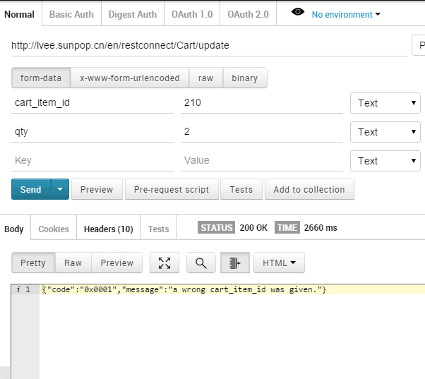

删除，参数cart_item_id，删除前要出提示信息问客户确认删除

[http://lvee.sunpop.cn/en/restconnect/Cart/remove](qq://txfile/)

## 取购物车中总金额及优惠券使用情况

[http://stamp.sunpop.cn/en/restconnect/Cart/getTotal](http://w.sunpop.cn/en/restconnect/Cart/getTotal)

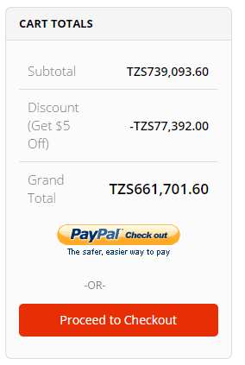

## 在购物车里使用和取消coupon优惠券

[http://stamp.sunpop.cn/cn/restconnect/Cart/postCoupon](http://demo.sunpop.cn/en/restconnect/Cart/postCoupon)

参数1、 coupon_code：优惠券码 2、remove ：为1时表示移除优惠券，为0时表示使用优惠券，默认为0

