#英语口语2023暑假

英语口语避免重复

1.代词

2.省略

3.同义词

**One**

Success in Life  
 Success means different things for different people. Some may equate it with fame, some with wealth and still some with accomplishments.  
 For me, it means fulfilling one's dreams. Whatever your dreams are, you have a goal there and then focus all your attention on it.  
 Dreams bring you hope and happiness. In the process of struggling for it, you cry, sweat, complain or even curse, but the joy of harvesting makes you forget all the pains and troubles you have gone through. So an old proverb says that the sweetest fruit is one that has undergone the bitterest ordeal.

Equate with /regard as 看作 当作

sense of accomplishment 成就感

Fulfill/realize/achieve one’s dream

Make dream come true实现一个人梦想

Focus all your (attention on it)连读集中全力

/spare no effort to do 不遗余力的

In the process of 在过程中

struggling for 很努力 挣扎

sweat 流汗

No sweat 没问题

curse 咒骂

go through thick （**[θɪk]** ）and thin 同甘苦共患难

ordeal 艰难 痛苦 名词/hardship

an eye for an eye以眼还眼

key to 什么的关键

It’s possible /chances are that 可能

diligent patient persevering 勤劳的耐心的 坚持的

ake sth in your stride 淡然处之

make strides in 巨大进步

insurmountable 不可逾越的

in/sur/mount/able

determination 决心

equate sth with sth 把什么等同于

a sence of ....感

realize /acheive / fullfill one's dream 实现梦想

what brings you here? 啥风带你过来了

no sweat=it's a piece of cake 小事一碟

go through thick and thin 同甘苦，共患难

chances are that =it is possible that 很可能

take something in your strides 从容面对

**Two：**

As food is to the body, so is learning to the mind. （类比）Our bodies grow and muscles（**mʌsl**） develop with the intake（摄取） of food. Likewise（in the same way）, we should keep learning day by day to maintain our mental power and expand our intellectual（ɪntɪˈlektʃʊəl）capacity.(智力)  
 Constant learning supplies us with（provide/offer） fuel for driving(驱使)（driving force）（驱动力） us to sharpen our power of reasoning（推理）, analysis（**əˈnælɪsɪs**）（分析）, and judgement（判断）. Continuous learning is the best way to keep pace with the times（与时俱进） in the information age（信息时代）.  
 It is a common misunderstanding（misconception） to regard school as the only place for the acquisition of(acquire) knowledge. On the contrary,(与之相反) learning should be an endless process, from the cradle to the grave（从摇篮到坟墓，从生到死）. With the world changing so fast, to stop learning for just a few days will make a person lag behind.(落后)

Lack of learning will inevitably（不可避免的） lead to the stagnation（停滞）（slow down/boost stimulate 刺激） of the mind, or even worse（更糟糕的是）, its fossilization（僵化）. Therefore, to stay mentally（思想上)(physically身体上） young, we have to take learning as a lifelong career.（**kəˈrɪə**）

insider（业内的）

**Three：**

Every day, in all kinds of weather,（无论刮风还是下雨） thousands of（连读）（million billion trillion）（dozens of一提六个） men and women go jogging. Why has jogging-running slowly for long distances become so popular? Most joggers like it（连读） because they have heard it is very good exercise. Jogging makes the heart stronger and helps people lose weight. It can also help them feel better about themselves.

How fast should you go? Jog with a friend and talk to each other as you run. If you have difficulty talking, you are going too fast. How far should you jog? Remember not to go too far too soon. In fact you should walk, not run, the first few times. Then do some short jogs, but no more than what you can do comfortably.

After that, increase your distance a quarter or half of a（连读） mile every two weeks or so（大约）. Maybe in a few years, you, too, can run in a marathon like thousands of other people do.

Aerobics 有氧运动

Lung 肺

Help sb do/with sth帮助某人

Nearby/around/close to/about 左

Above/more than 超过 右

Marathon 马拉松

连读：

前辅后元

half an hour hal fa nhour

In all kinds of weather i na ll kindsof weather

They have 缩读 they‘ve

**Four：**

Americans feel（believe）that（It‘s well known that众所周知） physical（mental） contact can be important in breaking down barriers between people. Such physical acts as hugging, shaking hands and kissing in public are seen（regarded） as displays of affection（喜爱）.

In China, on the other hand, this is not common because physical contact is not the custom（习俗）.

Interestingly enough（有意思的是）, most Chinese who spend some time in America come to（慢慢的成为。。的人，慢慢喜欢） like hugging; they learn（第一反应了解，第二反应学习） that Americans use body language to express feelings. It is a way of saying "I like you and I care about you."

Shaking hands is another traditional way of greeting someone in America. Shaking hands is a more formal way of greeting than hugging.

Whereas(但是)(Nevertheless) hugging shows closeness, （content n.内容，目录adj.满意的）shaking hands means that there is a little more formality（**[fɔːˈmælɪtɪ]**） in the relationship.

Western people usually shake hands when meeting someone for the first time, or when they see someone again after a certain amount of time（相当长的一段时间） has passed. In Japan, people traditionally bow as a form of greeting. Other countries have different customs, like patting someone on the back or kissing.

**Five：**  
 Scientists （According to 根据）suggest（表明） that today, most adults get up to two hours' less sleep than（i have Num. more/less n. than语法结构） they need. As a result, those lacking in sleep are forgetful, tired, less productive and grumpy（ /angry/irritated 生气的）. Sleep is the time when our bodies and minds are rested and restored.

There are two types of sleep: Rapid Eye Movement and Non-REM. We need both types to be healthy. Rapid Eye Movement sleep is when we dream. Our brains are active, and our eyes have fast short movements, as if（like） watching something.This type of sleep helps restore（恢复） our mind.

Non-REM sleep is when our brain and body slow down. Our heart rate slows and our breathing is regular. This type of sleep helps restore our body.We have twice as much Non-REM sleep as（i have 倍数as much ..n名词... as ...是.....多少倍） Rapid Eye Movement sleep each night. To get better sleep, have a regular time for sleeping and a routine before you go to bed.

This will give your body the signal（send signal发送信号） that it is time to sleep. Make sure the bed and bedroom are quiet and comfortable. If your bed is too hard or too soft, if you are too cold or too hot, you will not sleep well. For two hours before going to bed do not drink coffee or alcohol（ˈælkəˌhɒl）, or do not smoke or exercise. All these activities stimulate your body and make sleep difficult.

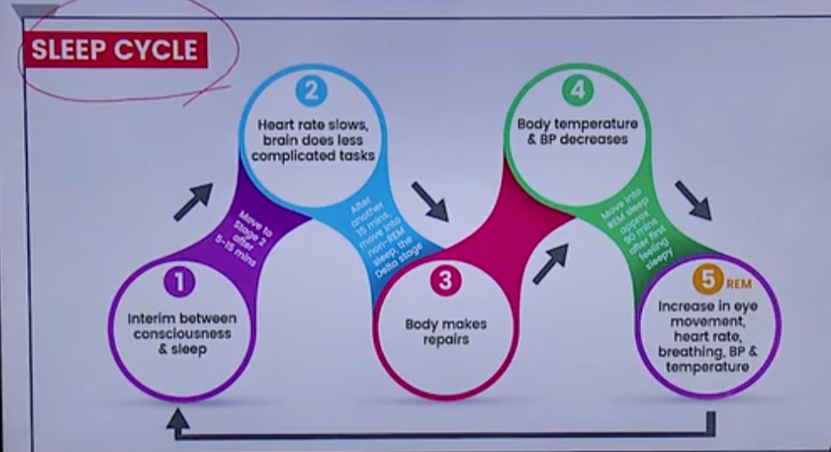

Interim adj. 暂时的，临时的

REM 做梦 repaid eye move 快速眼球运动

Latest 最近的

根据数据显示 st……。show that。

survey调查

lacking in 缺少

productive 工作效率

optimistic 乐观的

i am optimismistic about 人的主观

**Six：**

Swimming

Beijing is the hosting 2022 Winter Olympics.

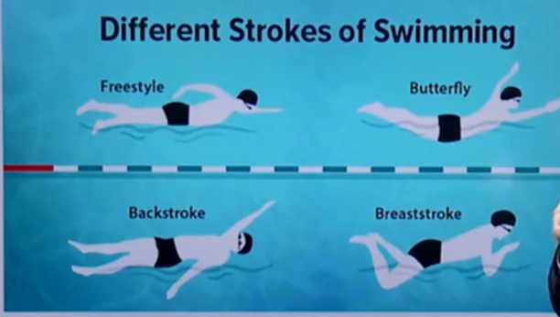

Freestyle, butterfly, backstroke, breaststroke

Be best at..... 最擅长......

Swimming is a competitive sport played around the world and on many different levels, including the Olympics. It's also an easy sport to do on your own, both for fun and for exercise.

Many doctors and athletes（**aθliːt**）（Athlete’s food脚气 ） agree that swimming is one of the best workouts(work out in gym/gi:m/在健身房健身) you can give your body, because it works almost on all of your major muscle **[ˈmʌsl]**groups at the same time.

Since you're floating in the water and not in contact with（不与...接触） any hard surfaces, there's less pressure on your joints（关节） and bones（sprain ankle扭伤脚踝）. You're less likely to suffer injuries than with other sports.

There are many ways to push yourself（too hard） and get better as a swimmer. If you're into（B级）（crazy about A级） speed, you can race the clock（同义词 against time） and see how long it takes you to do a certain number of laps（圈）（laps top 笔记本（放在膝盖上））. If you're into endurance（n. 忍耐（力））, you can slow down and see how many laps you can do before you have to take a rest.

Many teenagers like swimming best. One of the students says, "The best part about swimming is when you beat your(ty连读：戳cuo) time（break record 打破纪录 /record-breaking 破纪录的）. It doesn't even matter if you lose the race as long as you tried your best; you can walk away with a smile on your face.

When you're in the water you forget that people may be watching and all you care about（比I only care about更强烈） is getting to the other side of the pool and touching the wall. You can just let go and fly."

**Seven：**

The Dragon Boat Festival is one of three major Chinese festivals, along with the Spring and Moon Festivals. Of the three, it is possibly the oldest, dating back to the Warring States Period in 227 B.C. The festival commemorates Qu Yuan, a minister in the service of the Chu Emperor.

Despairing over corruption at court, Qu threw himself into a river. Townspeople jumped into their boats and triedlin vain to save him. Then, hoping to distract hungry fish from his body, the people scattered rice on the water.

Over the years, the story of Qu's demise transformed into the traditions of racing dragon boats and eating zongzi - a kind of rice wrapped in bamboo leaves. The races have certainly captured the imagination of people from all over the world.

Every spring there are nearly 60 dragon boat races held outside of China in cities from Vancouver to Sydney. Canada alone has nearly 50 dragon boat teams and Germany has nearly 30.

So what is it about the Dragon Boat Festival that appeals to foreigners? "It's an unusual sport," says one racer from Germany. "It's not like everybody's doing it. That's one of the reasons that there's such great team spirit in a dragon boat team - everybody feels like we're doing something special."

commemorate纪念

minister大臣

In the service of为....效力

emperor国王

court法院朝廷

scatter撒大范围撒无目的

sprinkle撒小范围有目的撒

distract ....from.... 使分心，转移注意力

demise死亡败落n/v death

Transform v.改观使变形转换演变

Transform into演变成为

wrap包裹

**Eight**

These days, the American President is one of the most powerful men in the world. He can make war, or peace.  
He can touch the lives of millions in many different  
countries, but the President cannot do just what he wants. The Congress must agree first.

In some ways, the United States is like fifty small countries and not one large one. Every state has its own governor, its own police, and its own laws. For example, in some states you can buy an alcoholic drink when you  
are 18. In others, you must wait until you are 21.

The government of the whole country (the 'federal' government) works from Washington, the capital city.  
This is where Congress is based. Congress has two parts, the Senate, and the House of Representatives.

There are 100 members of the Senate (called Senators), two from each state. The President cannot act without the Senate's agreement. The House of Representatives  
has 435 members. Like the senators, they can make new laws.

Americans choose a new President every four years.  
The election is a great occasion. It is serious business, of course, but the Americans make sure that it is fun too.

**Nine**



In the years after World War Il, the world greatly changed. Much of this was due to new technology. For instance, the jet(喷气式飞机) was developed. This increased the speed that people could travel.

There were also advances(科技发展很少用develop，用advance) in telecommunications.（telescope望远镜）

Computers and the Internet were invented. It became much easier for people to communicate with others all around the world. This has led to（result in导致） the spread of globalization.

Basically, the world is becoming a smaller place. （a global village地球村）In the past, what happened in one country rarely （接近否定，但不是完全否定）affected  
other countries. Or it took a long time for any effects  
to occur. But the world is different today. Because of globalization, what happens in one part of the world can affect places all around it.  
 Thanks to globalization, people can now do business  
 more easily with those in other countries. When you go to the supermarket, you can see various foods from all of the different countries. This happens because of  
globalization. Also, people are learning more about other countries these days. This leads to more understanding about other countries.  
 In the age of globalization, there has not been a single world war. And the world is becoming richer.  
Globalization has surely been good for the world.

strike/keep blances  
constitution 宪法 根本大法  
veto 否定  
touch 影响 打动 affect/influence  
do what you want 为所欲为  
governor 州长   
due to/thank to/owing to  
jet lag倒时差  
telescope 望远镜  
be advances in 。。的发展  
lead to/result in 导致  
a global village 地球村  
rarely 罕见 接近否定

EVELEN

Everyone has five senses. The five senses are sight, hearing, smell, taste(stuffy塞满) and touch. We use different body parts for different senses. We need to take care of the parts of our bodies that let us use our senses.

For example, you use your eyes for seeing. You should protect your eyes and have a doctor regularly check（have sth done 让其他人做，不是你自己） （pull out your teeth 拔牙）your eyesight. Don't sit too close to the TV or computer monitor（显示器）, and don't read in the dark or in dim light. Never look directly at the sun or at very bright lights.

Your ears let you hear the things around you. You should clean your ears all the time. Don't listen to loud music, and try to avoid places that are really loud. Protect your ears when you play sports.

Your nose cleans the air you breathe and lets you smell things. Avoid things that have very strong smells（perfume 香水 ）

Your tongue（舌头） help you taste things you eat and drink. Your skin protects your body from germs(微生物) and gives you sense of touch. Always wash your hands after blowing your nose（擤鼻涕）, playing outside, or using the restroom, Protect your skin from sunburns. Use sunscreen（防嗮霜） to protect your skin from the sun.

TWELVE

Nowadays, we live in an advanced world. We use many new inventions that people long ago never imagined. In the past, people could not regularly communicate with others. It took days, weeks, or even months just to send a letter. There were no telephones. So people had to talk face to face.

Nowadays, we use cell-phones to call anyone anywhere in the world. And we send email to people instantly thanks to the internet. In the past, traveling short distances took a long time. People either walked or rode on a horse.

Now, most people own cars. They can drive long distances in short period of time. And people can even fly around the world on airplanes now.

In the past, people often died because of poor medical treatment. Even a toothache could sometimes kill a person! Now, vaccines protect people from disease. And doctors are making more and more discoveries every day.

1.emerging country 发展中国家

developed developing，underdeveloped advanced economy发达经济体

2.regular 经常地，不是定期地

3.penpal 笔友

4.Video chatting 视频通话

5.do sth in person亲自做某事

6.instant 及时的，（互联网时代用到特别多）

7. increasing number of 不断增长的=more and more