十一、select语句之where
- Where 条件查询
- group by 分组
- having 筛选
- order by 排序
- limit 限制结果条数

- select 5种子句 之where介绍

- where expression
- 用法:expression为真,则该行取出
- 运用场合
各种条件查询场合,如按学号查学生,按价格查商品,按发布时间查新闻等

Select * from goods;---------- 所有行 所有列
Select goods_id,goods_name from goods;----------------所有行 部分列
Select * from goods where goods_id >20;------------------部分行 所有列
Select goods_id,goods_name,shop_price,market_price from goods;
Select goods_id,goods_name from goods where goods_id>20;------部分行 部分列

右击-----属性------改窗口大小

查询shop_price >1500;

select goods_id,goods_name,shop_price,market_price from goods where shop_price>1500;

查询本地价格比市场价格低200的以上

select goods_id,goods_name,shop_price,market_price from goods where market_price-shop_price>200;

系统来学习下where语句
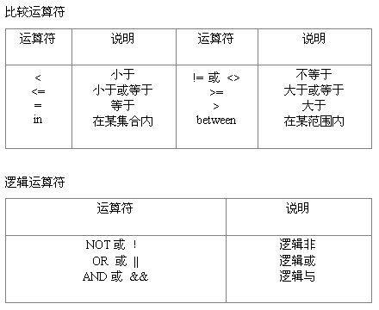

取小于2000的数值

select goods_id,goods_name,shop_price,market_price from goods where shop_price<2000;

取小于等于2000的数值

select goods_id,goods_name,shop_price,market_price from goods where shop_price<=2000;

取等于2000的数值

select goods_id,goods_name,shop_price,market_price from goods where shop_price<=2000;

同理做
>
>=

查不属于第三号栏目的

select goods_id,cat_id,goods_name from goods where cat_id <>3;

查
In<值1，值2，、、、值N>,等于值1—>N任意一个都行
想查询第四个栏目或者第五个栏目

select goods_id,cat_id,goods_name from goods where cat_id in(4,5) ;

between 值1 and 值2，表示在值1和值2之间
取出商品本地价格在2000和3000之间

select goods_id,goods_name,shop_price from goods where shop_price between 2000 and 3000 ;

复杂点：
现在去买手机 想买3000-5000之间的商品或者500-1000之间的商品

Select goods_id,goods_name,shop_price from goods where shop_price >=3000 and

想买3000-5000之间的商品 但不用between and
select goods_id,goods_name,shop_price from goods where shop_price >=3000 and shop_price<=5000;

想买500-1000之间的商品 但不用between and
select goods_id,goods_name,shop_price from goods where shop_price >=3000 and shop_price<=5000;

用and 和or的用法
select goods_id,goods_name,shop_price from goods where shop_price >=500 and shop_price<=1000 or shop_price>=3000 and shop_price<=5000;

not 的用法
取出不属于第4和第5个栏目的商品
------用！=
select goods_id,cat_id,goods_name from goods where cat_id !=4 and cat_id !=5;

------用not in
select goods_id,cat_id,goods_name from goods where cat_id not in(4,5);

