Summary
In the triage package, there are many big log files are split into several small ‘GZ’ files, but we cannot know the start time of these log files, in current LINUX environment, we can only open these files one by one to find that we want to use.
It is awfully boring, so I write a simple Arm to check log start time as follows:
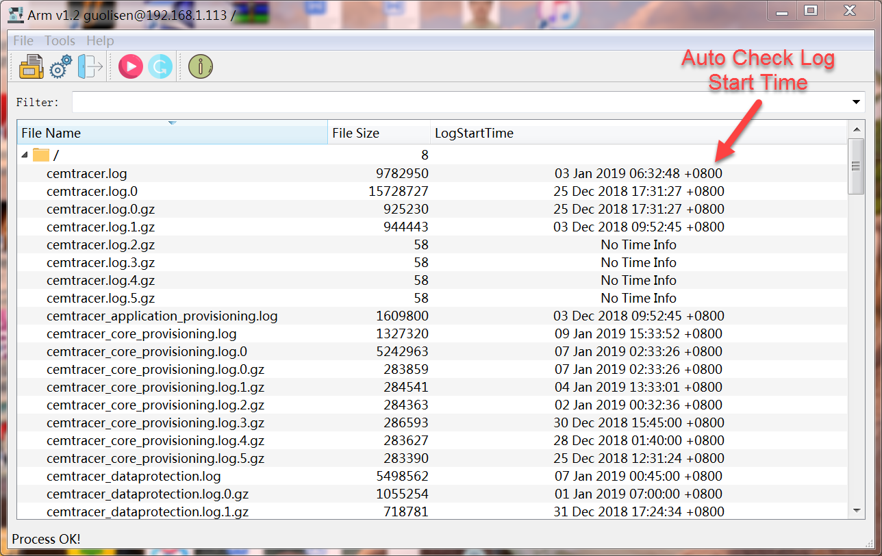
We can login DEV/Array server by SSH, the Arm will load the log file and parse the log format and then get the start time of this log file.
After the log file loading, we can double click the file, the Arm will download the log file and then open by the local text editor.

Feature

Login
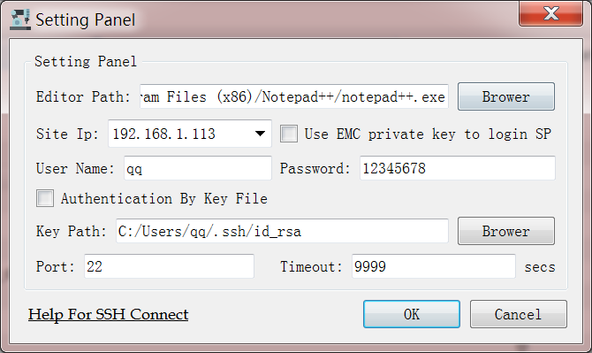
- Login SP by EMC Root Private Key
You can select 'Use EMC private key to login SP' to login in all of SP ssh server.

- Login By Key File(user name is 'root')
For example: My DEV simulator is '10.207.141.30'.
Open 'git bash' on your computer(win10).
- Create public/private rsa key pair
[root@localhost ~]# ssh-keygen -t rsa -C "YOUR_EMAIL@YOUREMAIL.COM"

- Copy the public key to '10.207.141.30'
[root@localhost ~]# ssh-copy-id -i ~/.ssh/id_rsa.pub root@10.207.141.30

- Open Arm Setting Panel, select the private key path
- Select the 'Authentication By Key File', and click 'OK'
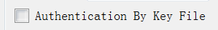
- Login By User Name and Password
Our DEV simulator forbid login by password, we should set SSH configure file to get the permission.
For example: My DEV simulator is '10.207.141.30'.
- Changing the '/etc/ssh/sshd_config' on '10.207.141.30'
PasswordAuthentication yes
PermitRootLogin yes
- Reset sshd service
systemctl restart sshd.service

Attention:
- If you login by key file, the user name should be consistent with key file.
For Example: use 'root' create key file, also should use 'root' login.
- All remote command will run on current ssh server, so don't run some DEV simulator command on SP
For Example: run 'swarm' on SP, or run 'uemcli' on DEV simulator
- the default config of 'PasswordAuthentication' on DEV simulator is OFF, if you want to login by user name
please follow 2 to change ssh config file and then reset SSH server.

Open Log Path
- Open Remote/Local log path
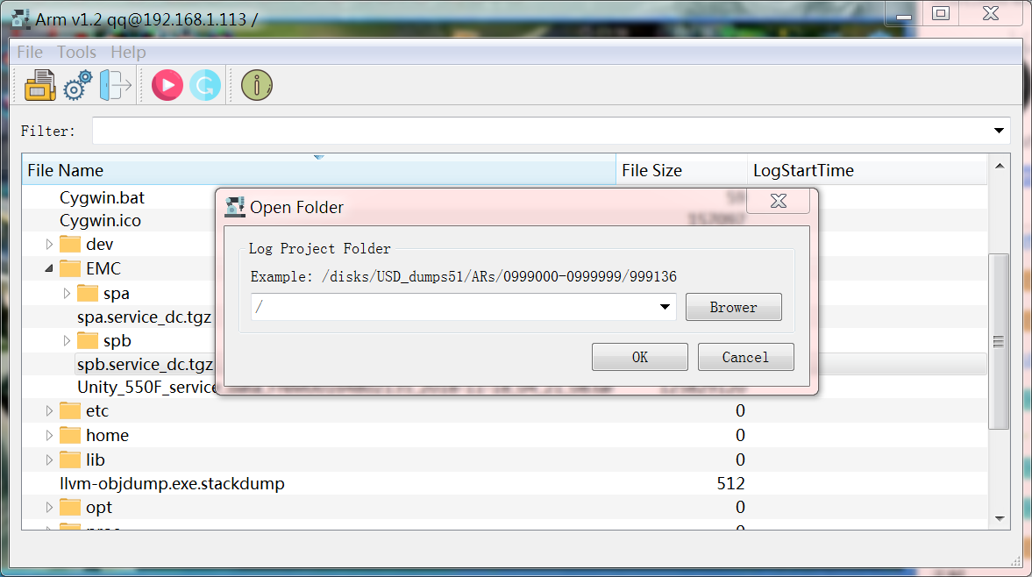
- Open log path, the Arm will parse log file and load the start time of log automatically
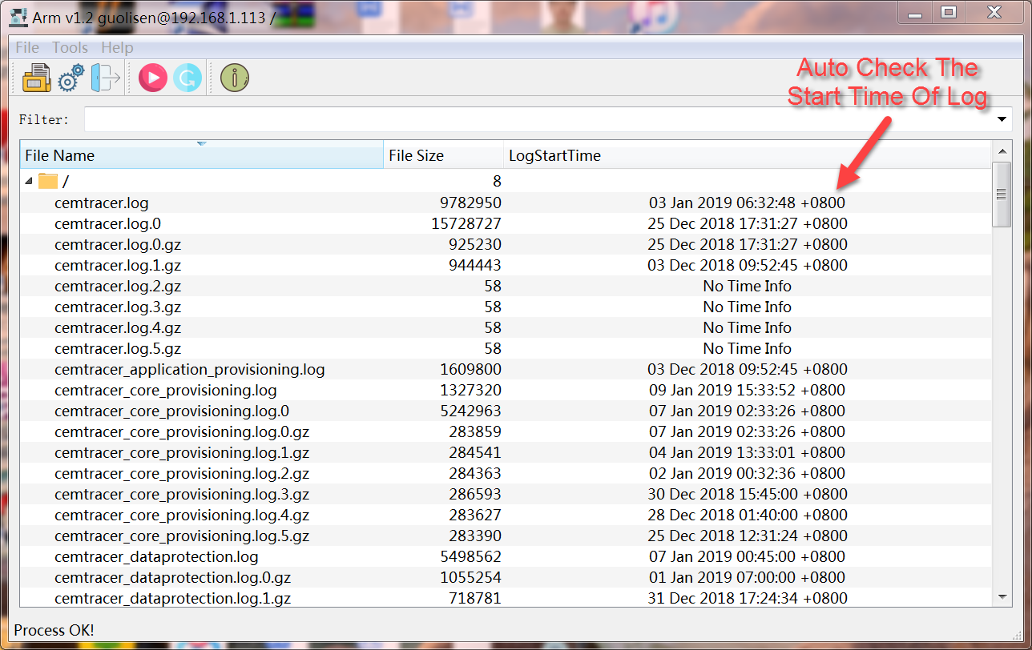
Current version support c4_safe_ktrace format and cemtrace format. You can write LUA script to support other log format in FileTypeScript folder.

Right Pop Menu
The right click pop menu support ‘Download’, ‘Upload’, ‘Uncompress’, ‘Remove’
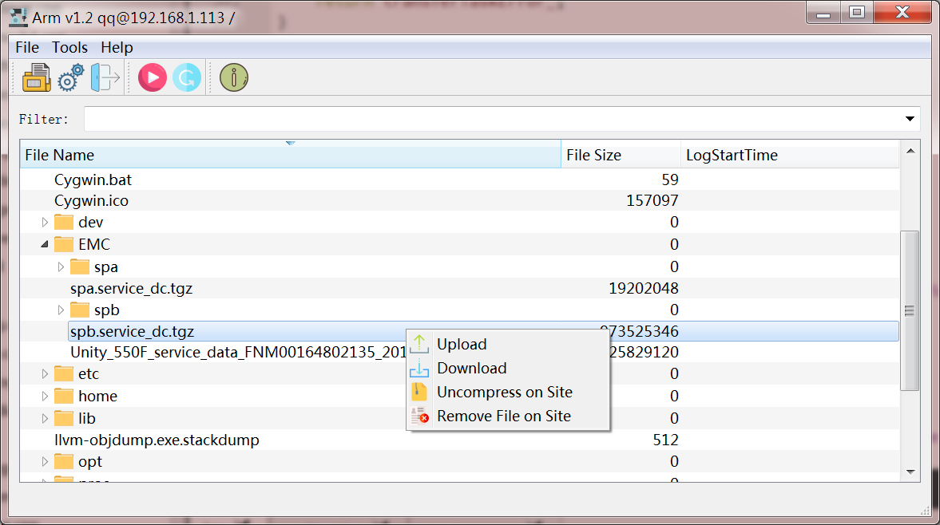

Open Log By Local Editor
- Set local editor path
- Double click the log file, the Arm will download the log file and then open by local editor. If the file format is ‘GZ’, the Arm will uncompress the file automatically.

Run Command
The Arm can run some simple SSH command on current login SSH server, for example, if you login some Array, you can run MluCli.exe and FbeCli.exe, if you login DEV simulator, you can run ‘swarm’ etc.

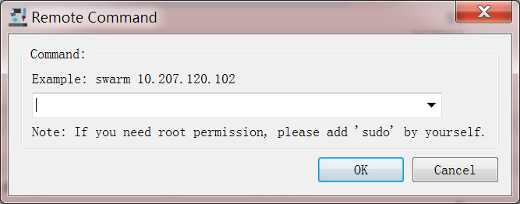

Add Custom Log Format
You can add your own log format at Arm/FileTypeScript, the LUA format file has 3 interfaces.
- isMyType(filename)
Check whether the file name belong to this format script.
- getTypeName()
Return current format script tag name
- getLineTime()
Parse the input log string by Regex, return the time struct.
struct DateEntry
{
bool exist;
int year;
int month;
int day;
int hour;
int minute;
int second;
int mSecond;
};

Edit Config.ini File
All setting of Arm is saved in Config.ini file.
Setting\EditorPath=C:/Program Files/Notepad++/notepad++.exe // Local editor path
Setting\siteIp=192.168.1.113 // remote server IP
Setting\port=22 // port
Setting\userName=qq // user name
Setting\password=12345678 // password
Setting\timeOut=9999 // time out
Setting\keyFilePath=C:/Users/qq/.ssh/id_rsa // local private key path
Setting\keyFile=1 // key file switch
Setting\threadNumber=5 // parse log thread number
Setting\emcRootKeyPath=./EmcRootKey/id_rsa.root //EMC private key path
Setting\emcKeyFile=0 //EMC private key swtich
Setting\logEnable=1 // log switch

