**Assignment 2: Landscape Photography**

**Due date: Thursday September 30, 2021 by 11:59PM.**

### **Description**

As you have learnt so far, pbrt is written using a total of 10 key abstract base classes, shown in Table 1, one of which is the Camera class.

Table 1. List of the ten pbrt base classes.

| **Base class** | **Directory** | **Section in the book** |
| --- | --- | --- |
| Shape | shapes/ | [3.1](https://www.pbr-book.org/3ed-2018/Shapes/Basic_Shape_Interface.html#sec:shape-interface) |
| [Aggregate](https://www.pbr-book.org/3ed-2018/Primitives_and_Intersection_Acceleration/Aggregates.html#Aggregate) | accelerators/ | [4.2](https://www.pbr-book.org/3ed-2018/Primitives_and_Intersection_Acceleration/Aggregates.html#sec:aggregates) |
| [Camera](https://www.pbr-book.org/3ed-2018/Camera_Models/Camera_Model.html#Camera) | cameras/ | [6.1](https://www.pbr-book.org/3ed-2018/Camera_Models/Camera_Model.html#sec:camera-model) |
| [Sampler](https://www.pbr-book.org/3ed-2018/Sampling_and_Reconstruction/Sampling_Interface.html#Sampler) | samplers/ | [7.2](https://www.pbr-book.org/3ed-2018/Sampling_and_Reconstruction/Sampling_Interface.html#sec:sampling-interface) |
| [Filter](https://www.pbr-book.org/3ed-2018/Sampling_and_Reconstruction/Image_Reconstruction.html#Filter) | filters/ | [7.8](https://www.pbr-book.org/3ed-2018/Sampling_and_Reconstruction/Image_Reconstruction.html#sec:image-reconstruction) |
| [Material](https://www.pbr-book.org/3ed-2018/Materials/Material_Interface_and_Implementations.html#Material) | materials/ | [9.2](https://www.pbr-book.org/3ed-2018/Materials/Material_Interface_and_Implementations.html#sec:material-interface) |
| [Texture](https://www.pbr-book.org/3ed-2018/Texture/Texture_Interface_and_Basic_Textures.html#Texture) | textures/ | [10.3](https://www.pbr-book.org/3ed-2018/Texture/Texture_Interface_and_Basic_Textures.html#sec:texture-interface) |
| [Medium](https://www.pbr-book.org/3ed-2018/Volume_Scattering/Media.html#Medium) | media/ | [11.3](https://www.pbr-book.org/3ed-2018/Volume_Scattering/Media.html#sec:media) |
| [Light](https://www.pbr-book.org/3ed-2018/Light_Sources/Light_Interface.html#Light) | lights/ | [12.2](https://www.pbr-book.org/3ed-2018/Light_Sources/Light_Interface.html#sec:light) |
| [Integrator](https://www.pbr-book.org/3ed-2018/Introduction/pbrt_System_Overview#Integrator) | integrators/ | [1.3.3](https://www.pbr-book.org/3ed-2018/Introduction/pbrt_System_Overview#sec:integrator-intro) |

In this assignment, you will practice your knowledge of how modern cameras operate combined with your learnings of pbrt to create a beautiful landscape, and then try to produce some realistic camera effects, such as depth of field and motion blur using pbrt.

In photography realm, *landscape* and *portrait* are most used to describe the orientation of a photo. Landscape orientation is when the image is wider than it is tall. Landscape format is best to fit more into view and give a perspective closer to what the eye sees. Besides the way your photo is formatted, landscape, or portrait, is also a type of photography genre. Portrait photography is usually to showcase a person - be it a group of people, or of a single subject - rather than an environment.

Landscape photography, on the other hand, is a photo of a beautiful view. It doesn’t matter whether it’s in a city or somewhere in the nature. The ultimate goal of this photography genre is to make your audience feel like they were there. To give them the feeling like they were standing where your camera was.

While portrait photography favors a wide aperture to create a shallower depth of field by blurring the background for the subject to stand out, landscape favors a smaller aperture. With a smaller aperture, you increase the depth of field, and more will be in focus at once. This is useful for taking images of an overall environment since you want everything to be in focus.

1. **Setting up Gitlab**

You will be using the Gitlab repository you created for assignment 1 again for this assignment. Create a new branch based on your unmodified master branch:

$ git checkout -b assignment2 master

Be sure to make your changes in this branch as you work through the assignment.

|  |  |
| --- | --- |
|  |  |

The landscape view (left) and the portrait view(right)

1. **Rendering the Landscape**

You can download the starter pbrt files for your second assignment from **here,** and extract them into scenes/assignment2. Again, you will be including these files in your submission, so please make sure they're in the right location. ‘photography.pbrt’ is the scene file you will be working on through this assignment.

Now you can render the initial view in both portrait and landscape modes. The correctly images are shown in the figure above. In this scene, the camera is pointed directly at the origin.

You may have noticed in assignment 1 that manually placing lights in the scene is not an easy task. A technique that has become common in the last few years is to use HDR “environment map” that has captured light from all directions in a real-world environment, and use it as a light source for rendering. A few of such maps are provided in the starter files, in the subfolder ‘textures’. For instance, the map textures/skylight-dusk.exr is shown here:

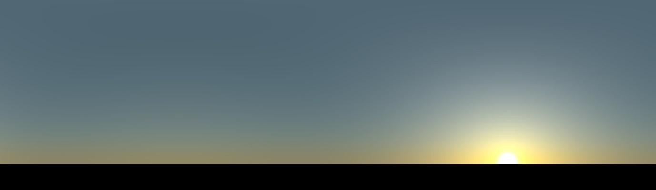

We already have the necessary configuration line in the .pbrt file to use this map for lighting:

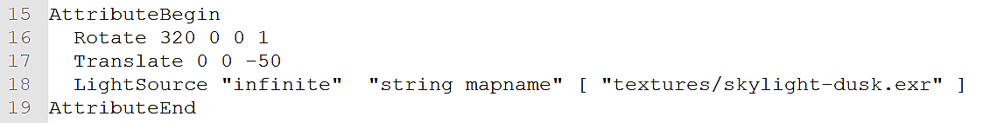

We use the dark half of the map as part of the scene, which looks perfect under dusk sky!

It is now time to add more elements to the scene to make it more pleasing and realistic. Add two more maple trees to the left of the single tree, and a series of ten pine trees to its right in a way that the landscape illustrated in the below figure is created. For the sampler, use at least 128 samples per pixel for your final hand-in images. However, you are recommended to use lower sampling frequencies, e.g. 8, when maneuvering in the scene to speed up the rendering.

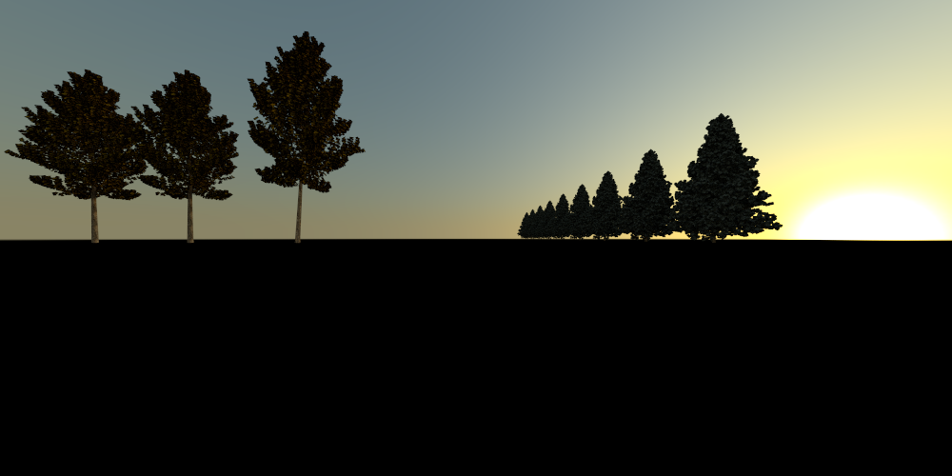

Note that you have to use “image textures” to adhere rather realistic textures to your trees, similar to what has been given in the starter scene file for the maple tree:

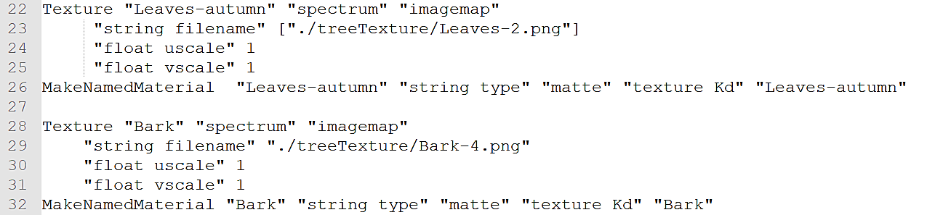

At the end, park a garnet red BMW in front of the maple trees! Please note that all the files you would require to create this landscape are provided in the starter zip file. The BMW M6 car is one of the several free pbrt-v3 scenes which are available for [**download**](http://storage.googleapis.com/pbrt/pbrt-scenes.git.tar.gz) and use.

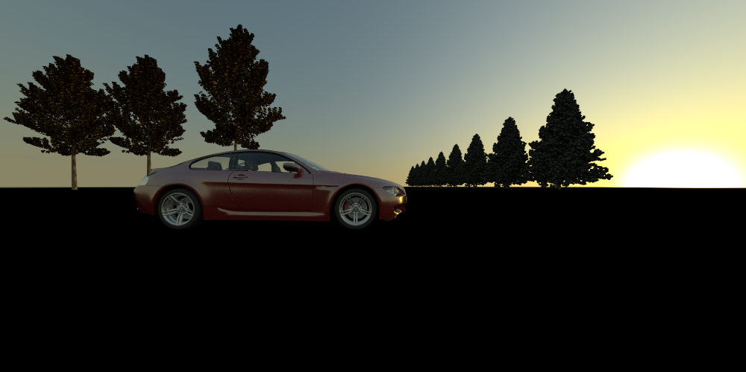

Everything looks fine so far, except for the overall brightness of the scene. In real-life scenarios when capturing a lowlight scene by a DSLR camera, one can choose a very low shutter speed, and/or a very high ISO, a wide aperture to let the maximum light come in, and finally use the flash. Modify the lighting of the scene to mimic the effect of the camera flash to add a little bit brightness to the scene. Although you are capturing a landscape here, but you can use the valuable studio lighting experience you have gained through assignment 1 to achieve the desired level of brightness like what is illustrated in the below image:

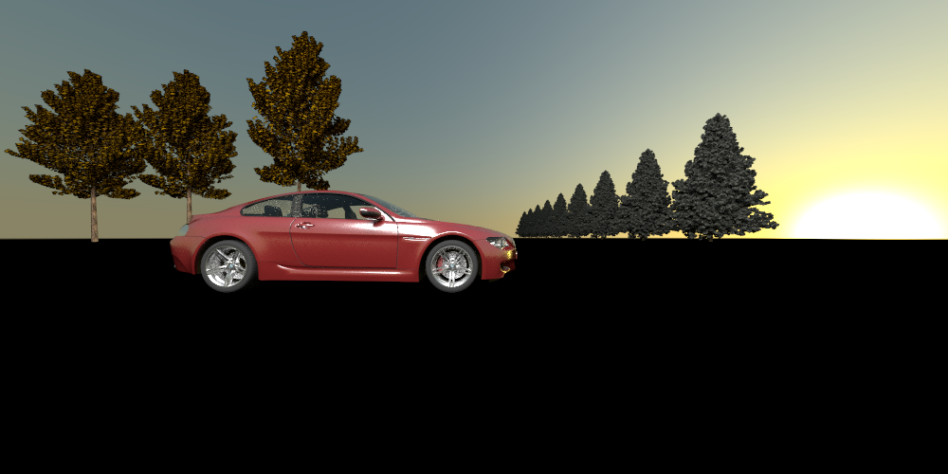

Try your best to recreate the scene configurations in the example renderings, but don't worry if your images aren't perfect matches. Save a copy of the modified photography.pbrtfile with your settings in scenes/assignment2/landscape.pbrt. Save the rendered results respectively as render1, render2 and render3.png in scenes/assignment2. Please remember that you are expected to include all the modifications you have made to generate your results in the submitted scene files, and comment them out where needed. Also prepare a brief summary of the process you followed to achieve the rendering results. You will need to include this summary in the “Submission.md” file in your final submission.

1. **Depth of Field**

Adjusting the depth of field is a crucial part of the landscape photography. When capturing a vast area within one single frame, it is desired that all elements of the scene - foreground, middle ground, and background - are in sharp focus (this is also known as “deep focus” in filmmaking). This is where “depth of field” comes in play. In its current state, the setting of your scene file guarantees an image which is in deep focus. The car in the foreground, the maple trees in the middle ground, and the pine trees and the sun in the background are all in focus.

The thin lens model enables the camera models in pbrt to create more realistic images in terms of depth of field. We recommend you read the section [**6.2.3**](https://www.pbr-book.org/3ed-2018/Camera_Models/Projective_Camera_Models#TheThinLensModelandDepthofField) of the pbr book before you proceed with the following section of assignment. After figuring out the major components of the camera model which plays roles in adjusting the depth of field, lower the depth of field so that only the car remains in sharp focus, and blur the middle ground and the background:

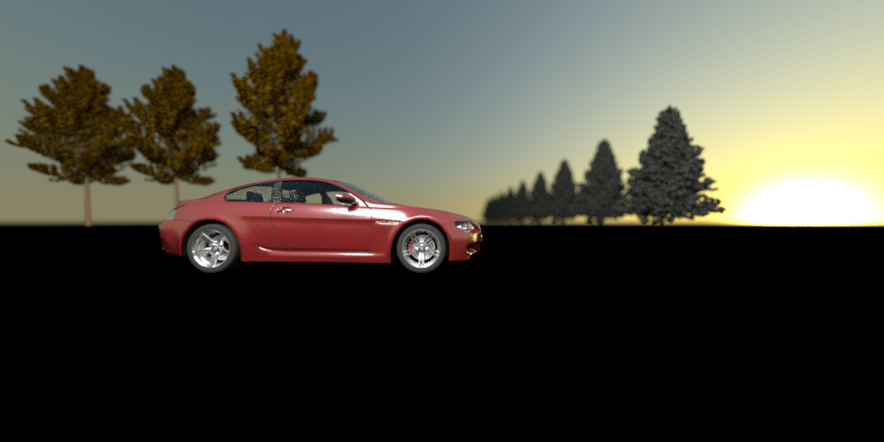

Low depth of field: only the car in focus

Try to even lower the depth of field by blurring out the middle and background more:

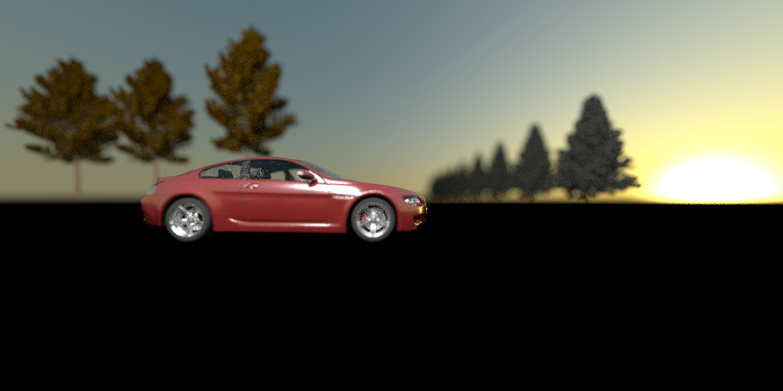

Lower depth of field: only the car in focus

Finally, make the necessary adjustments in your setting so that only the maple trees and the closest pine tree to the camera are in focus while the rest of the scene is blurred out:

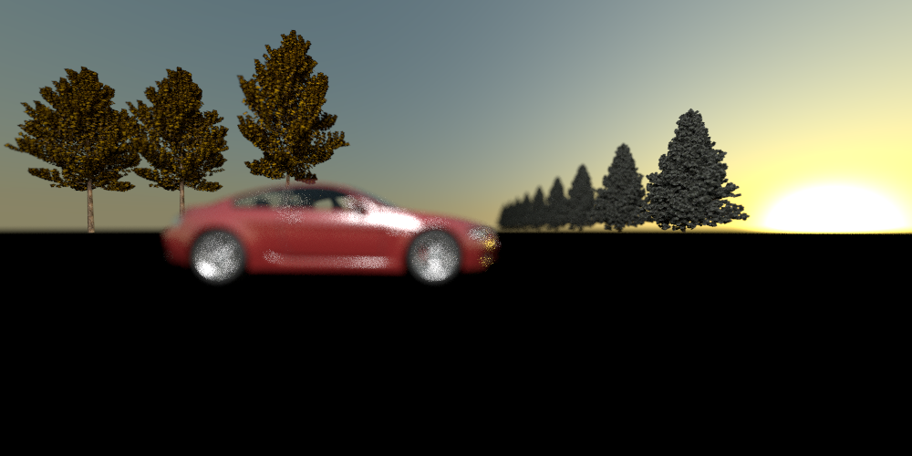

Lower depth of field: only the middle ground in focus

Save your setting to create the above effects in scenes/assignment2/depthoffield.pbrt, and save the corresponding rendered results respectively as render4-6.png in scenes/assignment2. Do not forget to prepare a brief summary of the process you followed to achieve the rendering results. You will need to include this summary in your final submission.

1. **Motion blur**

Motion blur is the blur seen in a photograph when there is a moving object in the scene. It happens because objects move during the time it takes to expose the photo, and the movement gets recorded as a blur. The slower the image is recorded on the film, the more pronounced the motion blur will be. To understand better how pbrt enables you to create motion blur, please read the section [**2.9**](https://pbr-book.org/3ed-2018/Geometry_and_Transformations/Animating_Transformations) of the pbr book.

For this part of the assignment, while the entire scene is in deep focus, you are asked to move the car towards the right and then manipulate the camera model parameters to create the motion blue effect, similar to the following image. Try to achieve a higher degree of motion blur by making the required adjustments in the setting of the scene file, while maintaining the speed of the car:

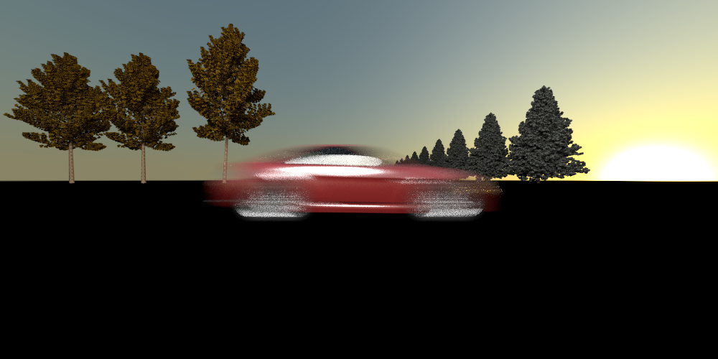

Motion blur: car is moving

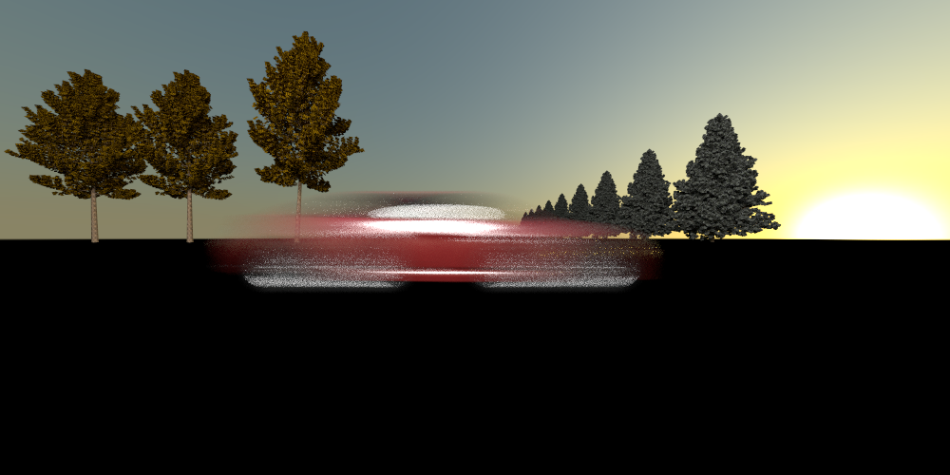

Higher motion blur: car is moving with the same speed as before

Save a copy of the modified photography.pbrtfile with your settings in scenes/assignment2/motionblur.pbrt, and save the rendered results respectively as render7-8 in scenes/assignment2. Again, write a short summary on how you developed the correct scene description and rendering results.

1. **Wide-angle photography**

The use of extreme wide-angle lenses is a very common practice in landscape photography. A wide-angle lens is a type of lens that has a shorter focal length than a normal lens. Photographers use the short focal length of wide lenses to capture a wide field of view like a mountain range. With a wide-angle lens, subjects closer to the camera will appear larger than subjects further away, resulting in a slight distortion of the image. A wide-angle lens keeps almost everything in focus, unless the subject is too close to the lens. A fish-eye lens is an ultra-wide-angle lens which can take in a full 180-degree radius and is often used to create perspective distortion in photography and cinematography.

A telephoto lens, on the other hand, makes a photographic subject appear closer than it actually is. This can be ideal for photographers who are unable to be close to their subjects—either due to physical constraints or out of concern for safety. These lenses also serve an artistic purpose, and are remarkable at creating contrasting focuses between foreground and background. This is the type of lens that wildlife photographers use to capture massive lions on the savannah, or cheetahs resting in trees!

The realistic camera model in pbrt enables you to create such effects that only real camera lenses allow. The following image is rendered using the realistic camera model.

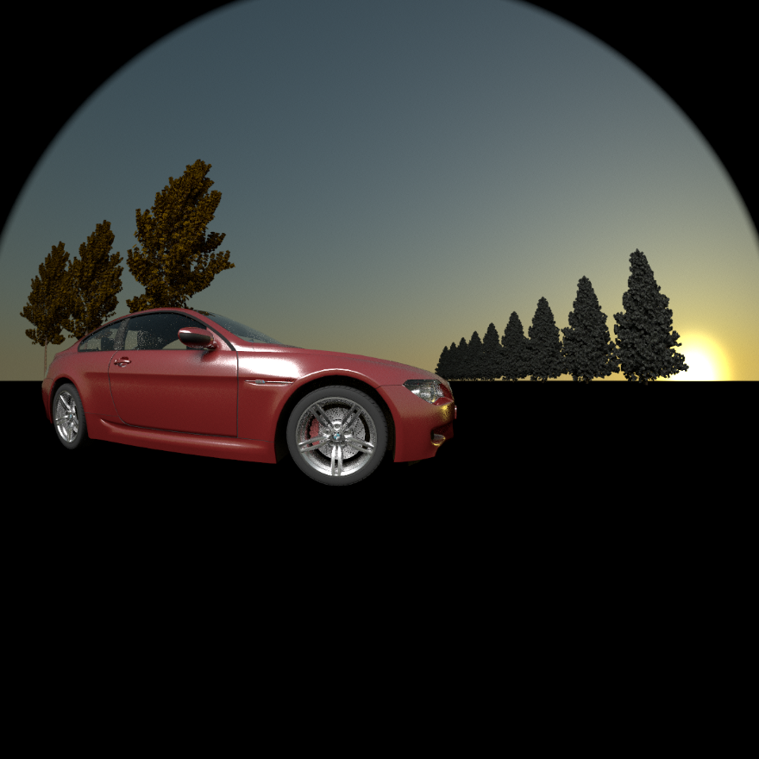

Wide-angle image

A few lens models utilized by pbrt realistic camera are provided in the assignment starter file: assignment2/lenses. Make use of them to generate the above rendering with an attempt to achieve the closest match.

Finally, save the modified scene description file with your setting in scenes/assignment2/wideangle.pbrt, and save the corresponding rendered result as render9.png in scenes/assignment2.

1. **Submission and Grading**

This assignment will be graded on a credit/no credit basis. Credit will be given if the example renderings are reproduced to reasonable accuracy. Try your best to mimic the lighting configurations in the example renderings, but don't worry if your images aren't perfect matches.

Once you are done configuring the scene and rendering all images, create a file named “Submission.md” in the root of your repository, and add to this file all brief summaries you have written for each part of the assignment. To make it more organized, use the same section headings:

* Rendering the landscape

Your summary …

* Depth of field

Your summary …

* Motion blur

Your summary …

* Wide-angle photography

Your summary …

To do this, go to your repository on Gitlab and choose the branch “assignment2”, and follow these [**instructions**](https://docs.gitlab.com/ee/user/project/repository/web_editor.html) to create the new file “Submission.md”.

To add all the files that you have created for this assignment (i.e. all .pbrt files and .png images) to your Gitlab project and commit them, run the following commands in Git Bash (if you have closed your Git bash window, open another one within the folder “pbrt-v3”):

$ git checkout -b assignment2

$ git add scenes/assignment2

$ git commit -m "Your Message"

Please note that -b “assignment2” is the remote branch and scenes/assignment2 is the local subfolder. After you commit your changes, you can push to the remote branch using the command below to push to the remote branch "assignment2":

$ git push -u origin assignment2

Once you have successfully associated your local branch assignment2 with the remote branch assignment2, you can push new changes to the remote branch with just:

$ git push

When you are ready to submit, you can issue a pull request to your TAs following these [**instructions**](https://docs.gitlab.com/ee/user/project/merge_requests/creating_merge_requests.html#new-merge-request-from-your-local-environment). This means creating a pull request from your *assighnemt2* branch to your *master* branch, and adding the TAs as reviewers of the pull request. Note that you should not make a pull request to the public pbrt repository, as this would require making your solution public.

Once your pull request is created, review it to ensure it contains all the required files (please **do not** include .exr files):

1. Nine images you rendered in the steps above in .png format (You should render all these images with at least 128 samples per pixel):

* three for Rendering the Landscape
* three for Depth of Field
* two for Motion Blur
* one for Wide-angle Photography

1. Four .pbrt files (landscape-depthoffield-motionblur-wideangle.pbrt)
2. Your Submission.md file