**Test application over HTTPS connection, (screenshot evidence)**

I deployed the admin-panel (react) on the vercerl.com

**Login page**



**program page**



**create a program**



**update a class**



**delete a class**

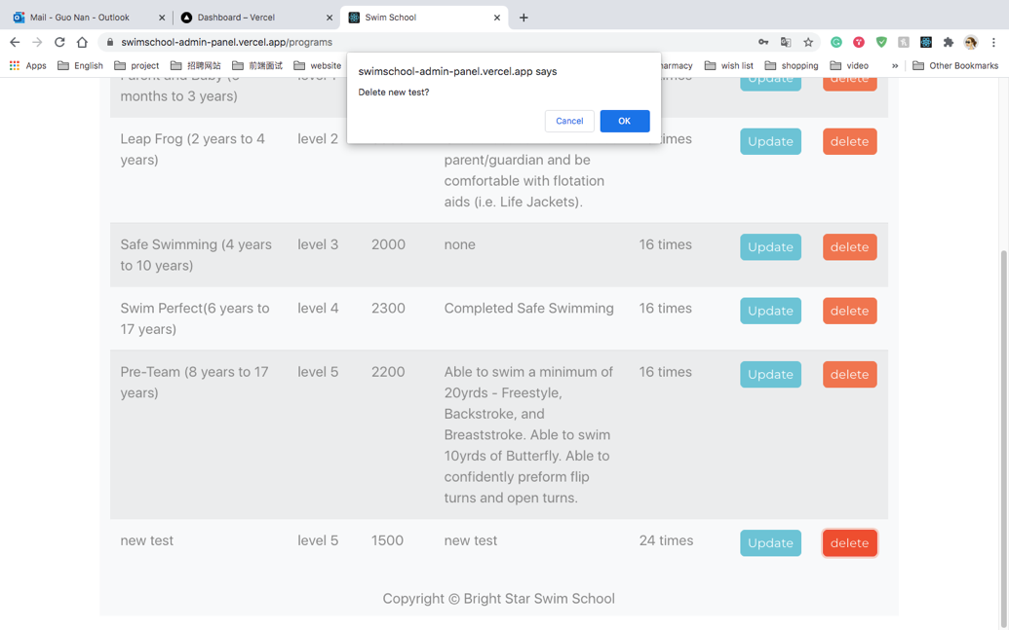

**class page**



**Comment on each of the 3rd party frameworks used, why was it chosen**

I use React to complete admin panel. According to NPM trends, React is the most downloaded framework. It is a popular, declarative, efficient, and flexible open-source JavaScript library for building user interfaces, allowing developers to design simple views for each application state and have React JS efficiently update and render just the right components when data changes. It is widely used by many of Fortune 500 companies, because：

* Development speed: React JS embraces reusable components to make it easier for developers to develop and maintain applications and achieve a consistent look and feel across the whole project.
* Stability：Considering that React JS is backed by Facebook, as well as countless enterprise contributors from around the world, the chance of it becoming obsolete in the near future is fairly slim.
* Search Engine Optimization (SEO)：all enterprises know how critical for their success it is to rank on the first page of major search engines. React JS can render on the server using Node, which means that search engine crawlers get to see the web application in its final form, making it much easier for them to index it properly.

https://brainhub.eu/blog/why-react-js/

**What other technologies did you investigate in order to settle on a path**

I also researched other top front-end frameworks like Vue and Angular. Angular is a complete package that offers you all the tools right from development to testing while developing a web application, whereas React is a flexible library that requires the support of other libraries for the development. Vue is the mix package of Angular and React, that adds speed, efficiency, and simplicity to web app development.

* Performance:

DOM is considered as the UI of any application.

React is a front-end library that uses the Virtual DOM and enhances the performance of any size of application which needs regular content updates. For example, Instagram. React is based on single-direction data flow. This will provide better control over the entire project.

As React constantly changes, developers working with the React need to update their skills regularly to go with the new things flawlessly. Everything keeps evolving, so sometimes the tech giants will not find them in a comfortable position to work with it.

Angular is the popular framework of Javascript that uses real DOM and is best suited for the single-page-applications where content is occasionally updated. Angular uses a Two-Way Data binding process that replicates all the changes made in the Model into the views in a secure, efficient and intuitive way. However, due to many features of this framework, while translating your project into heavy applications, it will slow down the performance as compared to React and Vue.

Vue is the youngest JS framework, developed with incredible features to overcome the hurdles that developers face with Angular and React. It consists of all the good things of React and Angular; therefore, it utilizes the virtual DOM to deliver high performance and memory allocation. Being a new member of a family, Vue has the smallest community support as compared to React and Angular.

* Migration：If comparing the migration process of Angular vs React vs Vue in 2020, Vue has the most straightforward and quickest for upgrading.
* Framework Size：Considering the below mentioned size of each framework and library, Vue and React are suitable for the light-weight application, whereas Angular is a good fit for complex and heavyweight applications.
* Deployment Speed：The speed of configuration solely depends upon the number of libraries which are accessible by the developer. Therefore, it is also concluded that developing a web app is faster and easier in Angular than React, whereas React’s architecture is more straightforward to scale than Angular.

<https://levelup.gitconnected.com/angular-vs-react-vs-vue-which-is-the-best-choice-for-2020-81f577697c7e>

Describe why you chose this particular encryption technology

PHP hash function password_hash is used in this project.

A hash function is any function that can be used to map data of arbitrary size to data of a fixed size. The values returned by a hash function are called hash values, hash codes, digests, or simply hashes.

The more computationally expensive the hashing algorithm, the longer it will take to brute force its output. PHP 5.5 provides a native password hashing API that safely handles both hashing and verifying passwords in a secure manner.

Describe the rules by which your authentication restricts access. Comment in code.

Check in code comment