•Teams
•Vimeo - IBM BPM 8.5 Teams
•DeveloperWorks - Common business process modeling situations in WebSphere Lombardi Edition V7.2, Part 1 - Role-based and dynamic routing of activities - 2011-06-29
Re-Assigning Tasks and changing group members
重新分配任务和改变组成员
Imagine a BPD instance which includes an activity associated with a team. If the team is
你可以任务一个BPD的实例是有关一个团队的一项活动，如果该团队与一个外部的
associated with an external system group then what will happen if the system group's membership
系统组有关系，且在任务创建之后，clained 之前，改变系统组成员，会发生什么变化呢？
Changes after the creation of a task but before it is claimed? The answer appears to be that any
tasks already created will honor the new group change.
答案看起来是这样子，已经被创建的人将拥有这些新变化。
Unfortunately, there does not appear to be a way to change the makeup of a team after the task is
不幸的是，在任务被创建之后，似乎没有办法能改变一个团队的组成。
created. So if a task is created with a certain set of potential owners those potential owners are
如果一个任务被创建时，被赋予一些特定的所有者，这些所有者将会与这个任务绑定在一起
fixed to that task (unless they come from a system group).
（除非他们来自一个系统组）
Assignment Examples
分配举例
Here are some examples of some of the more interesting assignment uses.
这里有一些比较有意思的分配用法的例子。
The Four Eyes Example
四眼原则例子
There are some processes where two staff members have to review or approve some activity.
有一些需要两个成员进行检查或批准。
As an example, let us think about hardware procurement at IBM. If I, as an IBM employee, wish a
举个例子，试想IBM的硬件采购，如果我作为IBM员工，希望申请一台新的笔记本电脑，
New laptop, I can submit my request to my procurement department.
我可以向采购部门提交我的申请。
Their process says that the request must be reviewed by two procurement specialists.
他们的流程需要两位采购专家检查申请。
We can imagine this being implemented in IBPM.
我们可以想象这个流程用IBPM实现的情况，
A Human Service would be executed that assigns the request to anyone in the Procurement
一个人工服务将会被执行来向采购组的任何一员指定处理该申请。
group. If the request is approved we now create a second Human Service and assign that also to
如果该请求被批准，我们现在创建第二个人工服务，指定采购组来处理该请求，
The Procurement group. Unfortunately, there is a problem in that simple solution. If the first task
Is assigned to the Procurement group and "Bob" works on it,
不幸的是，这个简单的解决方案有一个问题，如果第一个任务被指派给采购组，由“Bob”处理，
the second task will also be assigned to the Procurement group and, unfortunately, there is nothing to prevent "Bob" from working upon and claiming that second task as well.
第二个任务有被指派给采购组，不幸的是，并没有任何信息显示“Bob”不可以处理该任务，
The tasks "have" been handled by "someone" in the Procurement group …
事实上可能该任务已经被采购的另外一个人处理了…
it just was the same person each time and that is not the intent of our story.
每次都同一个人处理，这不是我们想要的目的。
Fortunately, there is a relatively easy solution.
幸运的是，有一个相对简单的解决方案。
We build a process that looks like this.
我们创建一个这样的流程。
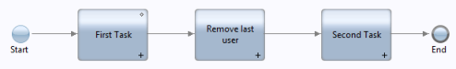
The assignment decisions for both tasks use the "List of Users" feature for owner selection.
After the first task has completed, we determine the owner of that task and remove them from the
list of potential owners for the second task. A suitable fragment of JavaScript to achieve this may
look like:
对于两个任务的分配使用“List of Users”特性来选择所有者。在第一个任务完成后，我决定这个任务的所有者，并将它从第二个任务的潜在所有者集合中删除。下面的javascript代码可以实现这个功能：
for (var i=0; i<tw.local.users.listLength; i++){
if (tw.local.users[i].id == tw.local.userName) {
tw.local.users.removeIndex(i);
log.info("Found and removing");
break;
}
}
log.info("Final list: " + tw.local.users.toXMLString());

The key to understanding this fragment is to realize that tw.local.users is an array of the
users that are in a particular group and tw.local.userName is the name of the user that was
assigned to the first task.
理解这个部分的关键是要明白w.local.users 是在一个特殊组里面的用户的集合，并且tw.local.userName 是指定处理第一个任务的用户的名字。
Assigning a task to a named user
分配任务给指定名字的用户
Consider the notion that within a process we know the identity of an specific user to whom we wish to assign a task. How can we achieve that within IBM BPM?
考虑这样一个概念，在一个流程里，我想给指定用户分配一个任务，在IBM BPM 中我们怎样才能实现呢？
We create a new Team Filter service called "Single User" that has the following signature:
我们创建一个叫“Single User”组过滤服务 ,它有以下特征：
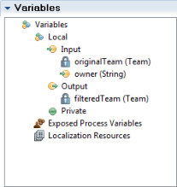
Its implementation is a single Server Script which contains the following logic:
他的实现在一个服务器脚本里，包含以下的逻辑：
tw.local.filteredTeam = new tw.object.Team();
tw.local.filteredTeam.name = tw.local.originalTeam.name;
tw.local.filteredTeam.managerTeam = tw.local.originalTeam.managerTeam;
tw.local.filteredTeam.members = [ tw.local.owner ];
What this code does is build the resulting Team object from the original Team object but comprises the new team's membership solely from the identity of the passed in user.
这些代码是为了从原来的组对象中创建我们想要的的组对象，但是它仅仅包含这个新键组的用户传递过滤的身份。
In a User Activity's assignment specification, we can now name the service and the user we wish to assign:
在一个用户活动指派的详情中，我们现在可以命名这个服务和我们想指派任务的用户
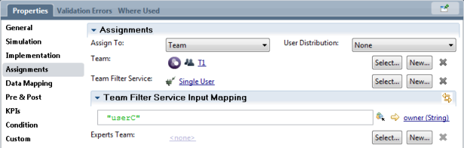
The desired owner can be obtained from a string or a variable.
期望得到的所有者可以从一个字符串或者一个变量中获取。
Timer Events
定时器事件
A timer can be added as an attribute on an existing task or can be an element in its own right. The
icon for this can be seen in the palette and looks as follows:
定时器可以作为一个属性加到一个已经存在的任务上，当然也可以是一个元素，定时器的图标可以再操作面板上看到，如下图所示：
Once added, its implementation type should be changed to Timer：
一旦被添加到面板上，它的实现类型应该改为定时器：这种方式叫“附着”一个定时器事件。
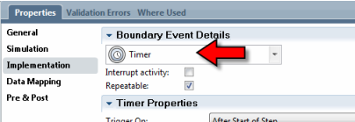
It can be dragged and dropped on an existing activity. This is called "attaching" a timer event. A
link from this timer can then be associated with a different activity. If the timer fires, the linked
activity will be called. In the following diagram, an activity called Human Task has had a timer
added to it and that is wired to the activity called Log.
定时器图标可以被拖拽，并且可以放在一个已经存在的活动上。从定时器可以引出线从而与不同的活动发生关联。如果这个定时器被触发，与它关联的活动将会被调用。在下面的图表中，一个人工服务的活动上有一个定时器，它与一个叫Log的活动发生关联。
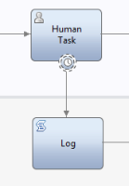
A timer has an associated Trigger On attribute. This is an algorithm used to select when the
timer will start ticking. The choices available are:
一个定时器自带有一个与之相关的触发器。当定时器开始计时时，这是一个用于选择的算法。
可选项如下：
•After Start of Step – A time after the step is reached
•Before due date – A time before the due date
•After due date – A time after the due date
•Before custom date – A time before a custom date
•After custom date – A time after a custom date
•开始计时之后 – 流程到达定时器的一个时间
•预定时间之前 – 流程到达预定时间之前的一个时间
•预定时间之后 – 流程到达预定时间之后的一个时间
•定制的时间之前 – 定制时间前的一个时间
•定制的时间之后 – 定制时间后的一个时间

The Before/After Difference field allows us to specify the time interval relative to the
Trigger On algorithm selection. The units for this field can be minutes, hours or days.
有关触发算法的选择，之前/之后 不同属性允许我们指定时间间隔。
The Tolerance Interval is an additional time interval associated with the algorithm. If a
task has not been claimed by a user, then when the primary interval is reached, the timer fires as
expected. However, if the task has already been claimed, then the additional Tolerance
Interval value is used to extend the deadline to complete the task before the timer fires.

宽限时间间隔是一个与算法相关的额外的时间间隔。如果一个任务还没被用户完成，那么当原本的时间间隔到达时，定时器就会按预想的那样被触发。尽管如此，如果这个任务已经完成，那么在定时器触发之前，额外的宽限间隔时间将会被用于延长截止日期。

The Interrupt Activity option causes the activity on which the timer is attached to end when the timer expires. The icon used to represent the Timer changes depending on the setting of Interrupt Activity:
当定时器到时间的时候，干扰活动选项会使与该活动绑定的定时器结束掉。用于表示定时器的图标会根据干扰活动设置的不同而发生变化。
Interrupt Activity: On
Interrupt Activity: Off 

干扰活动：开启
干扰活动：关闭

If this option is not selected (which of course means the attached activity continues to run), the
Repeatable option may be selected to cause the timer to start again after it has already fired.
The timer is restarted as though it had just been reached. A little care should be taken here. If we
flag a timer as repeatable and the date/time on which the timer is to fire is an absolute and that
date/time has passed, then the timer will immediately re-fire over and over again without much of a pause. It is unlikely that this is the desired result.

如果该选项没有被选中（哪一种选项意味着相关的活动会继续执行呢），该重复选项可能被选中使已经被触发的定时器再次执行。定时器重新开始执行定时任务，尽管它之前已经被执行过。这里要稍微注意一下，我们把定时器标识为可重复执行状态，并且定时器的日期或时间是一个绝对的日期或时间，且是过去的时间或日期，那么该定时器将立刻一遍又遍的被触发，这不是我们想要的结果。

Multiple timers can be attached to a single activity.
For the fields which can be used for time values, either constants or variables may be used.
多个定时器可以附加到一个活动上。
这些属性可以用作时间值，常量和变量都可能被用到。

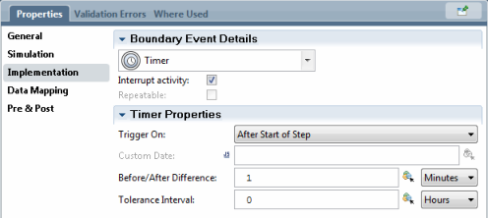
Similar to the attachment of timers to activities, timers can also be added in-line between activities.
与附加于活动上的定时器类似，定时器也可以串联到活动与活动之间。

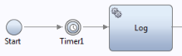
This has the same Timer Properties as previously discussed. When this Timer is reached,
processing delays until the timer expires. This allows for delaying the execution of a process for a
period of time.

跟之前我们所讨论的一样，这种情况有相同的定时器性质。当流程到达定时器时，执行被延迟知道计时结束。这允许延迟一段时间执行流程。

When a timer fires, its Post-assignment variables are in the scope of the attached activity. This
means that we can copy out the Task instance id that had time out on it.

当一个定时器被触发时，它的新增任务变量将存在于相关的活动的作用域内。这就意味着我们可以把超时的任务实例的id复制出来。
While working on the development and testing of a BPD that uses Timer Events, the Inspector view can be used to manually fire a timer even though the time interval has not yet expired. This can be useful for testing logic paths. If we right click on the token in the Execution State area, a
context menu pops up that provides Fire Timer. If selected, it will fire the timer and the system
will behave as though the timer had elapsed.

当开发或测试一个含有定时器时间的BPD时，Inspector 视图允许手动触发定时器，即使计时还没结束。它对测试逻辑路线很有用。如果我们右击执行状态区域的标记，将会出现一个提供有Fire Timer选项的快捷菜单。如果被选中，它将会触发定时器的定时任务，系统将会执行，尽管定时器已经过期。
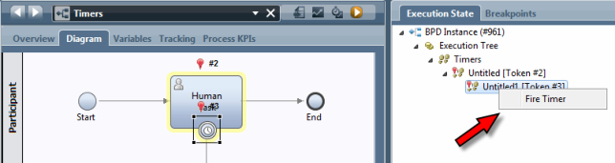
This is a great solution when one is able to attach a Process Designer but that is only available
within a development environment. An alternative which can also be used for testing is to use the
Process Admin console and switching to the Process Inspector tab. From here we can view the list
of processes and make changes to them. Notice the option at the bottom right of the page. Here we
find a list of active timers within the process. We can select a timer and cause it to fire immediately thereby bypassing any waits that may be outstanding.
当可以依赖流程开发工具时，这是一个伟大的解决方案，但是它仅仅在开发环境中可行。另外一种选择也可以用来测试，它是使用流程管理控制台，切换到流程Inspector页面。在这里我们可以看到流程的列表，并且可以改变它们。注意页面右下角的选项，从这里我们可以看到当前流程有效的定时器清单。我们可以选择一个定时器，并且可以立即触发它，从而省去一些等待时间。
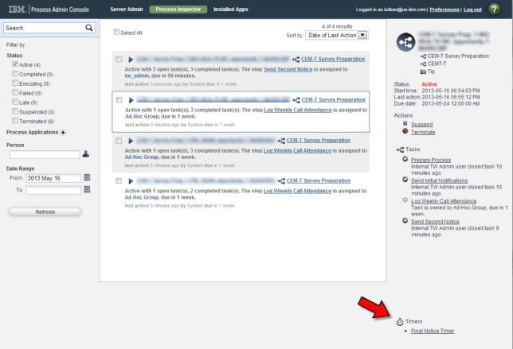
On occasion, the time when the timer is to fire is not a simple fixed value but must instead be
calculated. For example, we might want the timer to fire after four business hours instead of four
wall-clock hours. To achieve this, we need to explicitly calculate the date/time when the timer is to
fire and supply that as a custom time value.

有时，定时器触发的时间不是固定的值，但必须是可以计算的。例如，我们可能想在四个business hours而不是四个wall-clock hours，为达到这个目的，我们需要明确的计算定时器被触发的日期或时间，并将它作为定制的时间值。

See also:
•Error: Reference source not found
•Data Type – TWTimerInstance

Tracking Intermediate Event
追踪中间事件
A tracking intermediate event is used to generate a data point used in performance reporting on
process instances. When added to the diagram it looks as follows:

一个追踪中间事件是用来产生数据点，这些数据点用于提高流程实例报告的性能，当添加到流程图表上时，追踪中间事件如下图所示：

When encountered, a record that this point was reached in this instance of the process is made. In
the implementation section of the element, a reference is made to a Tracking Group:

在这个元素的实现部分里，Tracking Group 应选一个参考。
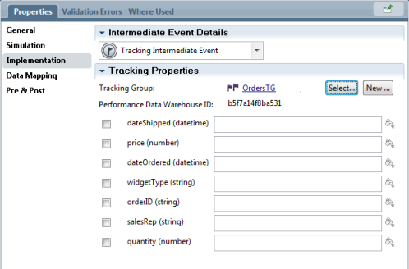
We can define which of the tracking group properties will be populated and with what values.
Checking the box next to the tracking group property causes that property to be included in the
output record. We can also define which variables or values within the process should be mapped
to the tracking group property.

我们可以定义填充哪一个追踪组的属性和填充什么值。检查靠近追踪组属性的复选框，使那个属性包含在输出记录中。我们还可以定义流程内部的哪些变量或值应该映射给追踪组属性。
See also:
•Tracking Groups Overview
•Monitor Tracking point data
也可以看到：
•追踪组概要
•监控追踪点数据

Ad-hoc Start Event
专用的开始事件

The Ad-hoc Start Event is a mechanism that allows us to start a chain of activities in an already
existing process instance. When added to the process, a new entry appears in the options for an
instance of this process or in the Process Portal. When the steps associated with the Ad-hoc Start
Event are invoked, these steps have visibility to the data contained within the process as a whole.
When added into the BPD diagram, an Ad-hoc Start Event step looks as follows:
这种专用的开始事件是一种机制，它允许我们在一个已经存在的流程实例上启动一系列活动。当这种专门的开始事件被加到这个流程上，一个新的入口将会出现在一个流程实例或者流程Portal的选项中。当与这种专用的开始事件相关的步骤被调用时，总的来说，这些步骤将可以看到包含在流程内部的数据。当被添加到流程图表上时，图标如下所示：

The name of this concept ("Ad-hoc event") is an odd one and one I find not representative of what
the function actually does. What we really have here is the ability to have an optional "event"
passed into the process which causes a new flow of control to execute in the same process context.
The implementation properties of this entity are shown below:

这个概念（“Ad-hoc event”）的名字有点古怪，我发现它并不能代表它实现的功能。我们真正拥有的是将可选择的“事件”传递给这个流程，使它产生一个新的控制流程并在同一个流程环境中执行。
具体实现的内容如下：
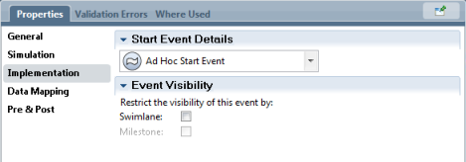

By default, the event can arrive at any time during the life span of the process. Further options are
also provided:
•Swimlane – TBD
•Milestone – The Ad-hoc start may only be initiated when a process token is within the same milestone as that of the ad-hoc activity

在默认情况下，这种事件可以出现在流程生命周期的任何时候，其他选项也有提供：
•Swimlane – TBD
•里程碑 - 这种Ad-hoc 开始事件可能只有当流程的记号在相同的里程碑事件的专门的活动里才会被初始化。

When added into the BPD, you can drop the Ad-Hoc start event in any area. We have the option to
associate an Ad-Hoc Start Event with a “milestone”. If added to a milestone, the event is only
available when the process is within the milestone area. You switch this on with with the check
marks in the implementation area of the Ad-Hoc event. By default, the Ad-Hoc event is available
in all milestones (and all swimlanes).
See also:
•Error: Reference source not found
•Starting Ad-Hoc entry points
•Securing Process Portal capabilities
•IBM Education Assistant – Ad-hoc tasks

当被添加到BPD中，你可以拖拽这个专门开始事件到任何地方。我们可以有选择性的将专门的开始事件与一个“里程碑事件”发生关联。如果添加到一个里程碑事件上，这个事件将仅在这个里程碑区域里有效。勾上专门事件实现区域的复选框，你可以开启它。默认情况下，这种专门事件在所有里程碑事件都是有效的（和所有的泳道）。

也可以看到：
•错误：没发现参考资源
•启动Ad-hoc 入口点
•确保流程门户功能
•IBM 教育助手– Ad-hoc任务

Message Intermediate Event
消息中间事件

The Message Intermediate Event is an Event listener that is used to listen for incoming events
within a process instance that is already running. Contrast this with a Message Start Event which
will initiate a new instance of a process when a message arrives. The Message Intermediate Event
has two flavors.

这种消息中间事件是一个事件监听器，它用于监听一个已经在运行的流程实例的进来的事件。相比之下，消息开始事件，当消息到来时，会初始化一个流程实例。消息中间事件有两种情况
These are called:
•Stand alone listener
•Attached listener
它们分别是：
•独立监听器
•附加监听器

The Stand alone listener is seen within a BPD as its own diagram element. When it is reached, it
suspends further execution of the process until an event is received or the process is terminated
elsewhere.
独立监听器被看做一个BPD自己的流程图表元素。当消息到达监听器时，它会推迟流程的进一步执行直到收到消息，或者别的地方的流程终止。
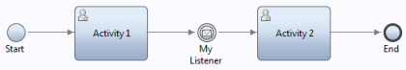

The other type of Message Intermediate Event is called the Attached listener. It is called this
because it attaches to an activity. While the activity is running, if an event arrives, a link coming
from the Message Event will be followed. An option called "interrupt activity" available on an
attached listener determines whether or not the outgoing link from the activity will also be followed when the activity completes. If "interrupt activity" is checked, then if a message arrives, the activity is canceled.
另外一个消息中间事件的类型叫做附加监听器。之所以这样叫，是因为它需要附加到一个活动上。当活动正在运行时，如果事件到来，从消息事件引出的连线将会被追踪。当活动结束时，在一个附加监听器上叫做“干扰活动”的选项将决定是否跟踪当前活动引出连线。如果“干扰活动”被勾选，那么如果消息出现，活动将会取消掉。
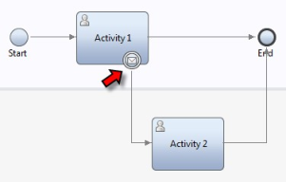
Because a Message Intermediate Event listener lives within an existing process instance, when an
event occurs that event must be matched against the correct instance of the process for which the
event is destined. The ability to match the event against this correct process instance is called
"correlation".

因为一个消息中间事件存在于一个已经存在的流程实例里，当一个事件产生时，该事件必须匹配上它所依赖的正确的流程实例。这种匹配事件和正确流程实例的能力叫做“相互关系”。

The Message Intermediate Event is actually watching for the arrival of a UCA. When that UCA
arrives, the event is said to have happened. This is the mapping between the logical concept of an
event and the actual implementation of an event within the IBPM product.
The settings for an Attached listener are as follows:
实际上，这种消息中间事件是等待UCA的到来。当所等待的UCA到来时，这个事件就会产生。这是IBPM产品中事件逻辑概念和事件具体实现的映射关系。
附加监听器的设置如下：
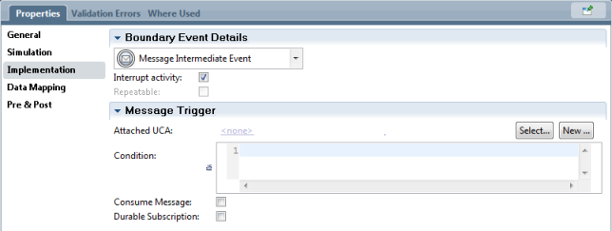
The settings for a Stand alone listener look like：
独立监听器设置如下：
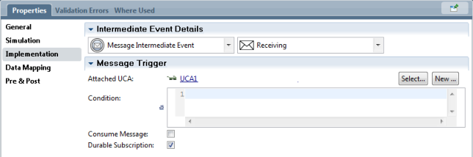

Now, what if the event that would trigger the listener occurs before the listener is reached? This is
where the concept of the Durable Subscription comes into play. If this flag is checked,
then the arrival of an event before the listener is reached is remembered and when the process
reaches the Message Intermediate Event, it is immediately notified that the message is available and the solution can continue. If this flag is not checked, then the event that arrived previously is
discarded and the process will wait for a further event.

现在，如果触发监听器的事件早于监听器的到达时，会发生什么呢？这就是Durable Subscription 起作用的地方。如果被勾选，那么早于监听器到达的事件将会被记住，并且当流程到达消息中间事件时，立即会被通知当前消息有效，解决方案可以继续。如果没有被勾选，那么 之前到达的将会被丢弃，并且流程将等待其他事件。

The Consume Message option is used to indicate that if this event listener is triggered by an
event, should a subsequent event listener also be triggered by this same event? If Consume
Message is checked then the next occurrence of the listener will not be triggered by this event
Occurrence.

Consume Message 选项是用来指示事件监听器是否被事件触发。一个紧跟其后的事件监听器是否应该被同一个事件触发？如果Consume Message被勾选，那么下一个监听器的出现将不会被这个事件的出现触发。

Consider a message arriving that says "Payment has been received". This is great news and now the process can continue. But wait a moment … we seem to have a problem. Assume that I am a car salesman and I have two separate customers waiting in my office. My finance department calls me and says that the payment has been received and the customer can leave with the car. This by itself is not sufficient. I have two potential recipients of keys … for which customer has the payment cleared?

试想一个消息说“付款已经收到”。这是一个好消息，流程可以继续。但是等一下… 我们似乎有一个问题。假设我是一个汽车销售员，并且我有两个不同的客户在我的办公室等待。我的财务部门打电话给我，说付款已收到，客户可以把车取走了。这个它本身是不充分的。关键我有两个潜在的取车人… 哪一位客户付款了呢？

In IBPM, the challenge is that when an event is to be delivered to a process we must know to which instance of the process should the event be delivered. To resolve this problem, an event must carry with it sufficient information to allow IBPM to uniquely identify to which instance of a process the message should be delivered. This information is called correlation. We need to correlate an incoming message with the process instance to which it is to be sent.

在IBPM里，难点在于当向一个流程传递一个事件时，我们必须知道这个事件应该传给哪一个流程实例。为解决这个问题，一个事件必须携带充分的信息从而使IBPM唯一的识别，消息应该传给哪一个流程实例。这个信息叫相互关系。我们需要把收到的消息和接收消息的流程实例关联起来。

A Message Intermediate Event is always associated with a UCA and a UCA can carry data with it.
In the IBPM PD, we can specify a variable who's value must match that of an incoming event's
UCA payload in order to be considered a match.

一个消息中间事件通常情况下会关联一个UCA，并且UCA本身可以携带数据。在IBPM 开发工具中，我们可以指定一个值与接收事件的UCA的载荷相匹配的变量将会看作一次匹配。

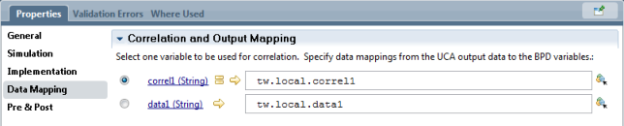
Note that it is vital that each of the UCA Output Correlation fields name a local variable even if
they are not to be used for the correlation mapping. Currently, the product only allows the selection of a single variable for correlation matching. If the match requires additional comparison, then a new variable must be defined which will be the concatenation of multiple values. In the UCA associated General Service, the incoming data will also need to be concatenated together to build the matching data.

注意关键在于每一个UCA输出相互关系定义了一个本地变量，即使这个变量不用于相互关系的映射上。现在BPM只允许单一变量用于相互关系映射。如果匹配需要的话，那么就定义一个新的变量用于拼接不同的值。在与General Service相关的UCA中，接收的数据也需要拼接起来用于匹配数据。

With this background information in place, we can now look at some potential usage scenarios.
The first one we will choose is the idea of the Multi Wake-up. In this scenario, we will have a
single process with two parallel Intermediate Message Events both waiting on the same event:

如果有合适的后台信息的话，我们就可以看到一些潜在的用法。首先我们要选择the idea of the Multi Wake-up，在这个方案里，我们将创建一个单独的流程，它有两个平行的中间消息事件都在等待同一个事件：
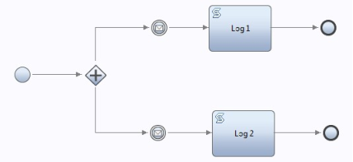
What we desire is for both of these to block and wait for a new event to arrive. We define the
Intermediate Message Events to:
•Be associated with the same UCA
•Use the same correlation value
•To not consume the message. If we consumed the message, one would wake and other other
wouldn't.
•To not have a durable subscription.

我们希望两条支路都处在等待新事件到来的阻塞状态。我们定义的中间消息事件有如下特征：
•关联同一个UCA
•用同一个相互关系的值
•不使用消息。如果我们使用消息话，那么将会只有一个中间消息事件被唤醒。
•不具有durable subscription.

In addition to blocking waiting for a message to arrive, the Message Intermediate Event can also be used to invoke a UCA which is the logical equivalent of generating a new message. A Message
Intermediate Event can be visually seen as sending a message rather than waiting for a message
because it has a different representation in the BPD diagram. Specifically, it has a black envelope
icon:

除了处于等待消息的阻塞外，这个消息中间事件也可以用于触发一个UCA，它在逻辑上等同于产生一个新消息。一个消息中间事件从视觉上可以看做发送消息而不是等待消息。因为它在BPM图表中有一个不同显示，它的图标是一个黑色的信封：
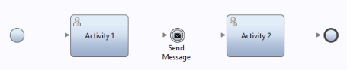
In the Implementation tab of the activity there is a selection option in which we can define it to be
either receiving or sending. Changing it to Sending results in the invoke of a UCA when reached.
The name of the UCA is also supplied on this section. Once a UCA has been chosen, any data
passed as input into a UCA of that type can be defined in the Data Mapping section.

在活动实现选项卡中，有一个选项，我们可以把它定义发送或者接收。当事件到达时，在调用UCA过程中发送结果。在这个部分提供了UCA的名字。一旦一个UCA被选中，在数据映射部分，我们设置传向UCA的任何输入参数。
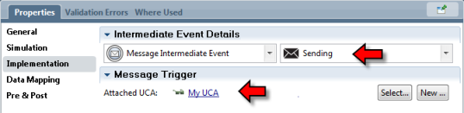
See also
•Message Start Event
•Undercover Agents (UCAs)
•Starting a UCA from REST
Message End Event
消息结束事件

