Guorun Huang, Project2 Report
Pattern Recognition and Computer Vision, 25Fall
(choose to use 2 travel days to adjust the ddl)

1. Project Overview
This project implements a content based image retrieval system in C++ with OpenCV. Instead of using tags, the system compares images by visual features such as color, texture, and learned embeddings. A simple center-region matcher, histogram methods, spatially aware histograms, a texture+color hybrid, and experiments with precomputed ResNet18 embeddings. For customized project and extention, the goal of this project is to find as many images containing cars/bananas as possible from a large image collection, given a single query image. To balance color, texture and semantic cues, I use a hybrid feature set—color histogram + Sobel texture histogram + ResNet deep embedding—and combine their similarities with a weighted distance.

- Results
1 Baseline Matching
7x7 square in the middle of the image as a feature vector
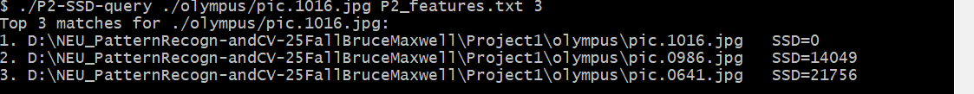
2 Histogram Matching
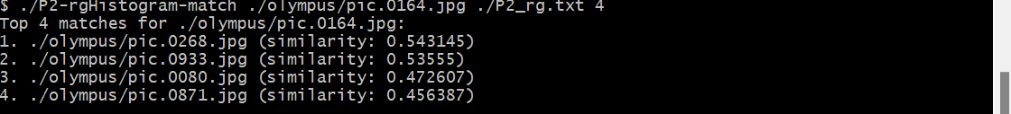
3 Multi-Histogram Matching

4 Texture and Color
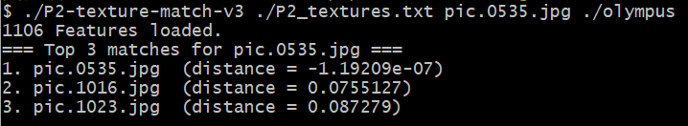
5 Deep Network Embeddings
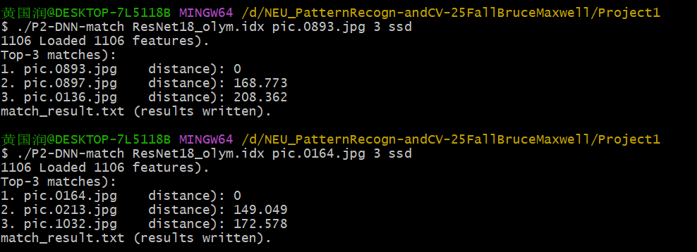
6 Deep Network Embeddings compare with traditional features
for pic.1072.jpg:
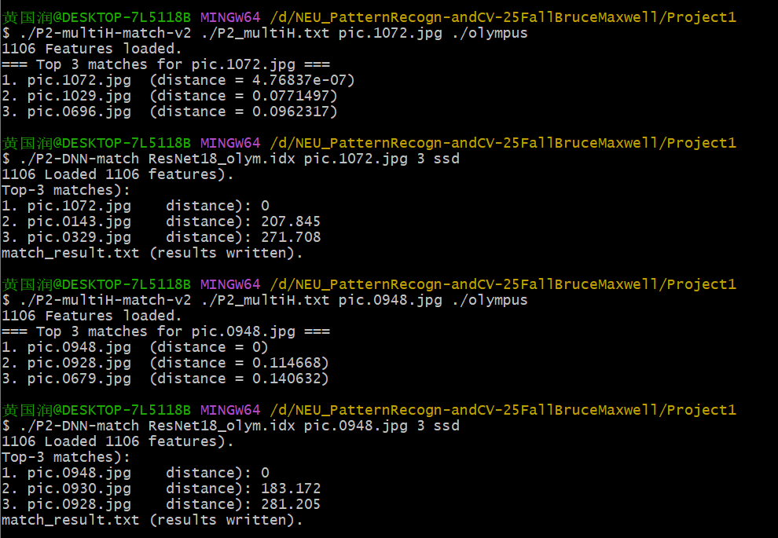
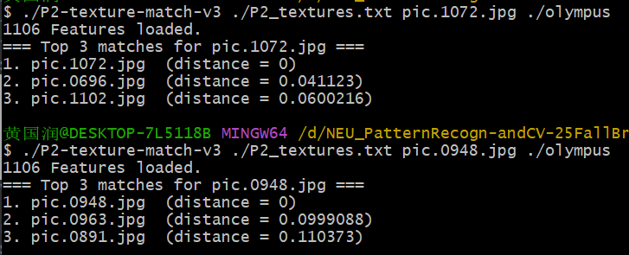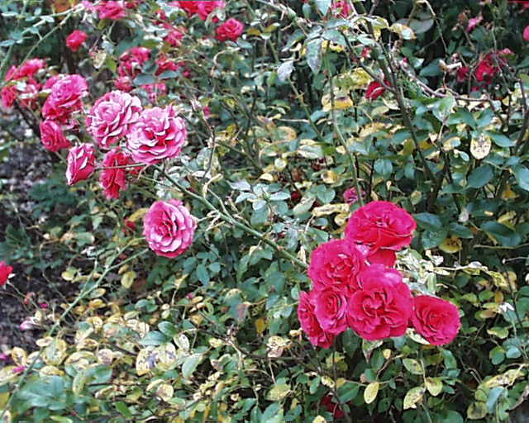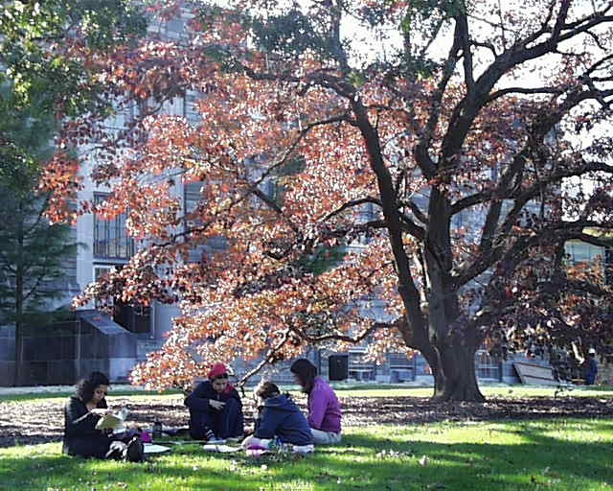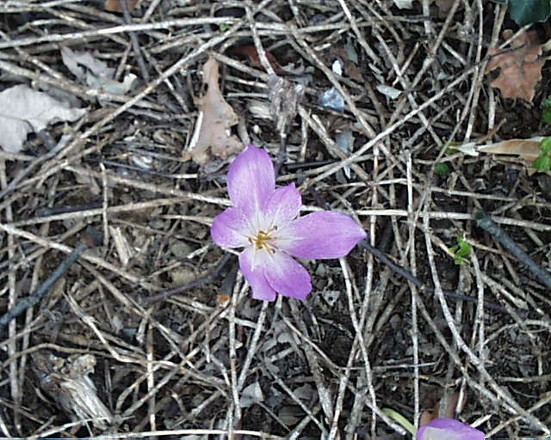
pic.1072.jpg pic.1029.jpg pic.0696.jpg
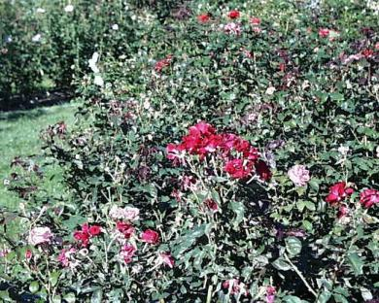
pic.1072.jpg pic.0143.jpg pic.0329.jpg
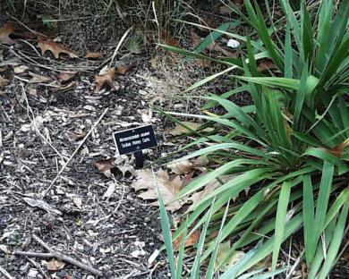
pic.1072.jpg pic.0696.jpg pic.1102.jpg
Reflection: When identifying flower beds, both RGB histograms and DNN embeddings work well. Using a simple average of RGB histogram and Sobel texture gives slightly worse results. This is likely because mixtures of texture and color can match grass patches that have no flowers—many textures and colors align, so false positives increase.

for pic.0948.jpg:
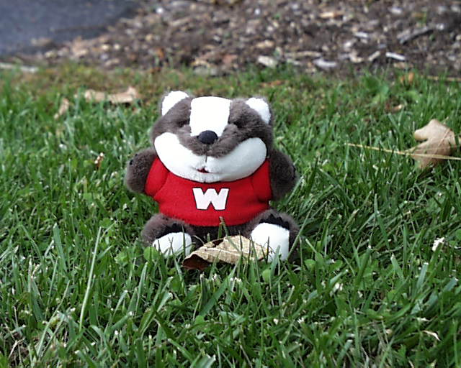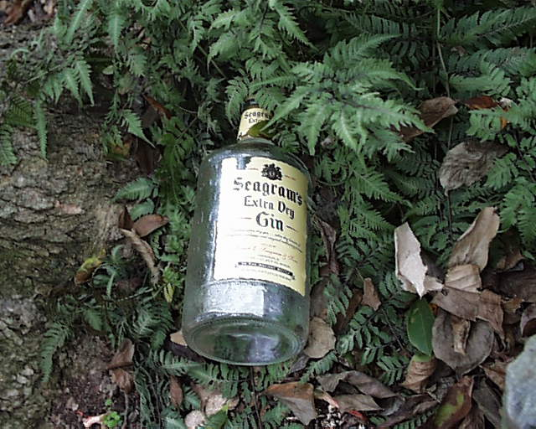
pic.0948.jpg pic.0928.jpg pic.0679.jpg
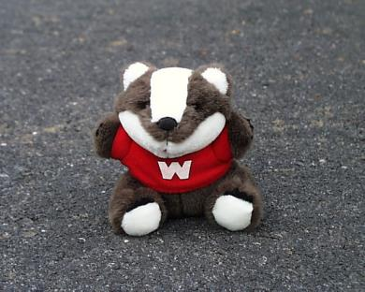
pic.0948.jpg pic.0930.jpg pic.0928.jpg
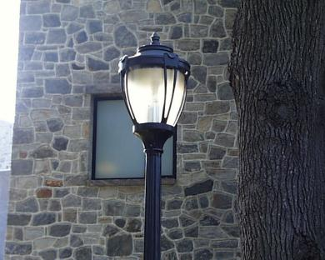
pic.0948.jpg pic.0963.jpg pic.0891.jpg
Reflection: For detecting toys placed in the center of an image, DNN embeddings perform very well. Using only an RGB histogram tends to return images with similar colors but different object shapes. Combining RGB histogram with Sobel texture (averaged) retrieves images that share both a similar color distribution and a centrally located round object, because many textures and colors align.

7 Custom Design
Overview: The goal of this project is to retrieve vehicles with similar shapes from a set of images given a single query image. The focus is on shape — body proportions, wheel placement, overall silhouette — rather than color or illumination, so the system is robust to background, lighting and color differences. The implementation uses C++ and OpenCV, with feature extraction and matching split into two separate programs to allow offline index building and fast online queries.
Design rationale
To find cars that are similar in shape we need to suppress variations in color, brightness and scene background, and concentrate on edge, contour and local structural cues.
Why these features were chosen:
- HOG captures the distribution of gradient orientations and is effective at representing body contours and aspect ratios.
- Laplacian variance (or a similar texture measure) captures local details such as tires and windows, complementing HOG where regions are smooth.
- Color or DNN semantic features are not used as primary signals to avoid color- or scene-driven matches; if semantic filtering is desired, a DNN embedding can be applied as a secondary filter.
Results and reflection:
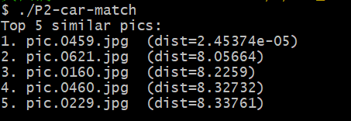
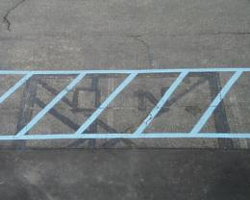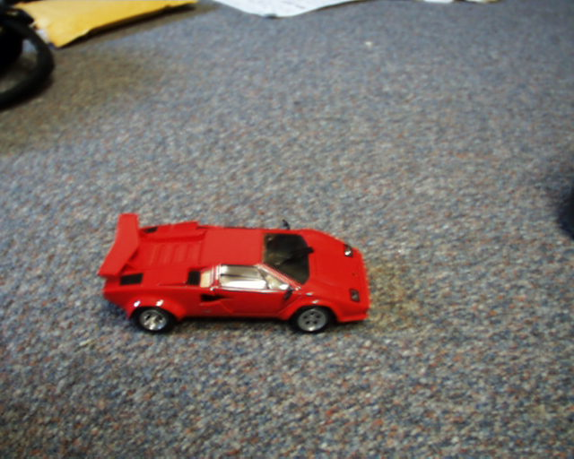
The good news is that using only conventional features—HOG and Laplacian variance—without any deep learning still produced fairly good matches. However, relying solely on texture measures can cause images with similar basic structures to be matched incorrectly—for example, circles (tires), trapezoids, rectangles that resemble parts of a car body.
How can we improve recognition? One approach is to enforce structural logic during matching. For instance, a car typically has a large trapezoidal body plus two roughly parallel circular shapes (the wheels) separated by a certain distance. Requiring such relationships makes matches more meaningful.
Also note that when a car’s body color is close to the background, edge detection becomes unreliable and those images are hard to match. Therefore, choosing the right lighting and camera angle when photographing candidate items is important for good matching results.

8 Extention
Overview: The goal of this project is to find as many images containing bananas as possible from a large image collection, given a single query image that includes a banana. To balance color, texture and semantic cues, I use a hybrid feature set—color histogram + Sobel texture histogram + ResNet deep embedding—and combine their similarities with a weighted distance.
Design Rationale
- Color: Bananas are typically yellow, so color histograms are a quick way to detect yellow regions, though they can be fooled by yellow backgrounds.
- Texture: Banana skin is relatively smooth; a Sobel gradient-magnitude histogram helps distinguish smooth objects from textured backgrounds, reducing false positives caused by color alone.
- Semantic: DNN embeddings from models like ResNet capture higher-level semantics and can recognize bananas across different poses and backgrounds; this is the strongest cue.
Distance combination: Use histogram intersection for color, SSD for texture, and cosine distance for DNN embeddings. Combine them with empirical weights: 0.3 * Color + 0.2 * Texture + 0.5 * DNN. This weighting emphasizes semantic information while keeping color and texture as useful supporting signals.
Results and reflection:
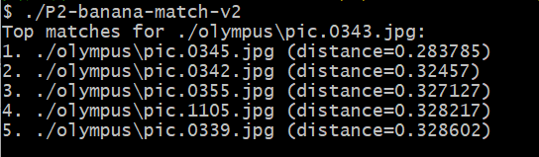
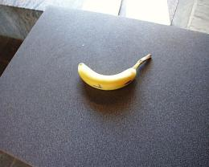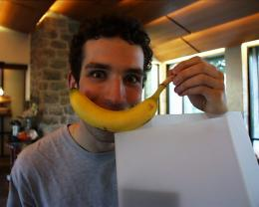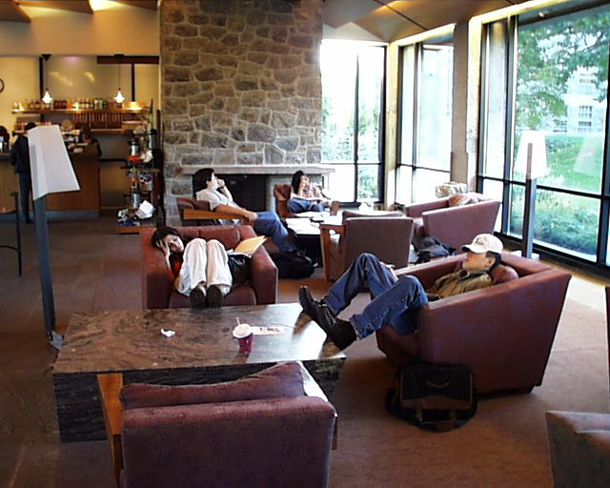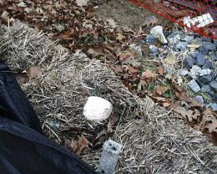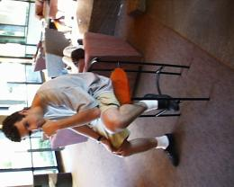
The good news is that the top match is exactly what we wanted—a banana. However, the other matches mostly contain items with a similarly curved shape, not actual bananas. How can we improve recognition? One approach is to require that matched items not only have the curved banana-like shape but also exhibit yellow/green color, which helps rule out curved but unrelated objects like bent legs.
Also note some practical failure modes. If the banana appears very small in the photo, or exists as part of a large bunch, both shape and color cues become less distinctive compared with a single banana, making those images hard to recognize. Likewise, if a banana is present but the image contains an even more dominant shape or color—say a yellow banana sitting on a large red semicircular table—other strong features may overwhelm the banana’s signal and the image will be missed.
These observations suggest a guideline: when trying to detect an object, reduce background color and shape/texture distractions as much as possible to improve recognition.

- Reflection
- Working through these tasks clarified how feature choice and distance metric shape retrieval results. Simple methods like center-patch SSD are fast and easy but brittle. Global histograms are more stable for color information but miss spatial cues. Adding spatial histograms or texture helps, and combining multiple features improves robustness. The biggest improvement came from the ResNet embeddings, which capture semantic content that low-level features cannot.
- Yet DNN embeddings are not a cure-all. We still need to design feature criteria tailored to the detection task — color, texture, etc. — and define stricter, task-specific rules where appropriate, for example relative positions of multiple characteristic shapes or relative color relationships, as well as the similarity measures used (SSD, cosine, etc.).
- Dataset quality also matters: use clear target images where the object’s color, shape and texture are well captured and the background does not introduce heavy noise. Better input images lead to more reliable matching results.

- Acknowledgements
Thanks to Professor Maxwell (the provided ResNet18 embeddings were essential for the deep-feature experiments) and the TAs for their guidance and support. I also referred to the official OpenCV documentation, Stack Overflow discussions, and various online tutorials throughout the project.

