ARCHITECTURE DESIGN
Intelligent Layer — High-Level Architecture
A modular intelligence plane for governed decisions, human review and controlled learning
Product: HaloFlow Medical Solution
Status: Draft for product, clinical, security and engineering review
Version: 0.1
Date: 23 August 2026
Delivery: Foundation in Phases 1–2; advanced intelligence in Phase 3+
Architecture decision Create a separate Intelligence Plane connected to HaloFlow through governed APIs and events. Establish the contracts, safety controls and outcome loop in Phases 1–2; introduce advanced models progressively in Phase 3 and beyond.

1. Architecture objectives
- Keep clinical and operational workflows independent from any single model or vendor.
- Use governed, permissioned and traceable data for every decision.
- Support deterministic rules, predictive models, knowledge retrieval and generative AI through one controlled decision path.
- Require human review according to use-case risk.
- Capture recommendations, actions and outcomes as the basis of HaloFlow’s learning advantage.
- Preserve core workflows when an intelligence component is degraded or unavailable.

2. Logical architecture
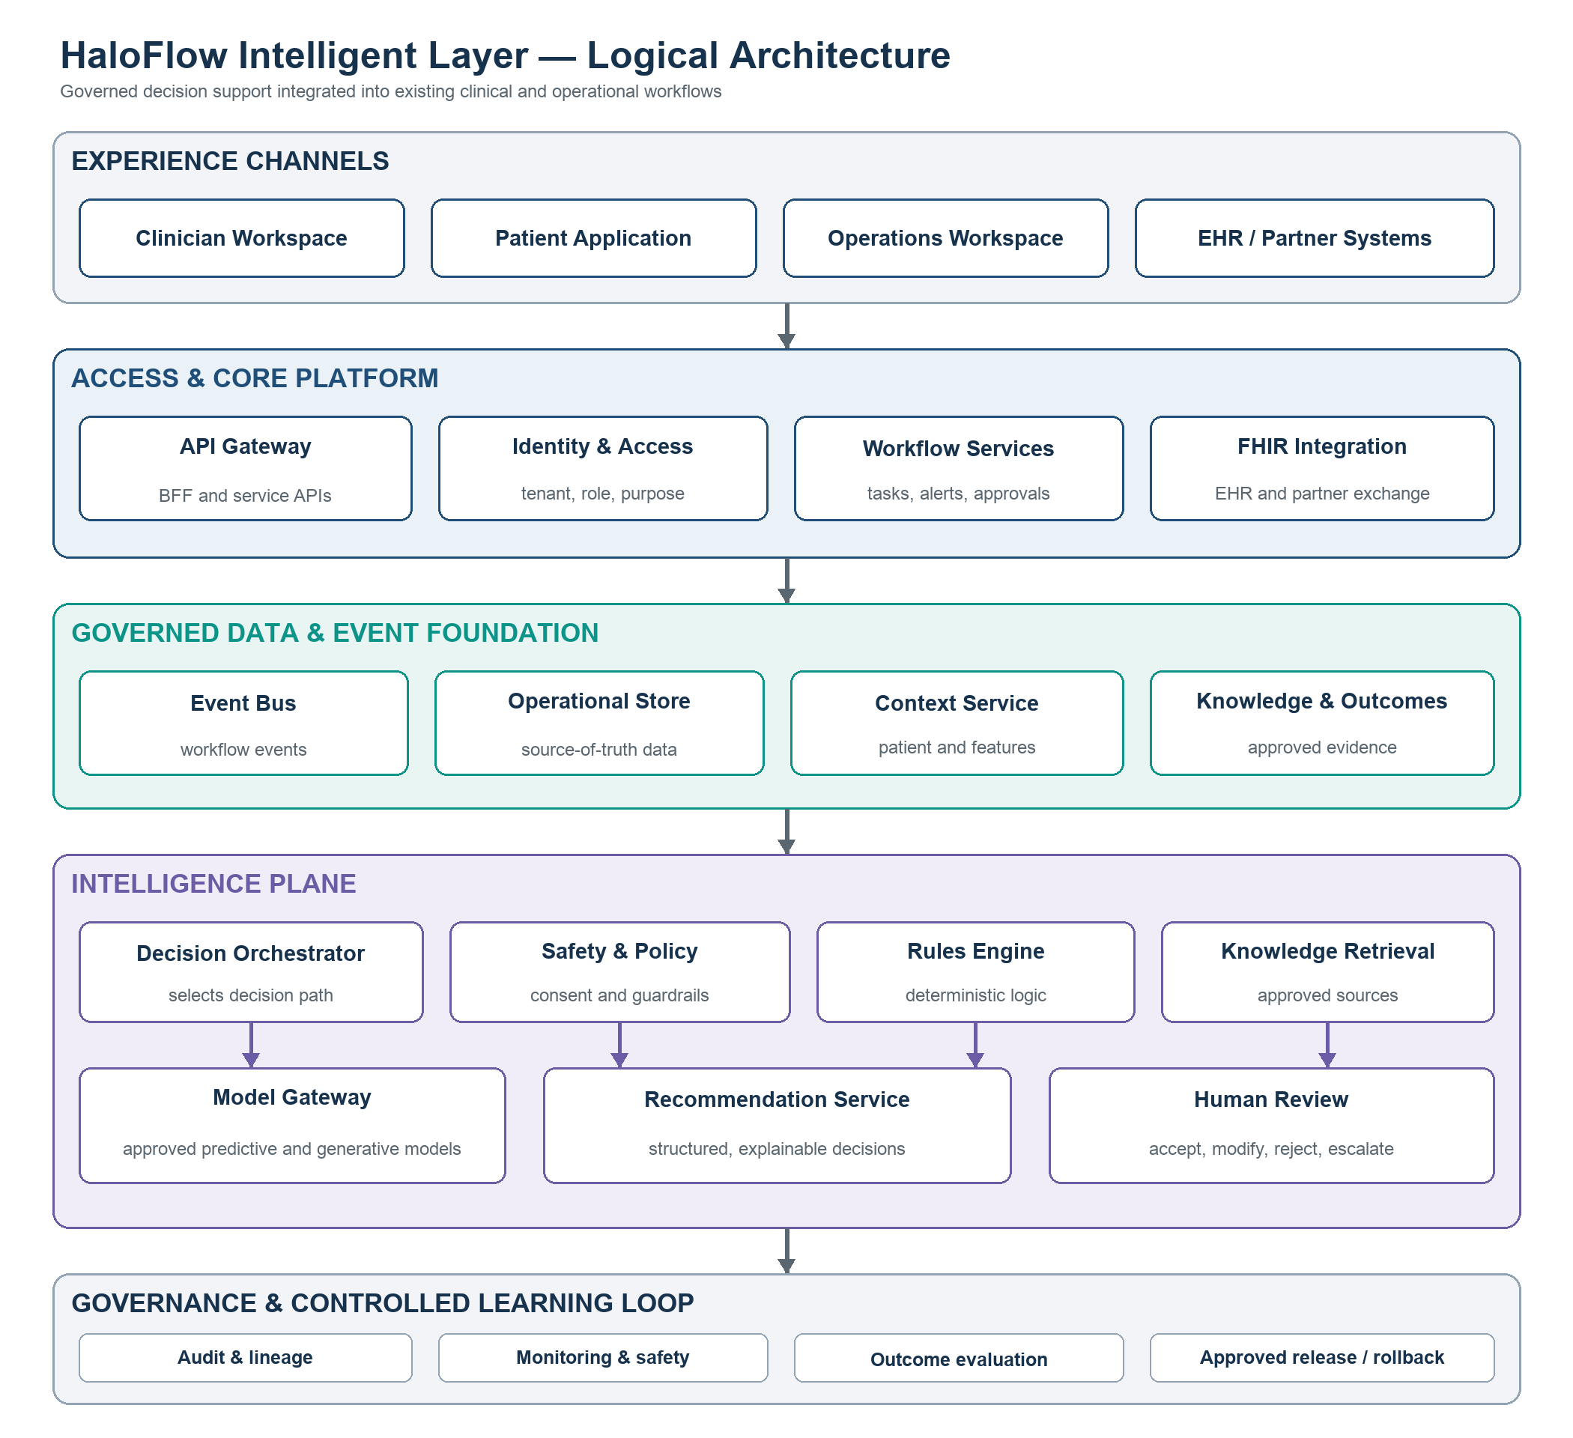
Figure 1. HaloFlow Intelligent Layer logical architecture
The architecture separates the runtime decision loop from the controlled learning loop. Production models and rules are updated only through evaluated and approved releases.

3. Architecture layers
Layer | Core components | Responsibility
Experience channels | Clinician, patient and operations applications plus EHR and partner systems. | Present intelligence inside existing workflows.
Access and core platform | API gateway, identity, tenant controls, workflow services and FHIR integration. | Authenticate, authorize, coordinate and persist core business operations.
Data and event foundation | Event bus, operational store, context service, knowledge repository and outcome store. | Supply governed, timely and traceable decision context.
Intelligence Plane | Orchestrator, safety policy, rules, retrieval, model gateway and recommendation service. | Select, execute, explain and control intelligence.
Governance and operations | Registry, evaluation, audit, monitoring, release and rollback. | Maintain safety, reproducibility and controlled improvement.

4. Core component design
Component | Responsibility
Integration Gateway | Exchanges data with EHRs, devices and partners using controlled APIs and FHIR where applicable.
API Gateway / BFF | Provides authenticated, tenant-aware interfaces for HaloFlow applications and external consumers.
Event Bus | Publishes versioned workflow events such as referrals, visits, assessments, results, tasks and outcomes.
Operational Data Store | Maintains source-of-truth transactional data for HaloFlow workflows.
Patient Context Service | Builds an authorized, time-relevant patient and workflow view with provenance and quality indicators.
Knowledge Repository | Stores approved protocols, policies, pathways and educational content with versions and effective dates.
Decision Orchestrator | Selects the applicable rule, retrieval, predictive or generative path based on the use case.
Safety and Policy Engine | Enforces authorization, consent, risk, evidence, confidence, escalation and human-review policies.
Rules Engine | Executes deterministic, versioned and explainable clinical or operational logic.
Model Gateway | Offers one controlled interface to approved predictive and generative models and providers.
Recommendation Service | Returns a structured decision object containing action, reasons, evidence, versions and review state.
Outcome Store | Connects recommendation exposure, user response, completed action and subsequent outcome.
Registry and Evaluation | Versions and validates models, prompts, rules and knowledge before controlled release.
Monitoring and Audit | Records access, lineage, performance, drift, safety, cost and historical decisions.

5. Primary runtime flow
- A HaloFlow workflow publishes an event or requests decision support.
- The context service assembles only authorized, relevant and sufficiently current information.
- The safety and policy engine verifies identity, tenant, purpose, consent and use-case eligibility.
- The decision orchestrator selects a rule, predictive model, knowledge retrieval, generative model, combination, or no automated recommendation.
- The recommendation service constructs a structured and explainable result.
- The policy engine determines whether the result may be displayed, requires review, must be escalated or must be blocked.
- The recommendation appears within the existing HaloFlow workflow.
- HaloFlow captures the user response, completed action and subsequent measurable outcome.

6. Controlled learning loop
- Recommendation exposure and reviewer response are captured as structured events.
- Downstream actions and relevant outcomes are linked using stable identifiers.
- Offline evaluation measures benefit, safety, drift and relevant subgroup performance.
- Clinical, product, privacy and security owners approve changes according to risk.
- Approved rules, prompts and models are released gradually with monitoring and rollback.
- Feedback never updates a production model directly.

7. Key interfaces and contracts
Contract | Owner | Minimum content
Workflow event | Event bus | event_id, type, schema_version, source, organization, subject, timestamp, authorization context
Context request | Context service | subject, use_case, requesting role, permitted purpose, point-in-time
Decision request | Orchestrator | use_case, context reference, requested action, tenant and trace identifiers
Recommendation | Recommendation service | action, priority, reason codes, explanation, evidence, uncertainty, versions, review state, expiry
Feedback event | Outcome store | recommendation, reviewer, response, modification, reason, action and timestamp
Outcome event | Outcome store | recommendation/action linkage, outcome definition, value, observation period and source

8. Recommendation contract
Every intelligence path shall converge on a common recommendation object. The contract should include:
Field group | Required information
Identity | recommendation_id, use_case, organization and trace identifiers
Decision | recommended_action, priority and permitted follow-up actions
Rationale | reason codes, user-facing explanation and relevant input indicators
Evidence | source identifiers, versions and applicable effective dates
Uncertainty | confidence or uncertainty indicator and data-quality warnings
Governance | rule, model, prompt and policy versions
Workflow | human-review requirement, status, creation time and expiry

9. Security, safety and privacy controls
Control domain | High-level design
Identity and tenant | OIDC/OAuth, service identity, tenant isolation and least privilege
Authorization | Role-, purpose- and context-based policies evaluated for every decision
Consent | Permitted-use metadata checked before data retrieval or model invocation
Data protection | Encryption in transit and at rest, secrets management and minimization
Clinical safety | Risk classification, human review, evidence requirements and escalation thresholds
External models | Approved providers, no unauthorized retention or training, strict logging policy
Audit | Tamper-evident access, decision, version, review and action records
Resilience | Timeouts, safe fallbacks, circuit breakers and no silent unapproved substitution

10. Logical deployment boundaries
- Core HaloFlow platform — application APIs, workflows, identity and operational database.
- Integration services — FHIR adapters, partner APIs and event publishing.
- Intelligence services — orchestrator, policy engine, rules, retrieval, model gateway and recommendation service.
- Data platform — context features, analytics, outcomes and approved knowledge.
- Governance platform — registries, evaluation, monitoring, audit and incident response.
Implementation guidance Phase 1 may implement several logical components as modules within a small number of deployable services. Preserve the boundaries through stable interfaces; split deployments only when scale, ownership, security or release cadence justifies it.

11. Suggested technical stack
Capability | Starting option
Application APIs | Existing HaloFlow stack; Python/FastAPI for intelligence-facing services
Operational data | PostgreSQL
Healthcare exchange | FHIR R4 APIs and SMART on FHIR where applicable
Events | Managed event bus or queue; Kafka when throughput and replay needs justify it
Analytics | Object storage plus a cloud data warehouse
Context/features | Curated PostgreSQL or warehouse tables initially; feature store later if needed
Rules | Versioned application rules initially; DMN or policy engine as complexity grows
Knowledge retrieval | Controlled document storage plus PostgreSQL/pgvector initially
Predictive models | Python, scikit-learn or XGBoost; PyTorch when justified
Generative AI | Vendor-independent gateway to approved model providers
Workflow orchestration | Existing workflow engine, Temporal or Camunda
Model lifecycle | MLflow or a managed cloud model registry
Observability | OpenTelemetry integrated with existing monitoring
Security | OIDC/OAuth, RBAC/ABAC, secrets management, encryption and immutable audit records

12. Phased architecture delivery
Stage | Architecture capability
Phase 1 — Foundation | Schemas, consent, identity, audit, outcome capture, rules, recommendation contract and workflow review.
Phase 2 — Assisted intelligence | Context service, approved knowledge retrieval, model gateway, low-risk AI, feedback, shadow mode and monitoring.
Phase 3 — Predictive intelligence | Validated models, full orchestration, registry, controlled releases, drift and subgroup monitoring.
Phase 4 — Optimization | Outcome-driven optimization, organization configuration and carefully bounded automation.

13. Architecture decisions required now
- Canonical event model and schema-versioning rules
- Structured recommendation contract
- Patient and workflow context interface
- Consent, authorization and tenant policy boundaries
- Outcome definitions and recommendation-to-outcome linkage
- Human-review and clinical-risk classifications
- Audit, traceability and retention requirements
- Provider-neutral model gateway interface
Bottom line Architect the Intelligence Plane now. Build the governed data, event, safety, feedback and interface foundations in Phases 1–2; defer sophisticated models until real workflows, representative data and measurable outcomes are available.

