Part I: Use H-JTAG to Burn U-boot

1.Use J-TAG board connect S3C2440 board and PC(LPT Port)
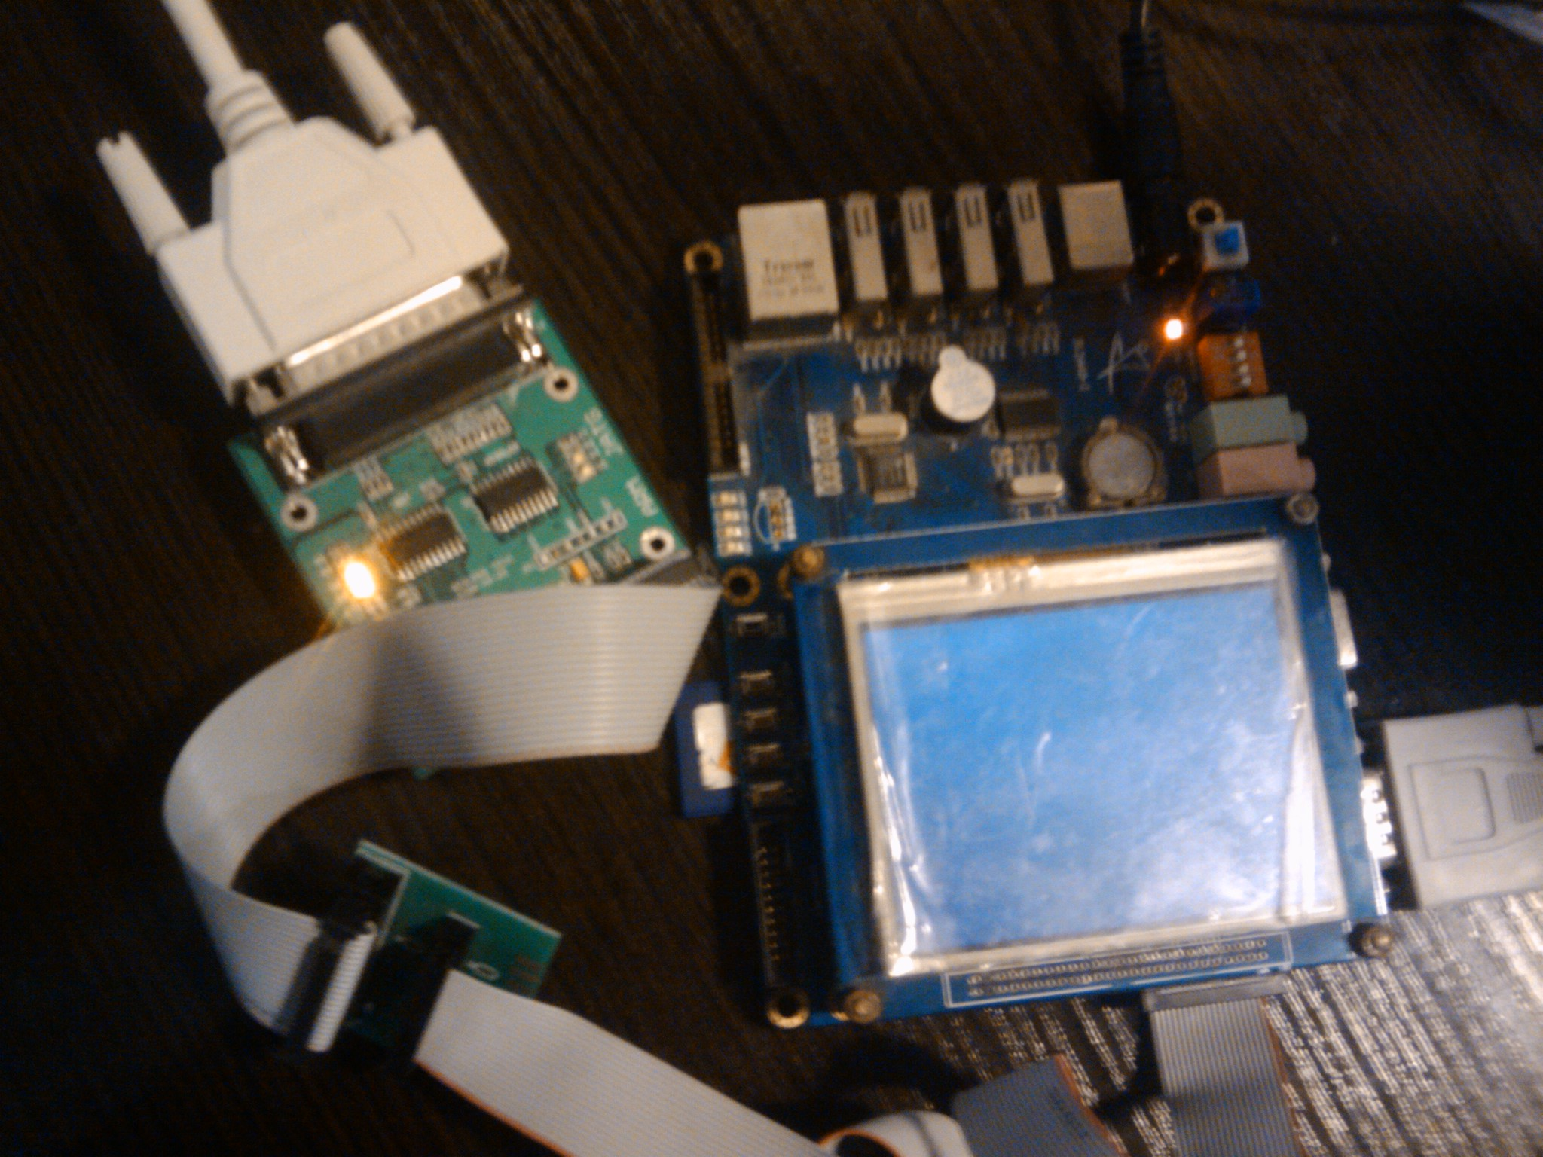
2. Erease the exist u-boot on Nandflash
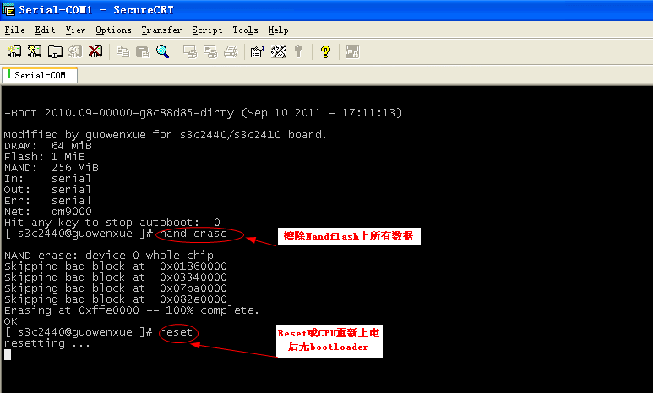
3. Run H-Jtag and Detect CPU
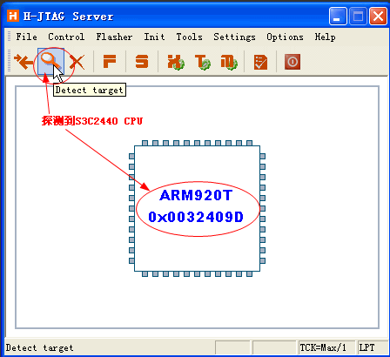
4. Run Flasher
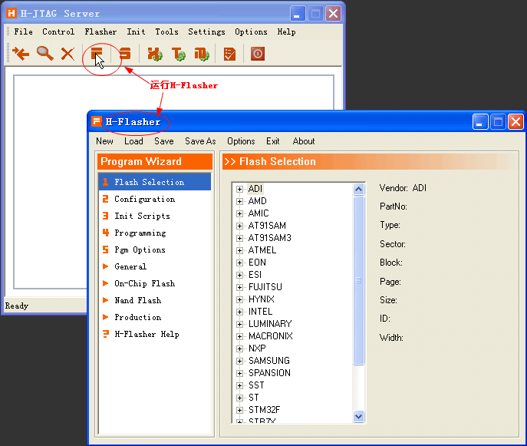
5. Set Flash Selection
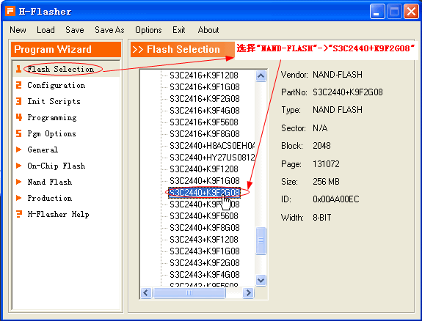
6. Configure Flasher Memory
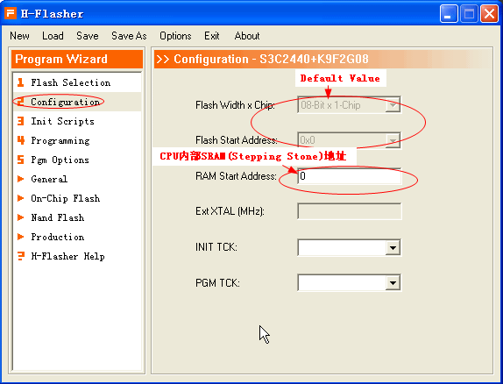
7. No Need configure for Init Scripts
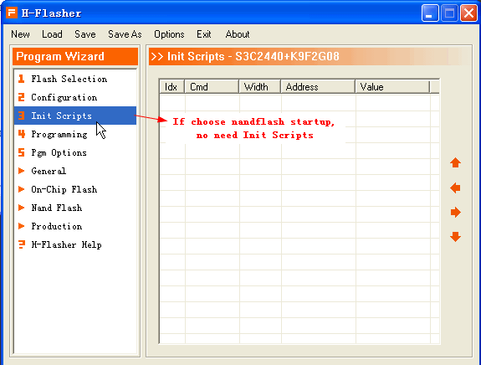
8. Check CPU and Nandflash types
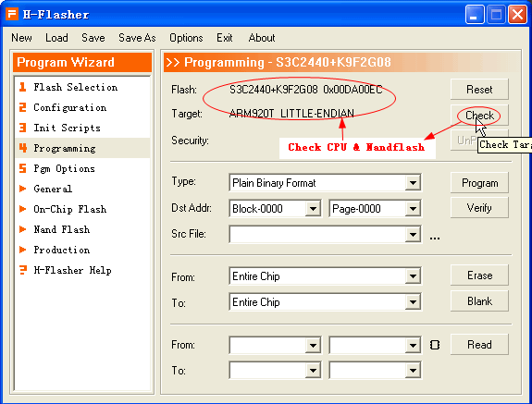
9. Prepare Setting before Burn u-boot
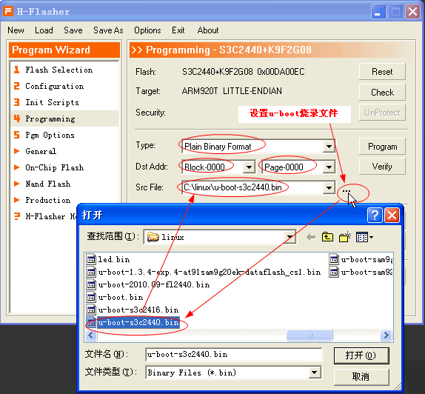
10. Program U-boot to Nandflash
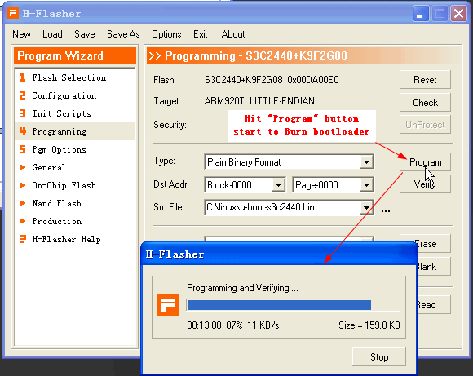
11. Verify the Burn procedure successfully and U-Boot can Running
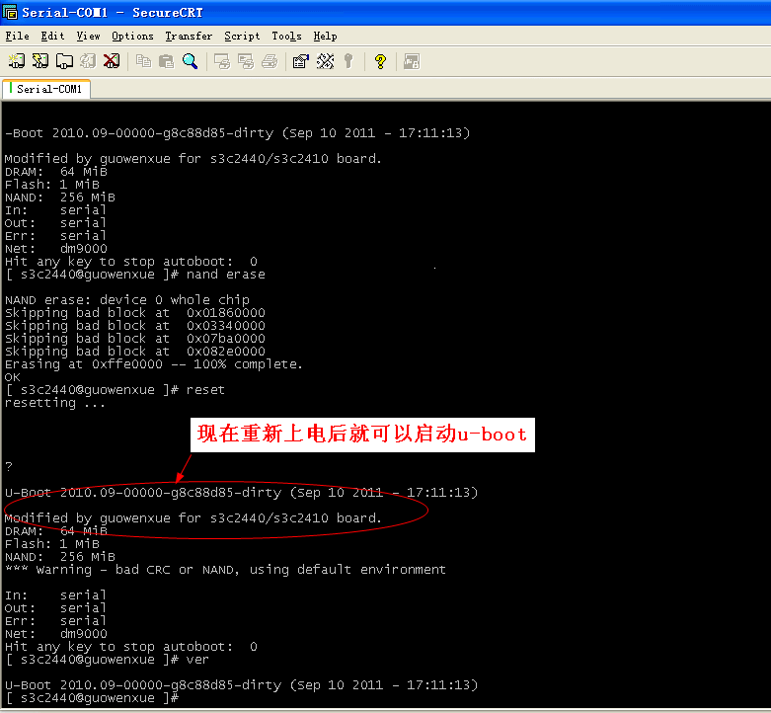
Part II Use J-Link to Burn U-boot
1, Use J-Link connect PC(USB) and S3C2440 J-TAG port
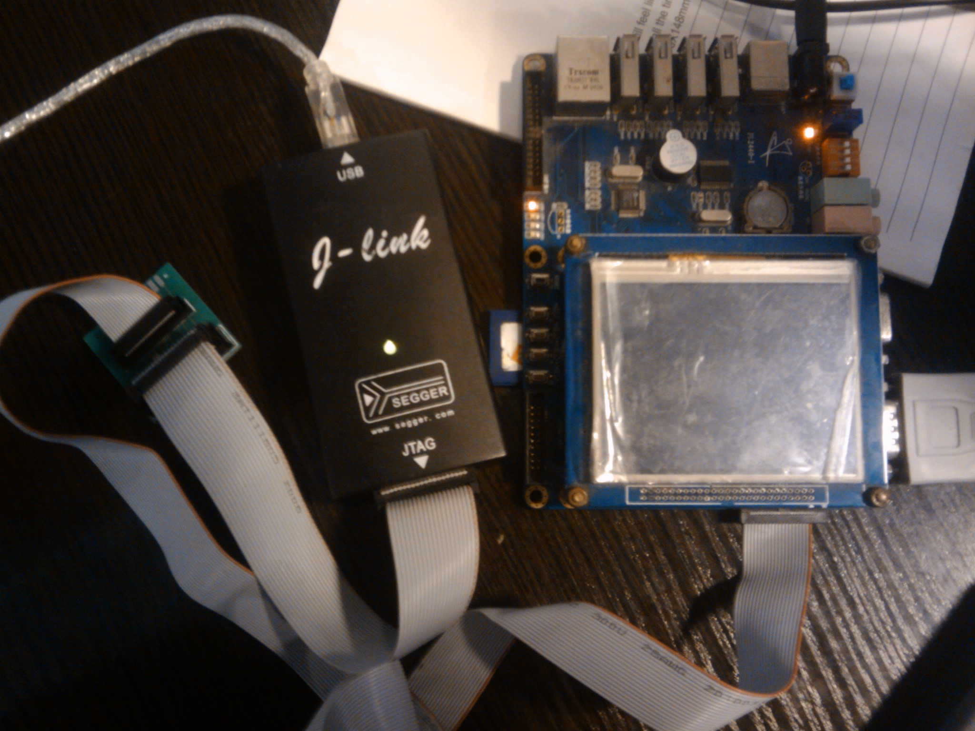

2, Erase the the Nandflash to clear the exist U-boot
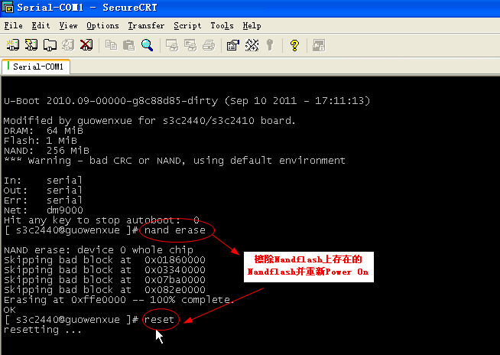
3. Run J-link commander
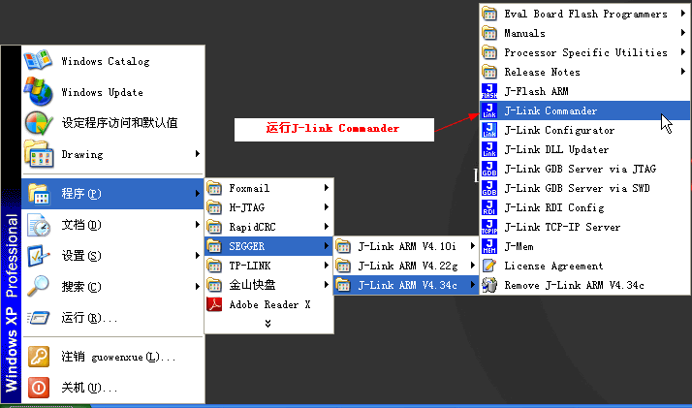
4. Download u-boot to SDRAM to execute it
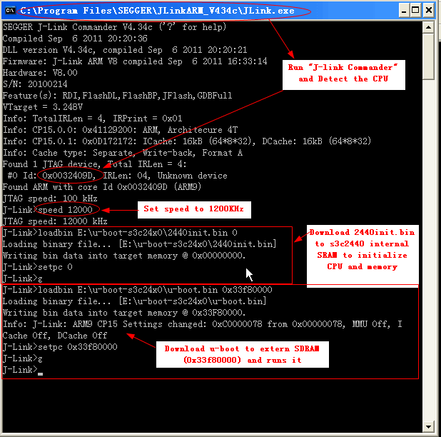
5. When U-Boot running, we can download the u-boot by tftp and burn it to Nandflash
