Builroot-2011.02交叉编译器制作

Author: GuoWenxue <guowenxue@gmail.com>
Date: 2011.04.15
Copy Ringht Reserved
ChangeLog:
1, Version 1.0.0 (2011.04.15)
Initial first version, build the crosstool for AT91SAM9260(ARM926EJS), build with
buildroot-2011.02, Linux-2.6.37, gcc-4.3.5, gdb-6.8, uClibc-0.9.31, binutils-2.21, ccache-3.1.4,
gmp-5.0.1, mpfr-3.0.0, lzo-2.03, zlib-1.2.5, expat-2.0.1
1，下载并解压缩制作交叉编译所需要的源代码
[root:/opt]#tar -xjf ~/winxp/crosstool/buildroot-2011.02/buildroot-2011.02.tar.bz2
[root:/opt]#cd buildroot-2011.02/
[root:/opt/buildroot-2011.02]#mkdir dl
[root:/opt/buildroot-2011.02]#ls
board boot CHANGES Config.in configs COPYING dl docs fs linux Makefile package scripts target toolchain
[root:/opt/buildroot-2011.02]#cp ~/winxp/crosstool/buildroot-2011.02/* dl/
[root:/opt/buildroot-2011.02]#chmod 666 dl/*
[root:/opt/buildroot-2011.02]#ls dl/
binutils-2.21.tar.bz2 expat-2.0.1.tar.gz gmp-5.0.1.tar.bz2 mpfr-3.0.0.tar.bz2 zlib-1.2.5.tar.bz2
buildroot-2011.02.tar.bz2 gcc-4.3.5.tar.bz2 linux-2.6.37.tar.bz2 ccache-3.1.4.tar.bz2 gdb-6.8.tar.bz2 lzo-2.03.tar.gz uClibc-0.9.31.tar.bz2
[root:/opt/buildroot-2011.02]#export TERM=vt100
[root:/opt/buildroot-2011.02]#make menuconfig

2， 顶层make menuconfig设置如下：

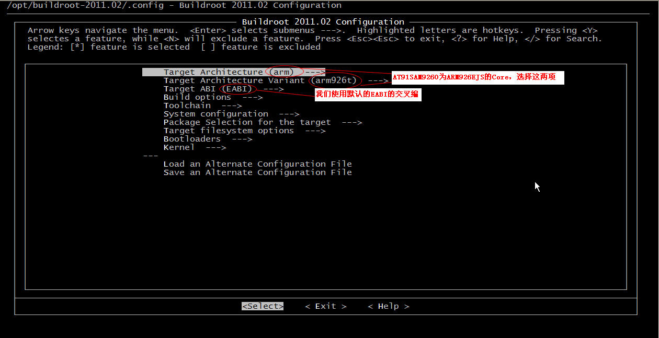

3， Build options ---> 设置

/opt/buildroot-2011.02/.config - Buildroot 2011.02 Configuration
-----------------------------------------------------------------------------------------------------------------------------------
+--------------------------------------------------------- Toolchain ---------------------------------------------------------+
| Arrow keys navigate the menu. <Enter> selects submenus --->. Highlighted letters are hotkeys. |
| Pressing <Y> selectes a feature, while <N> will exclude a feature. Press <Esc><Esc> to exit, |
| <?> for Help, </> for Search. Legend: [*] feature is selected [ ] feature is excluded |
| +-----------------------------------------------------------------------------------------------------------------------------+ |
| | Commands ---> | |
| | ($(TOPDIR)/dl) Download dir | |
| | ($(TOPDIR)/arm920t) Host dir | |
| | Mirrors and Download locations ---> | |
| | (6) Number of jobs to run simultaneously | |
| | [*] Enable compiler cache | |
| | [ ] Show packages that are deprecated or obsolete | |
| | [ ] build packages with debugging symbols | |
| | strip (strip) ---> | |
| | gcc optimization level (optimize for size) ---> | |
| | [*] prefer static libraries | |
| | [ ] documentation on the target | |
| | [ ] development files in target filesystem | |
| | | |
| +--------------------------------------------------------v(+)----------------------------------------------------------------+ |
+--------------------------------------------------------------------------------------------------------------------------------+
| <Select> < Exit > < Help > |
+--------------------------------------------------------------------------------------------------------------------------------+

4， Toolchain ---> 设置

/opt/buildroot-2011.02/.config - Buildroot 2011.02 Configuration
-----------------------------------------------------------------------------------------------------------------------------------
+--------------------------------------------------------- Toolchain ---------------------------------------------------------+
| Arrow keys navigate the menu. <Enter> selects submenus --->. Highlighted letters are hotkeys. |
| Pressing <Y> selectes a feature, while <N> will exclude a feature. Press <Esc><Esc> to exit, |
| <?> for Help, </> for Search. Legend: [*] feature is selected [ ] feature is excluded |
| +-----------------------------------------------------------------------------------------------------------------------------+ |
| | Toolchain type (Buildroot toolchain) ---> | |
| | *** Kernel Header Options *** | |
| | Kernel Headers (Linux 2.6 (manually specified version)) ---> | |
| | (2.6.37) linux version | |
| | *** uClibc Options *** | |
| | uClibc C library Version (uClibc 0.9.31.x) ---> | |
| | (toolchain/uClibc/uClibc-0.9.31.config) uClibc configuration file to use? (NEW) | |
| | [ ] Thread library debugging (NEW) | |
| | [ ] Compile and install uClibc tests (NEW) | |
| | *** Binutils Options *** | |
| | Binutils Version (binutils 2.21) ---> | |
| | () Additional binutils options (NEW) | |
| | *** GCC Options *** | |
| | GCC compiler Version (gcc 4.3.x) ---> | |
| | () Additional gcc options (NEW) | |
| | [ ] Objective-C cross-compiler support (NEW) | |
| | [ ] Fortran cross-compiler support (NEW) | |
| | [ ] Build/install Objective-C compiler and runtime? (NEW) | |
| | [ ] Build/install Fortran compiler and runtime? (NEW) | |
| | [*] Build/install a shared libgcc? (NEW) | |
| | *** Gdb Options *** | |
| | [ ] Build gdb debugger for the Target | |
| | [*] Build gdb server for the Target (NEW) | |
| | [*] Build gdb for the Host (NEW) | |
| | [ ] Purge unwanted locales (NEW) | |
| | [*] Enable MMU support (NEW) | |
| | [*] Use software floating point by default (NEW) | |
| | (-pipe) Target Optimizations (NEW) | |
| | *** Toolchain Options *** | |
| | [*] Enable large file (files > 2 GB) support (NEW) | |
| | [*] Enable IPv6 support (NEW) | |
| | [*] Enable RPC support (NEW) | |
| | [*] Enable WCHAR support (NEW) | |
| | [*] Enable toolchain locale/i18n support (NEW) | |
| | [ ] Enable 'program invocation name' support (NEW) | |
| | [*] Enable C++ support (NEW) | |
| | [ ] Enable stack protection support (NEW) | |
| | Thread library implementation (linuxthreads (stable/old)) ---> | |
| | [ ] Enable elf2flt support? (NEW) | |
| | [ ] Run mklibs on the built root filesystem (NEW) | |
| +--------------------------------------------------------v(+)----------------------------------------------------------------+ |
+--------------------------------------------------------------------------------------------------------------------------------+
| <Select> < Exit > < Help > |
+--------------------------------------------------------------------------------------------------------------------------------+

5， System configuration ---> 使用默认
(buildroot) System hostname
(Welcome to Buildroot) System banner
[ ] Generic serial port config --->

6， Package Selection for the target --->
[ ] BusyBox
[ ] customize
Audio and video libraries and applications --->
Compressors and decompressors
Debugging, profiling and benchmark --->
Development tools --->
Games --->
Graphic libraries and applications (graphic/text) Hardware handling --->
Interpreter languages and scripting --->
Libraries --->
Miscellaneous --->
Networking applications --->
Package managers --->
Shell and utilities --->
System tools --->
Text editors and viewers --->

除了选择Libraries ---> 下的
Compression and decompression --->
[*] lzo
[*] zlib

其他全部取消不选，以后需要的，我们自己编译。

下面的也全部不选，我们自己来移植bootloader, kernel和根文件系统
Target filesystem options --->
Bootloaders --->
Kernel --->

7， 开始编译交叉编译器
[root:/opt/buildroot-2011.02]#make
********
[root:/opt/buildroot-2011.02]#./arm926ejs/usr/bin/arm-linux-gcc -v
Using built-in specs.
Target: arm-unknown-linux-uclibcgnueabi
Configured with: /opt/buildroot-2011.02/output/toolchain/gcc-4.3.5/configure --prefix=/opt/buildroot-2011.02/arm926ejs/usr --build=i686-pc-linux-gnu --host=i686-pc-linux-gnu --target=arm-unknown-linux-uclibcgnueabi --enable-languages=c,c++ --with-sysroot=/opt/buildroot-2011.02/arm926ejs/usr/arm-unknown-linux-uclibcgnueabi/sysroot --with-build-time-tools=/opt/buildroot-2011.02/arm926ejs/usr/arm-unknown-linux-uclibcgnueabi/bin --disable-__cxa_atexit --enable-target-optspace --with-gnu-ld --disable-libssp --disable-multilib --disable-tls --enable-shared --with-gmp=/opt/buildroot-2011.02/arm926ejs/usr --with-mpfr=/opt/buildroot-2011.02/arm926ejs/usr --enable-threads --disable-decimal-float --with-float=soft --with-abi=aapcs-linux --with-arch=armv5te --with-tune=arm926ej-s --disable-largefile --with-pkgversion='Buildroot 2011.02' --with-bugurl=http://bugs.buildroot.net/
Thread model: posix
gcc version 4.3.5 (Buildroot 2011.02)

8, 同时给ARM920T做交叉编译器
我们在为ARM926EJS做完交叉编译器后，我们可以在该代码基础上同时给ARM920T做交叉编译器，我们首先在顶层目录执行make menuconfig，对交叉编译器配置作如下修改：

Target Architecture (arm) --->
Target Architecture Variant (arm920t) --->
Build options --->
($(TOPDIR)/arm920t) Host dir
然后再make clean && make. 这时将编译出新的ARM920T的交叉编译器放在arm920t目录下。这里要注意，先make menuconfig后，再make clean，否则的话，make clean会将之前生成的交叉编译器arm926ejs删掉。

9, 额外信息
如果我们在编译后，还想uClibc删除或添加一些特性的话，可以使用make uclibc-menuconfig进行配置，然后再开始编译。

