H-JTAG Burn W90P710 Bootloader

W90P710 Bootloader Download Address:

1.运行H-JTAG
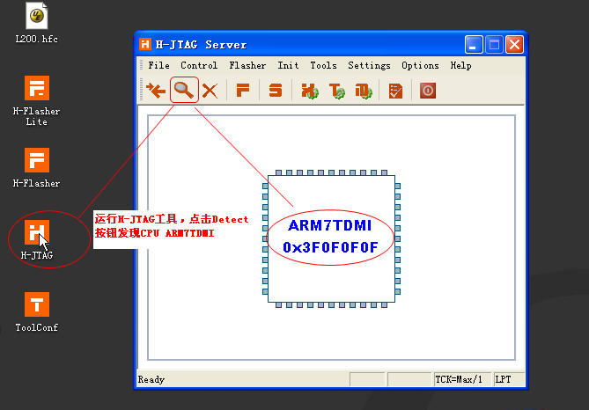

2.配置H-JTAG使用并口
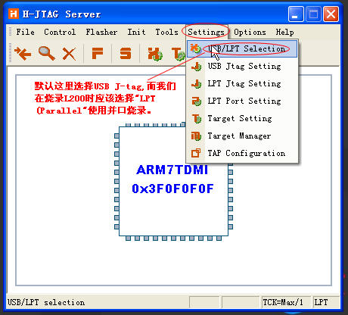
3.运行H-Flasher
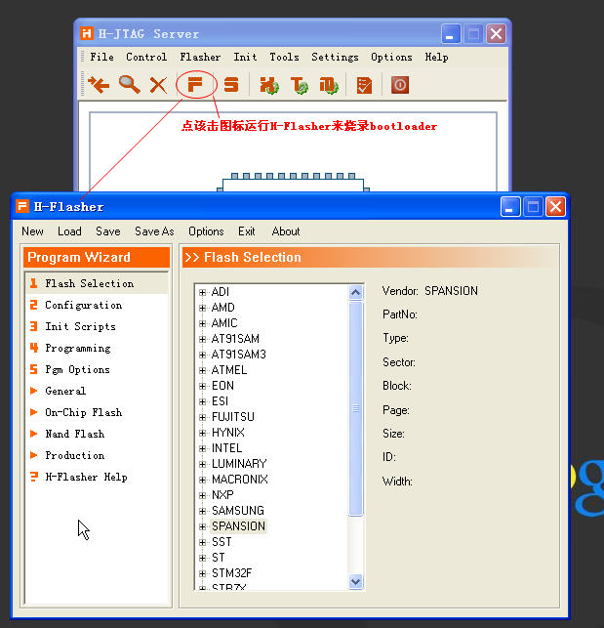
4.加载NUC710配置
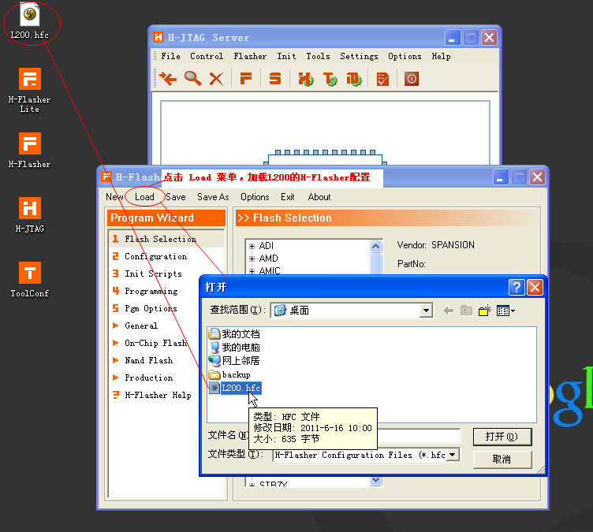
5.显示Norflash型号
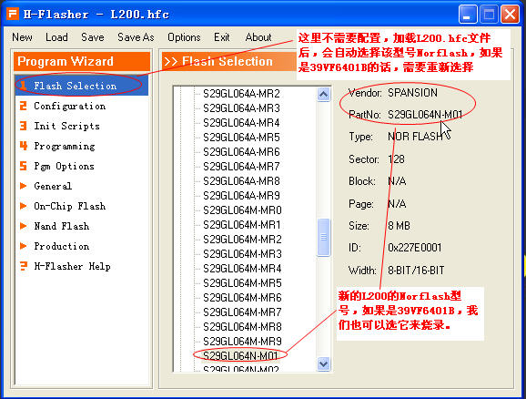
6.显示Norflash配置
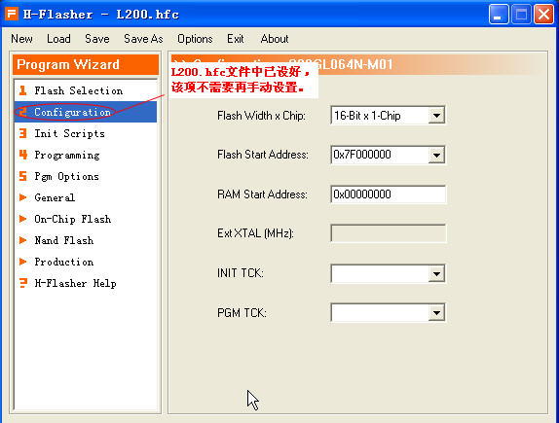
7,显示初始化脚本
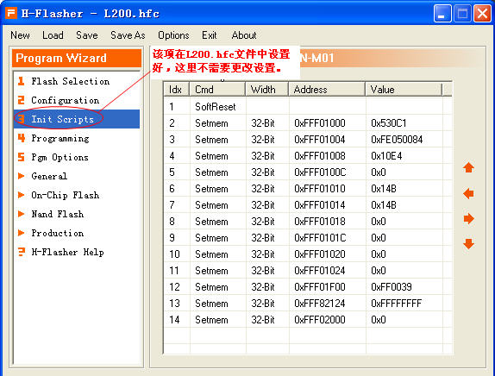
8.显示Flash烧录界面
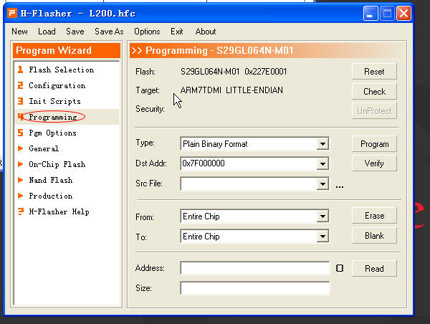
9.选择烧录文件位置
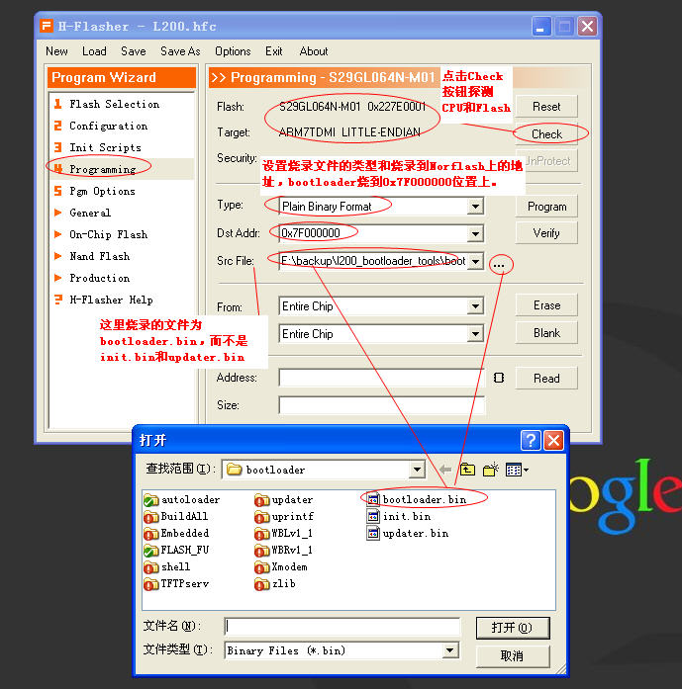
10.檫除Norflash.jpg
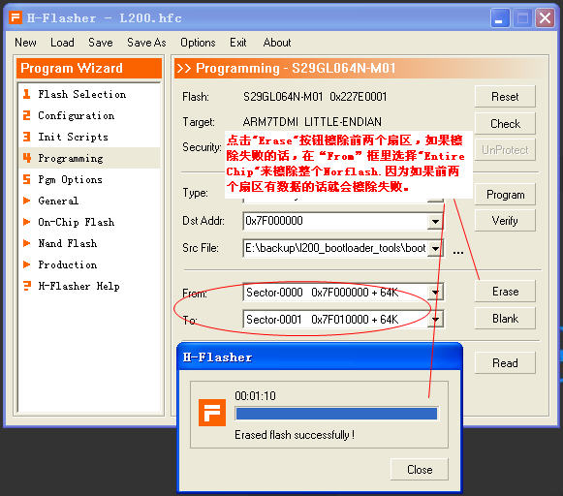
11.烧录bootloader文件
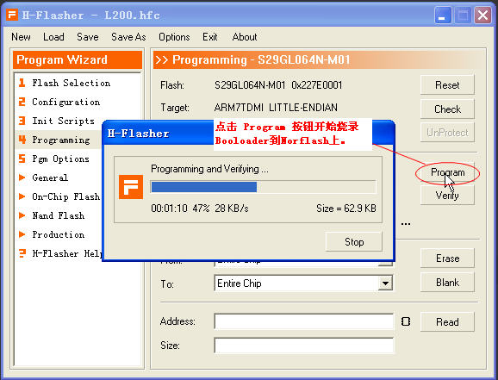
12.重启验证bootloader
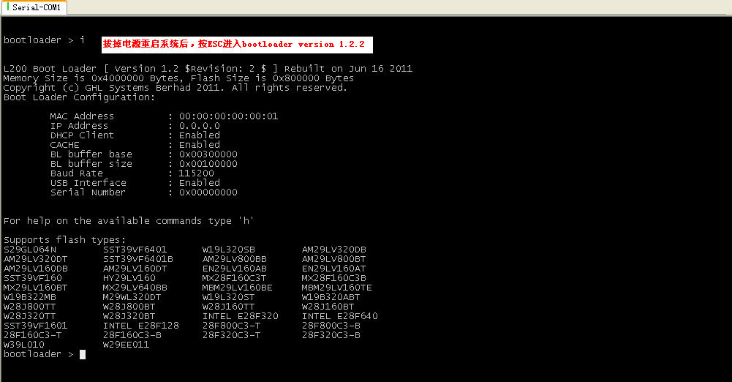
13.设置bootloader相关参数
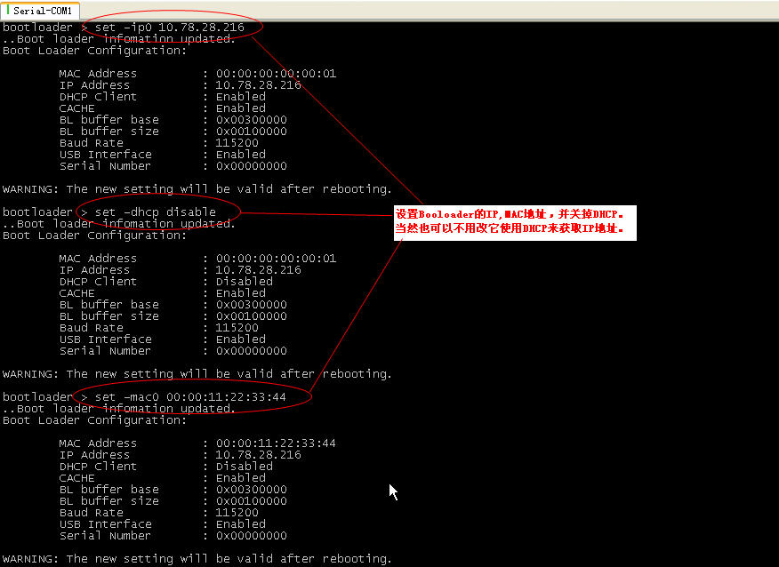
14.bootloader中使用fb命令升级bootloader
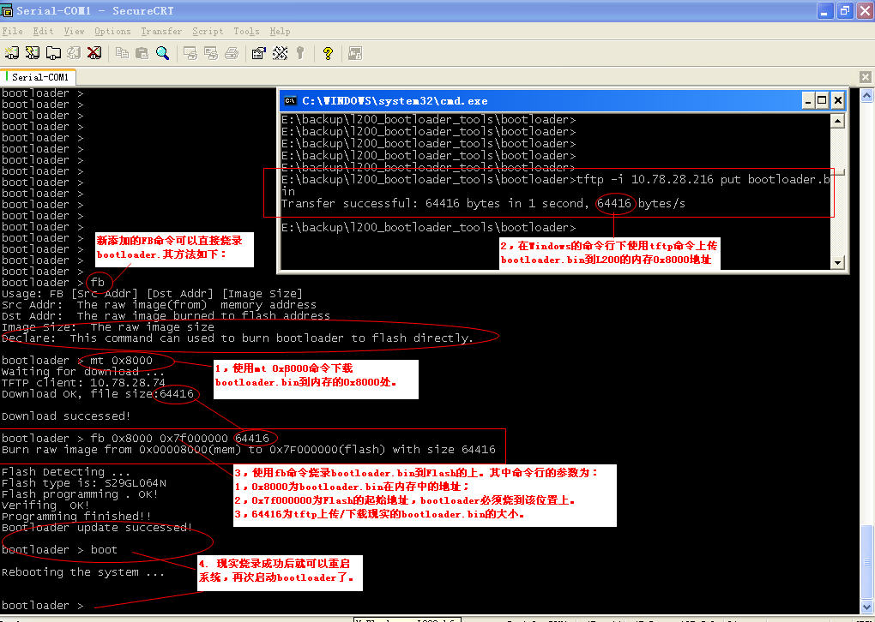
附: W90P710_S29GL064N H-JTAG Configure File(上图中的L200.cfg)内容

FLASH SECTION:
SPANSION
S29GL064N-M01
MEMORY SECTION:
16-BIT X 1-CHIP
0x7F000000
0x00000000
XTAL SECTION:
NULL
TCK SECTION:
-1
-1
SCRIPT SECTION:
SoftReset+++
Setmem+32-Bit+0xFFF01000+0x530C1
Setmem+32-Bit+0xFFF01004+0xFE050084
Setmem+32-Bit+0xFFF01008+0x10E4
Setmem+32-Bit+0xFFF0100C+0x0
Setmem+32-Bit+0xFFF01010+0x14B
Setmem+32-Bit+0xFFF01014+0x14B
Setmem+32-Bit+0xFFF01018+0x0
Setmem+32-Bit+0xFFF0101C+0x0
Setmem+32-Bit+0xFFF01020+0x0
Setmem+32-Bit+0xFFF01024+0x0
Setmem+32-Bit+0xFFF01F00+0xFF0039
Setmem+32-Bit+0xFFF82124+0xFFFFFFFF
Setmem+32-Bit+0xFFF02000+0x0
PGMOPTION SECTION:
ADDON SECTION:
NULL

