**点评CAT之AOP监控method**

SpringBoot AOP注解方式监控方法执行时间

源码中提供了CatAnnotation 以及 CatAopService 这两个类可以参照这两个类

## 1、在pom.xml中引入AOP的支持

```

<!-- SpringBoot对AOP的支持 -->

<dependency>

<groupId>org.springframework.boot</groupId>

<artifactId>spring-boot-starter-aop</artifactId>

</dependency>

```

## 2、书写CatAnnotation注解类

```

@Retention(RUNTIME)

@Target(ElementType.METHOD)

public @interface CatAnnotation {

}

```

## 3、书写CatAopService AOP类

```

@Aspect

@Component

public class CatAopService {

@Around("@annotation(catAnnotation)")

public Object aroundMethod(ProceedingJoinPoint pjp, CatAnnotation catAnnotation) {

MethodSignature joinPointObject = (MethodSignature) pjp.getSignature();

Method method = joinPointObject.getMethod();

Transaction t = Cat.newTransaction("method", method.getName());

try {

Object result = pjp.proceed();

t.setStatus(Message.SUCCESS);

return result;

} catch (Throwable e) {

t.setStatus(e);

Cat.logError(e);

} finally {

t.complete();

}

return null;

}

}

```

## 4、在相应的方法上面加上@CatAnotation注解

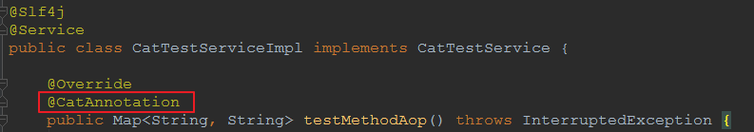

## 5、观察CAT监控页面

