**项目操作（增加，删除）：**

**增加**

|  |
| --- |
| step1：点击头像旁的加号（+）下的New repository，跳转到URL：https://github.com/new |

|  |
| --- |
| step2：填写项目名称点，点击Create repository按钮 |

|  |
| --- |
| step3：得到项目的git的HTTPS地址 |

**命令行操作：**

### create a new repository on the command line

|  |
| --- |
| echo "# test" >> README.md  git init  git add README.md  git commit -m "first commit"  git remote add origin https://github.com/guoxiaoxia/test.git  git push -u origin master |

### push an existing repository from the command line

|  |
| --- |
| git remote add origin https://github.com/guoxiaoxia/test.git  git push -u origin master |

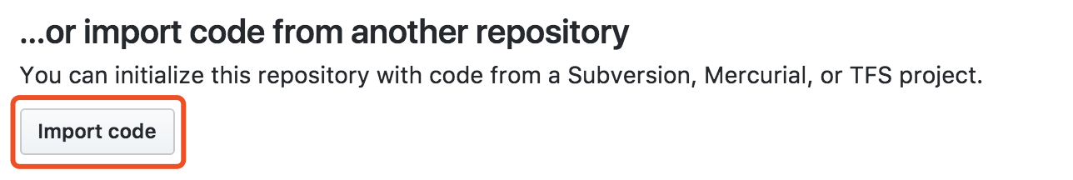

**项目未编写时：**

**命令行：**

**项目已编写时：**

**删除**

|  |
| --- |
| step1：点击头像下的Your profie，网站跳转到url：https://github.com/guoxiaoxia |

|  |
| --- |
| step2：将导航栏切换到Repositories，得到项目总览，点击对应的要删除的项目，跳转到对应的项目 |

|  |
| --- |
| step3:点击项目导航栏的Settings |

|  |
| --- |
| step4:settings页面的最底端有个Danger Zone，点击里面的 Delete this repository |

|  |
| --- |
| 弹出的对话框，输入要删除的项目名称，才能删除成功 |