MEMORANDUM
TO: Professor Brodnax
FROM: Guo Zhan
DATE: October 23, 2026
RE: Memo 1: Data and Analysis Plan

Research Objective
Between 2005 and 2026, the Global Fund reported USD 11.7 billion in purchases of HIV, tuberculosis (TB), and malaria medicines. One firm, Mylan, received a quarter of that money, and 38 of the 128 products were bought from a single manufacturer. In my work at the Clinton Health Access Initiative, I saw that buyers want more than one supplier for such products, because a single supplier leaves little room to negotiate price. Getting there is the work of market shaping, which builds sustainable markets for health products by speeding up their introduction, keeping them affordable, and making supply secure (Clinton Health Access Initiative, n.d.). Its tools include pooled procurement, volume guarantees, and quality assessment (U.S. Agency for International Development [USAID], 2014). Because these tools are costly, buyers need to know which firms could become a second or third supplier and which products need a stronger push.
Generic competition brought antiretroviral prices down in the 2000s (Waning et al., 2009). A single supplier also carries stockout risk. If that firm exits or fails a quality inspection, patients in many countries are affected at once.
My objective is descriptive and predictive. First, I will describe market concentration and how products are related through shared suppliers. Second, I will test whether that relatedness predicts which firms start supplying a product, so buyers know where to look for new suppliers.
Data
My main dataset is the Global Fund Price and Quality Reporting (PQR) transaction summary (The Global Fund, 2026). I kept the three medicine categories, which left 74,689 transactions. The key features are manufacturer, product, disease area, year, and cost.
The WHO list of prequalified finished products (World Health Organization [WHO], 2026) shows which firms hold quality approval for each product, an approval often required before a firm can bid. The USAID Supply Chain Management System (SCMS) delivery history (USAID, 2018) covers PEPFAR, a second buyer, for robustness checks. All three sources in Table 1 exceed 500 observations. PQR is the only one that links each purchase to a manufacturer, so it drives the analysis.
Table 1: Overview of Datasets
Dataset | Unit | N | Firms | Products | Years
Global Fund PQR (medicines) | Transaction | 74,689 | 110 | 128 | 2005-2026
WHO PQ finished products | Prequalified product | 655 | 119 | 335 | 2002-2026
PEPFAR SCMS deliveries | Shipment line | 10,324 | 88 sites | 86 | 2006-2015

HIV accounts for 71% of spend (Table 2). TB has the most products and manufacturers, but each TB product is bought in smaller amounts.
Table 2: Global Fund Medicine Purchases by Disease Area, 2005-2026 (N = 74,689)
Disease area | Transactions | Spend ($M) | Share | Products | Firms
HIV/ARV | 42,277 | 8,264.1 | 70.7% | 48 | 34
Tuberculosis | 23,578 | 1,714.9 | 14.7% | 60 | 62
Malaria | 8,834 | 1,715.7 | 14.7% | 20 | 39

HIV spend peaked in 2015 and rose again in 2021 (Figure 1). I have not yet identified what drove the 2015 peak. Most of the 2021 spend went to TLD, a three-in-one pill that WHO began recommending in 2019 (WHO, 2019). I assume that such changes in recommended treatments create new products that firms may enter.
Figure 1: Global Fund Medicine Spend by Year and Disease Area
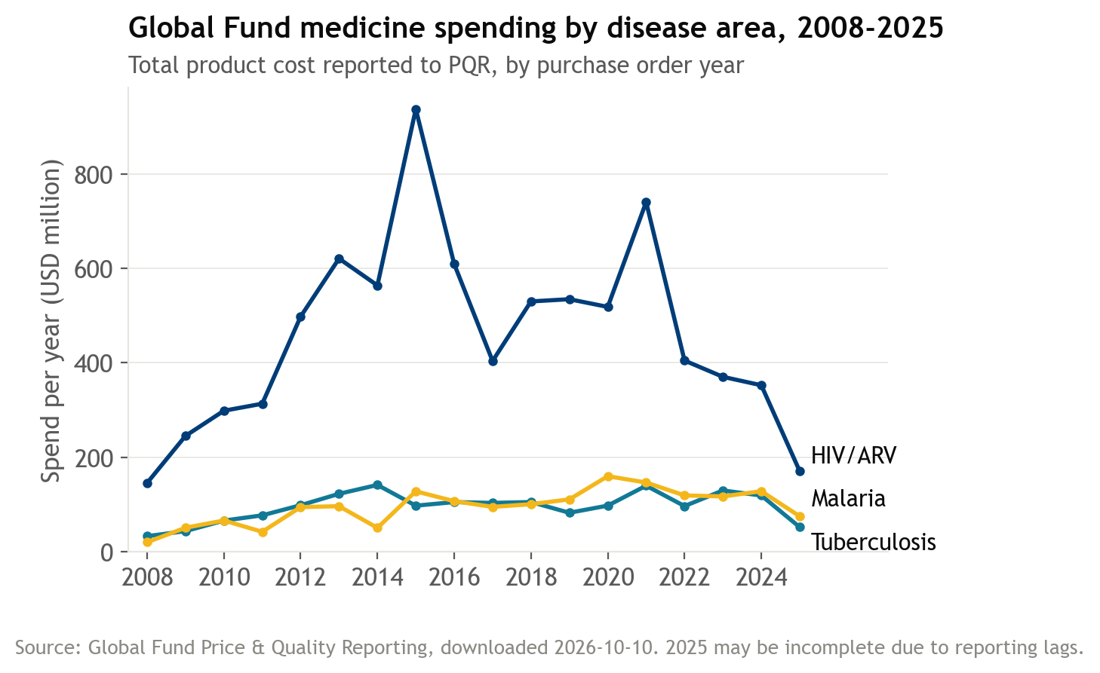
Of the 128 products, 57 (45%) had only one or two suppliers (Figure 2). They are mostly niche products, such as delamanid, worth only 2.8% of spend. The top five firms hold 62% of spend.
Figure 2: Number of Manufacturers per Product
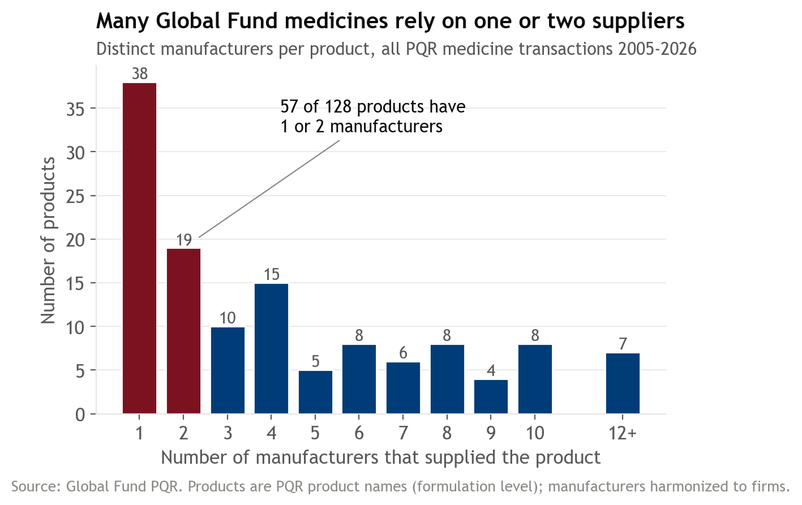
Limitations
PQR covers only Global Fund-financed purchases, so a firm may already supply a product to other buyers before it appears in PQR. The SCMS data only partly address this, since they cover HIV through 2015.
Techniques
The first technique is network analysis, from Data Science III. I will build a bipartite network that links each firm to the products it supplied, then project it onto products. Two products are close when the same firms supply both (Hidalgo et al., 2007). I will then use Louvain community detection (Blondel et al., 2008) to find groups of products that share suppliers. To check that these communities are not an artifact of a few large firms, I will compare their modularity (Newman, 2006), a score for how tightly products cluster within groups, with shuffled networks in which each firm keeps the same number of products. Comparing communities with disease areas will show whether production capability, not disease, links products.
The second technique is supervised learning, from Data Science II. For each firm and product the firm does not yet supply, I will compute density, the share of the product's close neighbors that the firm already supplies. I will fit a logistic regression, which estimates the probability that the firm starts supplying the product within three years, with firm and product controls, and compare it with a random forest, which combines many decision trees. Density will use only links that existed before each cutoff year, and I will test on later cutoffs. Because entry is rare, I will follow Albora et al. (2023) and judge the models by how many actual entries appear among the top-ranked predictions, along with AUC, the chance that the model ranks a real entrant above a non-entrant.
This plan builds on three studies. Hidalgo et al. (2007) projected a country-export network onto products and showed that countries move into products close to their current exports. Neffke and Henning (2013) found that Swedish firms also diversified mostly into industries that need related skills. Closest to my plan, Albora et al. (2023) predicted which products 169 countries would start exporting within five years and found that tree-based models beat relatedness benchmarks. I apply this to medicine suppliers.
For market shaping, the output is a short list of likely new suppliers for each product that now depends on one or two firms. Where some firms are already close, a buyer can approach them directly. Where no firm is close, organic entry is unlikely, and the product would need more active support. I will repeat the main checks with the SCMS data to test whether the patterns reflect firm capabilities rather than Global Fund procurement rules.

References
Albora, G., Pietronero, L., Tacchella, A., & Zaccaria, A. (2023). Product progression: A machine learning approach to forecasting industrial upgrading. Scientific Reports, 13, Article 1481. https://doi.org/10.1038/s41598-023-28179-x
Blondel, V. D., Guillaume, J.-L., Lambiotte, R., & Lefebvre, E. (2008). Fast unfolding of communities in large networks. Journal of Statistical Mechanics: Theory and Experiment, 2008(10), P10008. https://doi.org/10.1088/1742-5468/2008/10/P10008
Clinton Health Access Initiative. (n.d.). How we work. Retrieved October 23, 2026, from https://www.clintonhealthaccess.org/how-we-work/
The Global Fund. (2026). Price & Quality Reporting: Transaction summary [Data set]. Retrieved October 10, 2026, from https://insights.theglobalfund.org/t/Public/views/PriceQualityReportingTransactionSummary/TransactionSummary
Hidalgo, C. A., Klinger, B., Barabási, A.-L., & Hausmann, R. (2007). The product space conditions the development of nations. Science, 317(5837), 482–487. https://doi.org/10.1126/science.1144581
Neffke, F., & Henning, M. (2013). Skill relatedness and firm diversification. Strategic Management Journal, 34(3), 297–316. https://doi.org/10.1002/smj.2014
Newman, M. E. J. (2006). Modularity and community structure in networks. Proceedings of the National Academy of Sciences, 103(23), 8577–8582. https://doi.org/10.1073/pnas.0601602103
U.S. Agency for International Development. (2014). Healthy markets for global health: A market shaping primer. Center for Accelerating Innovation and Impact. https://web.archive.org/web/20250201095915/https://www.usaid.gov/sites/default/files/2022-05/healthymarkets_primer.pdf
U.S. Agency for International Development. (2018). Supply chain shipment pricing data [Data set]. Development Data Library. https://web.archive.org/web/20210124123812/https://data.usaid.gov/HIV-AIDS/Supply-Chain-Shipment-Pricing-Data/a3rc-nmf6
Waning, B., Kaplan, W., King, A. C., Lawrence, D. A., Leufkens, H. G., & Fox, M. P. (2009). Global strategies to reduce the price of antiretroviral medicines: Evidence from transactional databases. Bulletin of the World Health Organization, 87(7), 520–528. https://doi.org/10.2471/BLT.08.058925
World Health Organization. (2019). Update of recommendations on first- and second-line antiretroviral regimens (WHO/CDS/HIV/19.15). https://www.who.int/publications/i/item/WHO-CDS-HIV-19.15
World Health Organization. (2026). Prequalified lists: Finished pharmaceutical products [Data set]. Retrieved October 10, 2026, from https://extranet.who.int/prequal

