1. I would like to investigate more into the spatial data manipulations and representations we have talked about in this course.

2. The topic I would like to cover in my project is the data from United States Drought Monitor built by University of Nebraska-Lincoln.

3. I would like to look into the drought patterns in **Rhode Island**, and compare to the previous years, showcase the hypothesis that there is an outside cause (precipitation & temperature) for the recent abnormal behavior.

4. Descriptive and spatial drought data.

5. 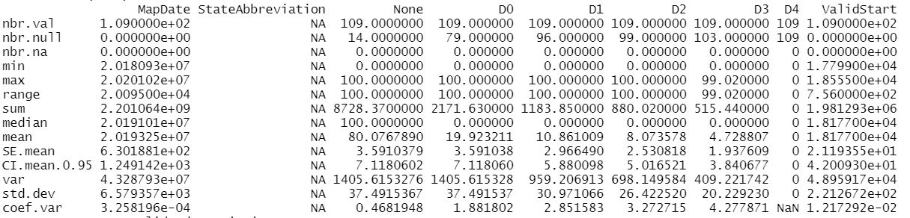

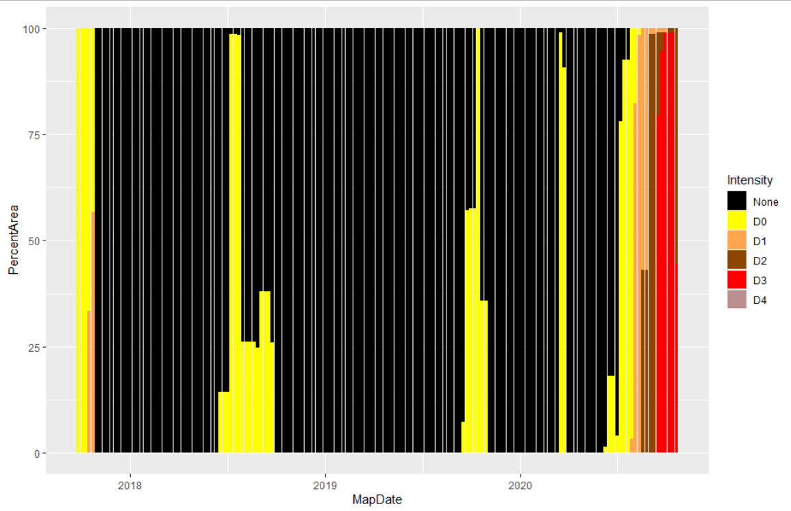

6. First according to the observation of the patterns in the descriptive data, find the representative snippets of drought intensity, generate appropriate maps and compare impacted areas. Then, look at the correlations between relevant factors between temperature, wind, and precipitations; if correlation coefficient is significant, make regression analysis.

7. Just from the look of the data, I might need to extend the times back a bit more, perhaps Y -10 years to investigate the patterns. Moreover, the other meteorological data might have inconstant entries and missing values that could hinder the analysis.

8. https://github.com/guozhaosengzs/ENVDS/blob/master/activity7/Activity7_script.R