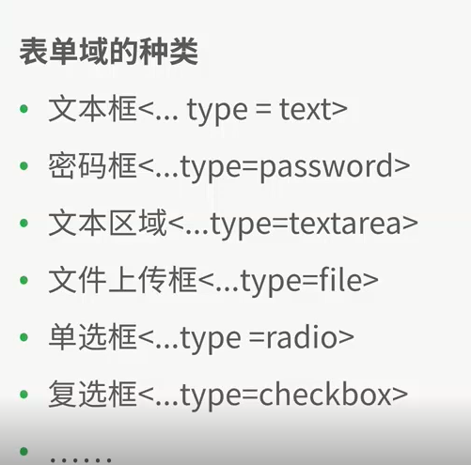

数据库表单：

更新数据：update test.test3 set name=”xueyuan” where id =1;

添加数据：insert into test.test3 (id,name) value (9,"lll")；

查找数据：select * from test.test3 where id=1 ；

按照条件顺序输出：select * from test.test3 order by id asc;

按照条件逆序输出：select * from test.test3 order by id desc;

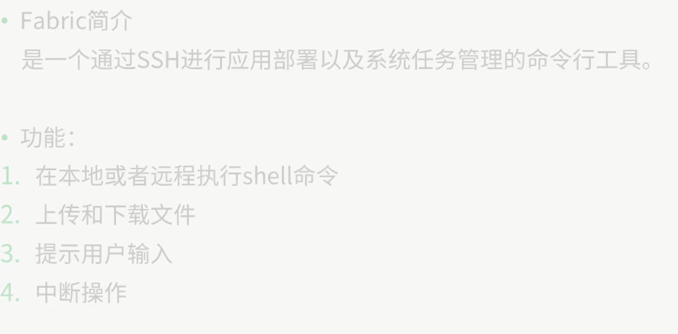

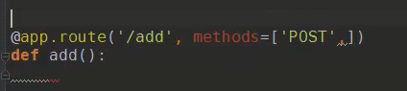

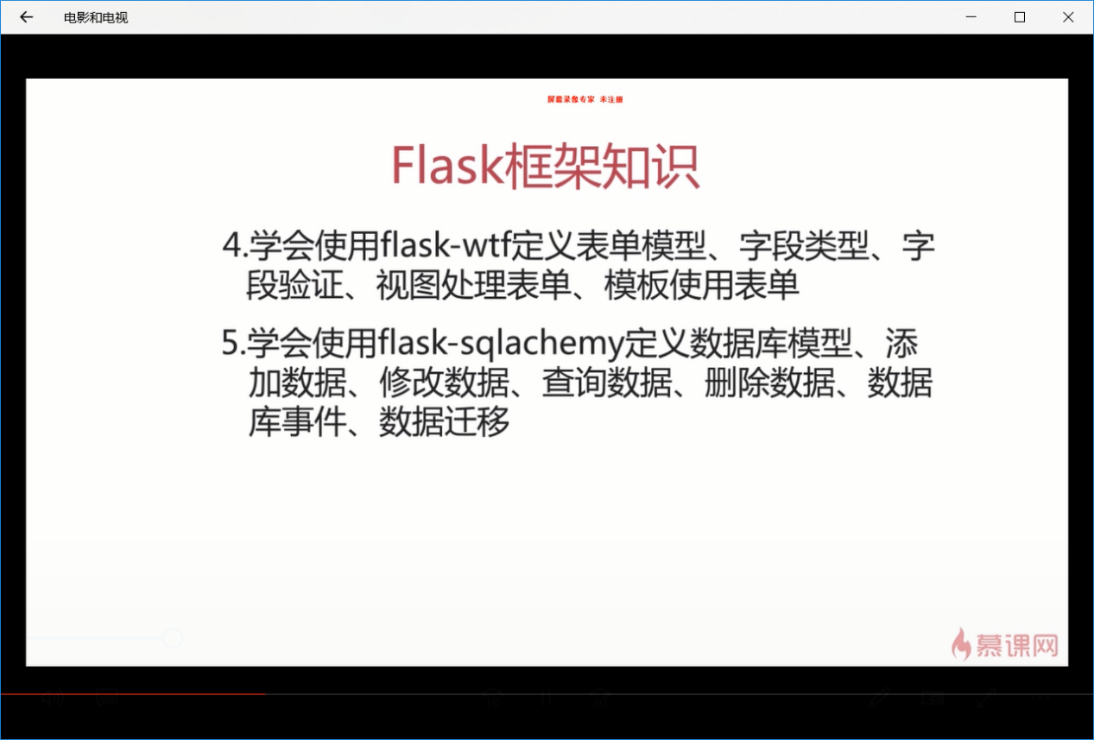

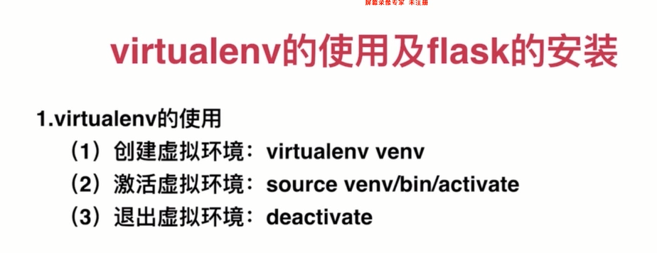

Flask 路由的两种注册方法

@app.route(**'/'**)   
 **def** hello():  
 **return 'hello world'  
 def** url():  
 **return '测试路由的另一种注册方法'** app.add_url_rule(**"/hello"**, view_func= url)

