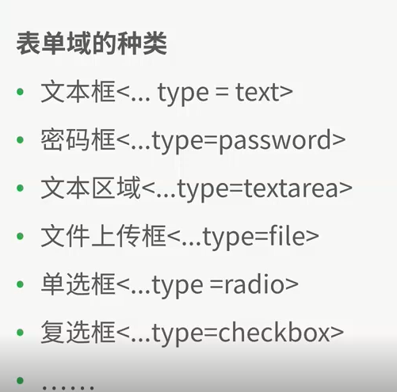

数据库表单：

更新数据：update test.test3 set name=”xueyuan” where id =1;

添加数据：insert into test.test3 (id,name) value (9,"lll")；

查找数据：select \* from test.test3 where id=1 ；

按照条件顺序输出：select \* from test.test3 order by id asc;

按照条件逆序输出：select \* from test.test3 order by id desc;

