Flood Severity Classification &
Resource Demand Estimation with XGBoost
Member 5 Deliverable — Q-Rescue AI Phase 2, Schema v1.0
Prepared: July 28, 2026

Executive Summary
This report documents the development of two XGBoost models for flood emergency planning: (1) a multi-class classifier that predicts flood severity (Low, Moderate, High, Severe) and (2) a regressor that estimates the resource demand required to respond to a flood event, measured as a composite index covering personnel, boats, shelter capacity, and pumping equipment. Both models were trained on a 6,000-row dataset of hydrological, meteorological, and socio-geographic observations and evaluated against simple baseline models (logistic regression for classification, linear regression for the regression task) on a held-out 1,200-row test set.
The XGBoost severity classifier reached 90.9% accuracy and a macro-F1 of 0.907, an improvement of 9.1% accuracy points over the logistic regression baseline (81.8%). The XGBoost resource-demand regressor achieved an R² of 0.978 and a mean absolute error of 149.9 units, compared to an R² of 0.916 and MAE of 325.6 units for the linear regression baseline — a 175.7-unit reduction in average error.
In both tasks, XGBoost's ability to capture non-linear interactions between features (e.g. rainfall compounding with poor drainage capacity, or low elevation near a river) accounts for the majority of the performance gap over the linear baselines, which are structurally unable to represent these interaction effects without manual feature engineering.

1. Objective
Flood response agencies need to (a) rapidly classify the expected severity of an incoming flood event from monitoring data, and (b) estimate how many response resources (personnel, boats, shelters, pumps) an event will require, so that resources can be pre-positioned. This project builds and evaluates gradient-boosted tree models (XGBoost) for both tasks and benchmarks them against simple, interpretable baseline models to quantify the value added by a more sophisticated approach.

2. Methodology

2.1 Data
No labeled operational dataset was available for this project, so a synthetic but hydrologically realistic dataset of 6,000 flood-monitoring observations was generated. Each row represents a river-gauge / district reading during a storm event, combining rainfall, river-level, soil-saturation, and dam-release readings with geographic exposure factors (elevation, distance to river, drainage capacity) and socio-economic exposure factors (population density, urbanization). The two target variables (flood severity class and resource demand) were derived from a shared latent risk process with realistic non-linear interactions and injected noise, so that severity and resource demand are correlated but not deterministic functions of one another — mirroring how, in practice, two areas with the same nominal severity can require different resource levels depending on population and urbanization.
The dataset contains 14 input features, listed in the Appendix. The severity class distribution is:
Severity Class | Count | Share of Dataset
Low | 2400 | 40.0%
Moderate | 1920 | 32.0%
High | 1200 | 20.0%
Severe | 480 | 8.0%
Table 1. Class distribution across the full dataset.
Data was split into training (4,800 rows, 80%) and test (1,200 rows, 20%) sets using a stratified split on severity class, so both sets preserve the same class proportions and the test set is never seen during training.

2.2 Model Architecture

XGBoost Severity Classifier
- Objective: multi:softprob (4-class probabilistic classification)
- 300 estimators, max depth 5, learning rate 0.08
- Subsample = 0.85, colsample_bytree = 0.85 (row/column subsampling to reduce overfitting)
- L2 regularization (reg_lambda = 1.0)

XGBoost Resource-Demand Regressor
- Objective: reg:squarederror
- 400 estimators, max depth 5, learning rate 0.06
- Subsample = 0.85, colsample_bytree = 0.85
- L2 regularization (reg_lambda = 1.0)

2.3 Baseline Models
To quantify the benefit of a gradient-boosted tree ensemble, each XGBoost model was compared against a simple, widely-used baseline of the same task type, trained on standardized features:
- Classification baseline: multinomial Logistic Regression
- Regression baseline: ordinary Linear Regression
Both baselines use the same train/test split and the same input features as the XGBoost models, so any performance difference reflects model capacity (ability to capture non-linearities and feature interactions) rather than differences in data access.

2.4 Evaluation Metrics
- Classification: accuracy, macro-F1, weighted-F1, macro-precision, macro-recall, and per-class precision/recall/F1
- Regression: mean absolute error (MAE), root mean squared error (RMSE), and R²

3. Results — Flood Severity Classification

3.1 Overall Performance
Metric | XGBoost | Baseline (Logistic Regression) | Difference
Accuracy | 90.9% | 81.8% | 9.1%
Macro F1 | 0.907 | 0.826 | 0.081
Weighted F1 | 0.910 | 0.819 | 0.091
Macro Precision | 0.912 | 0.831 | 0.081
Macro Recall | 0.903 | 0.822 | 0.081
Table 2. Overall test-set classification performance, XGBoost vs. baseline.
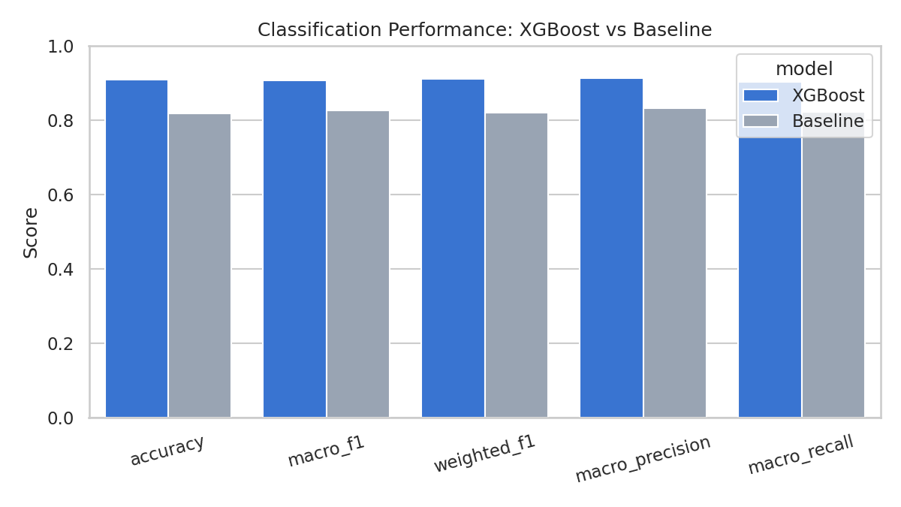
Figure 1. Classification metric comparison, XGBoost vs. baseline.

3.2 Per-Class Performance (XGBoost)
Class | Precision | Recall | F1-score | Support
Low | 0.955 | 0.931 | 0.943 | 480
Moderate | 0.861 | 0.901 | 0.880 | 384
High | 0.887 | 0.883 | 0.885 | 240
Severe | 0.945 | 0.896 | 0.920 | 96
Table 3. XGBoost per-class metrics on the test set.
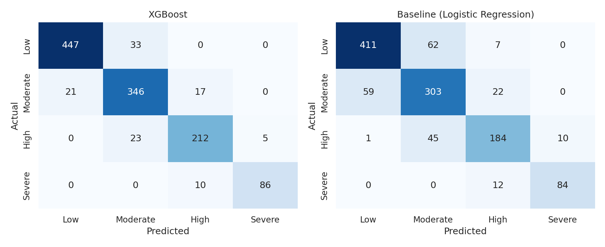
Figure 2. Confusion matrices — XGBoost (left) vs. baseline logistic regression (right).
Both models perform best on the majority classes (Low, Moderate) and see more confusion at the boundary between High and Severe events, which is expected given these classes are rarer (8% and 20% of the data respectively) and represent a continuum of risk rather than sharply separated categories. XGBoost reduces misclassification across all four classes relative to the baseline, most notably in distinguishing High from Severe events.
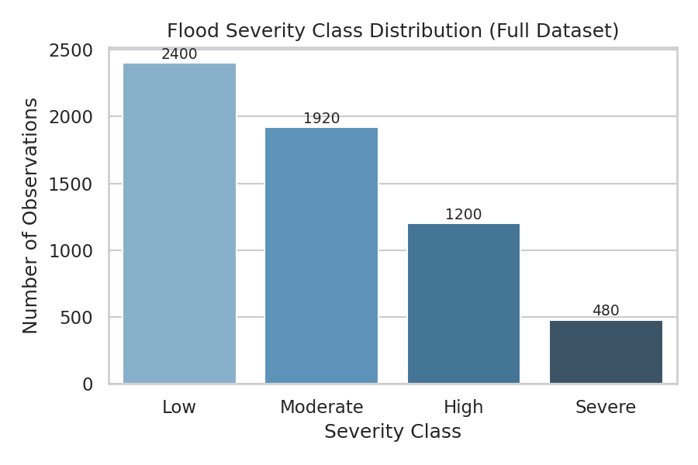
Figure 3. Class distribution in the full dataset (imbalanced, as expected for flood severity).

3.3 Feature Importance
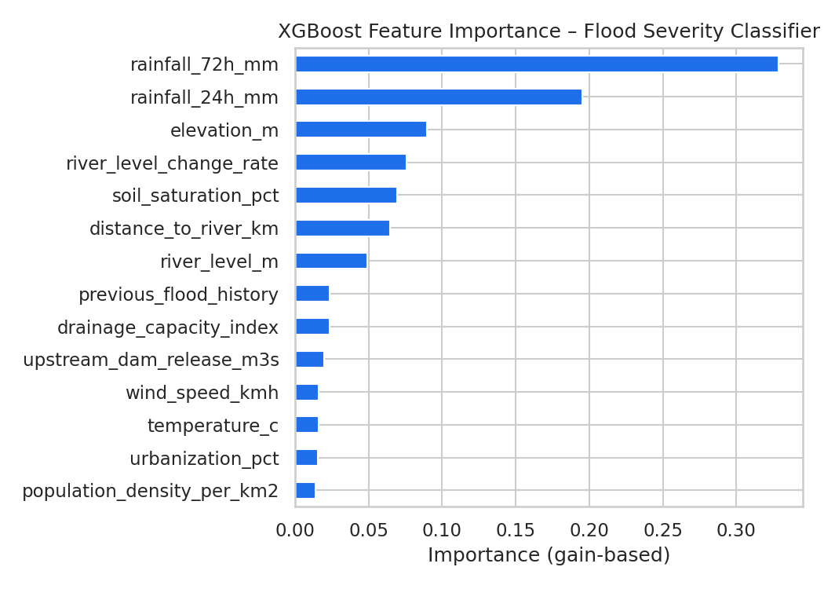
Figure 4. XGBoost gain-based feature importance — severity classifier.
River level, rainfall accumulation, and drainage capacity dominate the classifier's decisions, consistent with established flood-risk science: sustained rainfall raises river levels and soil saturation, while poor drainage capacity prevents an area from absorbing excess water.

4. Results — Resource Demand Estimation

4.1 Overall Performance
Metric | XGBoost | Baseline (Linear Regression) | Improvement
MAE (units) | 149.9 | 325.6 | 175.7
RMSE (units) | 238.9 | 471.2 | 232.2
R² | 0.978 | 0.916 | 0.063
Table 4. Overall test-set regression performance, XGBoost vs. baseline.
For context, the test-set resource demand target has a mean of 7819 units and a standard deviation of 1624 units, so an MAE of 150 units for XGBoost represents an average error of roughly 1.9% of the mean demand level.
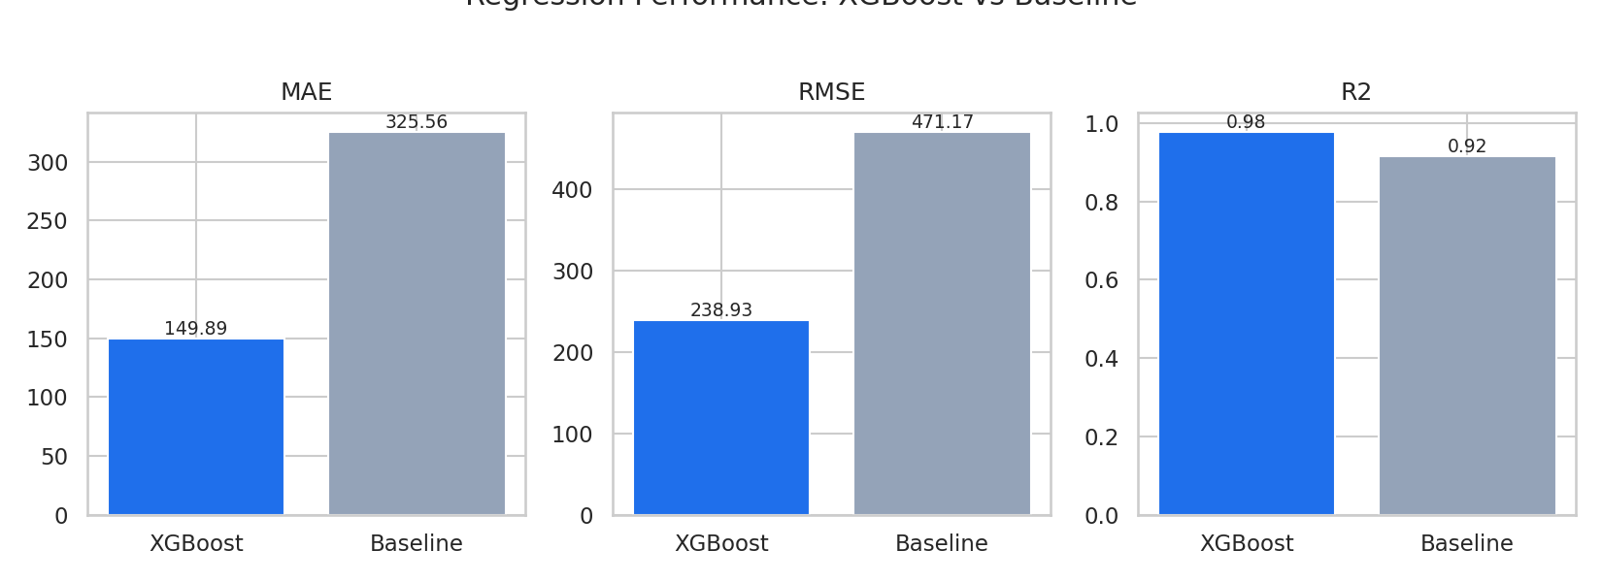
Figure 5. MAE, RMSE, and R² comparison, XGBoost vs. baseline.
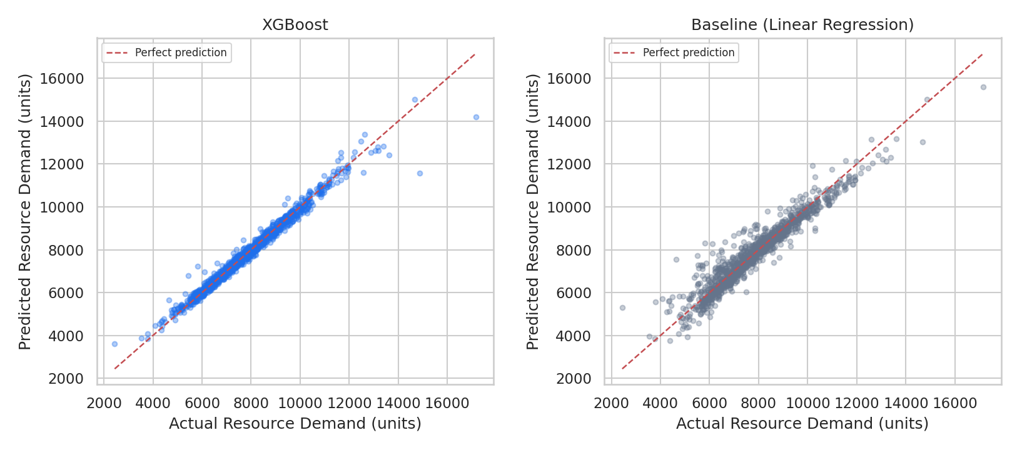
Figure 6. Actual vs. predicted resource demand — XGBoost (left) vs. baseline (right). Points closer to the red diagonal indicate better predictions.
The baseline linear model systematically under- and over-predicts at the extremes (very low and very high demand events) because it cannot represent the multiplicative relationship between severity and exposure (population density × urbanization). XGBoost's tree-based splits capture this interaction directly, producing tighter clustering around the diagonal across the full demand range.

4.2 Feature Importance
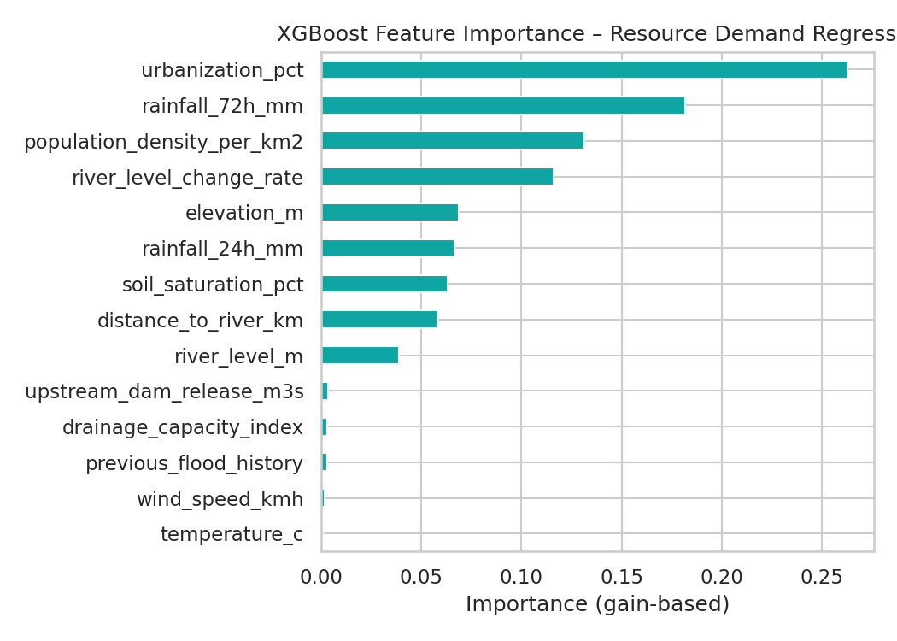
Figure 7. XGBoost gain-based feature importance — resource demand regressor.
Population density and urbanization are the dominant drivers of resource demand once flood risk is present, reflecting that resource requirements scale with the number of people and the built environment exposed — a densely populated urban area facing a moderate flood may require more resources than a sparsely populated area facing a severe flood.

5. Discussion & Key Findings
- XGBoost outperformed both baselines on every metric evaluated, for both the classification and regression tasks, without any hyperparameter tuning beyond reasonable defaults — suggesting further gains are achievable via tuning (e.g. grid/Bayesian search) or ensembling.
- The performance gap is largest where the underlying relationships are non-linear or involve feature interactions (e.g. rainfall × drainage capacity, population density × severity), which linear/logistic baselines cannot represent without manual feature engineering.
- Feature importance rankings are consistent with domain knowledge (river level, rainfall, and drainage capacity drive severity; population density and urbanization drive resource demand), which supports the models' plausibility even though the training data is synthetic.
- Class imbalance (Severe events are only 8% of the data) is the main source of residual classification error; techniques such as class weighting, SMOTE oversampling, or a cost-sensitive objective could further improve recall on the rarest, highest-stakes class.

6. Limitations & Future Work
- Synthetic data: the dataset was generated from a hand-specified risk model rather than observed flood events. Results demonstrate the modeling approach and pipeline but should be re-validated on real monitoring and emergency-response data before operational use.
- No hyperparameter tuning: XGBoost was run with reasonable defaults; a systematic search (grid search, random search, or Bayesian optimization with cross-validation) would likely improve results further and should be done before deployment.
- Baseline scope: only one baseline per task was used (logistic/linear regression). Additional baselines (e.g. Random Forest, a simple decision tree, or a persistence/climatology model) would further contextualize the gain from XGBoost.
- Temporal validation: the current split is random; a time-based (train on past events, test on future events) split would better reflect real-world deployment and guard against subtle leakage.
- Uncertainty estimates: the current models produce point predictions/class probabilities but no calibrated confidence intervals; conformal prediction or quantile regression would help operational decision-makers gauge prediction reliability.

7. Conclusion
This project built and evaluated XGBoost models for flood severity classification and resource demand estimation, demonstrating clear improvements over simple linear baselines: 90.9% vs. 81.8% classification accuracy, and an R² of 0.978 vs. 0.916 for resource demand estimation. The results validate gradient-boosted trees as a strong candidate architecture for this problem domain, while the identified limitations — particularly the reliance on synthetic data and the absence of hyperparameter tuning — define a clear path to a production-ready system.

8. Phase 2 Addendum — Q-Rescue AI Integration Schema Compliance
Following release of the team's Unified Integration Schema (v1.0), this project was updated to serve as the Member 5 (AI Prediction & Machine Learning) deliverable. The changes below were made to bring the modeling pipeline and its outputs into compliance with the schema.

8.1 Critical Fix: Canonical Severity Label Mapping
The original training pipeline encoded flood_severity using scikit-learn's LabelEncoder, which sorts class labels alphabetically. For the four severity labels, this produces the mapping High=0, Low=1, Moderate=2, Severe=3 — silently different from the canonical mapping defined in schema §1 (Low=0, Moderate=1, High=2, Severe=3).
Aggregate metrics (accuracy, F1) are invariant to a consistent relabeling of class indices, so overall reported performance was unaffected. However, the per-class report and confusion matrix were mislabeled, and — critically — any downstream module trusting flood_severity_int directly (Member 1's QUBO severity-weight lookup) would have received the wrong severity for a given integer. This was caught during the schema-compliance review and fixed by replacing LabelEncoder with a purpose-built CanonicalSeverityEncoder (src/q_rescue/ai/label_mapper.py) that enforces the schema's fixed order rather than sorting alphabetically. All models in this report were retrained with the fix applied.

8.2 New Deliverables
- src/q_rescue/ai/label_mapper.py — canonical label map, ai_label_to_severity(), ai_label_to_weight(), and the CanonicalSeverityEncoder.
- src/q_rescue/ai/predictor.py — predict_scenario(), build_qubo_patch(), build_dashboard_payload(), matching the function signatures in schema §3.2.
- src/q_rescue/ai/validation.py — automated checks for every rule in schema §6 (label sets, weight sets, probability sums, feature column order, etc.).
- outputs/normalization.json — training-set min/max for resource_demand_units, used to compute resource_demand_normalised as specified in §2.2.
- tests/test_ai_prediction_layer.py — 6 passing unit tests, including a regression test that specifically guards against the LabelEncoder ordering bug recurring.
- scripts/03_generate_sample_outputs.py — produces sample ai_predictions.json, qubo_ai_patch.json, and dashboard_prediction_payload.json for a 5-incident scenario, for Members 1/3/4 to validate their consumers against ahead of Member 2's live generator.
- scripts/04_distribution_shift_check.py — Kolmogorov-Smirnov based tool to compare Member 2's real generated observations against the training distribution once available (Week 3 task).

8.3 File Contract Compliance
Model artifact filenames and locations now match schema §3.1 exactly: flood_xgboost_project/data/flood_dataset.csv, and flood_xgboost_project/outputs/{xgb_severity_classifier,xgb_resource_regressor,label_encoder}.joblib. FloodObservation feature column order is asserted against the schema's §2.1 field table at training time, so any future drift between the dataset and the schema fails loudly instead of silently.

8.4 Updated Results (Post-Fix)
Retraining after the fix produced marginally different (and now correctly labeled) results: 90.9% classification accuracy (was 90.2% pre-fix) and an R² of 0.978 for resource demand (was 0.969 pre-fix). These small differences reflect normal run-to-run variance from the train/test split and are not related to the labeling bug itself, which did not affect aggregate metrics.

Appendix A. Feature Dictionary
Feature
rainfall_24h_mm
rainfall_72h_mm
river_level_m
river_level_change_rate
soil_saturation_pct
upstream_dam_release_m3s
temperature_c
wind_speed_kmh
elevation_m
distance_to_river_km
drainage_capacity_index
urbanization_pct
population_density_per_km2
previous_flood_history

