Enhanced spam comment detection Using Machine learning and Deep Learning
Now-a-days almost everything is available on internet such as traffic information, news, online banking, chat with friends and many more and this advantage leads a security issue where come malicious hackers can post Fake news or can steal information from network while sending request to bank or any other servers and to avoid such spamming or stealing many machine learning and deep learning algorithms are introduced but this algorithms has two limitation where ML require manual features for training and deep learning can extract features automatically but its computation cost is high.
To overcome from above issues author of this paper introduce novel algorithm called Dynamic Deep Ensemble Approach for spam Detection also known as Deep Convolution Forest (DCF).
Propose DCF algorithm consists of following modules
- Convolution Neural Network: The proposed model utilizes convolutional and pooling layers for feature extraction. This layer get trained on SMS SPAM dataset and this trained model can be used to extract features. This model will filter dataset features multiple times so we will have relevant and important features required to predict message as HAM or SPAM
- Random Forest & bagging Classifier: bagging classifier will take base estimator as Random Forest and this Random Forest has base estimator called Extreme or Extra tree and this combination of multiple algorithms (also known as ensemble) will get trained on Convolution extracted features and this trained model giving high accuracy compare to other existing algorithms
- Existing Algorithm: in this paper as existing algorithm we are SVM and the SVM accuracy comparing with Convolution and DCF algorithms accuracy.
- Dataset over-sampling: SMS dataset contains more than 5000 messages and 4300 messages are HAM and only 700 are SPAM messages and this lead to data imbalance as one class contains 4300 records and another class contains only 700 records. To balance dataset we have used SMOTE algorithm which will generate new records to balance dataset
To implement this project we have used SMS SPAM dataset and below screen showing dataset details
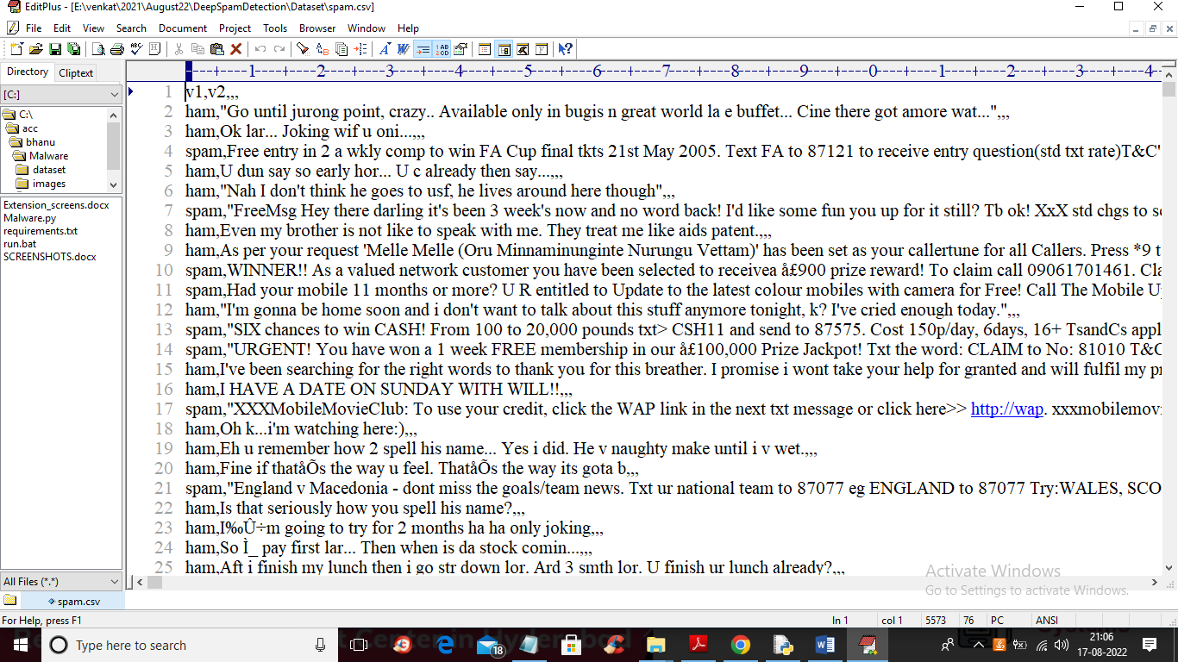
In above dataset first column contains class label as SPAM or HAM and second column contains MESSAGE and by using above dataset we will train existing and propose algorithms. In above screen we can see dataset contains non-numeric values and algorithm accept only numeric values so by applying WORD-EMBEDDING algorithm we will convert above dataset to numeric values by finding average frequency of each word.
To implement this project we have designed following modules
- Upload SMS Dataset: using this module we will upload dataset to application and then plot graph with total HAM and SPAM message count
- Preprocess & Word Embedding Vector: by applying Preprocessing technique we will read all messages and then process messages by converting to lower case, remove stop words, apply stemming and lemmatization and then apply word-embedding algorithm to convert message into numeric vector
- Run SMOTE Over-Sampling Dataset: using this module we will apply SMOTE algorithm to balance dataset and then split dataset into train and test where application used 80% dataset for training and 20% for testing
- Run Existing Algorithm: As existing algorithm we have used SVM and then input 80% training data to SVM to train model and this model will be applied on 20% test data to calculate prediction accuracy
- Convolution Based Features Extraction: using this module we will train CNN algorithm to extract features and then will calculate accuracy of this model
- Run Propose DCF Algorithm: using this module we will extract features from CNN and then input this features to combination of ensemble algorithm such as Bagging, Boost and Random Forest to train a model and this model will be applied on test data to calculate prediction accuracy
- Comparison Graph: using this module we will plot comparison graph between all algorithms
- Spam Prediction from Test Data: using this module we will upload test messages and then DCF will predict those messages as SPAM or HAM.
SCREEN SHOTS
To run project double click on ‘run.bat’ file to get below screen
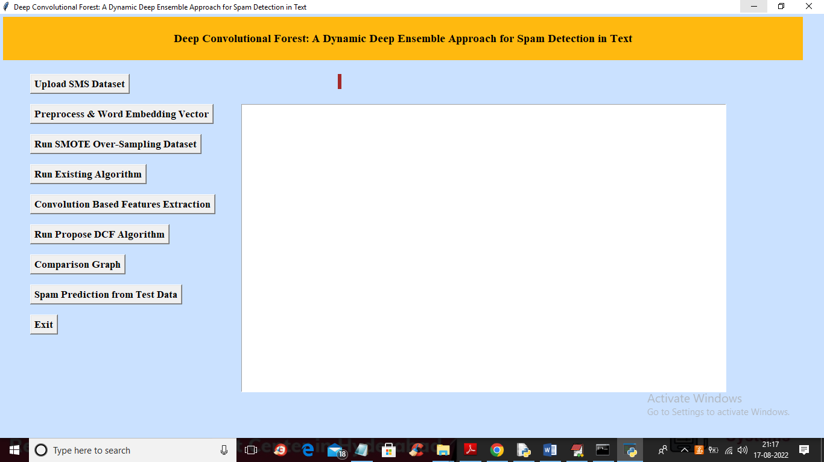
In above screen click on ‘Upload SMS Dataset’ button to load dataset and get below output
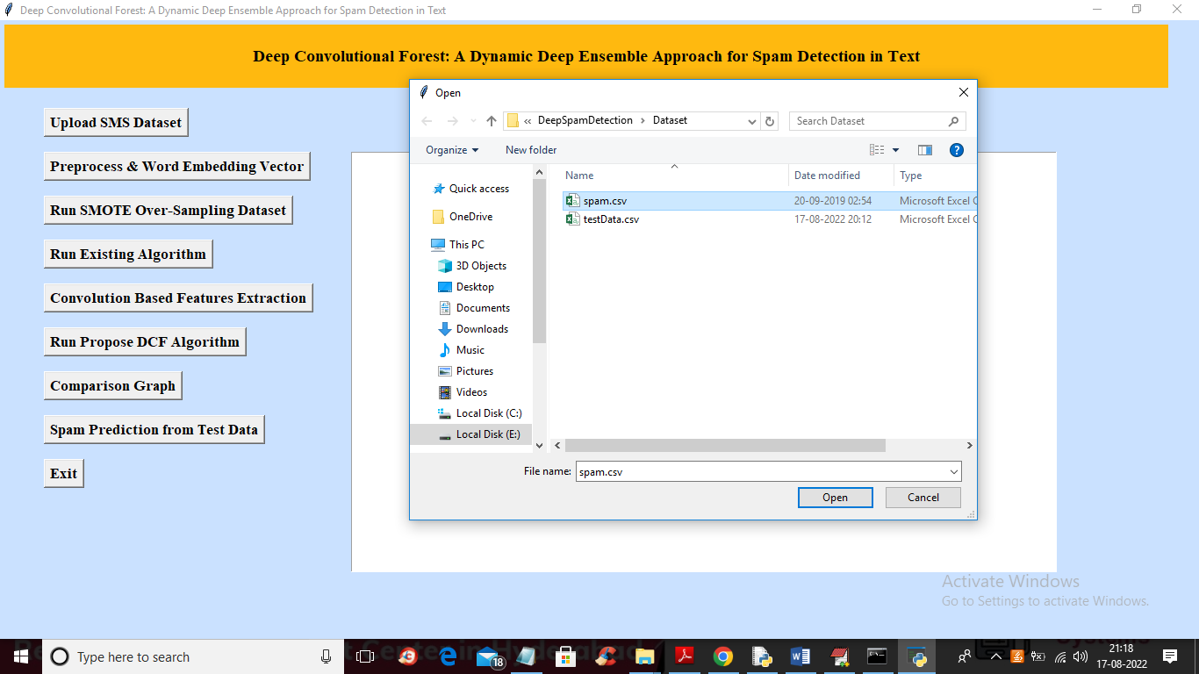
In above screen selecting and uploading ‘spam.csv’ dataset file and then click on ‘Open’ button to get below output
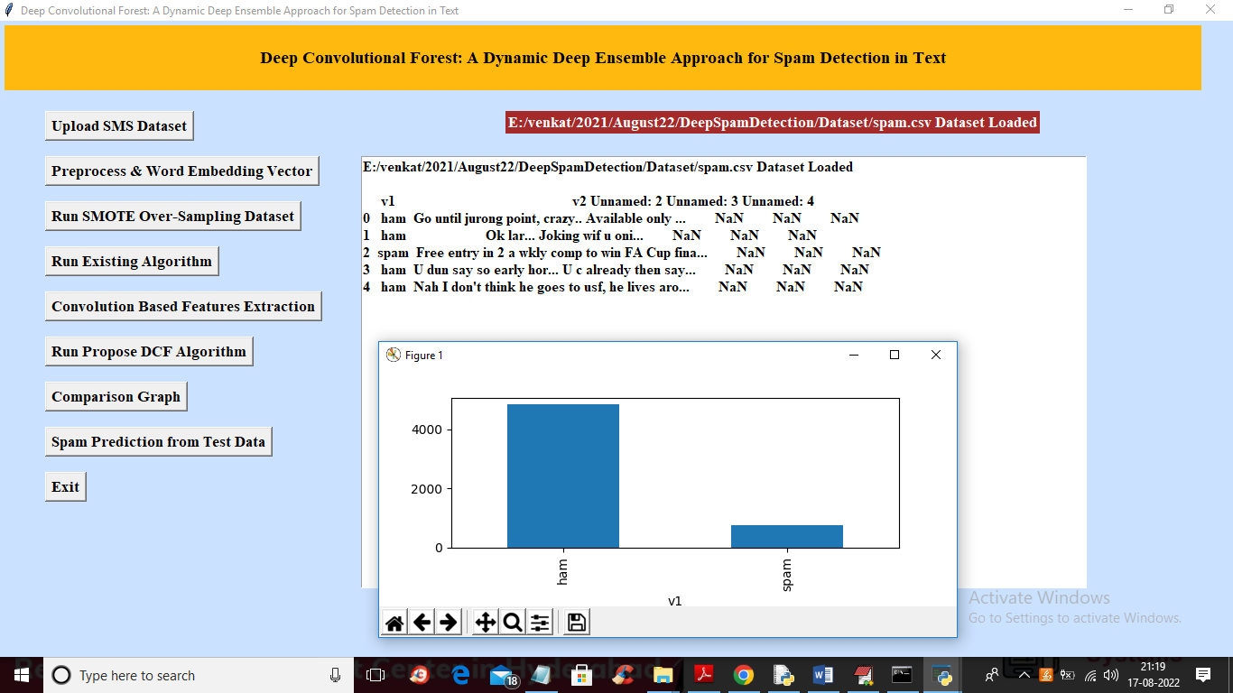
In above screen we can see dataset loaded and in graph x-axis contains message type as SPAM or HAM and we can see HAM contains more than 4000 records and SPAM contains only 700 records and now close above graph and then click on ‘Preprocess & Word Embedding Vector’ button to clean messages by removing stop words and then convert into numeric vector and get below output
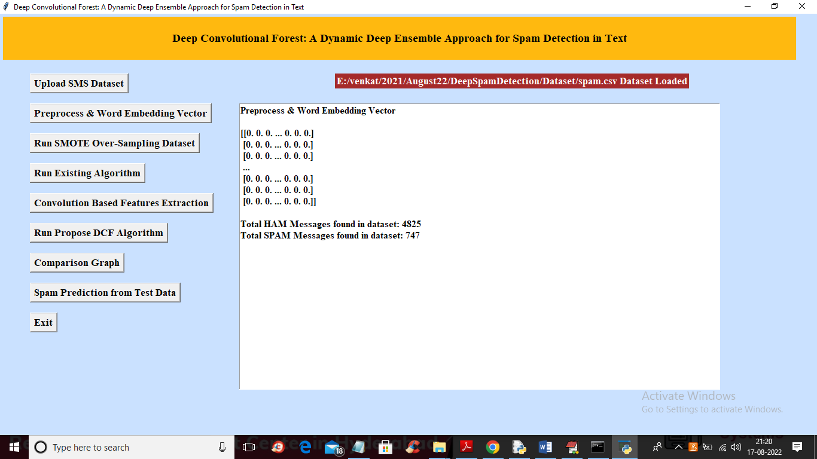
In above screen in square bracket we can see dataset convert to numeric array and then we can see HAM count is 4825 and SPAM count is 747 and now click on ‘Run SMOTE Over-Sampling Dataset’ button to apply SMOTE to balance dataset and get below output
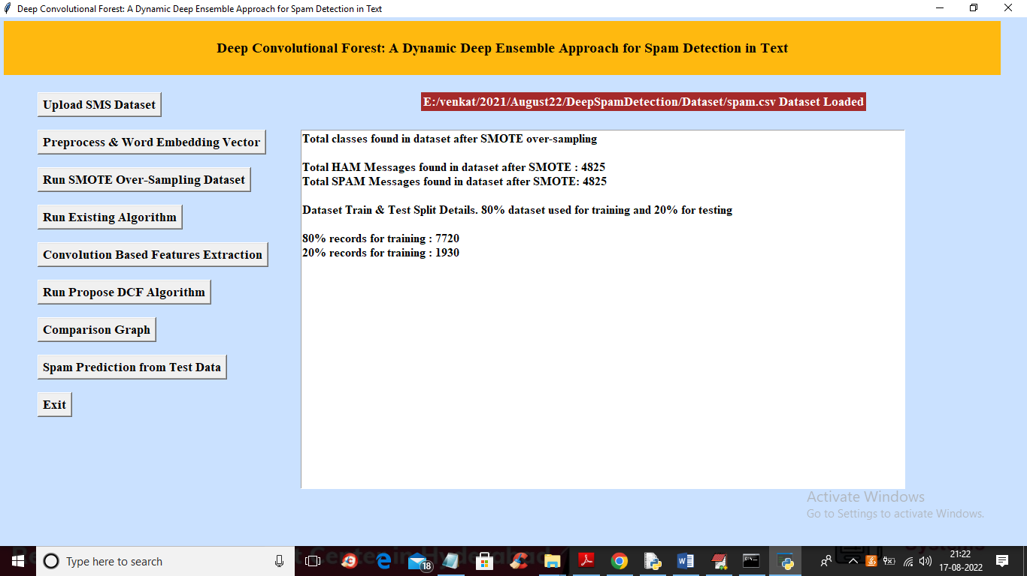
In above screen we can see after applying SMOTE both classes contains equal number of records as 4825 and 4825 and we can say dataset is balanced and then we can see application split dataset into train and test and now click on ‘Run Existing Algorithm’ button to train SVM and get below output
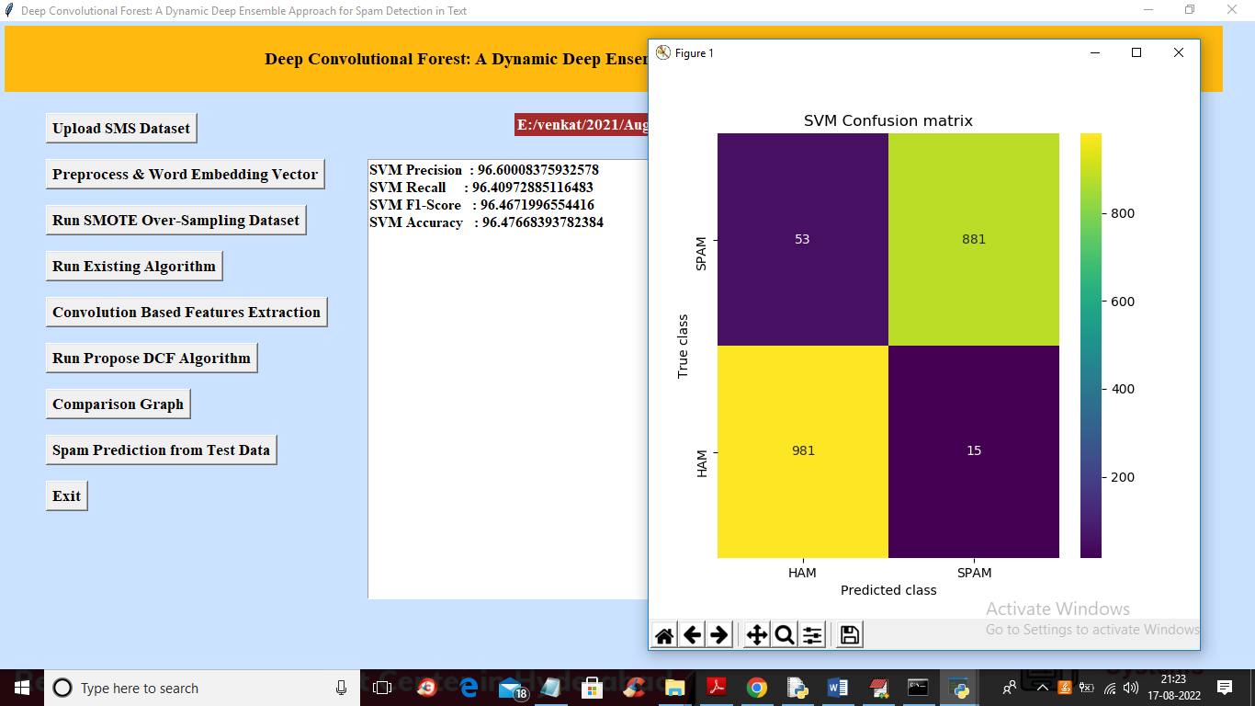
In above screen with SVM we got 96% accuracy and in confusion matrix graph x-axis contains PREDICTED classes and y-axis contains true classes and blue colour boxes contains wrong prediction count which is 53 and 15 and different colour boxes (yellow and green) contains correct prediction count. Now click on ‘Convolution Based Features Extraction’ button to train CNN to extract features and then calculate accuracy
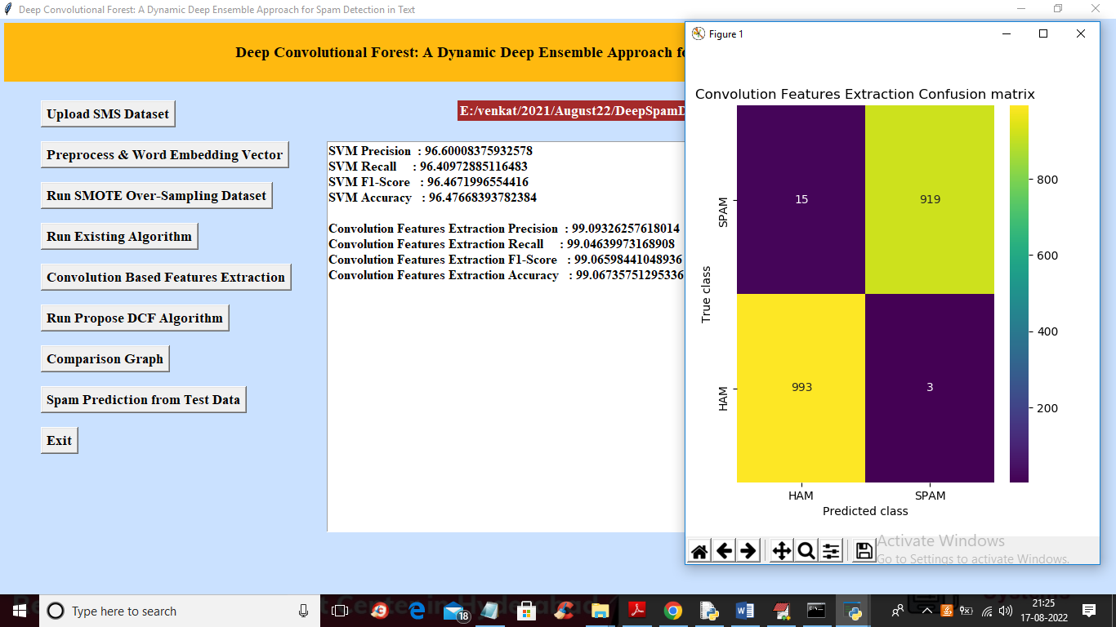
In above screen with CNN features extraction we got 99.09 as the accuracy and in confusion matrix graph we can see wrong prediction count as 15 and 3 which are less than SVM so CNN is better than SVM and now click on ‘Run Propose DCF Algorithm’ button to get below output
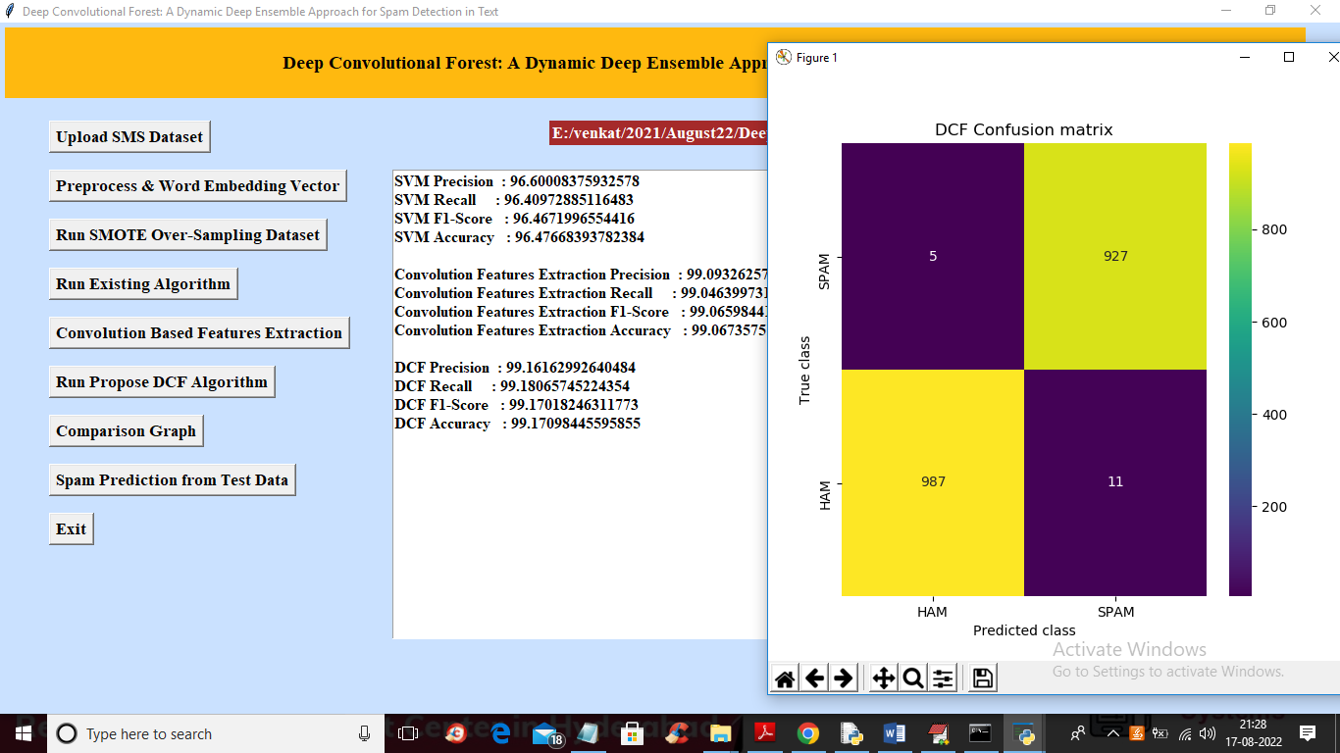
In above screen with DCF we got 99.16% accuracy which is higher than Convolution CNN and in confusion matrix wrong prediction are 5 and 11 which is lesser than SVM and Convolution so DCF is better than all algorithms. Now close above graph and then click on ‘Comparison Graph’ button to get below graph
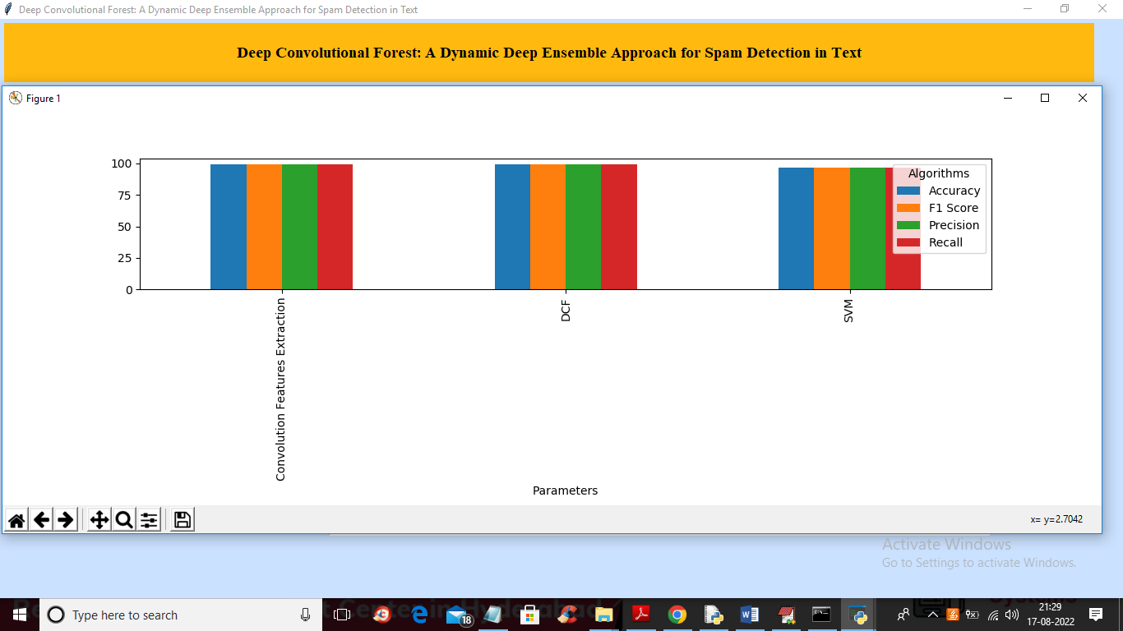
In above graph x-axis represents algorithm names and y-axis represents accuracy, precision, recall and other metric in different colour bar and in all algorithms DCF got high values. Now close above graph and then click on ‘Spam Prediction from Test Data’ button to get below output
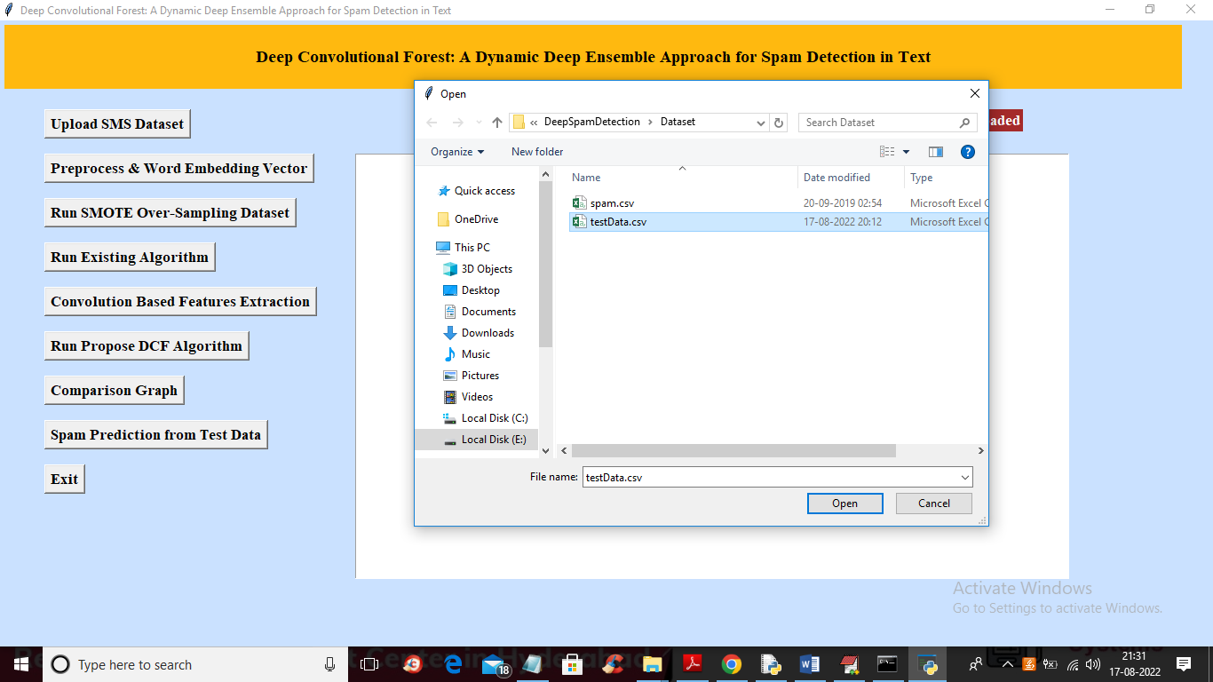
In above screen selecting and uploading ‘testData.csv’ file and then click on ‘Open’ button to get below output
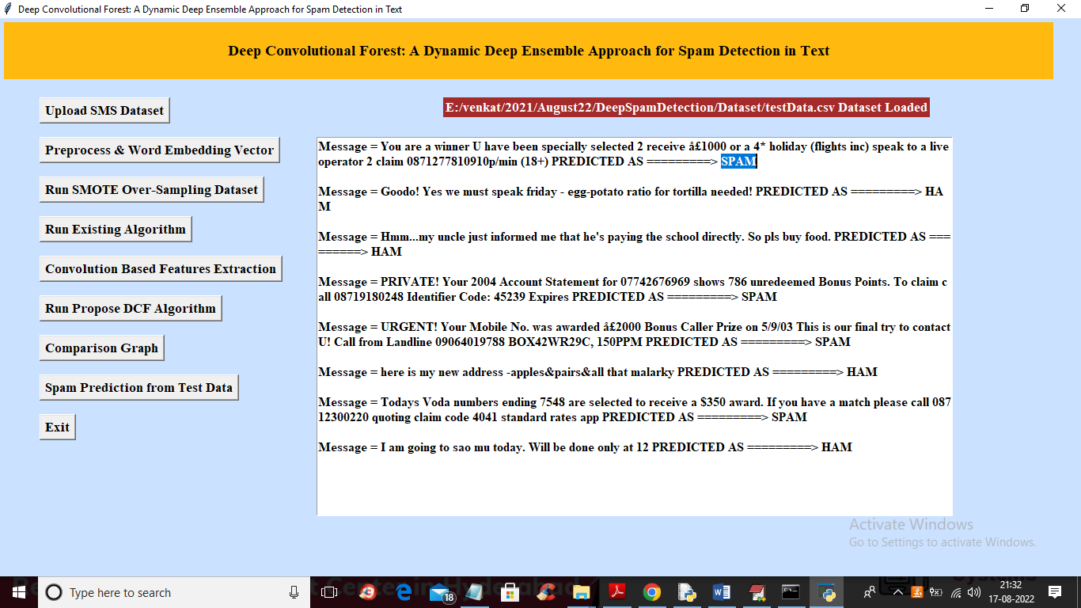
In above screen after = symbol we can see MESSAGE and then after arrow symbol we can see that message predicted as SPAM or HAM

