INTERNSHIP REPORT
IIT Jammu Summer School 2026 — IoT & Drones Program

Submitted by

Heli Gupta
Branch: Information & Communication Technology (ICT)

Adani University

Internship Mentor: Majid

Table of Contents

Internship Completion Certificate 5
STUDENT DECLARATION 6
ACKNOWLEDGEMENT 7
ABSTRACT / EXECUTIVE SUMMARY 8
CHAPTER 1: INTRODUCTION 9
  - ​Background 9
  - ​Purpose of the Internship 9
  - ​Internship Objectives 9
  - ​Scope of Work 9
  - ​Internship Duration 10
  - ​Organization of the Report 10
CHAPTER 2: INTERNSHIP OVERVIEW 11
  - ​Internship Details 11
  - ​Internship Objectives 11
  - ​Roles and Responsibilities 11
  - ​Expected Deliverables 12
  - ​Weekly Timeline 12
CHAPTER 3: TRAINING AND LEARNING PHASE 14
  - ​Orientation Program 14
  - ​Tools Learned 14
  - ​Software / Platforms Used 14
  - ​Technical Concepts Studied 14
  - ​Documentation Reviewed 15
CHAPTER 4: PROJECT WORK (WITH SCREENSHOTS) 16
4A: IoT Home-Assignment Projects (P1–P10) 16
4B: OmniNode Capstone — Plug-and-Play IoT Sensor Platform 17
  - ​Project Introduction 17
  - ​System Design 18
  - ​Technology Stack 19
  - ​System Implementation 19
  - ​Algorithms / Models Used 20
  - ​APIs / Integrations 20
  - ​Deployment 20
  - ​Final Output 20
CHAPTER 5: WEEKLY WORK LOG 23
CHAPTER 6: CHALLENGES FACED 24
  - ​Technical Challenges 24
  - ​Communication Challenges 24
  - ​Time Management 25
  - ​Problem-Solving Summary 25
CHAPTER 7: SKILLS DEVELOPED 27
  - ​Technical Skills 27
  - ​Professional Skills 27
CHAPTER 8: LEARNING OUTCOMES 29
  - ​Academic Concepts Applied 29
  - ​Industry Exposure 29
  - ​Best Practices Learned 30
  - ​Professional Ethics 30
  - ​Team Collaboration 30
  - ​Career Insights 30
CHAPTER 9: SELF ASSESSMENT 32
  - ​Strengths 32
  - ​Areas for Improvement 32
  - ​Reflection on Internship Experience 33
CHAPTER 10: CONCLUSION AND FUTURE SCOPE 34
  - ​Conclusion 34
  - ​Future Improvements 34
  - ​Recommendations 34
  - ​Career Plans 35
APPENDICES 36
Appendix A: Internship Offer Letter 36
Appendix B: Internship Completion Certificate 36
Appendix C: Weekly Reports 36
Appendix D: Project Screenshots 36
Appendix E: Source Code Snippets 36
Appendix F: Presentation Slides 36
Appendix G: User Manual 37
Appendix H: Attendance Record 37
Appendix I: Resume / CV 37

Internship Completion Certificate

STUDENT DECLARATION

I, Heli Gupta, hereby declare that this Internship Report titled "Internship Report – IIT Jammu Summer School 2026 (IoT & Drones Program)" is an authentic record of original work carried out by me under the guidance of Majid, submitted in partial fulfillment of the requirements for the ICT program at Adani University. This work has not been submitted elsewhere for any other degree or diploma.

I further affirm that all sources of information and data referenced in this report have been duly acknowledged, and that the content presented herein is a true and accurate representation of the work I undertook during the internship period.

I accept full responsibility for the originality and integrity of this report.

Place: Ahmedabad

Date: 01-08-2026

Name: Heli Gupta

Signature:

ACKNOWLEDGEMENT

I would like to express my sincere gratitude to my mentor, Majid, for his valuable guidance, constant support, and encouragement throughout the IIT Jammu Summer School 2026 – IoT & Drones Program. His feedback and technical insights played a crucial role in helping me understand key concepts and complete the assigned projects effectively.

I am also thankful to the organizing team and faculty of IIT Jammu Summer School 2026 for structuring a well-paced, hands-on curriculum and for providing the resources and platform needed to learn IoT and drone systems practically.

I extend my gratitude to my college guide and HOD at Adani University for their continuous support and for approving this internship as part of my academic curriculum.

I would also like to thank my teammates, Vraj Ramavat and Prathamesh Naik, for their collaboration and contribution during the OmniNode capstone project, which made the simulation and testing phase a much richer learning experience.

Finally, I am grateful to my family and friends for their constant motivation and support throughout the duration of this internship.

Heli Gupta
Ahmedabad, August 2026

ABSTRACT / EXECUTIVE SUMMARY

This report documents my internship under the IIT Jammu Summer School 2026 IoT & Drones Program, mentored by Majid, covering structured hands-on IoT development alongside drone/UAV systems fundamentals. Over three intensive weekly modules (June 20 – July 5, 2026), I progressed from Git/GitHub fundamentals and CI/CD through Arduino state-machine programming to sensor and actuator interfacing, building projects including a traffic light controller, a vending machine finite state machine, and a weather monitoring station.

I then completed all 10 IoT home-assignment projects (July 19–23, 2026) — spanning climate monitoring, gas/fire safety, ultrasonic parking assistance, plant watering automation, a Wi-Fi weather dashboard, pressure/altitude logging, stepper-motor positioning, and a capstone home-automation hub — adapting firmware to real hardware substitutions along the way, including switching from I2C to SPI for the OLED display and from DHT11 to DHT22 sensor logic.

Alongside this, I contributed to OmniNode, a team capstone project (with Vraj Ramavat and Prathamesh Naik) building a plug-and-play IoT sensor platform with auto-detecting swappable modules. The full firmware and cloud pipeline — ID-pin sensor detection, WiFi connectivity, and MQTT publishing to a live broker — was validated end-to-end in simulation using Wokwi and Tinkercad. I also completed a theory assignment on drone/UAV systems fundamentals.

This internship strengthened my practical skills in embedded C++, sensor interfacing, MQTT-based IoT architecture, and systematic debugging, while reinforcing the value of a simulate-first engineering workflow before committing to physical hardware.

CHAPTER 1: INTRODUCTION

Background

The Internet of Things (IoT) and unmanned aerial vehicle (UAV) technologies have emerged as two of the most transformative fields in modern engineering. IoT connects physical devices to digital platforms, enabling intelligent automation across smart cities, agriculture, healthcare, and industrial systems. Simultaneously, drones have found applications far beyond defense — from precision farming and environmental monitoring to logistics and disaster response. IIT Jammu runs the Summer School program to equip emerging engineers with the hands-on, industry-relevant skills needed to work confidently across these domains.

Purpose of the Internship

To gain hands-on exposure to IoT hardware and firmware development, sensor integration, cloud/dashboard pipelines, and drone/UAV fundamentals through structured weekly modules and home assignments.

Internship Objectives

    - Learn Git/GitHub workflow and CI/CD basics.

    - Build Arduino/ESP32 firmware for sensors, actuators, and state machines.

    - Complete 10 IoT & Drones home-assignment hardware projects.

    - Design and simulate a capstone IoT platform (OmniNode) end-to-end before hardware build.
    - Understand drone/UAV systems fundamentals.

Scope of Work

Covers weekly hands-on IoT modules (Weeks 1–5 and final project), 10 independent home-assignment projects, the OmniNode capstone simulation, and a theory assignment on drone/UAV systems. Physical drone flight testing and OmniNode hardware assembly beyond simulation were not within scope for this program period.

Internship Duration

The internship spanned approximately six weeks, from June 20, 2026 to August 1, 2026, encompassing three structured weekly IoT modules, a five-day intensive home-assignment sprint (July 19–23), the OmniNode capstone simulation phase (July 23–31), and the drone/UAV theory assignment (August 1).

Organization of the Report

This report is organized into ten chapters. Chapter 1 introduces the internship context and objectives. Chapter 2 provides an overview of the program structure and deliverables. Chapter 3 details the training and learning phase. Chapter 4 documents all project work, including the OmniNode capstone and the 10 home-assignment projects. Chapters 5 through 9 cover the weekly work log, challenges faced, skills developed, learning outcomes, and self-assessment respectively. Chapter 10 presents the conclusion and future scope. Appendices include the certificate, code excerpts, screenshots, and the resume/CV link.

CHAPTER 2: INTERNSHIP OVERVIEW

Internship Details

Program | IIT Jammu Summer School 2026 – IoT & Drones Program
Intern Name | Heli Gupta
Mentor | Majid
Institution | Adani University, Ahmedabad
Branch | Information & Communication Technology (ICT)
Mode | Online
Duration | June 20 – August 1, 2026 (approx. 6 weeks)

Internship Objectives

(Same as Section 1.3 — restated in the context of the program structure.) The program aimed to build embedded systems and IoT development skills through weekly structured modules, independent project work, and a collaborative capstone simulation.

Roles and Responsibilities

    - Complete weekly IoT hands-on modules and push code to GitHub with proper commit history.
    - Independently complete and document 10 IoT & Drones home-assignment projects.

    - Contribute to the OmniNode capstone simulation as a team (with Vraj Ramavat and Prathamesh Naik), focusing on the Target Audience analysis and Benefits of the System sections.
    - Submit theory assignments, including Drone/UAV Systems fundamentals.

Expected Deliverables

    - Working Arduino/ESP32 sketches for each weekly module and home assignment, with wiring and demo evidence.
    - A validated simulation (Wokwi/Tinkercad) of the OmniNode capstone with a documented simulation log.
    - Theory assignment write-ups (e.g., Drone/UAV Systems answers).

    - This final internship report and resume/CV link.

Weekly Timeline

Week | Period | Activities
Week 1 | Jun 20–25 | GitHub setup & version control — Git workflow, branching, CI/CD actions, theory
Week 2 | Jun 26–30 | IoT fundamentals & Arduino programming — traffic controller, serial interface, fading, state machines, theory
Week 3 | Jul 1–5 | Sensors, actuators & data acquisition — DHT11, LDR, HC-SR04, servo, DC motor, relay, LCD, theory

Week | Period | Activities
Week 4 | Jul 19–23 | Home assignments P1–P10: climate monitoring, gas/fire safety, ultrasonic parking, plant watering, Wi-Fi dashboard, pressure/altitude, stepper motor, home automation hub
Week 5 | Jul 23–31 | OmniNode capstone — plug-and-play IoT sensor platform (design, simulation, MQTT validation)
Final | Aug 1 | Drone/UAV theory assignment; report compilation

CHAPTER 3: TRAINING AND LEARNING PHASE

Orientation Program

The IoT & Drones Program at IIT Jammu Summer School 2026 began with an orientation session that introduced participants to the structure and objectives of the program. The session covered an overview of IoT and embedded systems, an introduction to the weekly module structure, expectations for home assignments, and submission guidelines including the GitHub workflow requirements.

Tools Learned

    - Git & GitHub (branching, commits, GitHub Actions CI/CD).

    - Arduino IDE / embedded C++ (.ino sketch development).

    - Wokwi and Tinkercad circuit simulators.

    - Node-RED for cloud dashboards.

    - MQTT client tools (HiveMQ WebSocket client).

Software / Platforms Used

    - Arduino UNO, ESP32/ESP8266 (simulated and/or physical).

    - Wokwi, Tinkercad (simulation environments).

    - Node-RED + HiveMQ public MQTT broker.

    - GitHub Actions (CI/CD).

Technical Concepts Studied

    - Non-blocking multitasking and state machines in embedded C++.

    - Sensor/actuator interfacing (digital & analog I/O, I2C/SPI displays).

    - Wireless communication protocols and MQTT-based pub/sub messaging.

    - IoT system architecture (device → cloud → dashboard layers).

    - Drone/UAV systems fundamentals (from the theory assignment).

Documentation Reviewed

    - MDN Web Docs — for understanding HTTP methods (GET, POST, etc.) and debugging web page/network errors while working on the ESP32's WiFi and web-facing features.
    - Arduino and ESP32 library documentation — referred to extensively while integrating various sensors, displays, and communication modules, including: Adafruit_SSD1306 (SPI OLED display driving), DHTesp (DHT22 temperature/humidity sensor), PubSubClient (MQTT publish/subscribe connectivity to the HiveMQ broker).
    - Arduino IDE and ESP32 core reference docs — for board-specific pin configurations, ADC behavior (relevant to OmniNode's ID-pin voltage detection logic), and library installation/management.
    - Wokwi and Tinkercad documentation — for simulator-specific setup (adding libraries via libraries.txt, wiring diagrams, network access via Wokwi-GUEST).

CHAPTER 4: PROJECT WORK (WITH SCREENSHOTS)

This chapter covers two main bodies of practical work: (A) the 10 IoT & Drones home-assignment projects, and (B) the OmniNode capstone simulation. OmniNode is treated as the primary project since it is the most complete end-to-end system; the 10 home assignments are summarized as supporting modules.

4A: IoT Home-Assignment Projects (P1–P10)

As part of the program, I independently completed all 10 home-assignment projects (July 19–23, 2026), exceeding the minimum requirement of 5. Each project involved firmware development, sensor/actuator interfacing, and documented evidence (screenshots, demo videos, GitHub commits).

Project | Title | Key Components
P1 | Climate Monitor | DHT22, OLED (SPI), real-  time temperature & humidity display
P2 | Gas/Fire Safety Alert | MQ-2 gas sensor, buzzer, LED alert system with threshold logic
P3 | Ultrasonic Parking Assist | HC-SR04, OLED display, distance-based proximity warning
P4 | Plant Watering Automation | Soil moisture sensor, DHT22, relay-controlled water pump
P5 | Wi-Fi Weather Dashboard | ESP32 WiFi,  OpenWeatherMap REST

Project | Title | Key Components
 |  | API, JSON parsing, OLED display
P6 | Pressure/Altitude Logger | BMP280 (I2C), DHT22, 24-  point circular buffer for trend tracking
P7 | Stepper Motor Positioning | 28BYJ-48 stepper, ULN2003 driver, degree-accurate positioning
P8 | MQTT Sensor Publisher | ESP32 WiFi, PubSubClient, HiveMQ broker, JSON payloads
P9 | IR Remote Control | IR receiver, NEC protocol decoding, multi-device control
P10 | Home Automation Hub | ESP32, DHT22, OLED (SPI),  relay, MQTT — capstone integrating P1–P9 concepts

Hardware substitutions were handled throughout: the kit shipped a 7-pin SPI OLED instead of the specified 4-pin I2C OLED (SSD1306), requiring all affected sketches to be rewritten for the SPI constructor. The kit also supplied a DHT22 (AM2302) instead of DHT11, requiring the DHTesp constant to be updated across four projects (P1, P4, P6, P10).

4B: OmniNode Capstone — Plug-and-Play IoT Sensor Platform

​Project Introduction

Problem Statement: OmniNode addresses the problem that each IoT use case (water-level, gas leak, occupancy, etc.) typically requires its own dedicated hardware unit. OmniNode solves this by building a single reusable base unit that auto-detects whatever sensor module is plugged in and reconfigures itself — no reflashing needed.

Objectives:

    - Validate ID-pin auto-detection logic in simulation before committing to hardware.

    - Build and test the cloud/dashboard layer (Node-RED) in parallel with hardware sourcing.

    - Arrive at the hardware phase with proven firmware logic.

Scope: Covers the virtual-first simulation phase (firmware and cloud pipeline validated in Wokwi/Tinkercad); physical wiring, soldering, and two sensor modules (weight/vibration, GPS/motion) were identified as first-touch-on-real-hardware items, not yet simulated.

​System Design
Overall Architecture: 3-layer design. Layer 1 — swappable sensor modules, each with a unique ID resistor. Layer 2 — reusable ESP32 base unit that reads the ID-pin voltage to detect the attached module and dispatches to the matching driver. Layer 3 — Node-RED cloud platform and dashboard that updates dynamically based on which sensor is connected.
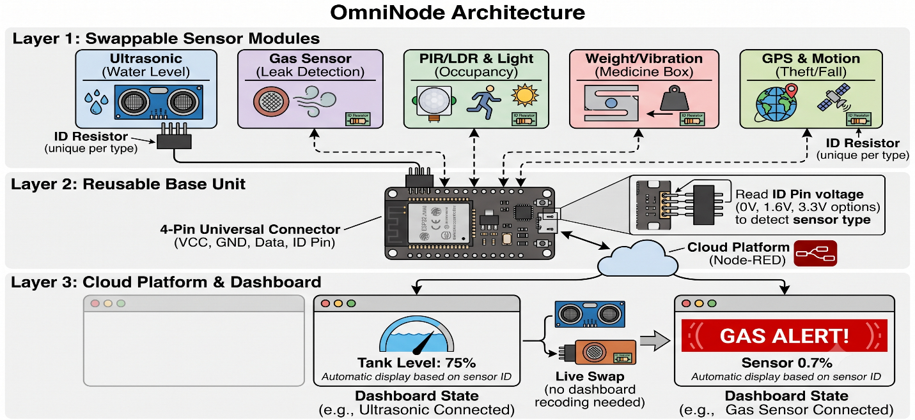

Workflow: The ESP32 reads an analog voltage from the ID pin on startup and during each polling cycle. Depending on the voltage range detected (~0 V → ultrasonic/water-level, ~1.6 V → gas/leak detection, ~3.3 V → PIR/occupancy), it loads the corresponding sensor driver and begins publishing structured JSON payloads to the MQTT broker. The Node-RED dashboard subscribes to the same topic and renders the appropriate widget for the detected module type.
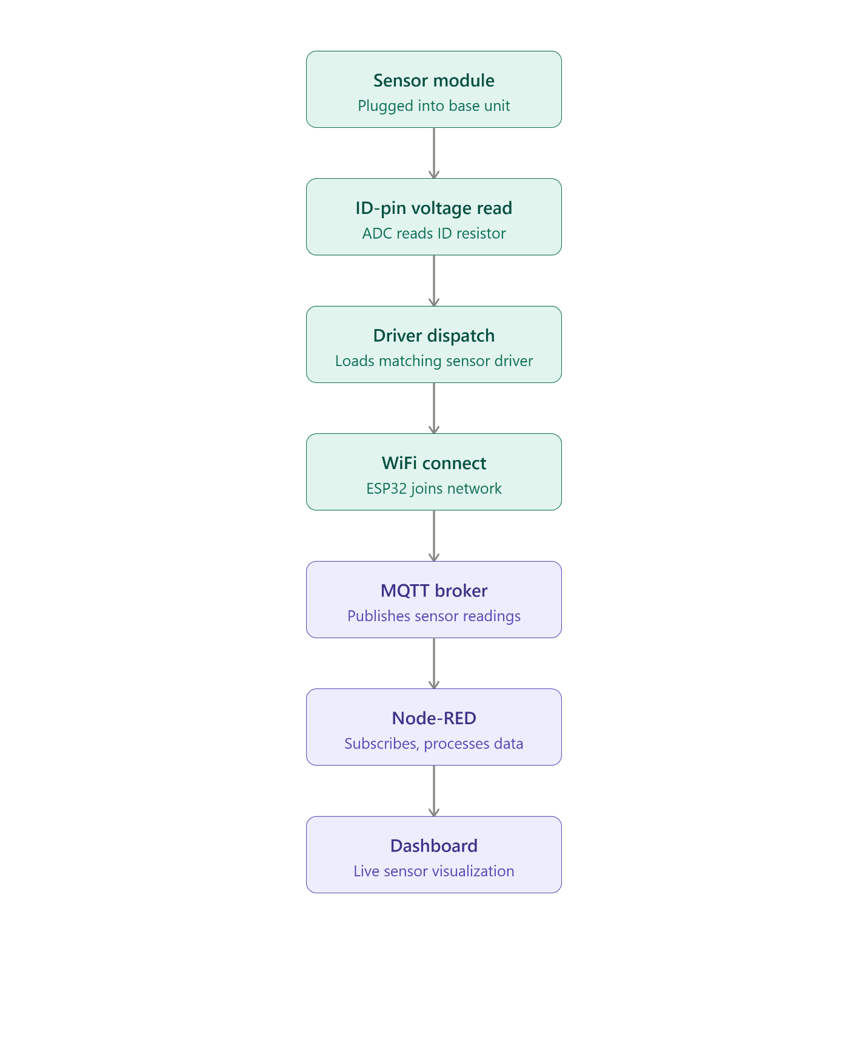

Use Case Diagram:
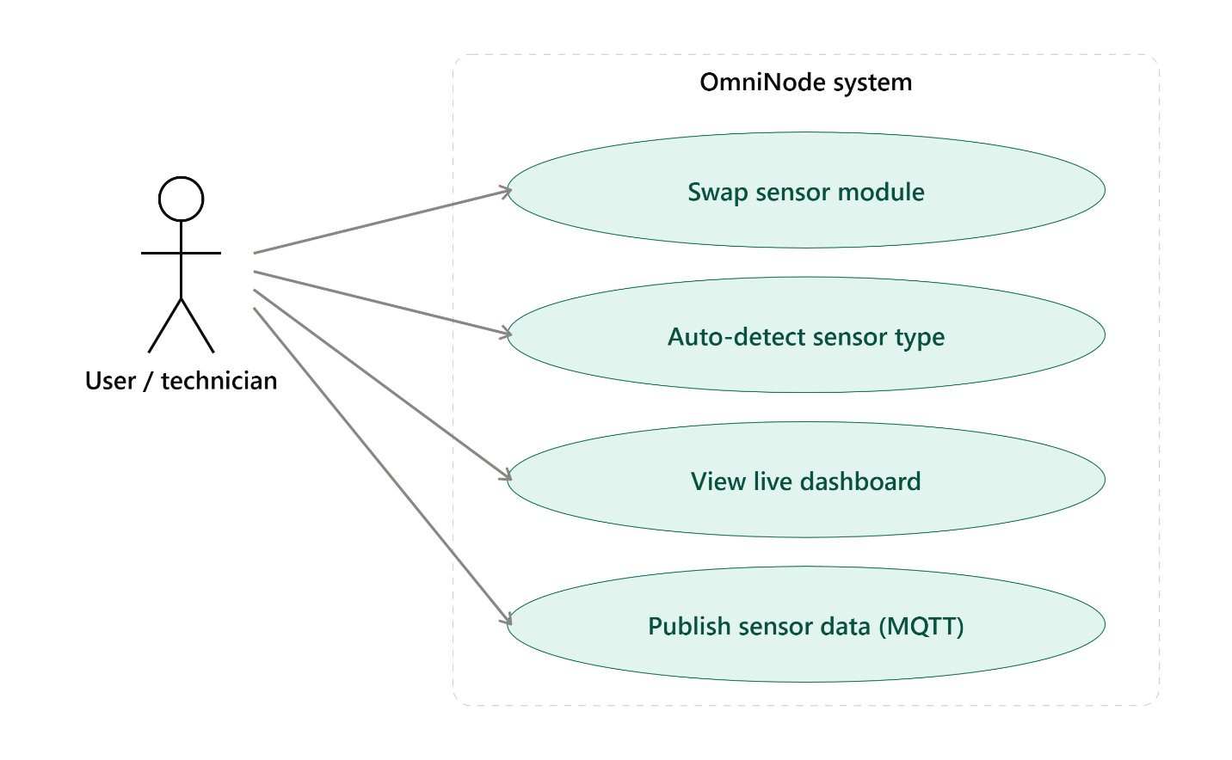
Database Design: N/A — OmniNode uses live MQTT streaming rather than persistent storage.
ER Diagram: N/A.

​Technology Stack

Category | Details
Programming Languages | Embedded C++ (Arduino .ino sketches), Python (helper scripts)
Hardware Platform | Arduino UNO, ESP32/ESP8266
Frameworks / Libraries | PubSubClient (MQTT), Adafruit_SSD1306, DHTesp
Simulation Environments | Wokwi, Tinkercad
Cloud / Dashboard | Node-RED
Messaging Protocol | MQTT (public broker.hivemq.com)
Version Control | Git & GitHub (with GitHub Actions CI/CD)
Development Tools | Arduino IDE, VS Code, HiveMQ WebSocket client

​System Implementation

Module 1 — ID-Pin Auto-Detection Logic (OmniNode)

Purpose: detect which sensor module is physically attached, without manual configuration or reflashing.
Implementation: a potentiometer simulates the ID resistor; firmware reads the ID-pin voltage and dispatches to the matching driver (~0 V → ultrasonic/water-level, ~1.6 V → gas/leak detection,
~3.3 V → PIR/occupancy).

Module 2 — Sensor Drivers (Ultrasonic, Gas, PIR)

Purpose: read and interpret data from each swappable sensor type.

Implementation: ultrasonic (HC-SR04, water-level distance readings), gas sensor (MQ-2, leak detection — Wokwi only), PIR (occupancy detection) — each validated in Wokwi and/or Tinkercad.

Module 3 — Cloud Connectivity (WiFi + MQTT + Node-RED)

Purpose: get sensor data from the device to a live dashboard.

Implementation: ESP32 connects over WiFi (Wokwi-GUEST simulated network) and publishes JSON payloads (e.g., {"module":"ultrasonic","distance_cm":42}) to a public MQTT broker; verified using HiveMQ's WebSocket client since Wokwi's Serial Monitor had a known rendering issue.

​Algorithms / Models Used
Threshold-based voltage classification for ID-pin sensor detection (comparing ADC-read voltage against fixed thresholds to select a driver). No ML models were used.

​APIs / Integrations
    - MQTT publish/subscribe via PubSubClient library to broker.hivemq.com.

    - Node-RED flow subscribing to the MQTT topic to drive the dashboard.

​Deployment
Simulated deployment only (Wokwi + Tinkercad) as of this report; physical hardware deployment (resistor sizing, wiring, soldering, enclosure) is listed as future work.

​Final Output

Performance:

Formal latency benchmarking was not part of the simulation phase, but the HiveMQ WebSocket client logs provide a practical picture of the pipeline's real-world behavior. Publish reliability: across all three module types tested (ultrasonic, gas, occupancy), every simulated reading appeared in the MQTT client with no dropped or malformed messages observed. Publish interval: messages arrived roughly every 1 second per module, consistent with the firmware's polling loop. Payload correctness: each module published a correctly structured JSON payload —
{"module":"ultrasonic","distance_cm":405}, {"module":"gas","raw":1675,"alert":false}, and
{"module":"occupancy","motion":false} — confirming the driver-dispatch logic was tagging and formatting data correctly per sensor type. Simulation fidelity: Wokwi reported simulation speed between 96–99% of real time across runs, meaning firmware timing behavior in simulation closely tracked how it would run on real hardware.

Results — Confirmed working in simulation:

    - ID-pin voltage read and threshold-based module detection: the potentiometer-driven ID-pin logic correctly identified and dispatched to three distinct sensor drivers — ultrasonic, gas, and occupancy (PIR) — each publishing its own correctly structured payload.
    - Live re-detection without reboot: switching between module types (as seen across the three separate simulation runs) worked without needing to reset or reflash the ESP32.
    - Ultrasonic distance readings: published as {"module":"ultrasonic","distance_cm":405}.

    - Gas/leak detection readings: published as {"module":"gas","raw":1675,"alert":false}, confirming the MQ-2 driver path.
    - PIR occupancy/motion readings: published as {"module":"occupancy","motion":false}.

    - WiFi connection: all three runs show a connected WiFi indicator and simulation running at 96–99% real-time speed on the Wokwi-GUEST network.
    - MQTT publish reaching a real public broker: every reading was visible live in the HiveMQ WebSocket client under the topic omninode/vrajheliprathmesh2026/data, confirming the full ESP32 → WiFi → MQTT broker leg of the pipeline works end-to-end.

GitHub Repositories:

IOT Summer School 2026 (gupta-heli)

Home Assignments (gupta-heli)

OmniNode Simulation (team repository)

CHAPTER 5: WEEKLY WORK LOG

Date | Activity | Learning | Hours
Jun 20–25 | Week 1 — Git/GitHub setup, branching, CI/CD | Git workflow, GitHub Actions basics | 12
Jun 26–30 | Week 2 — Arduino programming (traffic controller, state machines) | Non-blocking multitasking in embedded C++ | 15.5
Jul 1–5 | Week 3 — Sensors & actuators (DHT11, HC-SR04, servo, LCD) | Sensor interfacing techniques | 17.5
Jul 19–23 | Home assignments P1–P10 | Hardware substitution handling, OLED/DHT wiring | 21.5
Jul 23–31 | OmniNode capstone  — simulation & MQTT validation | System architecture, MQTT pub/sub, Node-RED | 12
Aug 1 | Drone/UAV theory assignment; report writing | Drone/UAV fundamentals | 3

CHAPTER 6: CHALLENGES FACED

Technical Challenges

    - Hardware mismatch: kit sheet specified a 4-pin I2C OLED (SSD1306) but a 7-pin SPI OLED was actually supplied — required rewriting every OLED sketch (P1, P3, P4, P6, P8, P9, P10) for SPI.
    - Sensor substitution: kit sheet specified DHT11 but DHT22 (AM2302) was supplied — required switching the DHTesp constant across four projects (P1, P4, P6, P10).
    - Wokwi's Serial Monitor panel was not rendering in-browser during OmniNode testing — worked around it by verifying the MQTT pipeline directly via HiveMQ's WebSocket client instead.
    - Gas sensor (MQ-2) not available in Tinkercad's component library — had to rely on Wokwi only for that module.
    - No suitable simulator parts for weight/vibration and GPS/motion modules — these remain first-touch-on-real-hardware items.
    - I2C BMP280 sensor caused a startup hang on disconnect — restructured P8 and P10 to parse sensor data immediately at startup, bypassing the hang caused by screen/display lag.
    - Overlapping/continuous buzzer tone bug across P2 and P3 — patched static-variable transitions in both sketches to correctly reset tone state between triggers.

Communication Challenges

Coordinating the OmniNode capstone as a three-person team (with Vraj Ramavat and Prathamesh Naik) required aligning on module ownership and simulation environments early, since the project spanned firmware, cloud/dashboard, and documentation work happening in parallel. Working across Wokwi and Tinkercad simultaneously — each with different capability gaps (no MQTT or gas-sensor support in Tinkercad) — meant the team had to clearly communicate which environment was authoritative for which test, to avoid conflicting or duplicated verification work.

Getting timely feedback from mentor Majid on architectural decisions (such as the ID-pin threshold design and the choice to simulate-first before hardware purchase) required proactively raising questions rather than waiting for scheduled check-ins, given the compressed weekly timeline of the program.

Time Management

Balancing the program's multiple concurrent tracks was one of the more demanding aspects of the internship. The three weekly IoT modules (June 20 – July 5) were front-loaded and fast-paced, averaging close to 3 hours a day of hands-on firmware work on top of theory components. This was followed by a dense five-day stretch (July 19–23) completing all 10 home-assignment projects — averaging over 4 hours a day — while also keeping the OmniNode capstone and the Drone/UAV theory assignment progressing in parallel rather than sequentially. The key time-management lesson was learning to batch similar work together rather than context-switching between unrelated projects.

Problem-Solving Summary

Challenge | Resolution
Kit shipped 7-pin SPI OLED instead of 4-pin I2C OLED (SSD1306) | Rewired and recoded every affected sketch to use Adafruit_SSD1306 with SPI constructor and hardware SPI pins
Kit shipped DHT22 (AM2302) instead of DHT11 | Set DHTesp constant to DHTesp::DHT22 across all four affected projects, keeping same 3-wire VCC/DATA/GND hookup
Wokwi's Serial Monitor panel not rendering in-browser during OmniNode testing | Switched to verifying MQTT pipeline end-to-end using HiveMQ's WebSocket client
MQ-2 gas sensor part not available in Tinkercad | Restricted gas-sensor simulation to Wokwi only; used Tinkercad solely for ultrasonic and

Challenge | Resolution
 | PIR modules
Overlapping/continuous buzzer tone bug across P2 and P3 | Patched static-variable transitions in both sketches to correctly reset tone state between triggers
I2C BMP280 sensor caused startup hang on disconnect | Restructured P8 and P10 to parse sensor data immediately at startup, bypassing display lag hang

CHAPTER 7: SKILLS DEVELOPED

Technical Skills

    - Embedded C++ programming (Arduino) — state machines, non-blocking multitasking, interrupt-driven sensor reads.
    - Sensor and actuator interfacing — DHT22, MQ-2, HC-SR04, BMP280, PIR, OLED (SPI/I2C), relay, servo, stepper motor.
    - Wireless communication protocols — WiFi, MQTT pub/sub, REST/JSON API calls on ESP32.
    - Cloud/IoT pipeline — Node-RED dashboards, MQTT-based cloud messaging, HiveMQ broker.
    - Version control — Git branching, commit discipline (feat/fix/docs convention), GitHub Actions CI/CD.
    - Simulation tools — Wokwi (with library support), Tinkercad (circuit design and simulation).
    - Debugging skills — hardware mismatch diagnosis, workarounds for tooling gaps, systematic root-cause isolation.

Professional Skills

    - Communication: documenting projects clearly (READMEs, simulation logs) for others to follow.
    - Teamwork: collaborating with Vraj Ramavat and Prathamesh Naik on the OmniNode capstone across firmware, cloud/dashboard, and documentation tracks.
    - Presentation: demo videos recorded per home-assignment project; progress updates to mentor Majid.
    - Time Management: handling 10 home assignments alongside weekly modules and the capstone simulation within a tight six-week schedule.

    - Critical Thinking: diagnosing hardware/kit mismatches and choosing a simulate-first strategy before hardware purchase to de-risk the build.
    - Technical Writing: internship report, structured README files, and hardware-substitution documentation across all projects.

CHAPTER 8: LEARNING OUTCOMES

Academic Concepts Applied

Embedded Systems concepts were the most heavily applied — firmware development in embedded C++ across all Arduino/ESP32 projects, including state machine design (traffic light controller, vending machine FSM), non-blocking multitasking (PWM fading night light, serial command interface), and both interrupt-driven and polling-based sensor reads.

Computer Networks concepts appeared in the WiFi connectivity work on the ESP32, MQTT publish/subscribe messaging to a public broker, and REST/JSON API design in the Wi-Fi Weather Dashboard project — along with a practical understanding of HTTP request/response behavior gained from referring to MDN while debugging.

Digital Logic and Microprocessor Systems concepts were evident in ADC-based voltage threshold detection (OmniNode's sensor auto-detection logic), PWM signal generation, and I2C/SPI display interfacing.

Data Structures concepts were applied in a concrete way — the 24-point circular buffer used to track pressure/altitude trends in the P8 logger project.

Software Engineering practices ran through everything: version control and branching strategy, CI/CD via GitHub Actions, modular code organization across ten-plus independent projects, and consistent documentation discipline through READMEs and simulation logs.

Industry Exposure

Exposure to real-world IoT development practices: simulate-before-hardware workflow, version-controlled firmware, CI/CD, and MQTT-based cloud architectures that mirror production IoT deployments.

Best Practices Learned

    - Validate logic in simulation before hardware purchase to catch bugs cheaply.

    - Structured commit discipline (feat/fix/docs) and per-project documentation.

    - Documenting known issues and workarounds (e.g., Wokwi Serial Monitor bug) instead of blocking on them.

Professional Ethics

Honesty in reporting results — documenting what actually worked in simulation versus what did not, and explicitly listing "still needs real hardware" items rather than overstating completion. Following the program's submission rules in good faith — including the "at least 3 commits per project" and hardware-substitution disclosure norms. Responsible use of shared/public resources
— using the public HiveMQ MQTT broker responsibly with careful topic naming to avoid interfering with other teams' data.

Team Collaboration

Worked with Vraj Ramavat and Prathamesh Naik on the OmniNode capstone project, with clear division of responsibilities across firmware, simulation environments, cloud/dashboard integration, and report documentation.

Career Insights

This internship provided a broad, hands-on view across the IoT stack — from low-level firmware and sensor interfacing to cloud messaging and dashboard design. Working across all these layers on a single project like OmniNode reinforced how much a real IoT product depends on getting the full pipeline right, not just one layer of it. The simulate-first approach on OmniNode also shifted how I think about engineering workflow — validating logic cheaply in simulation before

committing to hardware purchase is a mindset I will carry into future projects. The introduction to drone/UAV systems fundamentals has also opened a direction I would like to explore further.

CHAPTER 9: SELF ASSESSMENT

Strengths

Systematic debugging — the fixes documented across projects (rewiring for SPI when the OLED did not match the kit spec, patching static-variable transitions to fix overlapping buzzer tones, restructuring P8/P10 to bypass the BMP280 startup hang) show a pattern of isolating root causes rather than working around symptoms.

Documentation discipline — README files, a dedicated simulation log, hardware-substitution notes, and status badges across every project reflect a habit of writing things down as work progresses, not just at submission time.

Going beyond the minimum requirement — completing all 10 home-assignment projects instead of the required 5, gaining meaningfully broader exposure across the sensor and connectivity landscape.

Structured version control habits — consistent commit categorization (Feature/Docs/Chore/Merge) and adherence to the program's 3-commits-per-project requirement.

Areas for Improvement

    - Real hardware implementation is still pending for two OmniNode modules (weight/vibration for the medicine box, and GPS/motion for theft/fall detection) — these were simulated conceptually but have no working hardware build yet.
    - Actual resistor values for the ID-pin voltage divider still need to be calculated against real component tolerances, rather than relying on the simulated potentiometer stand-in.
    - The Node-RED dashboard itself has not been fully built out yet — only the MQTT topic/payload structure it will consume has been confirmed.

Reflection on Internship Experience

This internship provided my first real experience moving a project from an idea to a working, evidence-backed system — starting with Git fundamentals in Week 1 and ending with a fully simulated IoT platform (OmniNode) publishing live sensor data to a cloud dashboard pipeline. The pace was demanding at points, particularly during the five-day stretch completing all ten home-assignment projects, but it pushed me to work faster and more deliberately than I had before.

What stood out most was how often the real hardware did not match the spec sheet — the OLED display and the DHT sensor both arrived different from what the kit documentation described — and having to adapt firmware on the fly taught me more about robust, defensive coding than any of the projects that went smoothly. Working with Vraj Ramavat and Prathamesh Naik on OmniNode also gave me a sense of how a capstone-scale project gets divided and coordinated across people, rather than solved alone.

Looking back, I would call this internship a solid foundation in practical IoT development — not a finished product, but a clearly staged one, with an honest list of what is simulated versus what still needs to move to real hardware. That honesty about scope, more than any single project, is what I am most proud of from this program.

CHAPTER 10: CONCLUSION AND FUTURE SCOPE

Conclusion

This internship covered structured IoT fundamentals across Weeks 1–5, 10 independent home-assignment hardware projects, a fully simulated capstone (OmniNode) validating a novel auto-detecting sensor architecture end-to-end, and drone/UAV systems theory. The program progressively built competence from basic Git workflow and embedded C++ through complete IoT system design, cloud connectivity, and team-based project delivery.

The experience reinforced the practical value of a simulate-first engineering workflow, disciplined documentation, and adaptive problem-solving when hardware deviates from specification. It also demonstrated that a well-structured capstone project — even at simulation stage — can prove out a design's core logic rigorously before any physical components are purchased.

Future Improvements

    - Move OmniNode from simulation to physical hardware: resistor sizing, wiring, soldering, and enclosure.
    - Implement the weight/vibration and GPS/motion modules on real hardware.

    - Build out the Node-RED dashboard fully against the confirmed MQTT topic/payload structure.
    - Explore edge AI / TinyML integration — embedding lightweight ML inference on ESP32 for on-device sensor anomaly detection.
    - Implement secure MQTT communication using TLS and certificate-based authentication for production-grade deployments.

Recommendations

To future interns joining this program: verify hardware against the kit specification on day one rather than assuming it matches — the OLED display and temperature sensor both shipped as

different models than documented, and catching that early saves rework later. Where possible, simulate firmware logic (in Wokwi or Tinkercad) before committing to hardware purchase or wiring. It is also worth treating the minimum project requirement as a floor rather than a target — completing all 10 home-assignment projects instead of the required 5 gave meaningfully broader exposure.

Career Plans

This internship has strengthened my interest in pursuing further work in IoT and embedded systems, particularly at the intersection of firmware and cloud connectivity — the layer where a device's sensor logic actually becomes usable data on a dashboard. I would like to build on the OmniNode experience by completing the hardware-implementation work (GPS/motion and weight/vibration modules) that remained simulation-only here. The introduction to drone/UAV systems fundamentals has also opened a direction I would like to explore further through coursework, personal projects, or future internships. Within my ICT degree at Adani University, I plan to prioritize electives and projects that build on these embedded systems and networking foundations.

APPENDICES

Appendix A: Internship Offer Letter

The official offer letter issued by IIT Jammu confirming participation in the Summer School 2026 IoT & Drones Program. (Scanned copy to be attached upon submission.)

Appendix B: Internship Completion Certificate

The completion certificate issued by the program authority upon successful fulfillment of all internship requirements. (To be attached upon receipt from the program coordinator.)

Appendix C: Weekly Reports

Detailed weekly progress reports submitted to the program mentor documenting activities, outcomes, blockers, and plans. These served as the basis for the consolidated Weekly Work Log in Chapter 5.

Appendix D: Project Screenshots

A collection of screenshots documenting key project stages including Node-RED dashboard interface, sensor data plots, Gazebo/Wokwi simulation views, and the MQTT client verification logs. (Included in the final bound submission.)

Appendix E: Source Code Snippets

Selected source code excerpts representing critical modules. Complete source code is available in the GitHub repositories below:
IOT Summer School 2026 (gupta-heli)

Home Assignments (gupta-heli)

OmniNode Simulation (team repository)

Appendix F: Presentation Slides

The slide deck prepared for the final project presentation. (To be attached as a PDF export.)

Appendix G: User Manual

Operational guide for the IoT Home Automation System (P10) detailing hardware setup, network configuration, MQTT topic definitions, and Node-RED flow import procedures. Also hosted within the GitHub repository.

Appendix H: Attendance Record

The official attendance log maintained by the program administration confirming participation in all scheduled sessions, laboratory practicals, workshops, and evaluation events. (To be provided by the program coordinator.)

Appendix I: Resume / CV

My current curriculum vitae is attached as a Google Docs document at the link below. It reflects updated skills, project experience (including OmniNode and the 10 home-assignment projects), and academic qualifications as of August 2026. For further reference on the projects documented in this report, please refer to the GitHub repositories listed in Appendix E.

Resume / CV — Heli Gupta (Google Docs)

Note: Please replace the link above with your actual Google Docs resume link before final submission.

