Shiven Srivastava and James Russo

Ss2654 and jdr289

CS 4320

HW3

Question 1

1. If F ⊆ G then F+ ⊆ G+.
2. Assume an arbitrary functional dependency X → Y∈F+
3. By completeness, X → Y∈F
4. Since F ⊆ G, X → Y∈G by Reflexivity
5. By soundness, X → Y∈G+
6. F+ = (F+)+.
7. F+ ⊆ (F+)+ by the definition of a closure
8. Let there be an arbitrary f.d. X → Y∈ (F+)+
9. By completeness, X → Y∈F+
10. If for all f ∈ F, G |= f then F+ ⊆ G+.
11. If for all f ∈ F, G |= f, F ⊆ G by Reflexivity
12. By a), F+ ⊆ G+
13. The reflexivity and augmentation Armstrong axioms are sound (we proved soundess of the transitivity axiom in class).

Reflexivity: Prove that if Y ⊆ X, then X → Y for arbitrary attribute sets X and Y

1. Take arbitrary relation R
2. For arbitrary tuples s & t ∈R, s(X) = t(X)
3. Since s & t agree on all attributes in X and Y ⊆ X, then they agree on all attributes in Y
4. s(Y) = t(Y), QED

Augmentation: Prove that if X → Y, then XZ → YZ for arbitrary attribute sets X, Y, and Z

1. Assume an arbitrary relation R with arbitrary tuples s & t
2. Assume s(XZ) = t(XZ)
3. Thus, s(X) = t(X) and s(Z) = t(Z)
4. Since R satisfies X → Y, s(X) = t(X) implies s(Y) = t(Y) by reflexivity
5. Thus, s(YZ) = t(YZ), QED
6. Consider the criterion for testing whether a decomposition of a relation is dependency-preserving, on page 621 of your textbook. Let X, Y, F, FX, FY be as in your textbook. The criterion given in the textbook is (FX ∪ FY)+ =F+ . Show that the forward direction always holds, i.e. it is always true that (FX ∪ FY)+ ⊆ F+ .
7. FX is the projection of F on X, which is the set of FD’s in the closure F+ that involve only attributes in X therefore by definition FX ⊆ F+.
8. FY is the projection of F on Y, which is the set of FD’s in the closure F+ that involve only attributes in Y therefore by definition FY ⊆ F+.
9. FX ∪ FY is by the definition of union the set composed of everything in the two sets, therefore FX ∪ FY⊆ F+.
10. By 1b we know F+ = (F+)+ so all using these we can prove that FX ∪ FY=(FX ∪ FY)+ and (FX ∪ FY)+ ⊆ F+ .

Question 2

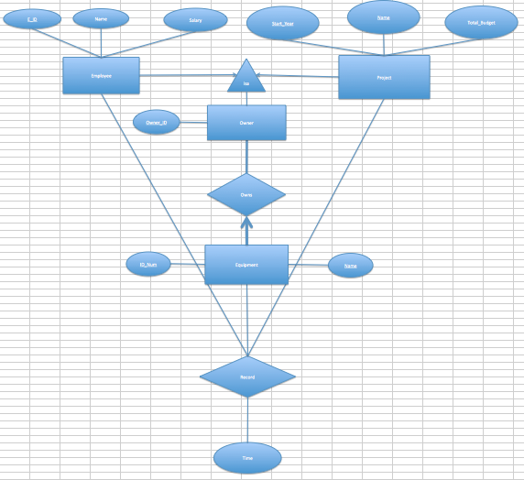

The above graph shows our ER diagram. Employee is an entity with primary key composed of E_ID and attributes name and salary. Project is an entity with primary key composed of Start Year and Name and attribute Total_Budget. Both Employee and Project are subclasses of the superclass Owner that has a key of Owner_ID. The relationship of the subclasses to the super class is many to one because each employee and project can only have one Owner_ID. There is also an entity Equipment whose key is composed of ID_Num and Name. Equipment and Owner form a relationship Owns where Equipment has a strong many to one relationship because each piece of equipment needs exactly one owner. Then the Record relationship keeps track of the record every time a piece of equipment is used. A Record takes in a piece of equipment, an employee, and a project, and also has a time attribute. This keeps track of the equipment used, the employees responsible, the active project, and the time.

Question 3

The first thing to accomplish is to find the keys for each set of functional dependencies. The following is the algorithm we used to do so:

1. Find all attributes not in one of the functional dependencies (f.d.)
2. Find all attributes present only on the right side of a f.d.
3. Find all attributes present only on the left side of a f.d.
4. Combine the attributes from 1) and 3)
5. Look for closures amongst the attributes from 4) and those present on both sides of some f.d.(s)
6. ABCDE, with A → B, BC → E, ED → A
7. Keys are ACD, BCD, CDE
8. Since A → B has A on the left, which is not a key, this relation is not in BCNF
9. Since all of the right hand sides are part of some key (B∈BCD, E∈CDE, A∈ACD) this relation is in 3NF
10. The relation is in 3NF (but not in BCNF)
11. ABCDE, with A → BC, C → DE, CE → A
12. Keys are A and C
13. Since CE → A has CE on the left, which is not a key, this relation is not in BCNF
14. Since C → DE has DE on the right, which is not part of some key, this relation is not in 3NF

IV. The relation is in neither 3NF nor BCNF