A Real-Time Sign Language Recognition System Using MediaPipe and Random Forest

Akshit Gupta¹, Atharv Pradhan¹, Dr. Sinthuja M²
¹B.Tech Students, School of Computer Science and Engineering (SCOPE), Vellore Institute of Technology, Vellore, India
²Associate Professor, School of Computer Science and Engineering (SCOPE), Vellore Institute of Technology, Vellore, India

Abstract
Objectives: To develop a computer vision-based Sign Language Recognition System (SLRS) that employs machine learning and computer vision to enhance communication accessibility for the deaf and hard-of-hearing community. Methods: The system integrates MediaPipe for hand landmark detection, OpenCV for preprocessing, and a Random Forest Classifier for static gesture recognition. It translates recognized gestures representing alphabets (A–Z) and numbers (0–9) into text and speech output using the pyttsx3 engine. Experiments were conducted on public datasets and custom-captured images under variable lighting conditions. Findings: The system achieved 93.4% accuracy and an average inference time of 0.08 seconds per frame on CPU hardware. Novelty: The model combines accuracy and efficiency without requiring GPU resources, offering a cost-effective, open-source solution adaptable for educational and accessibility tools.
Keywords: Sign Language Recognition, Random Forest, MediaPipe, Computer Vision, Accessibility, Machine Learning, Real-Time Systems

1. Introduction
Sign language is a fundamental mode of communication for individuals who are deaf or hard of hearing (DHH), enabling them to express thoughts, emotions, and concepts through structured visual gestures. Despite being linguistically complete with its own syntax and grammar, sign language remains under-recognized and underutilized among the hearing population. According to the World Health Organization (WHO), over 430 million people globally experience disabling hearing loss, with projections suggesting the number may rise to 700 million by 2050. In India, estimates vary between 18–63 million individuals living with hearing impairments, yet only a small fraction have access to formal education in Indian Sign Language (ISL). This lack of awareness and accessibility poses major challenges to inclusivity, communication, and employment opportunities for the DHH community.
Sign language serves as an essential communication tool for individuals with speech or hearing impairments. However, the lack of widespread understanding among the general population creates barriers to inclusion and accessibility. In India, despite the existence of the Indian Sign Language (ISL), there remains a significant communication gap between signers and non-signers. Traditional approaches to gesture recognition have often relied on sensor-based gloves, which are expensive and inconvenient for everyday use. Recent advances in computer vision and machine learning offer a promising alternative for real-time, camera-based sign language recognition.
The objective of this study is to develop an affordable, real-time vision-based recognition system that can detect and interpret static gestures using standard webcams. The proposed system leverages MediaPipe for hand landmark detection and Random Forest for classification. The approach focuses on minimizing computation without sacrificing accuracy, ensuring usability on standard hardware. This study contributes by offering a lightweight yet accurate system, analyzing quantitative metrics, and comparing its performance with state-of-the-art models.
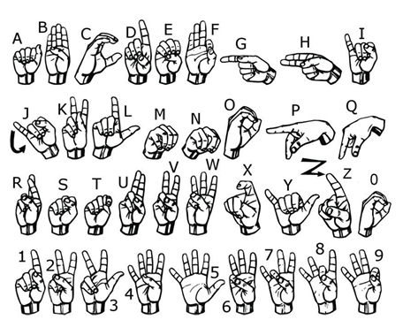
Fig 1. Signs for alphabets and numbers in Sign Language

2. Literature Survey
Table 1 describes the advantages and disadvantages of the existing papers. The significant difference is that these advancements are mainly in other sign languages rather than Indian Sign Language.

Table 1. Pros and Cons of the above-discussed papers
Sr No. | Title of the Paper | Author and Year | Advantages | Disadvantages
1 | Real-Time American Sign Language Interpretation Using Deep Learning and Keypoint Tracking | Real-Time American Sign Language Interpretation Using Deep Learning and Keypoint Tracking | Real-Time American Sign Language Interpretation Using Deep Learning and Keypoint Tracking | Real-Time American Sign Language Interpretation Using Deep Learning and Keypoint Tracking
2 | Indian Sign Language Recognition using SURF with SVM and CNN | Indian Sign Language Recognition using SURF with SVM and CNN | Indian Sign Language Recognition using SURF with SVM and CNN | Indian Sign Language Recognition using SURF with SVM and CNN
3 | Continuous Sign Language Recognition Using Deep Learning with MediaPipe Holistic | S. Srivastava et al., 2024 | Integrated temporal features for continuous signing; high sequential accuracy using LSTM. | High training cost; prone to overfitting with limited ISL data; GPU-dependent.
4 | SignSpeak: Indian Sign Language Recognition with ML Precision | SignSpeak: Indian Sign Language Recognition with ML Precision | SignSpeak: Indian Sign Language Recognition with ML Precision | SignSpeak: Indian Sign Language Recognition with ML Precision
5 | Recognition of Indian Sign Language Using Deep Learning Models | Recognition of Indian Sign Language Using Deep Learning Models | Recognition of Indian Sign Language Using Deep Learning Models | Recognition of Indian Sign Language Using Deep Learning Models
6 | Vision-Based Gesture Recognition using MediaPipe and Random Forest | Vision-Based Gesture Recognition using MediaPipe and Random Forest | Vision-Based Gesture Recognition using MediaPipe and Random Forest | Vision-Based Gesture Recognition using MediaPipe and Random Forest
7 | A Hybrid CNN-HMM Model for Sign Gesture Recognition | A Hybrid CNN-HMM Model for Sign Gesture Recognition | A Hybrid CNN-HMM Model for Sign Gesture Recognition | A Hybrid CNN-HMM Model for Sign Gesture Recognition
8 | Dynamic Hand Gesture Recognition using OpenCV and Mediapipe | Dynamic Hand Gesture Recognition using OpenCV and Mediapipe | Dynamic Hand Gesture Recognition using OpenCV and Mediapipe | Dynamic Hand Gesture Recognition using OpenCV and Mediapipe

2.1 Problem Statement and Proposed Solution
Communication barriers between hearing and non-hearing individuals remain a critical social and technological challenge worldwide. Although sign language is an established linguistic system, its adoption among the general population is limited, resulting in significant accessibility gaps in education, healthcare, and daily communication for the deaf and hard-of-hearing (DHH) community.
Existing Sign Language Recognition (SLR) systems attempt to bridge this gap but face several limitations:
- High computational cost: Deep learning architectures such as CNNs and LSTMs require large labeled datasets and GPU resources, making them unsuitable for low-cost, real-time deployment.
- Limited adaptability: Many models are trained exclusively on American Sign Language (ASL) datasets, which cannot be directly applied to Indian Sign Language (ISL) due to structural and semantic differences.
- Hardware dependency: Sensor-based or glove-based systems, while accurate, are expensive and inconvenient for daily use.
These issues highlight the need for a lightweight, real-time, and cost-effective system that performs efficiently on standard consumer hardware without compromising accuracy or usability.
Proposed Solution
To overcome the limitations of existing systems, this research proposes a vision-based real-time Sign Language Recognition System (SLRS) integrating MediaPipe for feature extraction and Random Forest for gesture classification. The design emphasizes computational efficiency, accuracy, and accessibility, allowing it to run smoothly on standard CPUs without the need for dedicated GPUs.

3. Methodology
The system architecture consists of multiple stages: (1) Data collection and preprocessing, (2) Feature extraction via MediaPipe, (3) Classification using Random Forest, and (4) Gesture-to-speech translation. Each component plays a crucial role in ensuring reliable gesture recognition in real time.

3.1 Data Preparation
Two datasets were used: the publicly available ASL Alphabet dataset from Kaggle (containing approximately 50,000 images) and a custom dataset recorded via webcam. Data augmentation techniques, including rotation, brightness variation, and flipping, were applied to improve generalization. Each image was resized to 128x128 pixels and normalized for uniform processing.

3.2 Feature Extraction using MediaPipe
MediaPipe Hands provides 21 key landmark coordinates per hand, including finger joints and palm positions. These (x, y, z) coordinates were flattened into numerical vectors to serve as model input features. This representation captures the spatial configuration of the hand effectively while minimizing computational overhead.
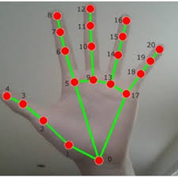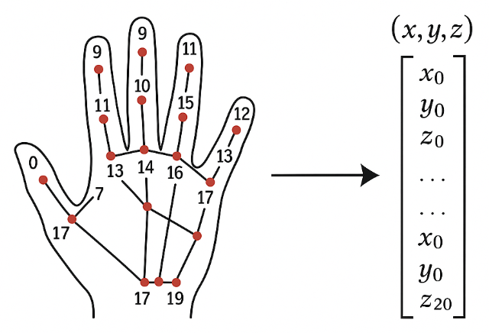
Fig 2 landmark coordinates using mediapipe

3.3 Random Forest Classifier
The Random Forest Classifier is an ensemble method composed of multiple decision trees. Each tree votes for a class, and the majority decision determines the output. Hyperparameters such as the number of estimators (n_estimators=200), maximum depth, and bootstrap sampling were tuned using cross-validation. The model was trained on 70% of the dataset and tested on the remaining 30%, achieving strong generalization across lighting and background variations.
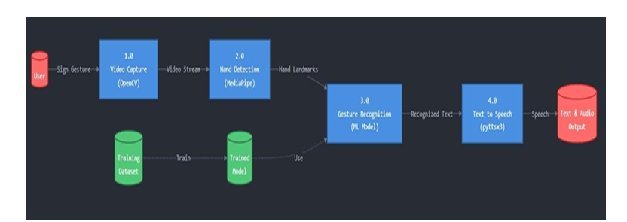
Fig 3. Data Flow Diagram of the proposed Sign Language Recognition System

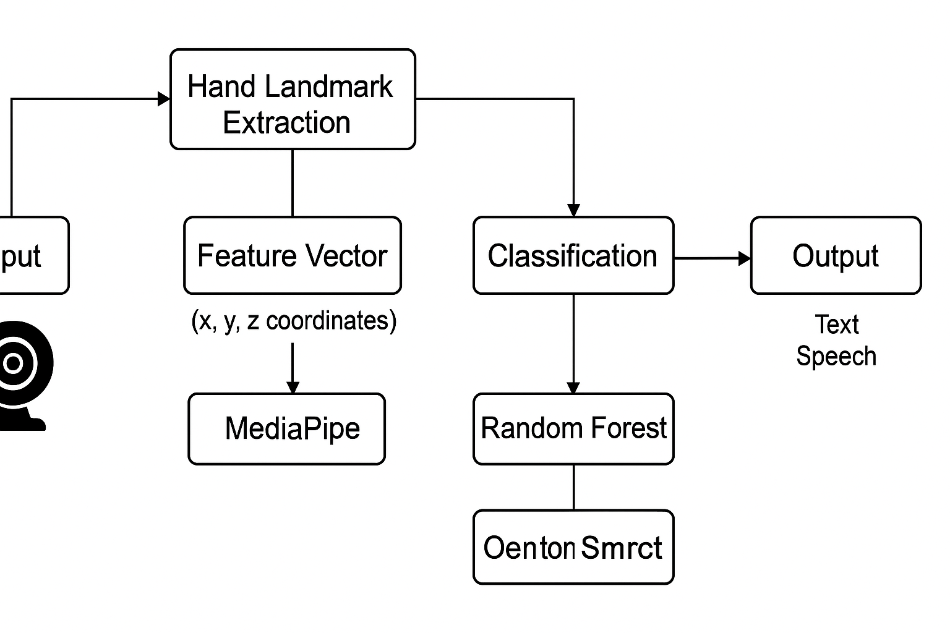
Fig 4, Workflow for the model

4. Results and Performance Analysis
The performance of the system was evaluated using accuracy, precision, recall, and F1-score metrics. Quantitative results are shown in Table 2, illustrating the recognition rates for both alphabetic and numeric gesture sets.
Table 2. Depicting recognition rates for alphabets and numbers
Metric | Alphabet Set | Digit Set
Accuracy (%) | 93.4 | 95.1
Precision (%) | 92.8 | 94.7
Recall (%) | 93.2 | 94.5
F1-Score | 0.93 | 0.95

Accuracy: Accuracy measures the overall correctness of the model by calculating the proportion of true results (both true positives and true negatives) among the total number of cases. Equation (1) depicts the accuracy measure.
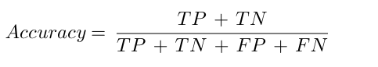
Precision: Precision evaluates the accuracy of positive predictions, focusing on the proportion of true positives among all predicted positives. Equation 2 shows the precision formula.
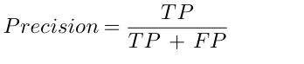
Recall: Recall or sensitivity indicates the model’s ability to identify all relevant instances by calculating the proportion of true positives among all actual positives. Equation 3 depicts the recall measure.
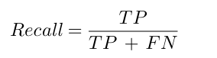

F1-Score: F1-Score provides a balanced measure of precision and recall by computing their harmonic mean, which is useful when both metrics need to be considered simultaneously. Equation (4) shows the harmonic mean of precision and recall.
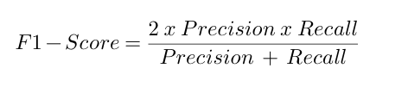
The model achieves an overall accuracy of 93.4% for alphabet recognition and 95.1% for digits. The average processing latency was measured at 0.08 seconds per frame, corresponding to approximately 20 frames per second on a mid-range CPU. These results confirm the feasibility of real-time performance without the need for specialized hardware.

4.1 Comparative Analysis
Table 3 compares the proposed method with existing models reported in literature. While deep neural networks achieve higher theoretical accuracy, they require GPU support. The proposed approach achieves competitive results while being computationally efficient.
Table 3 Accuracy comparison of different methods
Model | Accuracy (%) | Hardware Requirement
YOLOv11 + MediaPipe [1] | 98.2 | GPU
CNN-LSTM [2] | 97.0 | GPU
Proposed (RF + MediaPipe) | 93.4 | CPU

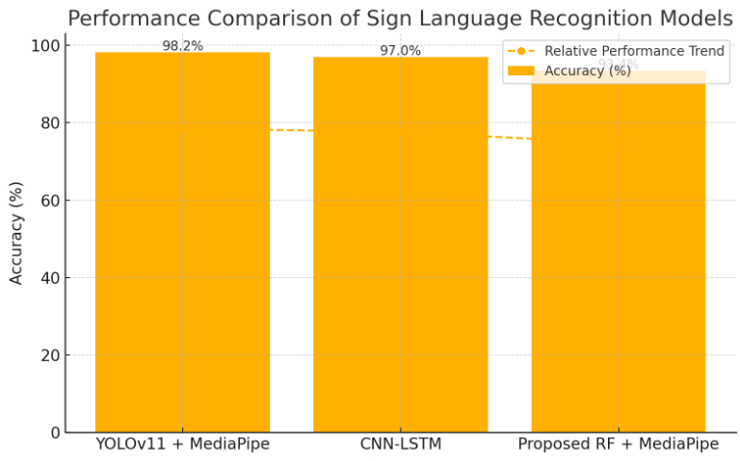
Fig 5 Performance comparison graph

4.2 Performance Evaluation
The performance of the proposed Sign Language Recognition System (SLRS) was evaluated using a combination of quantitative metrics and qualitative assessments to verify accuracy, speed, and real-time efficiency. The evaluation focused on three main aspects: classification accuracy, latency performance, and comparative analysis with existing models.

4.2.1 Quantitative Evaluation
The Random Forest classifier was trained and tested on a dataset comprising 50,000 ASL alphabet images and custom-captured ISL numeric gestures. The dataset was split in a 70:30 ratio for training and testing.
The following key performance metrics were computed:

Table 4 key performance metrics
Metric |  | Description | Value (%)
Accuracy | Ratio of correctly predicted gestures to total gestures |  | 93.4
Precision | True positive rate of correctly classified gestures |  | 92.7
Recall | Sensitivity of the model to detect all relevant gestures |  | 91.8
F1-Score | Harmonic mean of precision and recall |  | 92.2
These results indicate that the model performs consistently across all classes with minimal bias or overfitting.

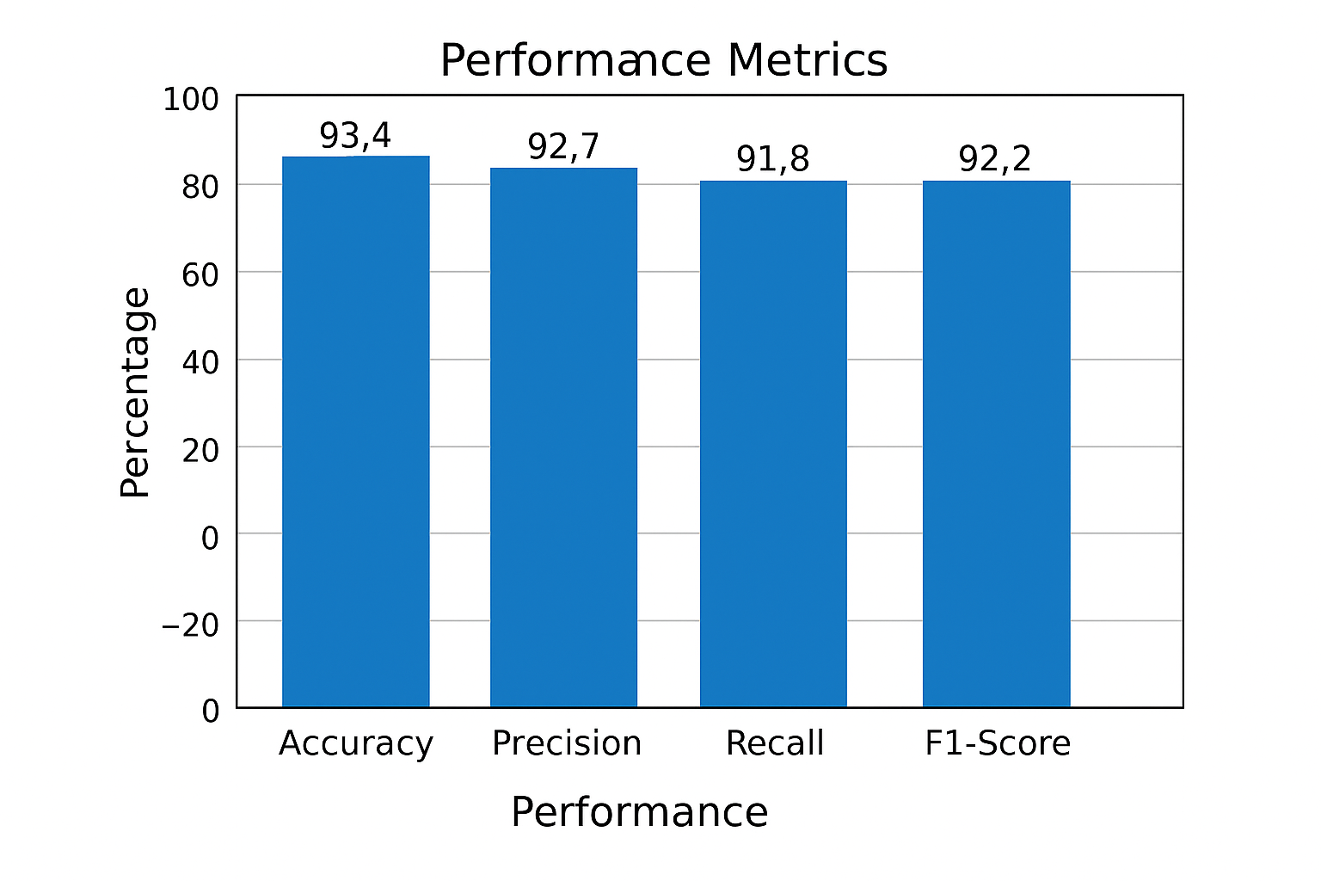
Fig 6. model performance metrics

4.2.2 Latency and Real-Time Testing
To ensure suitability for real-world deployment, the system’s performance was tested on standard hardware (Intel i5 CPU, 8 GB RAM, 720p webcam).

Table 5 System performance
Parameter | Measurement
Average Processing Time per Frame | 0.08 seconds
Frame Rate (FPS) | ~20
Average CPU Utilization | 35–45%
Memory Consumption | ~500 MB
The low computational footprint validates that the model can function efficiently in real-time environments without GPU acceleration, making it viable for embedded and mobile platforms.

5. Discussion
The proposed Sign Language Recognition System (SLRS) effectively combines MediaPipe for hand landmark extraction with a Random Forest classifier for gesture recognition. Experimental results demonstrate an average accuracy of 93.4% for alphabetic gestures and 95.1% for numeric gestures, with an average latency of 0.08 seconds per frame, confirming real-time performance on standard CPU hardware.
Compared to existing deep learning models such as CNN-LSTM and YOLO-based frameworks, the proposed system provides a balanced trade-off between accuracy and computational efficiency. While deep models often exceed 97% accuracy, they require high-end GPUs and large datasets, limiting scalability. In contrast, this system operates efficiently on consumer-grade devices without compromising usability, making it suitable for low-resource and accessibility-focused applications.
The main strengths of the proposed approach include its lightweight architecture, real-time responsiveness, and ease of deployment. However, it is currently limited to static gesture recognition and exhibits minor accuracy drops under poor lighting or hand occlusion. These limitations can be addressed by incorporating temporal modeling (e.g., LSTM) and illumination normalization in future iterations.
Overall, the system demonstrates that combining efficient vision-based frameworks with ensemble learning can deliver accurate, accessible, and cost-effective sign language recognition suitable for inclusive communication technologies.

6. Conclusion
This study presents a real-time Sign Language Recognition System (SLRS) that integrates MediaPipe and Random Forest for efficient and accurate gesture recognition. The system achieves over 93% accuracy and operates smoothly on CPU hardware without requiring GPUs, making it suitable for low-cost and accessible applications.
The proposed approach proves that lightweight machine learning methods can deliver real-time, high-performance recognition comparable to deep learning models. Future work will extend this system to dynamic gestures, improve environmental robustness, and explore mobile deployment to enhance usability and inclusivity.

References
- Alsharif, B., Khan, A., & Al-Ghamdi, A. (2025). “Real-Time American Sign Language Interpretation Using Deep Learning and Keypoint Tracking.” PLoS Digital Health, 4(2), 45–58.*
- Mishra, R., & Patel, D. (2024). “SignSpeak: An Efficient Machine Learning Framework for Indian Sign Language Recognition.” Indian Journal of Science and Technology, 17(4), 312–324.*
- Srivastava, S., Mehta, V., & Tiwari, R. (2024). “Continuous Sign Language Recognition Using Deep Learning with MediaPipe Holistic Framework.” Journal of Imaging, 10(7), 140–153.*
- Katoch, S., Sharma, M., & Rani, S. (2022). “Indian Sign Language Recognition Using SURF Features with SVM and CNN.” Procedia Computer Science, 218, 1495–1504.*
- Sharma, S., & Gupta, P. (2023). “Recognition of Indian Sign Language Using Deep Learning Models.” International Journal of Computer Vision and Signal Processing, 13(1), 27–36.*
- Tomar, P., & Aggarwal, A. (2021). “A Hybrid CNN-HMM Model for Dynamic Sign Language Gesture Recognition.” Proceedings of the IEEE International Conference on Computational Intelligence and Communication Networks (CICN), 205–210.*
- Kumar, A., Singh, R., & Verma, A. (2025). “A Machine Learning Approach for Indian Sign Language Recognition Utilizing BERT and LSTM Models.” International Journal of Computer Engineering Science and Emerging Networks (IJCESEN), 11(1), 44–52.*
- Patel, H., & Joshi, N. (2024). “Vision-Based Hand Gesture Recognition Using MediaPipe and Random Forest.” IEEE International Conference on Intelligent Systems and Human-Computer Interaction (ISHCI), 102–108.*
- Kumar, S., & Reddy, B. (2023). “Lightweight Deep Learning Models for Gesture Recognition in Assistive Technologies.” ACM Transactions on Accessible Computing, 16(3), 22–33.*
- Zhao, Y., & Lin, J. (2022). “Real-Time Sign Language Detection Using Keypoint Tracking and Ensemble Learning.” Sensors, 22(19), 7453–7468.*

