Prateek Gupta

gupta198@purdue.edu

ECE 661 Homework 6

**Theory Question**

Lecture 14 will present two very famous algorithms for image segmentation: The Otsu Algorithm and the Watershed Algorithm. These algorithms are as different as night and day. Present in your own words the strengths and the weaknesses of each. (Note that the Watershed algorithm uses the morphological operators that we will discuss in Lecture 13.)

Lorem ipsum dolor sit amet, consectetur adipiscing elit. Curabitur sodales magna eget nulla efficitur vulputate. Nulla ultricies justo tempor, tempor lorem vitae, maximus nulla. Donec iaculis dui gravida, accumsan augue vel, condimentum eros. Donec fermentum leo sit amet ex semper euismod. Curabitur scelerisque pulvinar sollicitudin. Fusce erat purus, tempus sed ipsum ac, interdum tincidunt ligula. In hac habitasse platea dictumst. Pellentesque tempor lacus ut ultrices ultricies. Curabitur iaculis nunc quis mollis accumsan. In arcu orci, laoreet a euismod id, porta ut magna. Orci varius natoque penatibus et magnis dis parturient montes, nascetur ridiculus mus. Suspendisse viverra leo nec quam semper, eu finibus justo venenatis. Orci varius natoque penatibus et magnis dis parturient montes, nascetur ridiculus mus. Cras ac leo felis. Curabitur ut nunc ut orci condimentum blandit in id nulla. Nulla vel erat dolor.

**Overview**

In this assignment, we will attempt to separate the foreground of an image from the background. This will be accomplished by separating each image into its red, green, and blue channels. Then, we will use the OTSU algorithm, and recombine the images on completion. There are two techniques for this. Each one will be discussed and implemented. Then, once the images have been segmented, we can extract the contours of the image and develop a contour map.

**Otsu’s Algorithm**

Otsu’s algorithm finds the threshold of gray values for distinguishing the foreground from the background. Of course, this assumes that there is indeed such a threshold that will allow us to make the discrimination. It does this by looking at the bimodal distribution of gray levels in a binary image and finds the threshold that maximizes the variance between the two classes. So, we need find the weighted sum of the variances within the two classes. This is done with the following equation

Here, the weights applied to each variance are computed by totaling the probabilities of a particular threshold t.

Since our goal is to maximize the variance between classes, we need to obtain an equation that represents the variance between classes. That is given below

Here, μ0, μ1, μT, are the mean values of class 0, class 1, and the overall data, respectively. The threshold is computed for each gray value, between 0 and 255, and the maximum threshold is kept.

**RGB Segmentation**

RGB segmentation utilizes the Otsu method. First, as the name implies, we separate an image into its red, green, and blue channels. Then we can utilize Otsu to find the threshold between the foreground and background and develop a mask for the channel. Then all three masks are combined using the logical AND operator. This may not yield the best result, so we can play with how many times we run Otsu for each channel.

**Texture Based Segmentation**

In texture-based segmentation, we calculate the variance of the image pixels using a sliding window of dimension N x N pixels. Here N is chosen to be 3, 5, or 7. We then apply the Otsu method to create a mask for each of the three window sizes, and then merge the three using the logical AND.

**Noise Removal**

Whether using RGB segmentation, or texture-based segmentation, there will likely be noise. This can be removed by applying a dilation and erosion several times. The amount of times varies, so we will do this as often as necessary, until there is minimal noise.

**Contour Extraction**

Once the images have been successfully segmented, whether through RGB texture based, and the noise removed, the contour can be extracted. We will perform a raster scan on the image, and if we find a foreground pixel whose 8-neighbors are not foreground pixels as well, we have found a border pixel, and this can be marked.

**Results**



Original Image 1

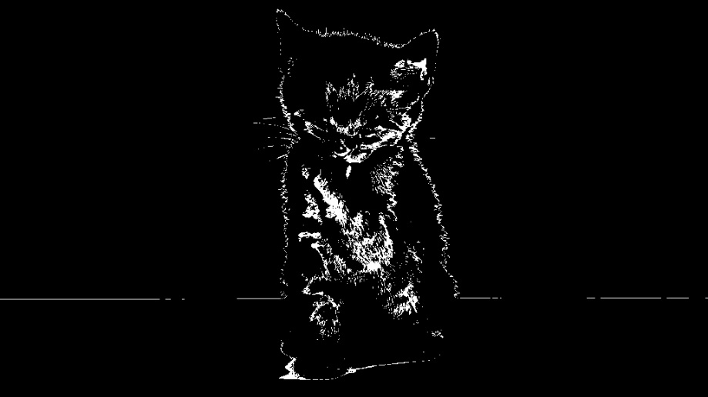

RGB Segmentation

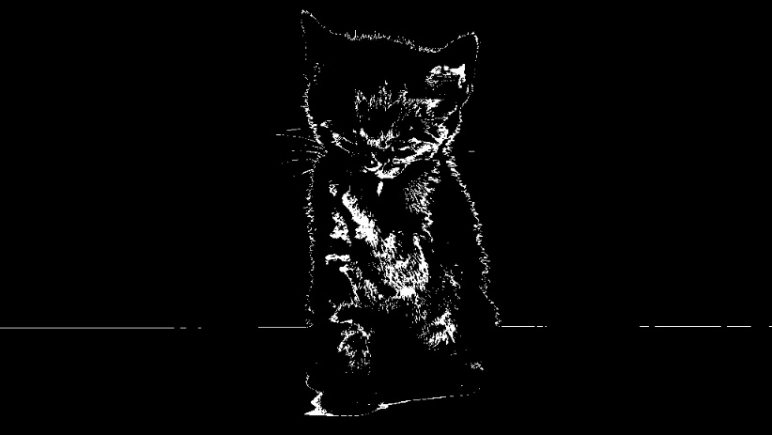

Texture Segmentation

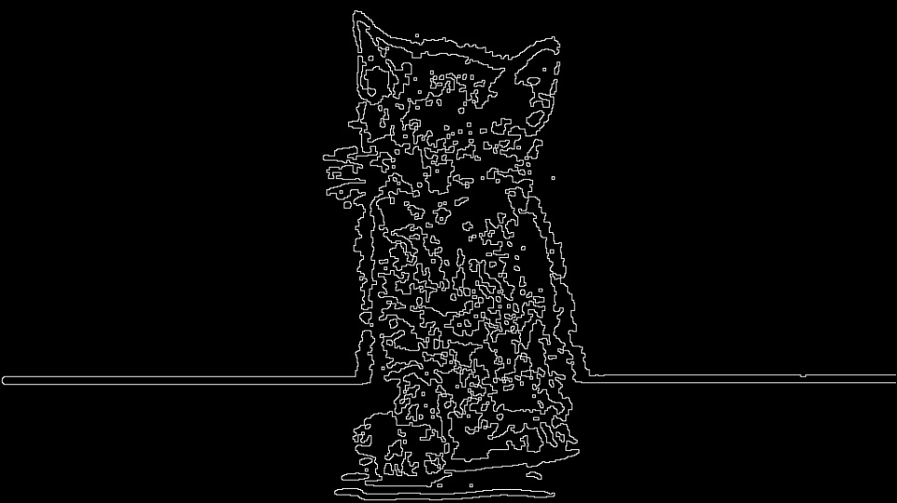

Contour

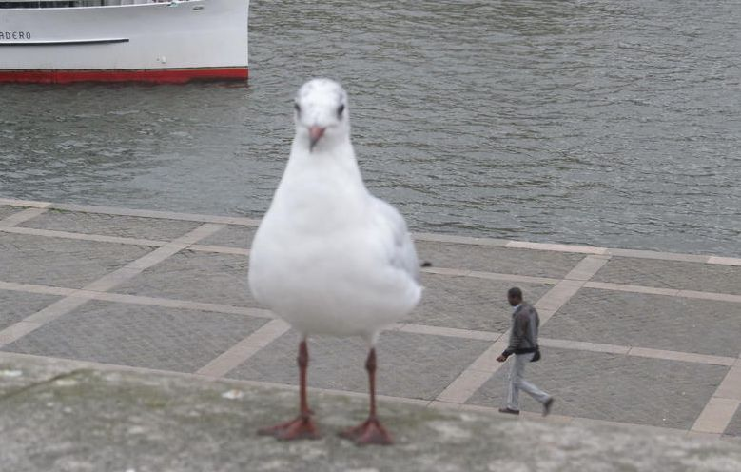

Original Image 2

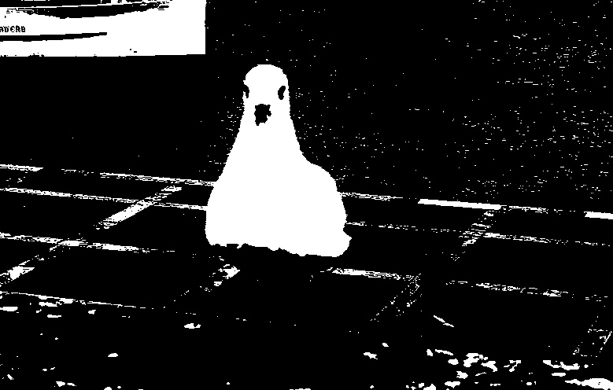

RGB Segmentation

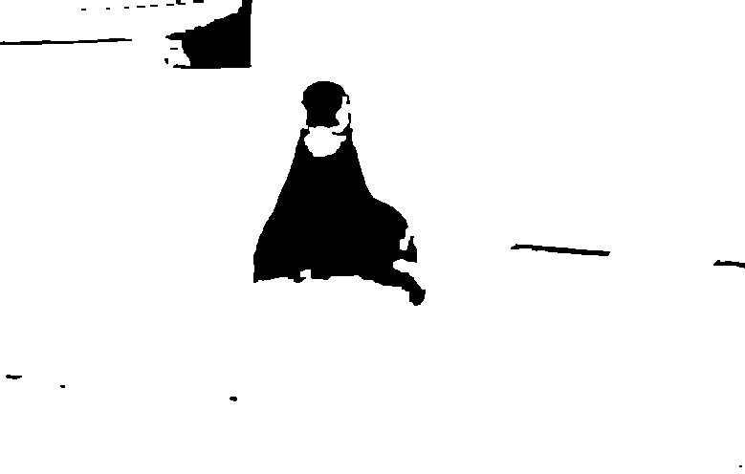

Texture Segmentation

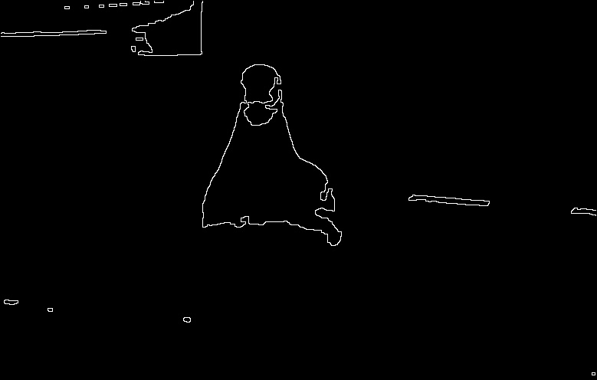

Contour

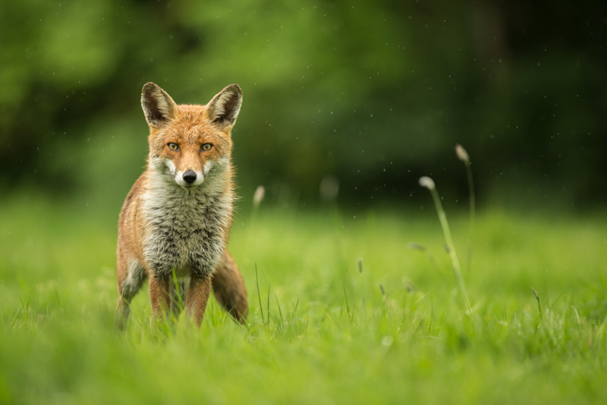

Original Image 3

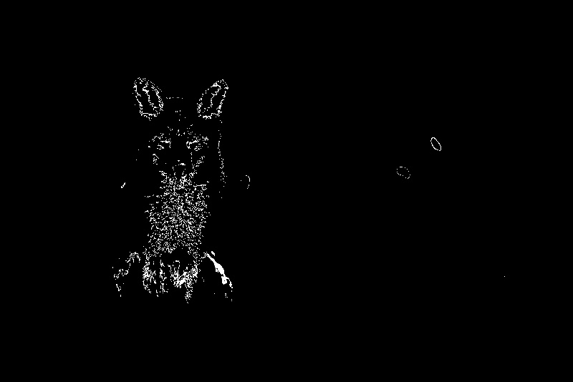

RGB Segmentation

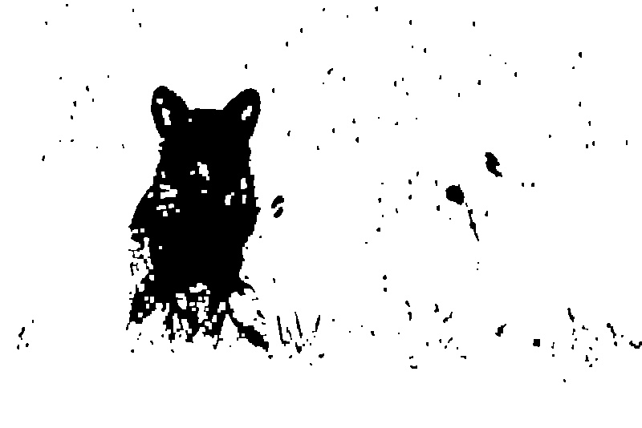

Texture Segmentation

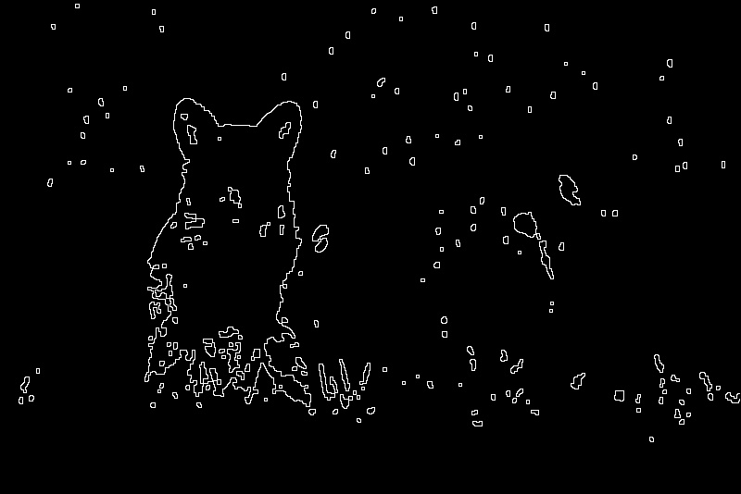

Contour