PHONEBOOK APPLICATION
ProJECT Design Specification
Version 1.0
20/02/2022

VERSION HISTORY

Version  # | Implemented  By | Revision  Date | Approved  By | Approval  Date | Reason
1.0 | Sanchi Gupta | 19/02/2022 | Milian Sir | 20/02/2022 | Initial Design Definition draft

TABLE OF CONTENTS
1 Introduction 5
1.1 Purpose of The Product Design Specification Document 5
2 General Overview and Design Guidelines/Approach 5
2.1 Assumptions / Constraints / Standards 5
3 Architecture Design 5
3.1 Logical View 5
3.2 Software Architecture 5
3.3 Security Architecture 5
4 System Design 6
4.1 Database Design 6
4.2 User Interface Design 6
Appendix A: References 8

Introduction

Purpose of The PROJECT
The main purpose of our Phonebook project is to manage all the information about contacts. It keeps all the contacts saved in the list, personal as well as business related.

General Overview and Design Guidelines/Approach
It is a simple tool that helps to make record of contacts. It can add a new contact, display all contacts, update a existing one, searching contacts and delete contact from the file. It also has settings option from which we can put contacts in favorites, grouping the same category contacts, sorting by and merging duplicate contacts. Moreover, a person can login in application as admin or as a user.

Assumptions / Constraints / Standards
- User should know how to use keyboard because user has to give input through keyboard.
- Application will work on windows operating system only.

Architecture Design

Logical View

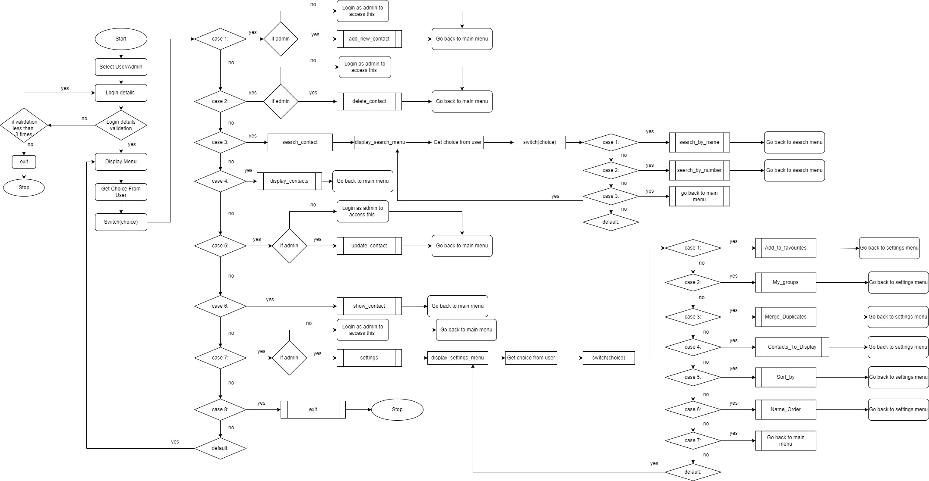

Software Architecture

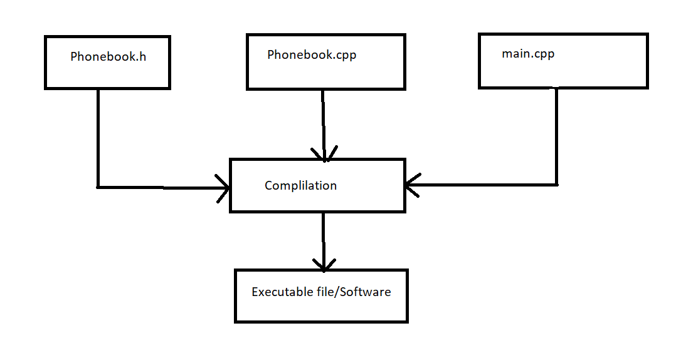

Security Architecture

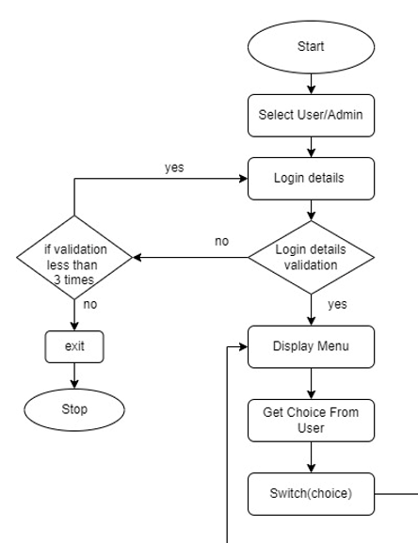

System Design

Database Design
We will use file as our database like we will open file and performs all operations on contacts and at last save all contacts in file and close it.

User Interface Design

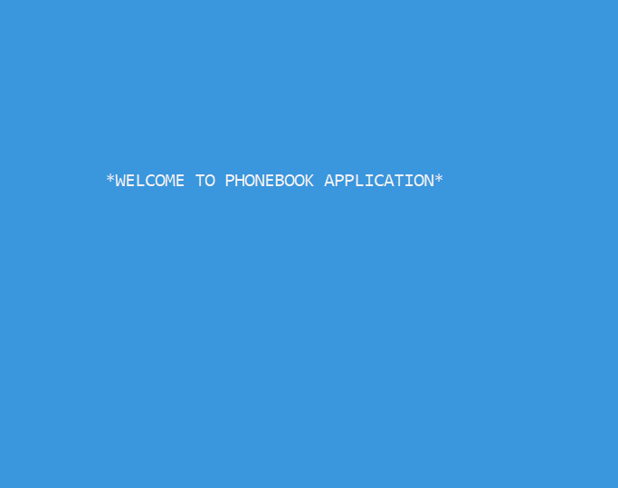



Appendix A: References

The following table summarizes the documents referenced in this document.
Document Name and Version | Description | Location
Phonebook Application. | Implementation of phonebook using linked list and file handling operations using C++. | https://www.youtube.com/watch?v=79ddBTXcPrA

