PIZZA SALES SQL QUERIES
A. KPI’s
1. Total Revenue: The sum of the total price of all pizza orders

SELECT SUM(total_price) AS Total_Revenue FROM TBL_PIZZA_SALES_DATA;

Output
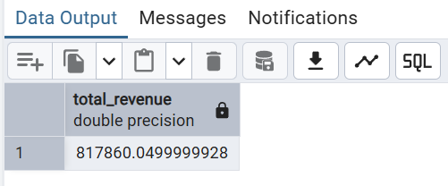

2. Average Order Value: The average amount spent per order, calculating by dividing the total revenue by the total number of orders

SELECT (SUM(total_price) / COUNT(DISTINCT order_id)) AS Average_Order_Value FROM TBL_PIZZA_SALES_DATA;

Output
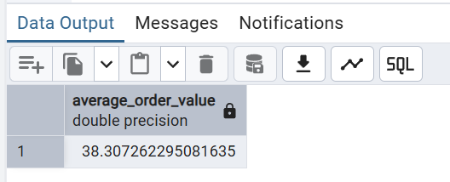

3. Total Pizzas Sold: The sum of the quantities of all pizza sold

SELECT SUM(quantity) AS Total_Pizza_Sold FROM TBL_PIZZA_SALES_DATA;

Output
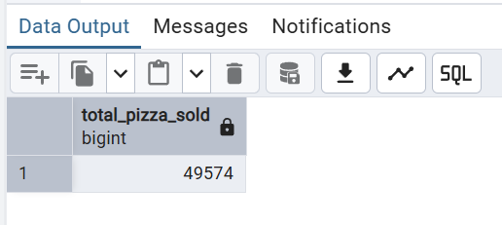

4. Total Orders: The total number of orders placed

SELECT COUNT(DISTINCT order_id) AS Total_Orders FROM TBL_PIZZA_SALES_DATA;

Output
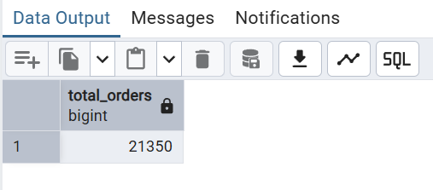

5. Average Pizzas Per Order: The average number of pizzas sold per order,calculating by dividing the total number of pizzas sold by the total number of orders.

SELECT (SUM(quantity) / COUNT(DISTINCT order_id)) AS Average_pizzas_per_order
FROM TBL_PIZZA_SALES_DATA;

Output
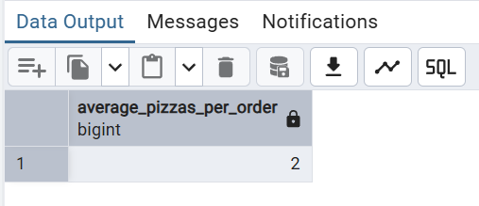

B. Daily Trend for Total Orders
SELECT TRIM(TO_CHAR(order_date,’Day’)) AS Day_Name,
COUNT(DISTINCT order_id) AS Total_Orders
FROM TBL_PIZZA_SALES_DATA
GROUP BY Day_Name,EXTRACT(DOW FROM order_date)
ORDER BY EXTRACT(DOW FROM order_date);

Output:
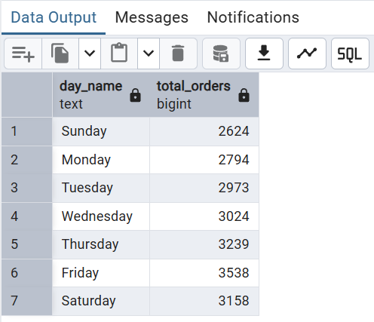

C. Monthly Trend for Orders
SELECT TRIM(TO_CHAR(order_date,’Month’)) AS Month_Name, COUNT(DISTINCT order_id) AS Total_Orders
FROM TBL_PIZZA_SALES_DATA
GROUP BY Month_Name,EXTRACT(MONTH FROM order_date)
ORDER BY EXTRACT(MONTH FROM order_date);

Output

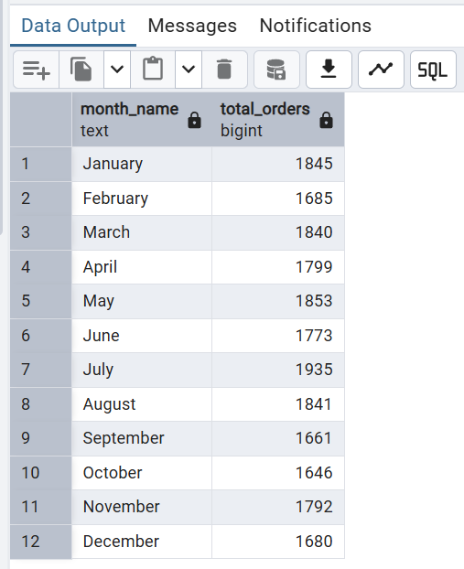

D. % of Sales by Pizza Category
SELECT pizza_category,
ROUND(SUM(total_price)::numeric,2) as Total_Revenue,
ROUND(((SUM(total_price)*100)/(SELECT SUM(total_price) FROM TBL_PIZZA_SALES_DATA))::numeric,2) || '%' AS Total_Sales
FROM TBL_PIZZA_SALES_DATA
GROUP BY pizza_category;
Output
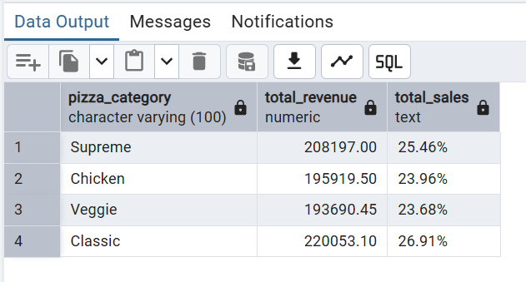
E. % of Sales by Pizza Size
SELECT pizza_size,
ROUND(SUM(total_price)::numeric,2) as Total_Revenue,
ROUND(((SUM(total_price)*100)/(SELECT SUM(total_price) FROM TBL_PIZZA_SALES_DATA))::numeric,2) || '%' AS Total_Sales
FROM TBL_PIZZA_SALES_DATA
GROUP BY pizza_size;
Output
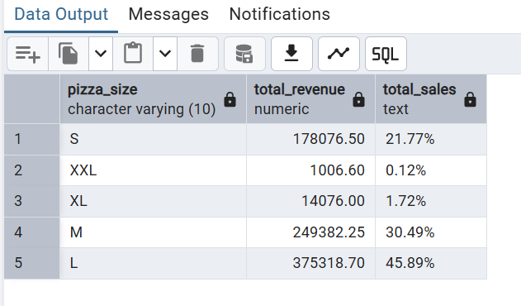

F. Total Pizzas Sold by Pizza Category
SELECT pizza_category, SUM(quantity) as Pizza_Sold
FROM TBL_PIZZA_SALES_DATA
GROUP BY pizza_category
ORDER BY Pizza_Sold DESC
Output
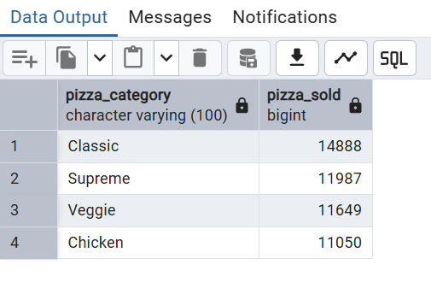

G. Top 5 Pizzas by Revenue
SELECT pizza_name, SUM(total_price) AS Total_Sales
FROM TBL_PIZZA_SALES_DATA
GROUP BY pizza_name
ORDER BY Total_Sales DESC
LIMIT 5;

Output
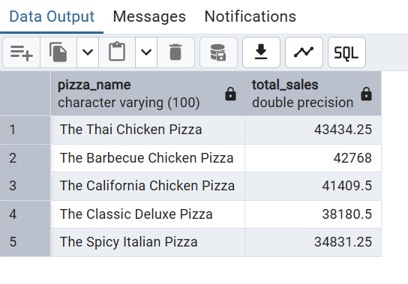

H. Bottom 5 Pizzas by Revenue
SELECT pizza_name, SUM(total_price) AS Total_Sales
FROM TBL_PIZZA_SALES_DATA
GROUP BY pizza_name
ORDER BY Total_Sales
LIMIT 5;
Output
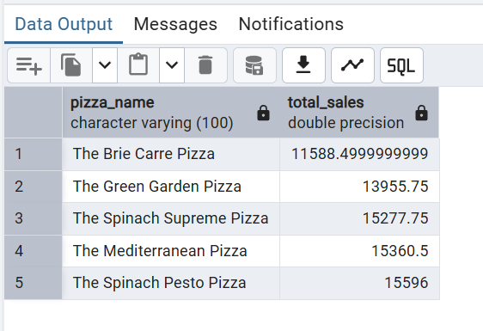
I. Top 5 Pizzas by Quantity
SELECT pizza_name, SUM(quantity) AS Pizza_Sold
FROM TBL_PIZZA_SALES_DATA
GROUP BY pizza_name
ORDER BY Pizza_Sold DESC
LIMIT 5

Output
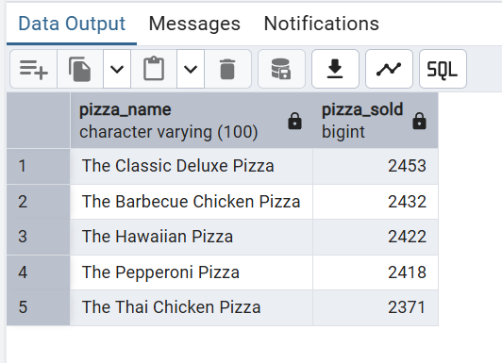
J. Bottom 5 Pizzas by Quantity
SELECT pizza_name, SUM(quantity) AS Pizza_Sold
FROM TBL_PIZZA_SALES_DATA
GROUP BY pizza_name
ORDER BY Pizza_Sold
LIMIT 5

Output
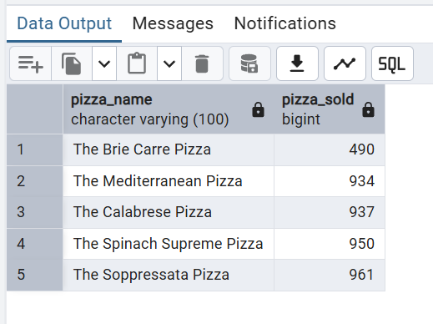
K. Top 5 Pizzas by Total Orders
SELECT pizza_name, COUNT(DISTINCT order_id) AS Total_Orders
FROM TBL_PIZZA_SALES_DATA
GROUP BY pizza_name
ORDER BY Total_Orders DESC
LIMIT 5;

Output
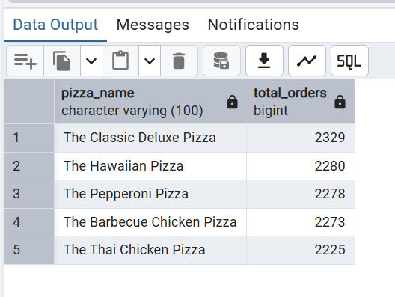
L. Bottom 5 Pizzas by Total Orders
SELECT pizza_name, COUNT(DISTINCT order_id) AS Total_Orders
FROM TBL_PIZZA_SALES_DATA
GROUP BY pizza_name
ORDER BY Total_Orders
LIMIT 5;

Output
