CS-303L

PROJECT ON

Downloads Log Analyser

SUBMITTED TO

Mr. saket saurav

**Submitted by:**

Abhinav gupta(2011001)

Rishabh gupta(2011127)

SHIVAM SHARMA(2011224)

INTRODUCTION:

The download log analyser helps the server administrator to monitor the download done by the different users within the institute operating on the institute’s server. It is a console based application which is interacts with the user with the help of menu driven list to perform the various functionalities.

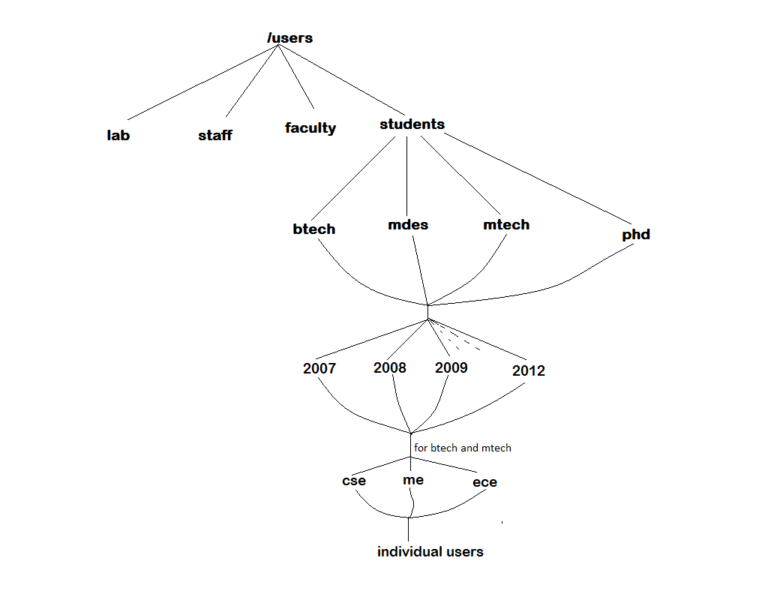

narmada/nis directory structure

FUNTIONALITIES:

The log analyser helps the server the administrator analyse the different types of downloads done by all types of users in narmada/nis server and take necessary actions in their user directory.

* It is basically a *utility tool* which can *delete* the unnecessary items like video files and files greater than the certain size limit of the server to enhance the performance of the server.
* The administrator can view the different files downloaded by any user with its size modification date.

FLOW OF ACTIONS:

1. Ask the administrator to enter into a particular directory like faculty, lab, staff & student.

2. Perform action on faculty, lab & staff such as

(i) Categorized downloads by type (movies, music, documents, etc.)

(ii) List the download with date of last modification.

(iii) Delete the files greater than size provided by administrator.

3. Perform action on student directories especially on individuals, whole group, particular batch or a particular branch.

(i) Total space taken by a group, batch or branch.

(ii) Delete the files greater than size provided by administrator.

4.Perform action on known ID/Roll No of any student ,staff ,faculty or lab instructor and directory structure is fetched from passwd.txt.

(i) Categorized downloads by type (movies, music, documents etc.)

(ii) List the download with date of last modification.

(iii) Delete the files greater than size provided by administrator.

5. All deleted downloads are stored in delete.log with structure

ID/Roll No: File Name: Size Of file:Time of delete

REFERENCES:

* [www.grymoire.com](http://www.grymoire.com)
* [www.unix.stackexchange.com](http://www.unix.stackexchange.com)
* web.eecs.utk.edu
* [www.unix.com](http://www.unix.com)
* [www.thegeekstuff.com](http://www.thegeekstuff.com)
* [www.cybercity.biz](http://www.cybercity.biz)
* [www.shell-tips.com](http://www.shell-tips.com)
* [www.linuxjournal.com](http://www.linuxjournal.com)
* [www.tldp.org](http://www.tldp.org)
* [www.examiner.com](http://www.examiner.com)
* [www.shortrecipes.blogspot.in](http://www.shortrecipes.blogspot.in)
* [www.silviogutierrez.com](http://www.silviogutierrez.com)