**CONTENTS**

1. APP INTRODUCTION

1.1 QUICK VIEW

2. SOFTWARE REQUIREMENT

3. DATA FLOW DIAGRAM

4. LANGUAGES USED

4.1 HTML

4.2 CSS

4.3 JAVA SCRIPT

4.3.1 J-QUERY

5. WORKING

6. SOME FEATURES

7. DEBUGGING PROCESS

8. CODE

9. REFERENCE

1. APP INTRODUCTION

**Carpooling** (also **car-sharing**, **ride-sharing**, **lift-sharing** and **covoiturage**), is the sharing of car journeys so that more than one person travels in a car.

By having more people using one vehicle, carpooling reduces each person's travel costs such as fuel costs, tolls, and the stress of driving. Carpooling is also a more environmentally friendly and sustainable way to travel as sharing journeys reduces carbon emissions, traffic congestion on the roads, and the need for parking spaces. Authorities often encourage carpooling, especially during periods of high pollution or high fuel prices.

In 2009, carpooling represented 43.5% of all trips in the United States and 10% of commute trips. The majority of carpool commutes (over 60%) are "fam-pools" with family members.

Carpool commuting is more popular for people who work in places with more jobs nearby, and who live in places with higher residential densities. Carpooling is significantly correlated with transport operating costs, including gas prices and commute length, and with measures of social capital, such as time spent with others, time spent eating and drinking, and being unmarried. However, carpooling is significantly less likely among people who spend more time at work, older workers, and homeowners.

# **1.1 QUICK VIEW**

In our project, there are two options in our front page i.e. **OFFER A RIDE** and **NEED A RIDE**. One can make an offer for a ride or raise a request need a car.

# **2.** **SOFTWARE REQUIREMENTS**

Install the following softwares to run the app successfully-

* Eclipse (Kepler).
* Java development kit (jdk).
* Software development kit (sdk).
* Accessory development kit (adk).
* IBM Mobile first environment.

**3. DATA FLOW DIAGRAM**

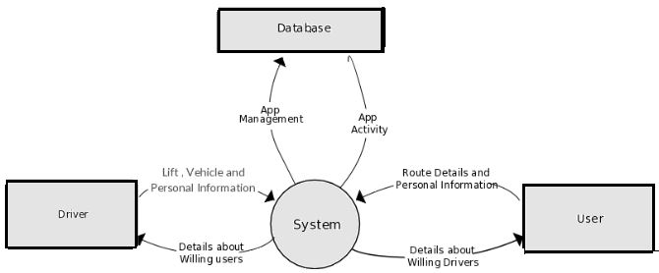

**4. LANGUAGES USED**

Following languages were used to build the application:

**4.1 HTML**

**Hypertext Markup Language** (HTML) is the standard markup language for creating web pages and web applications. With Cascading Style Sheets (CSS), and JavaScript, it forms a triad of cornerstone technologies for the World Wide Web. Web browsers receive HTML documents from a webserver or from local storage and render them into multimedia web pages. HTML describes the structure of a web page semantically and originally included cues for the appearance of the document.

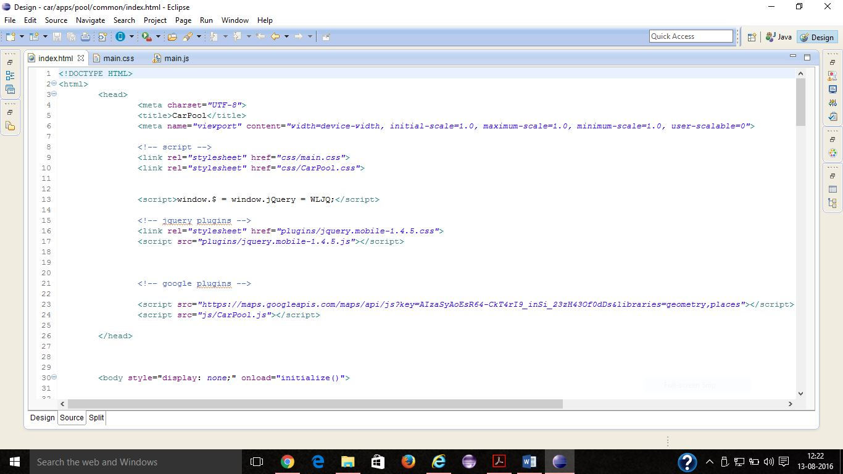

HTML elements are the building blocks of HTML pages. With HTML constructs, images and other objects, such as interactive forms may be embedded into the rendered page. It provides a means to create structured documents by denoting structural semantics for text such as headings, paragraphs, lists, links, quotes and other items. HTML elements are delineated by tags, written using angle brackets. Tags such as <img /> and <input /> introduce content into the page directly. Others such as <p>...</p> surround and provide information about document text and may include other tags as sub-elements. Browsers do not display the HTML tags, but use them to interpret the content of the page.

**4.2 CSS**

**Cascading Style Sheets** (CSS) is a style sheet language used for describing the presentation of a document written in a markup language. Although most often

used to set the visual style of web pages and user interfaces written in HTML and XHTML, the language can be applied to any XML document, including plain XML, SVG and XUL, and is applicable to rendering in speech, or on other media. Along with HTML and JavaScript, CSS is a cornerstone technology used by most websites to create visually engaging webpages, user interfaces for web applications, and user interfaces for many mobile applications.

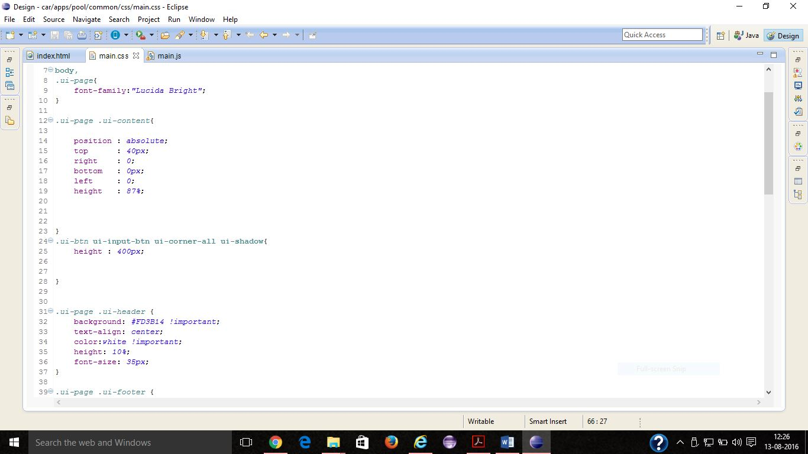

CSS is designed primarily to enable the separation of document content from document presentation, including aspects such as the layout, colors, and fonts. This separation can improve content accessibility, provide more flexibility and control in the specification of presentation characteristics, enable multiple HTML pages to share formatting by specifying the relevant CSS in a separate .css file, and reduce complexity and repetition in the structural content.

This separation of formatting and content makes it possible to present the same markup page in different styles for different rendering methods, such as on-screen, in print, by voice and on Braille-based, tactile devices. It can also be used to display the web page differently depending on the screen size or device on which it is being viewed. Readers can also specify a different style sheet.

# **4.3 JAVA SCRIPT**

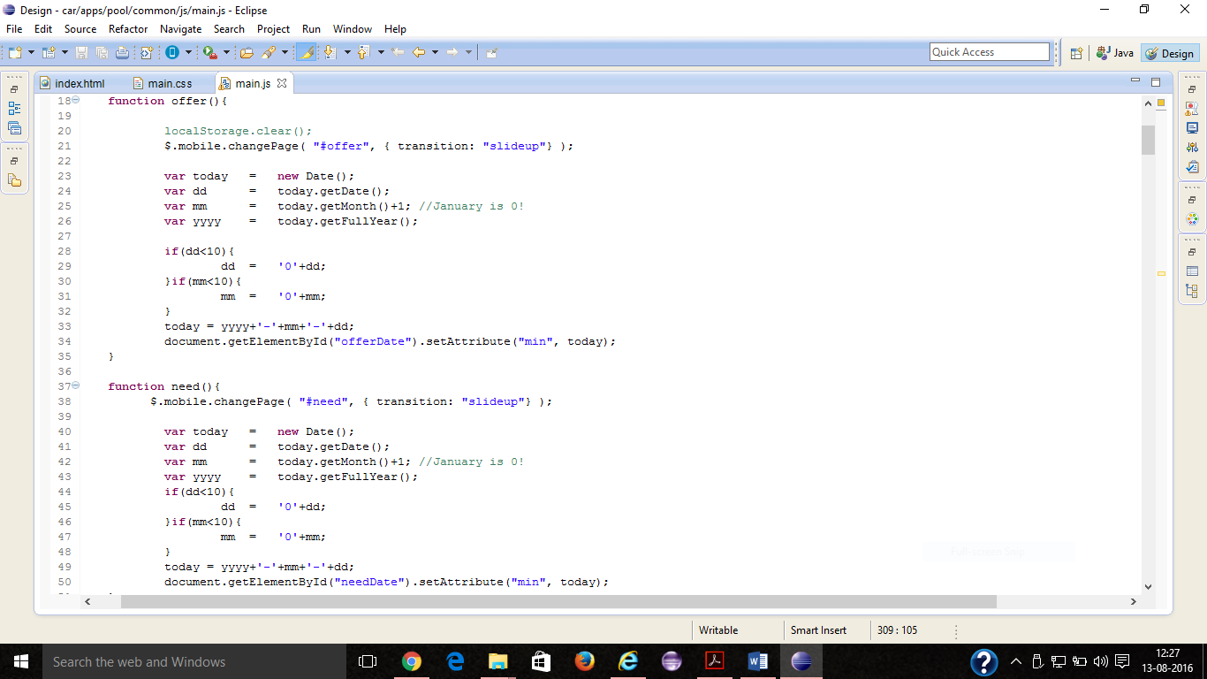

JavaScript is a high-level, dynamic, untyped, and interpreted programming language. It has been standardized in the ECMAScript language specification. Alongside HTML and CSS, it is one of the three core technologies of World Wide Web content production; the majority of websites employ it and it is supported by all modern Web browsers without plug-ins. JavaScript is prototype-based with first-class functions, making it a multi-paradigm language, supporting object-oriented, imperative, and functional programming styles. It has an API for working with text, arrays, dates and regular expressions, but does not include any I/O, such as networking, storage, or graphics facilities, relying for these upon the host environment in which it is embedded.

Although there are strong outward similarities between JavaScript and Java, including language name, syntax, and respective standard libraries, the two are distinct languages and differ greatly in their design. JavaScript was influenced by programming languages such as Self and Scheme.

JavaScript is also used in environments that are not Web-based, such as PDF documents, site-specific browsers, and desktop widgets. Newer and faster JavaScript virtual machines (VMs) and platforms built upon them have also increased the popularity of JavaScript for server-side Web applications. On the client side, JavaScript has been traditionally implemented as an interpreted language, but more recent browsers perform just-in-time compilation.

# **4.3.1 J-QUERY**

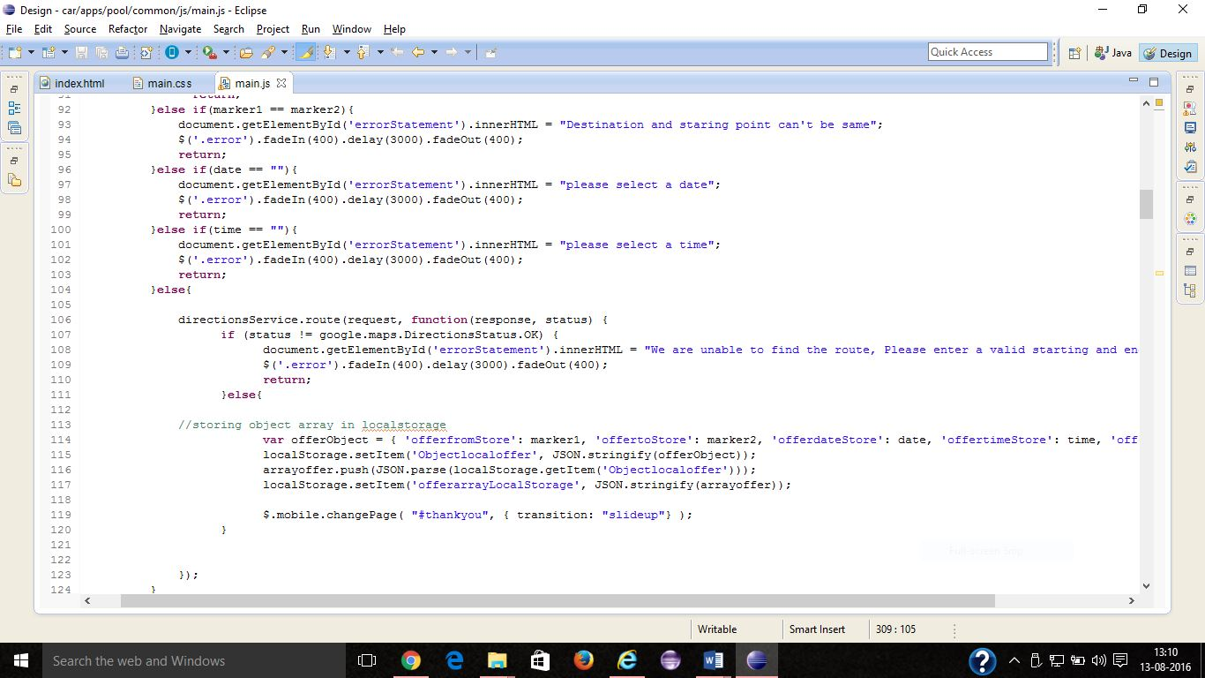

jQuery is a cross-platform **JavaScript library** designed to simplify the client-side scripting of HTML. jQuery is the most popular JavaScript library in use today, with installation on 65% of the top 10 million highest-trafficked sites on the Web. jQuery is free, open-source software licensed under the MIT License.

JQuery’s syntax is designed to make it easier to navigate a document, select DOM elements, create animations, handle events, and develop Ajax applications. JQuery also provides capabilities for developers to create plug-ins on top of the JavaScript library. This enables developers to create abstractions for low-level interaction and animation, advanced effects and high-level, theme able widgets.

**5. WORKING**

**🡪FRONT PAGE**

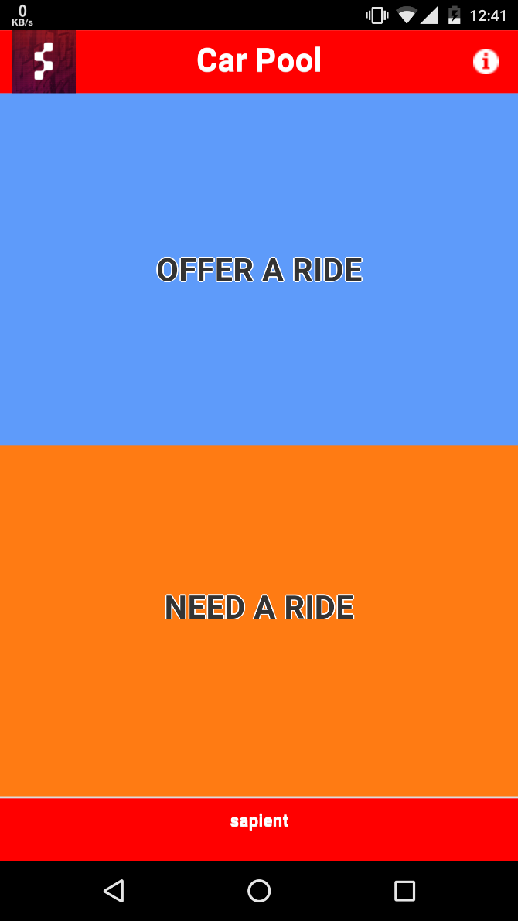 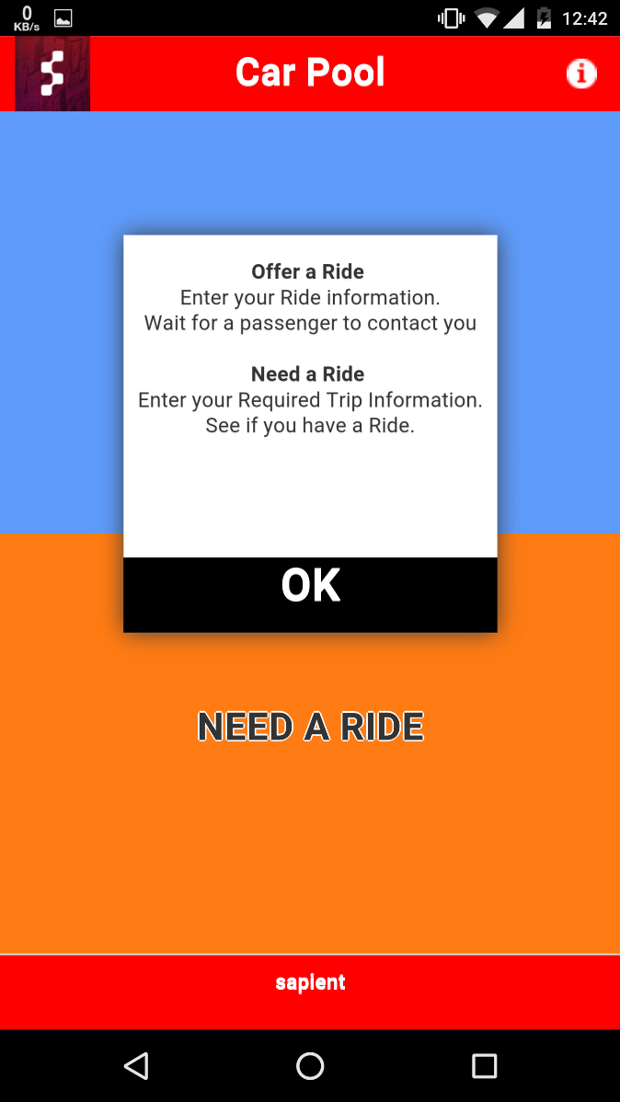

* AFTER TAPPING **“OFFER A RIDE”**

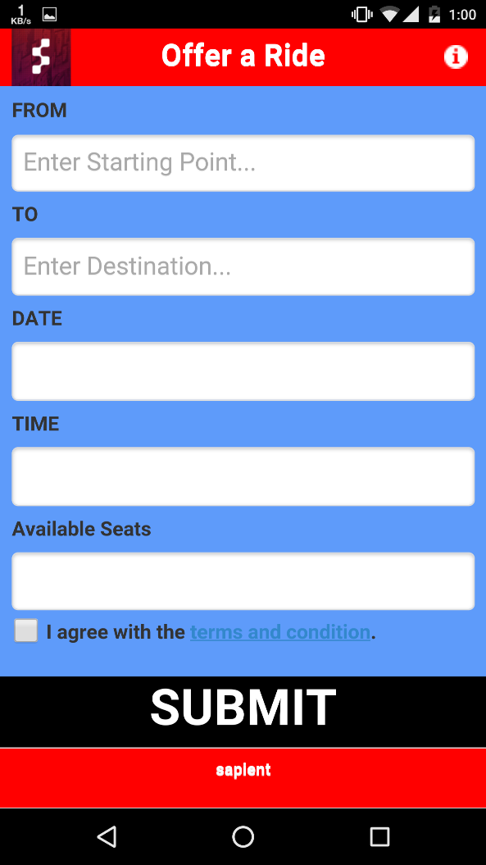

* AFTER TAPPING **“NEED A RIDE”**

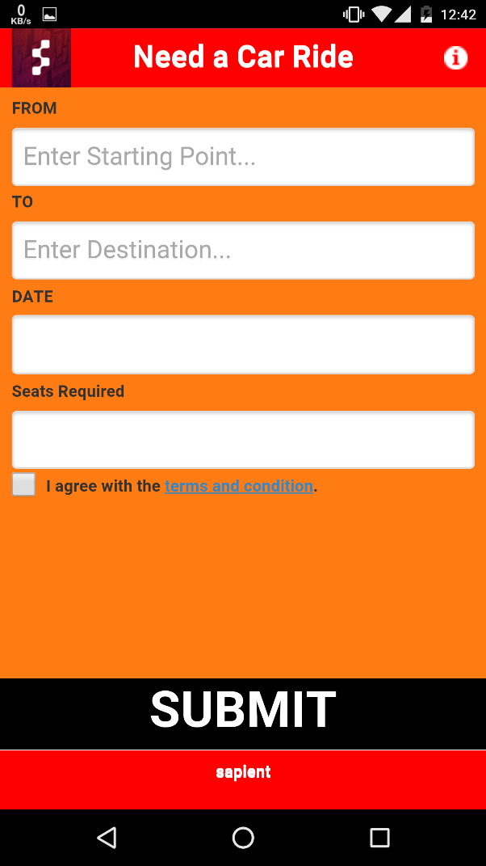

* **A ride can be offered as follows:**

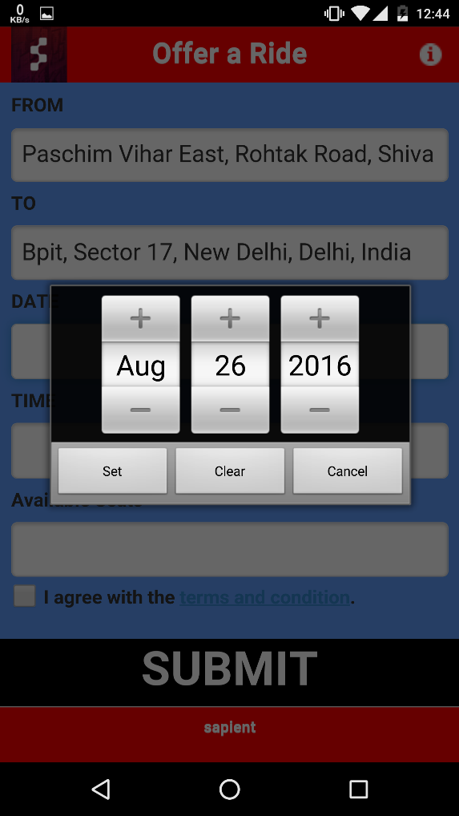 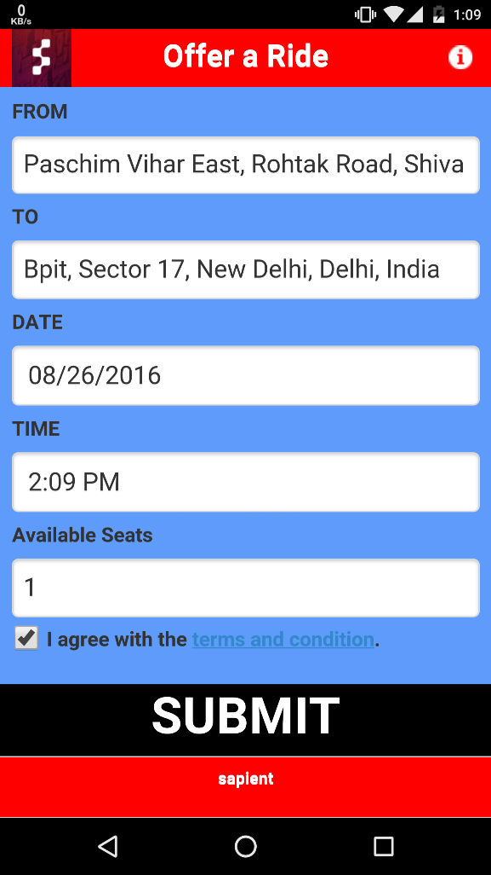

* **here a car ride is required**

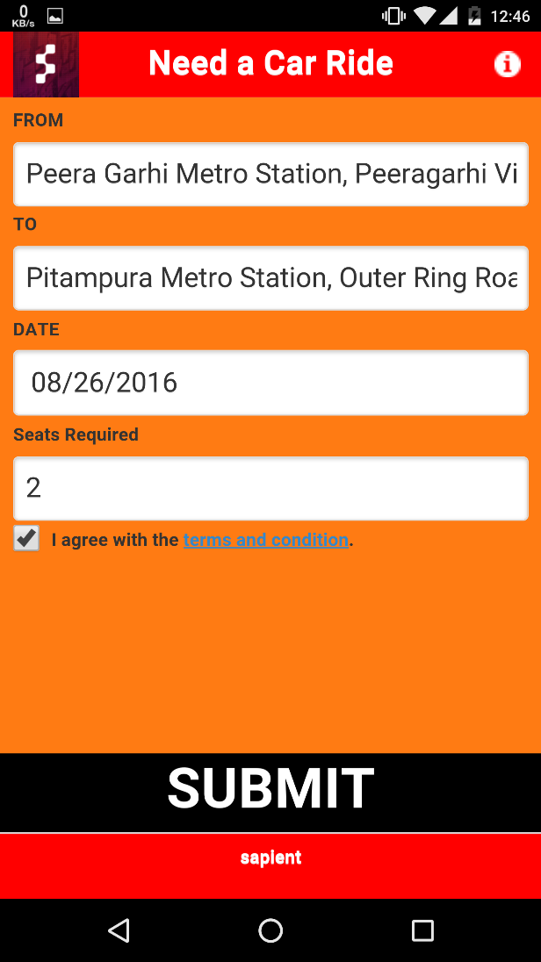

**🡪OUTPUT**

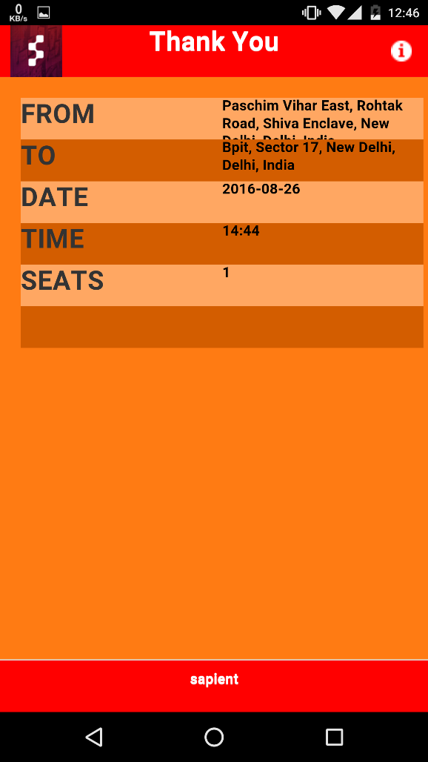

**6. SOME FEATURES**

* **Place auto fill**

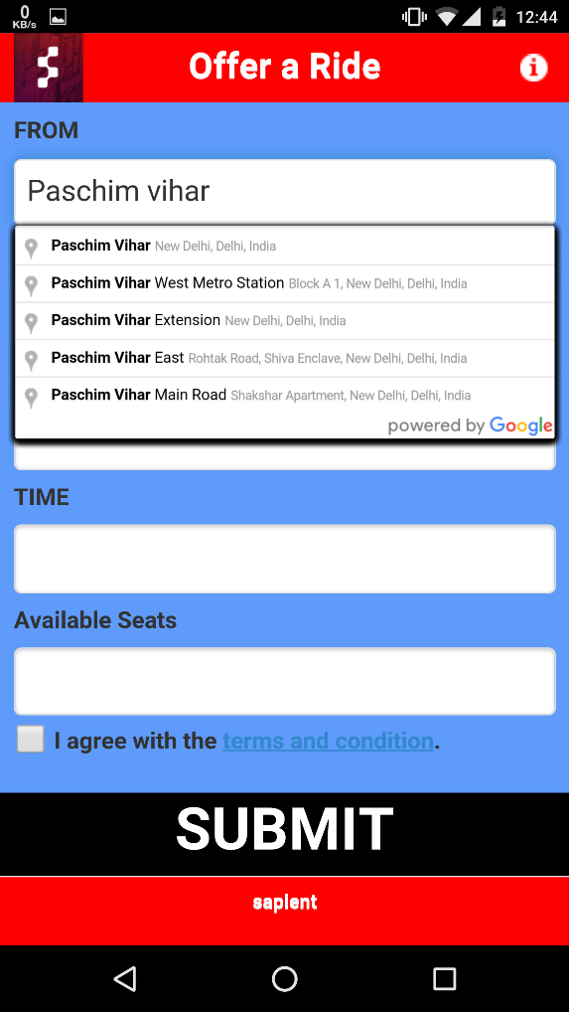

* **Error message**

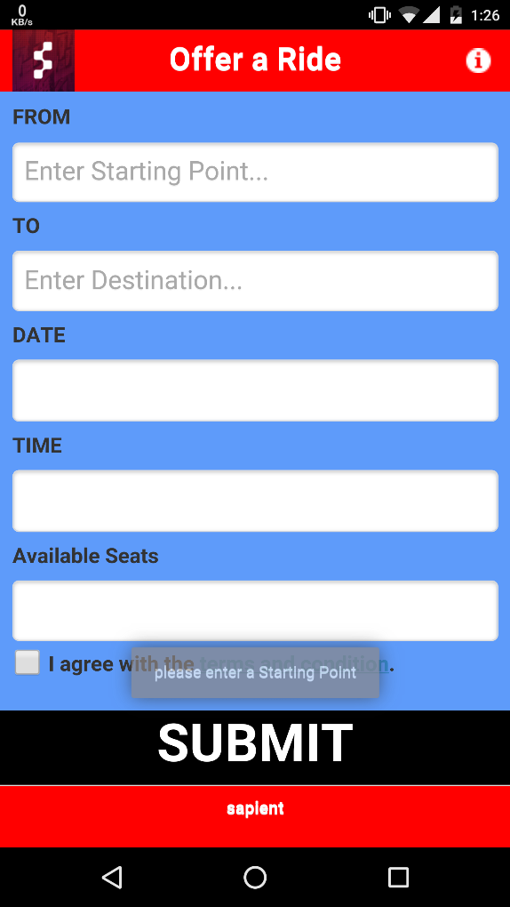

**7. DEBUGGING**

**Debugging** is the process of finding and resolving of defects that prevent correct operation of [computer software](https://en.wikipedia.org/wiki/Computer_software) or a [system](https://en.wikipedia.org/wiki/System). Debugging tends to be harder when various subsystems are [tightly coupled](https://en.wikipedia.org/wiki/Coupling_(computer_programming)), as changes in one may cause bugs to emerge in another.

Debugging ranges in complexity from fixing simple errors to performing lengthy and tiresome tasks of data collection, analysis, and scheduling updates. The debugging skill of the programmer can be a major factor in the ability to debug a problem, but the difficulty of software debugging varies greatly with the complexity of the system, and also depends, to some extent, on the [programming language](https://en.wikipedia.org/wiki/Programming_language)(s) used and the available tools, such as [debuggers](https://en.wikipedia.org/wiki/Debugger).. The term debugger can also refer to the person who is doing the debugging.

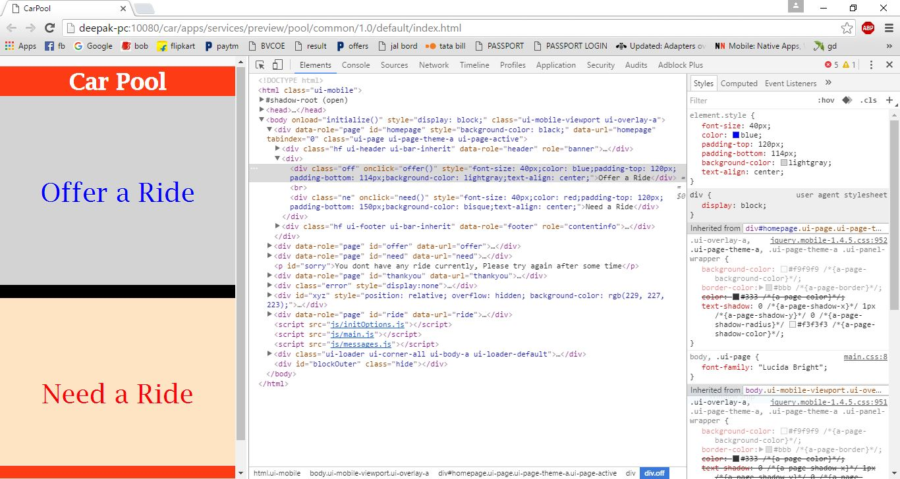

Generally, [high-level programming languages](https://en.wikipedia.org/wiki/High-level_programming_language), such as [Java](https://en.wikipedia.org/wiki/Java_(programming_language)), make debugging easier, because they have features such as [exception handling](https://en.wikipedia.org/wiki/Exception_handling) that make real sources of erratic behaviour easier to spot. In programming languages such as [C](https://en.wikipedia.org/wiki/C_(programming_language)) or [assembly](https://en.wikipedia.org/wiki/Assembly_language), bugs may cause silent problems such as [memory corruption](https://en.wikipedia.org/wiki/Memory_corruption), and it is often difficult to see where the initial problem happened. In those cases, [memory debugger](https://en.wikipedia.org/wiki/Memory_debugging) tools may be needed.

**8. CODE**

**8.1. HTML CODE**

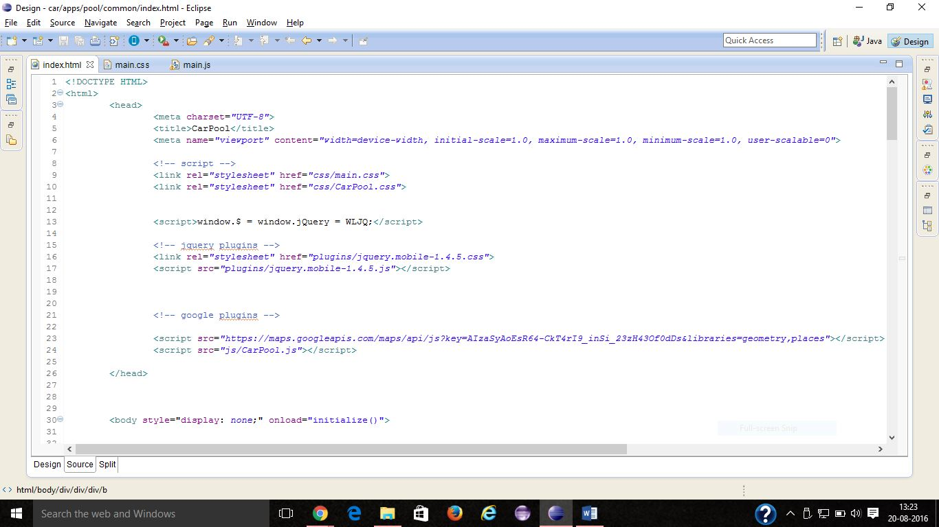

Fig 9.1.1

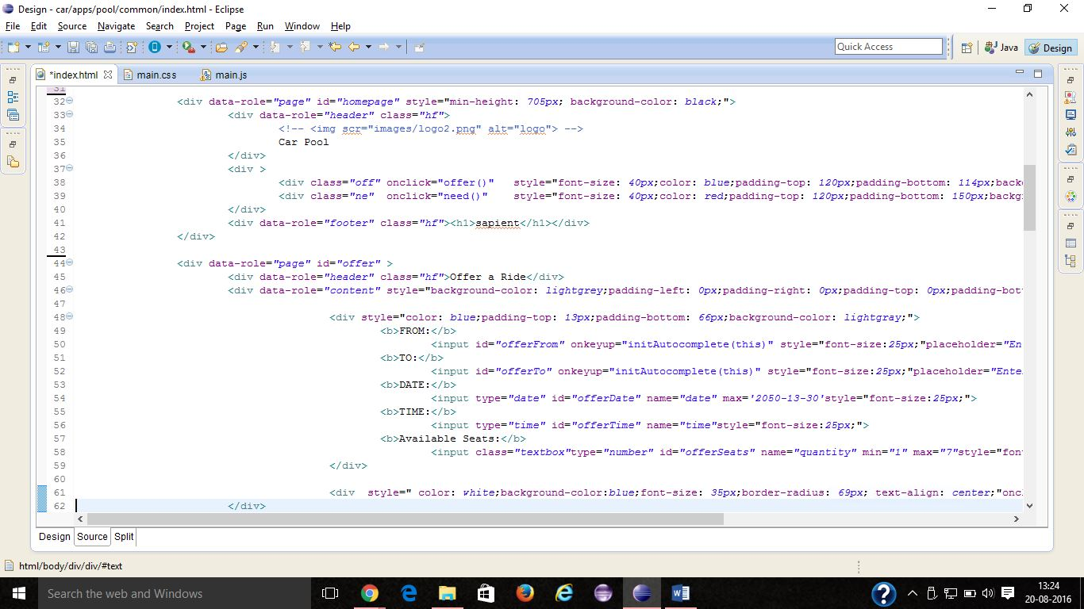

Fig 9.1.2

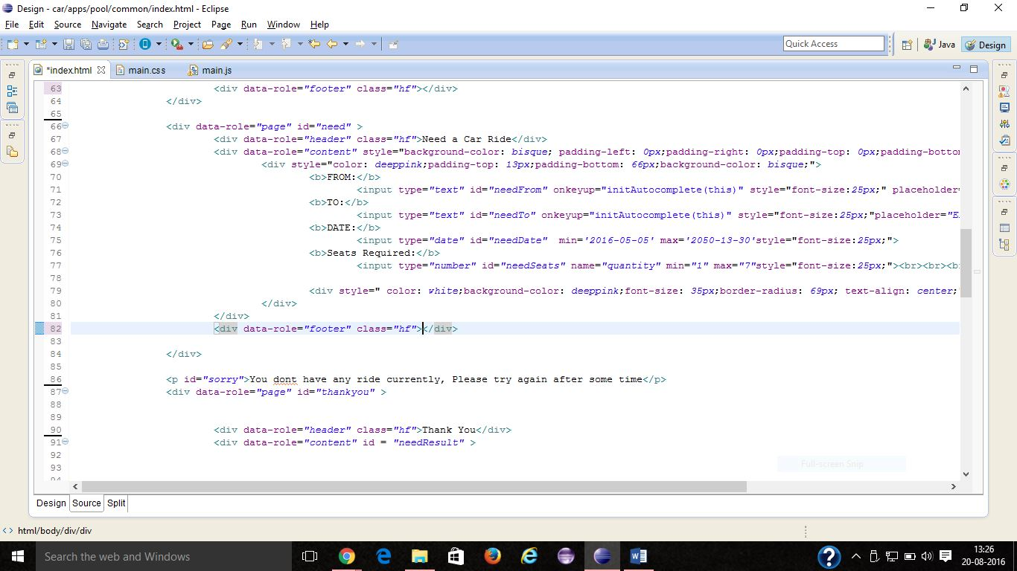

Fig 9.1.3

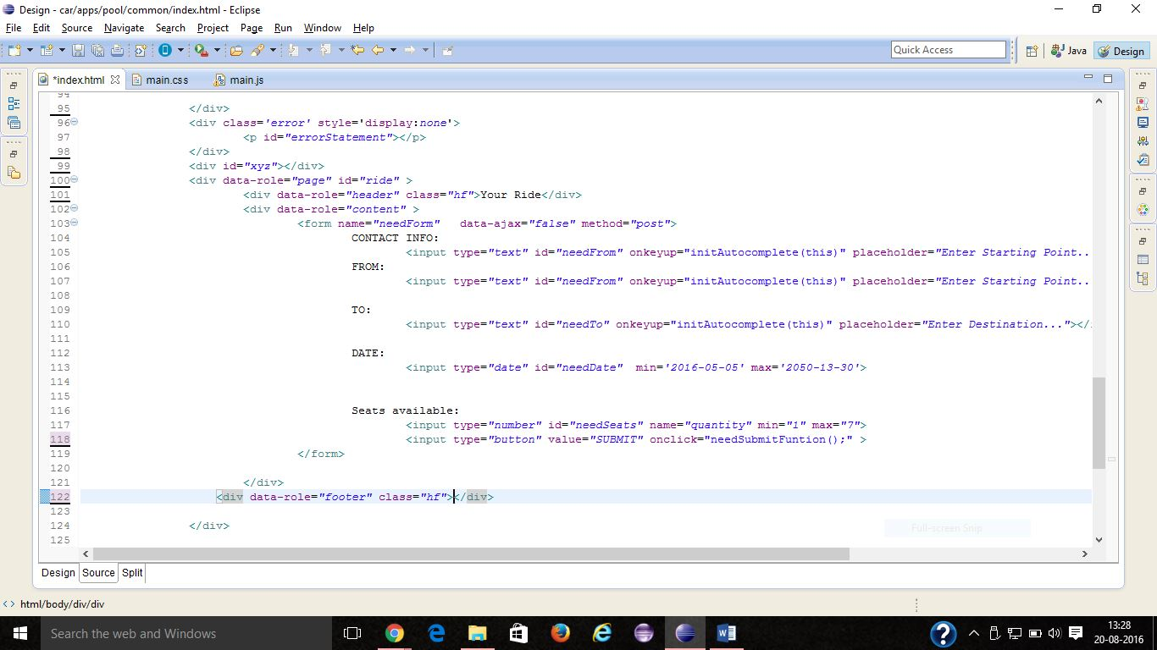

Fig 8.1.4

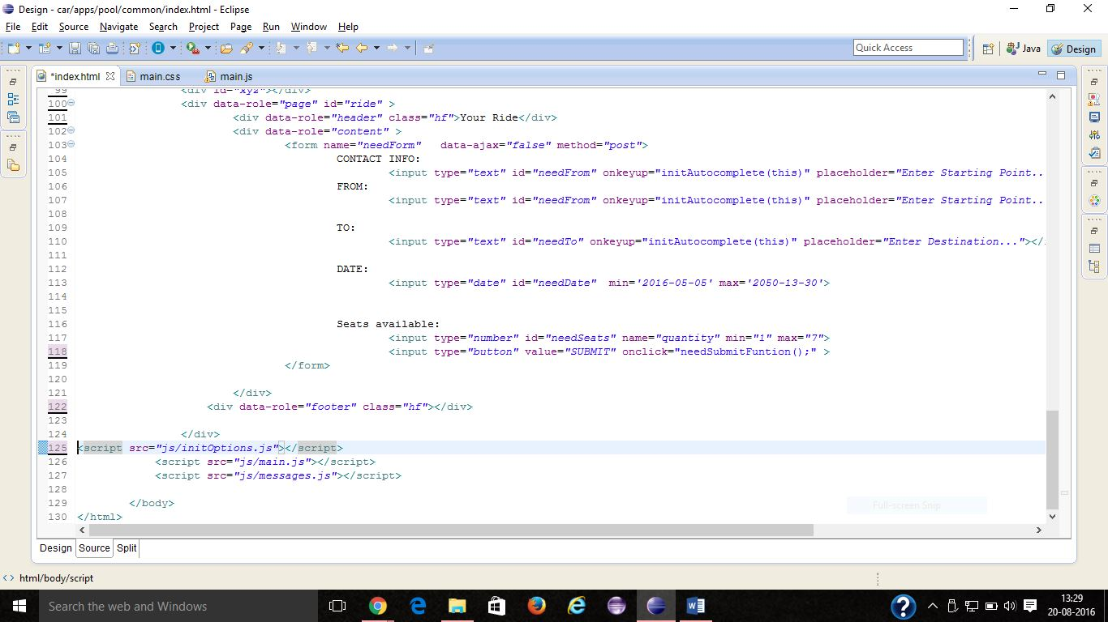

Fig 9.1.5

**8.2 CSS CODE**

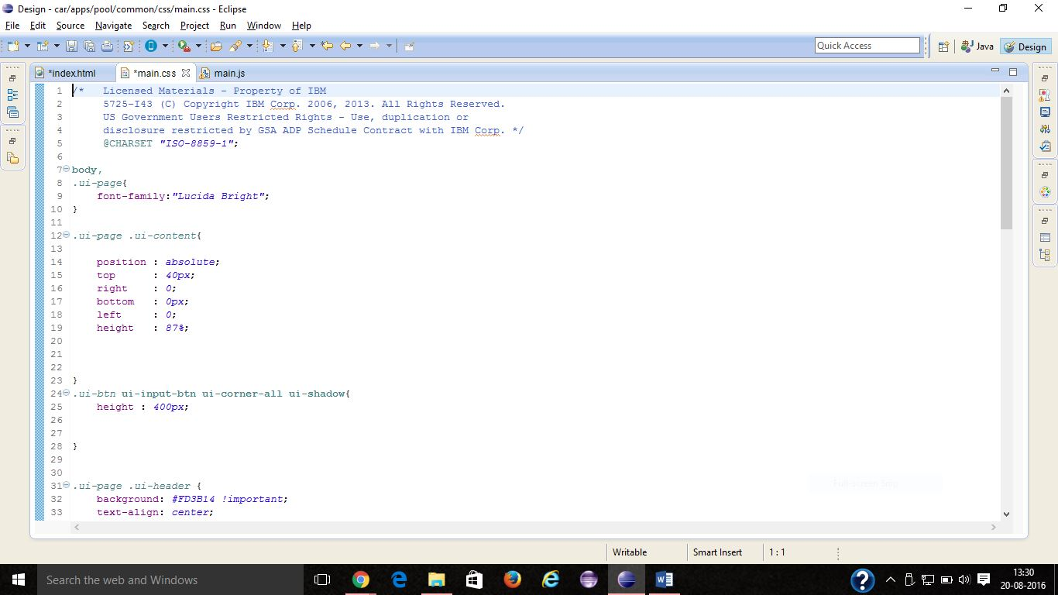

Fig9.2.1

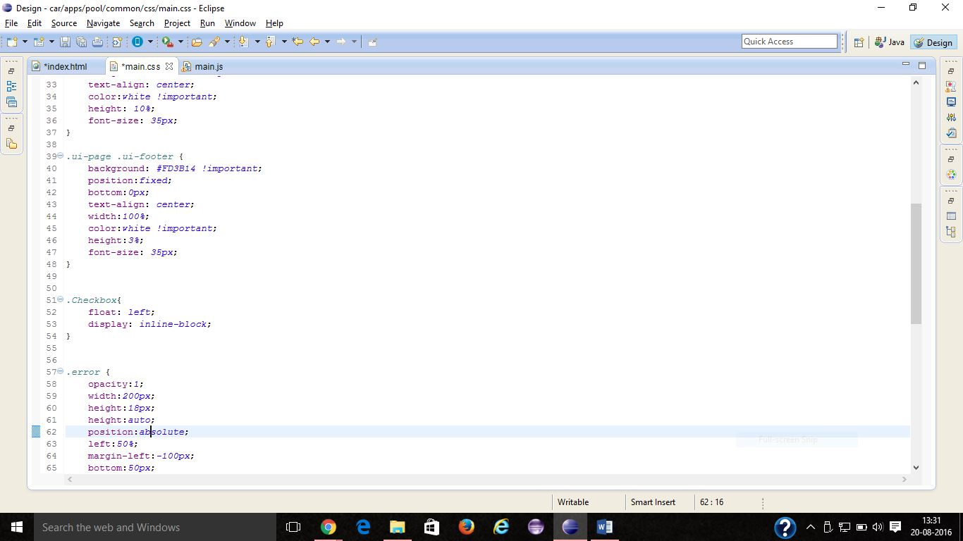

Fig 9.2.2

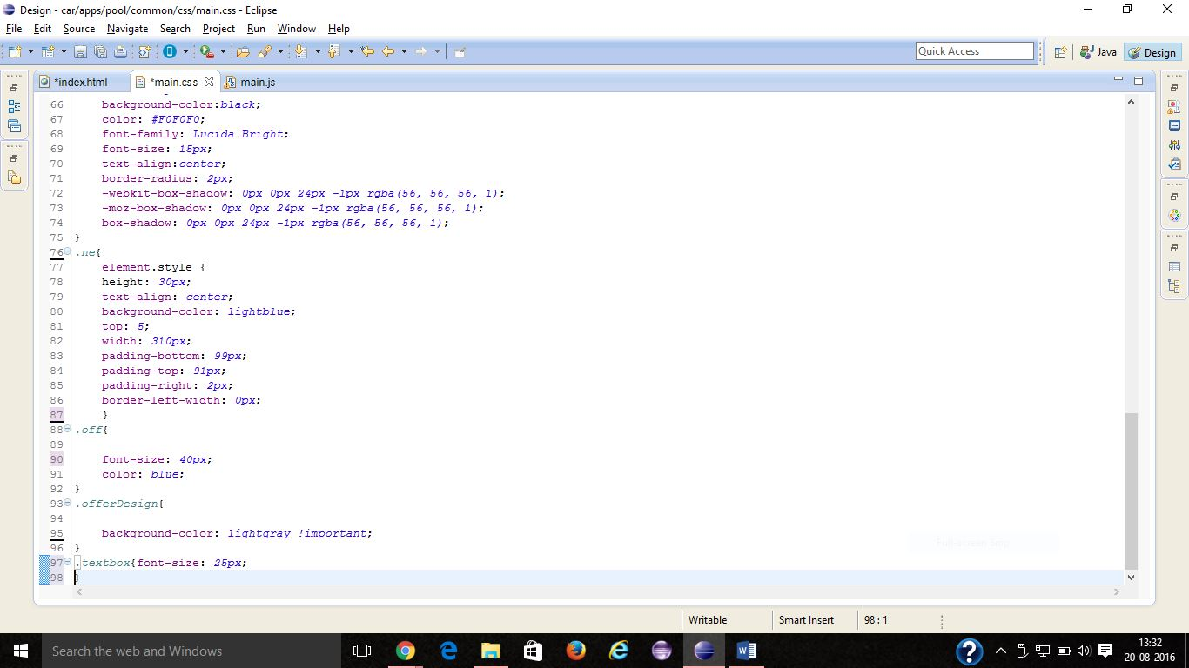

Fig 9.2.3

**8.3 JAVA SCRIPT**

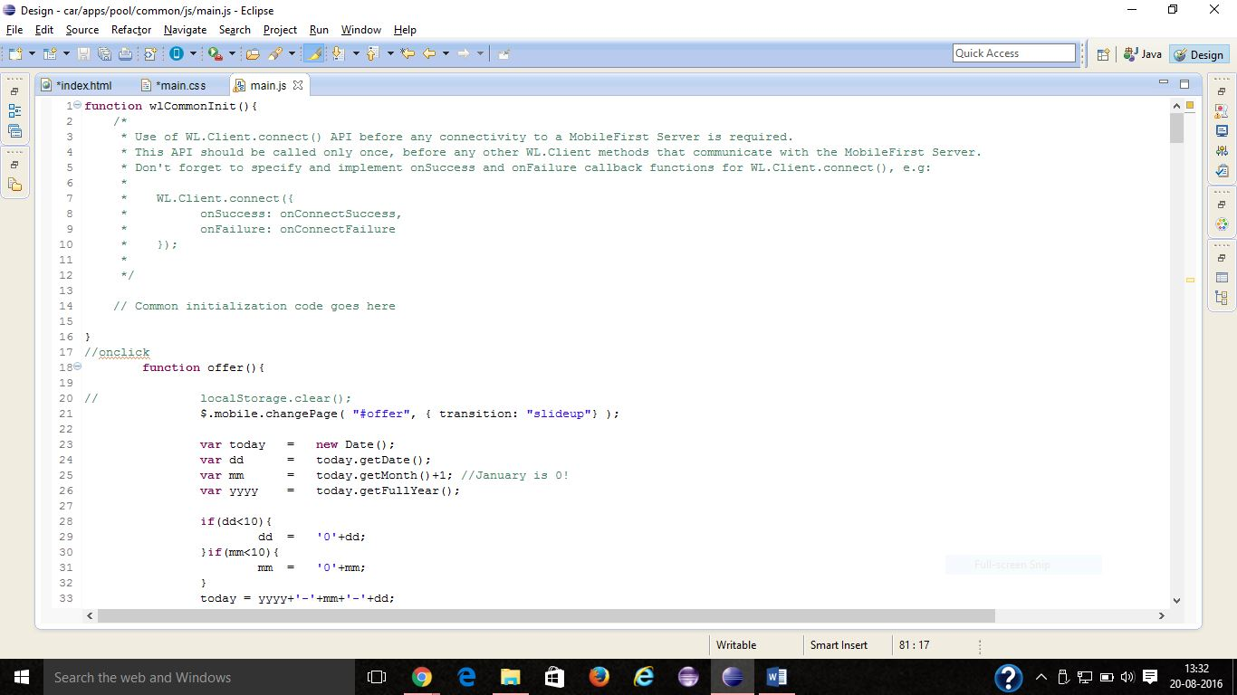

Fig 8.3.1

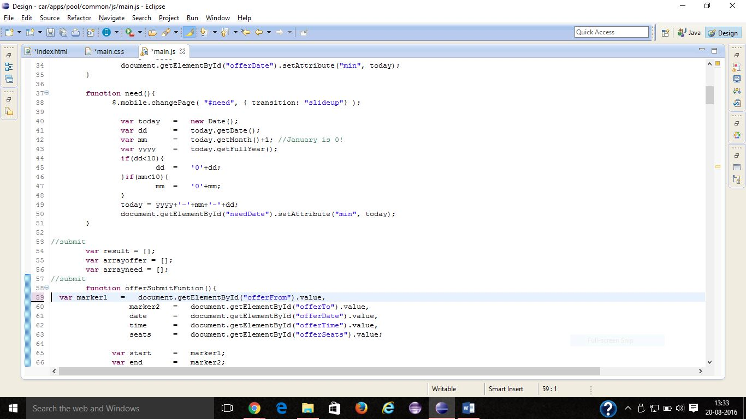

Fig 8.3.2

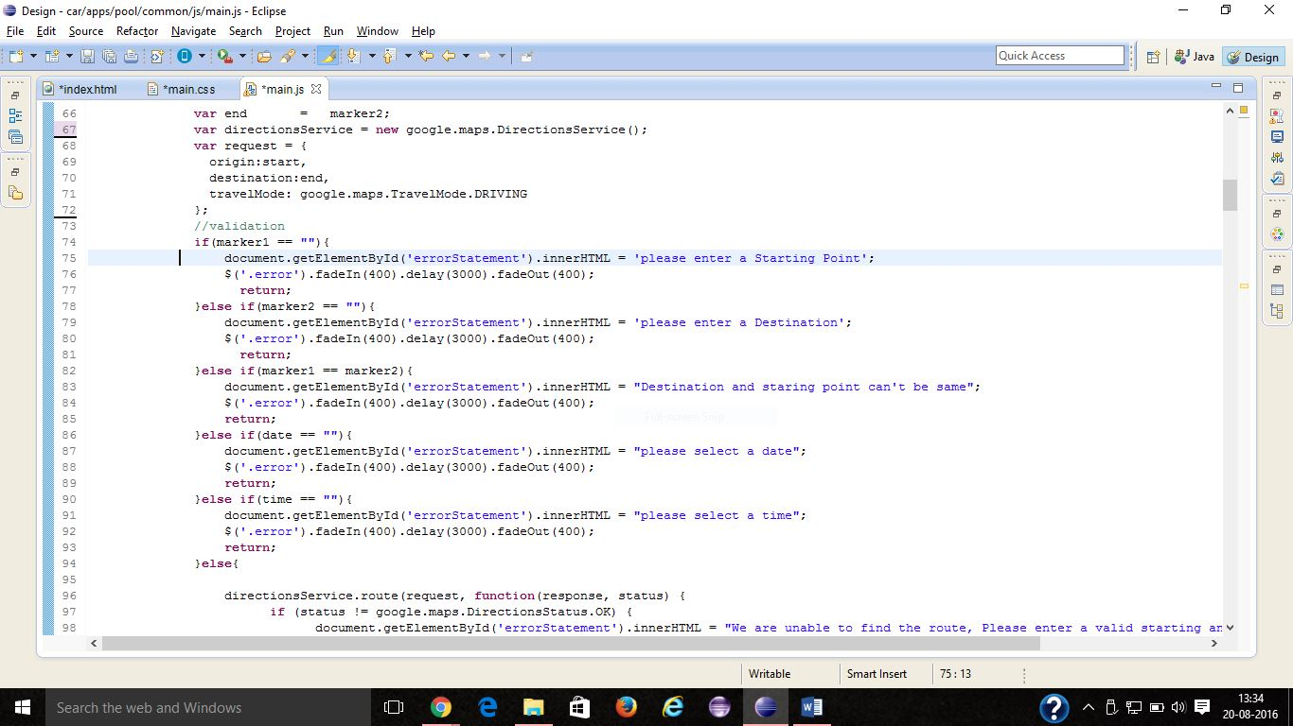

Fig 8.3.3

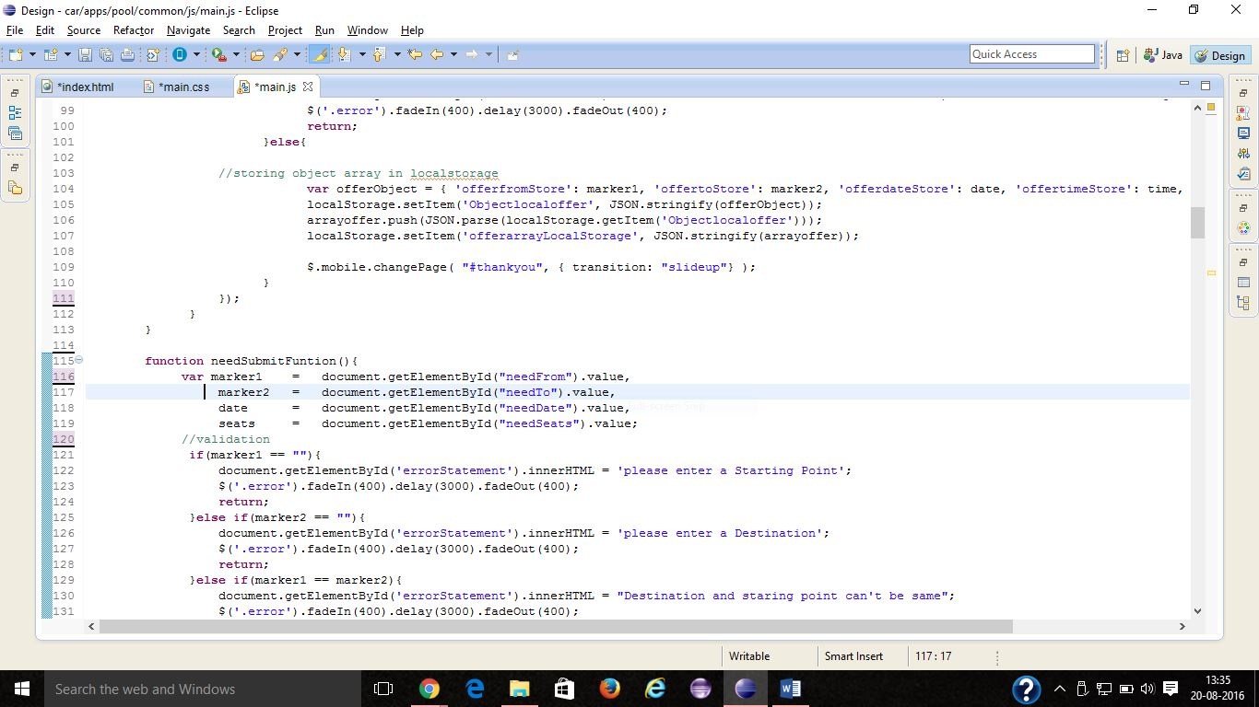

Fig 8.3.4

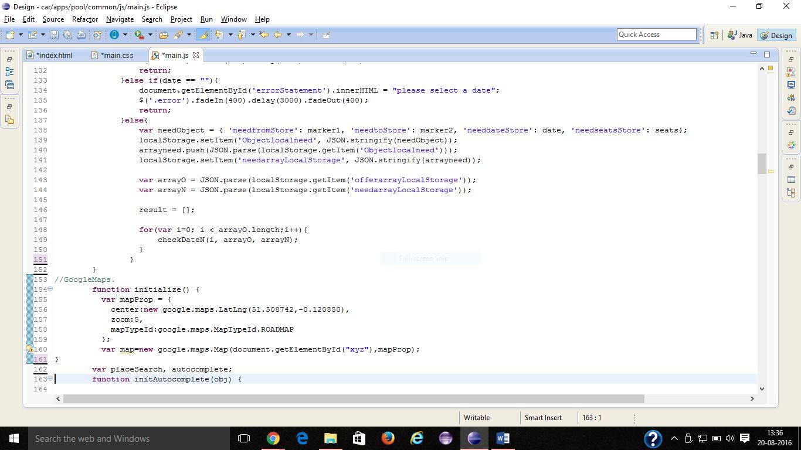

Fig 8.3.5

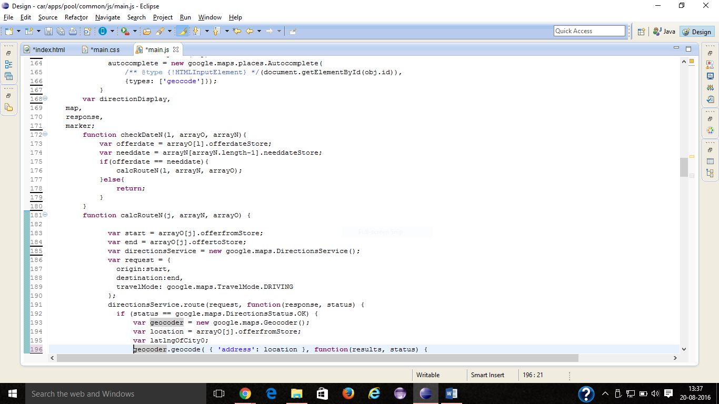

Fig 8.3.6

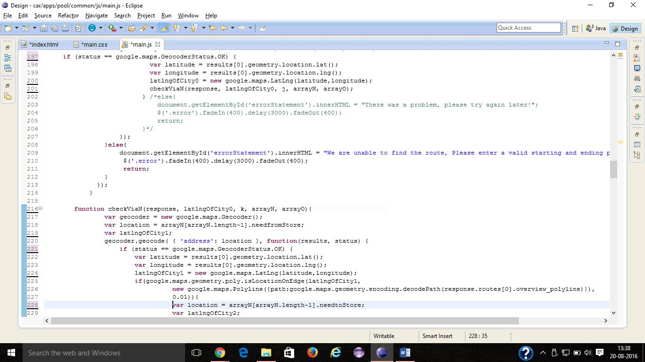

Fig 8.3.7

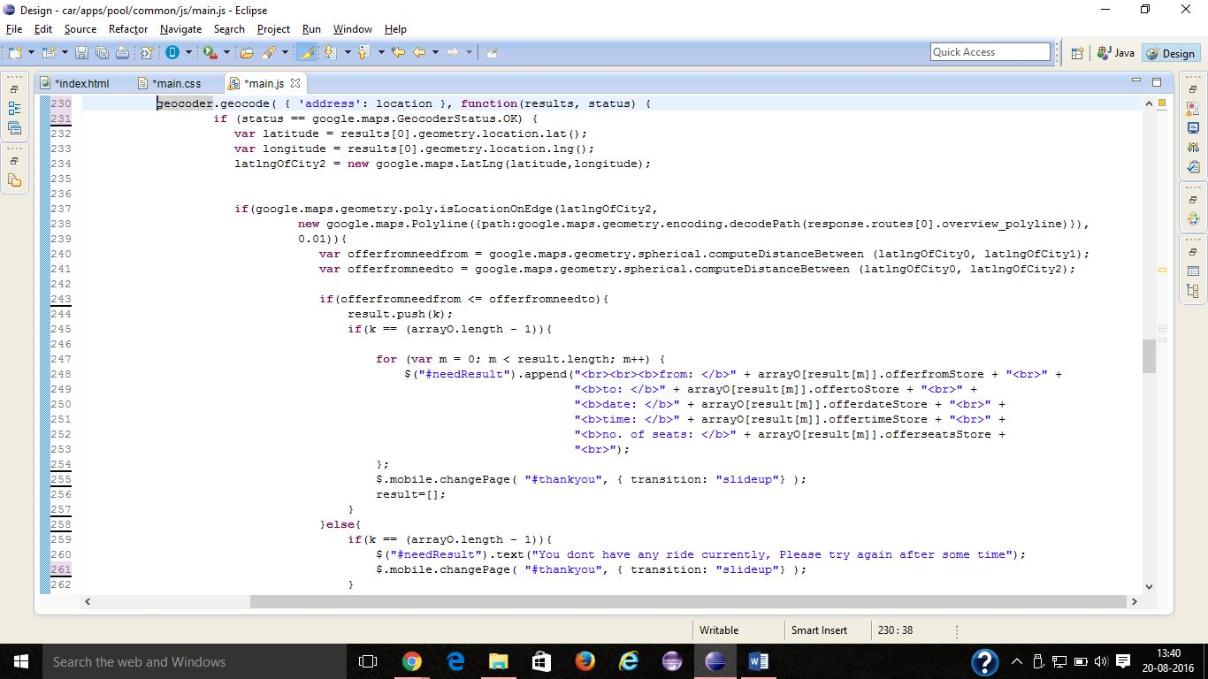

Fig 8.3.8

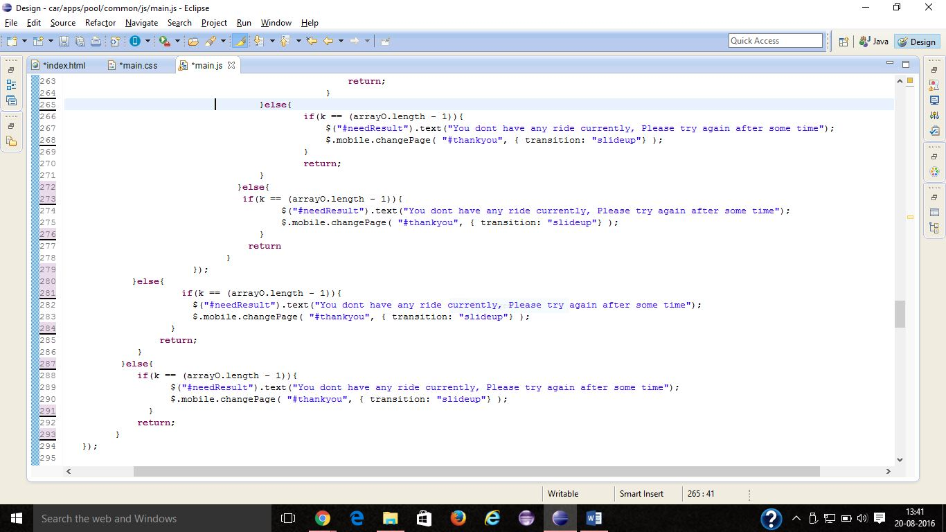

Fig 8.3.9

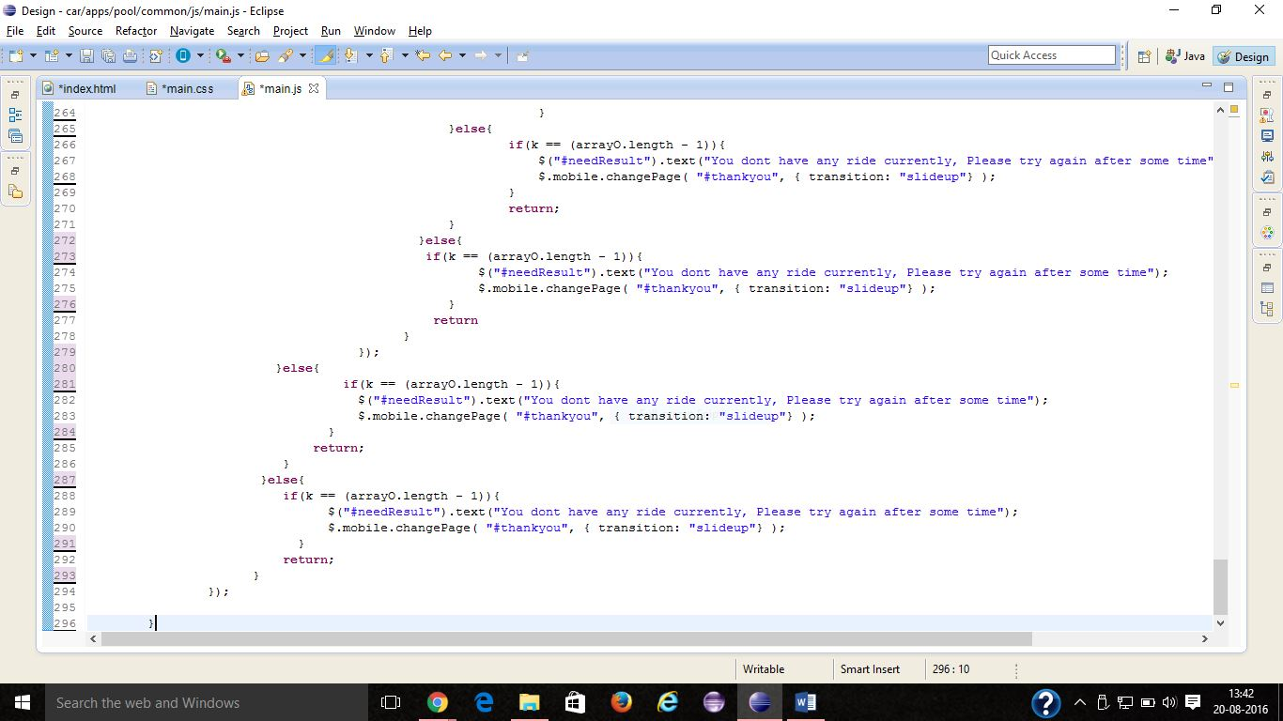

Fig 8.3.10

**9. REFERENCE**

1. http://www.w3schools.com/.
2. https://www.codecademy.com/learn/jquery.
3. http://www.geeksforgeeks.org/.
4. java script tutorial video <https://www.youtube.com/watch?v=_cLvpJY2deo>
5. https://developers.google.com/maps/