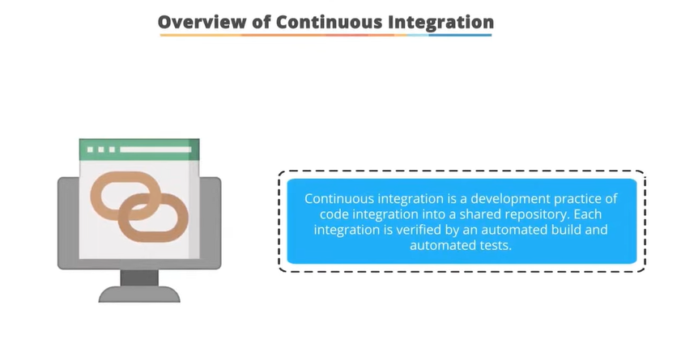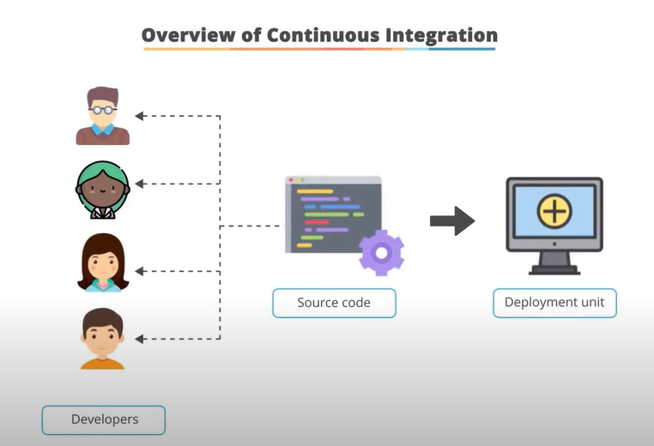

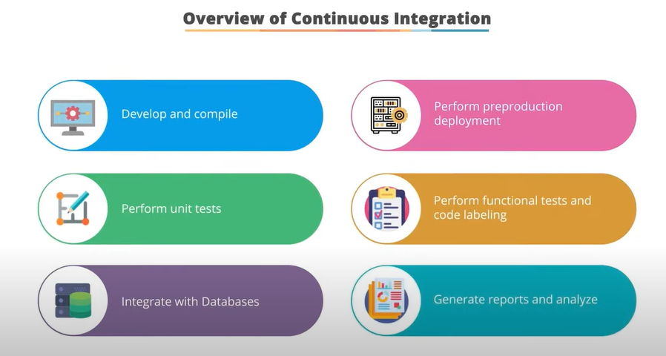

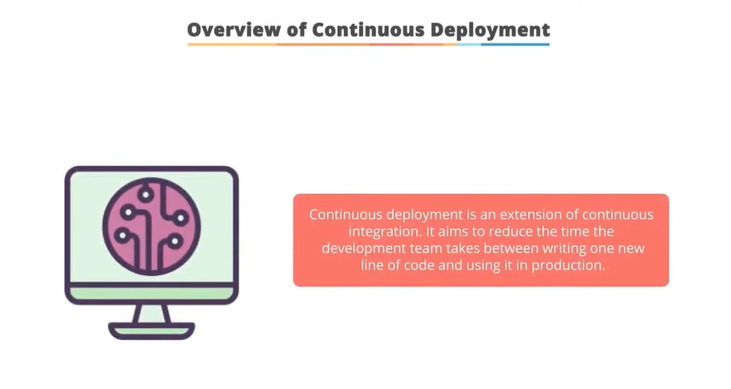

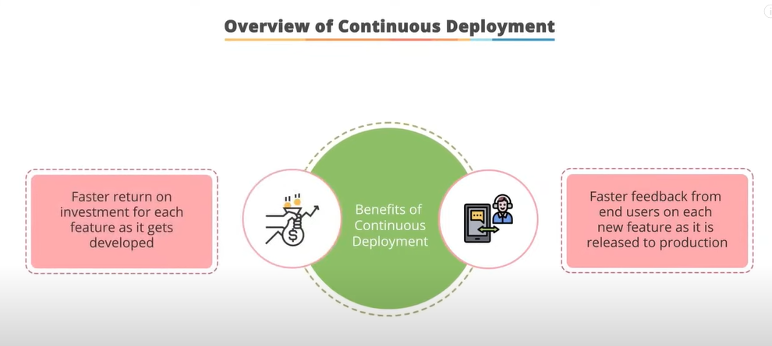

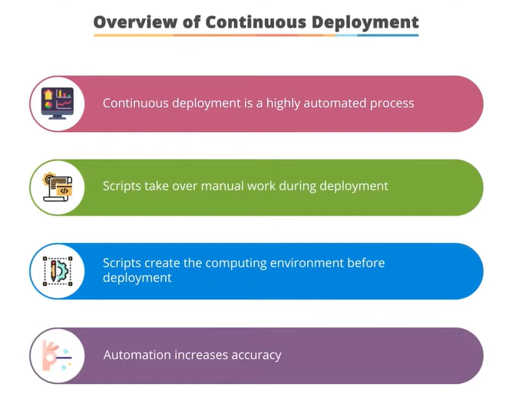

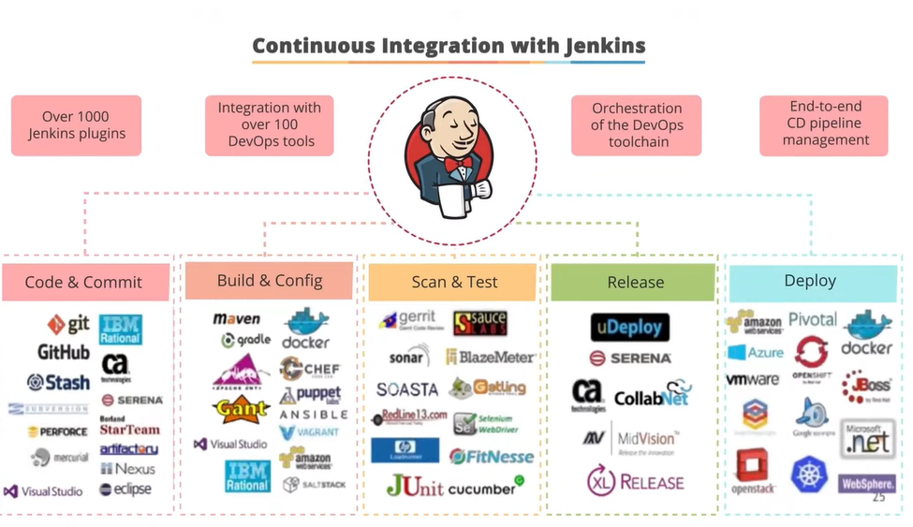

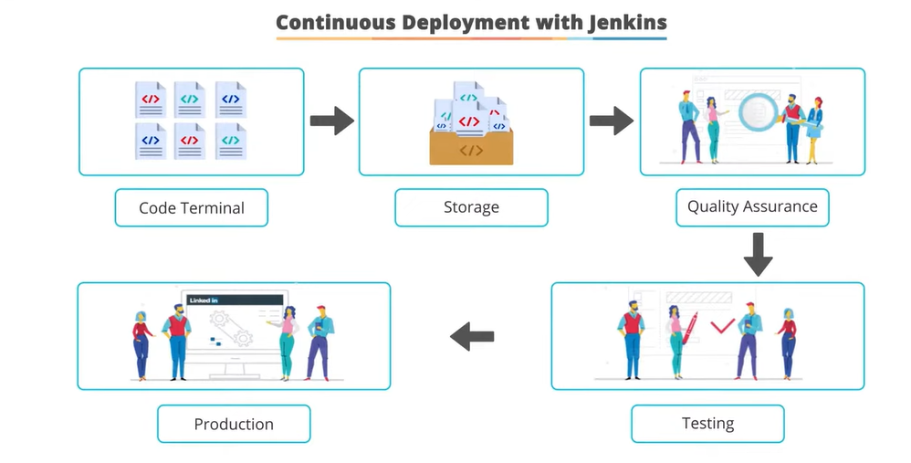

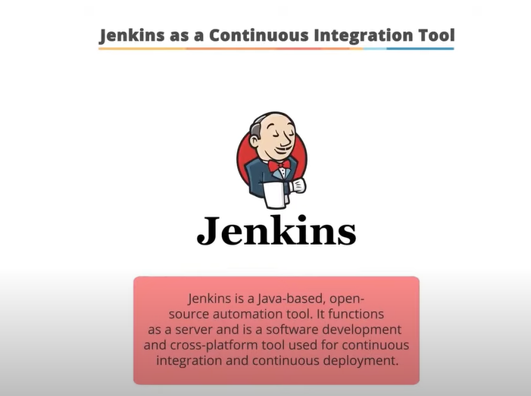

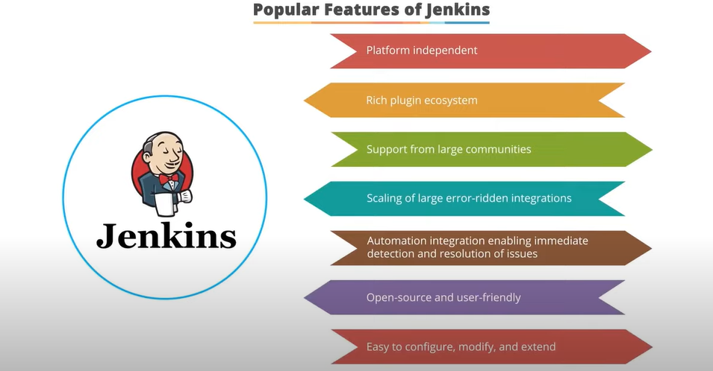

Hi

I hope this email finds you well. I am writing to express my interest in the Frontend Development role at Maersk. After reviewing the job description and researching the company, I am eager to bring my skills and experience to your team.

I have [X years/months] of experience in Frontend Development and am well-versed in technologies such as Javascript, Typescript, Angular 11, and React. I am confident that I can bring value to the role and make a positive impact on the projects that I work on. I have a proven track record of delivering stable and high-quality web pages in a fast-paced and collaborative environment.

I am excited about the opportunity to work for a company like [Company Name] and believe that I can make a meaningful contribution to the team. I would love the opportunity to discuss the role in more detail and learn more about the company culture.

Thank you for considering my application. I look forward to hearing back from you soon.

Sincerely, [Your Name]

Top of Form