**WATERFALL MODEL**

The Waterfall model is a traditional and sequential approach to software development. It was one of the earliest methodologies used for managing software projects and has its origins in the manufacturing and construction industries. The Waterfall model follows a linear and sequential progression of steps, where each phase must be completed before moving on to the next. The model is divided into distinct phases, and each phase has specific goals and deliverables. Let's dive into the different phases and characteristics of the Waterfall model:

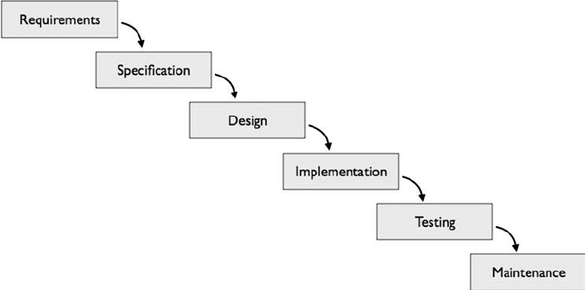

1. **Requirements Phase:** In this initial phase, the project requirements are gathered and documented in detail. This phase involves interactions between stakeholders, users, and the development team to ensure a comprehensive understanding of what the software needs to achieve.

2. **System Design Phase:** Once the requirements are clear, the system's architecture and design are planned. This phase involves designing the system's structure, components, and interfaces. The goal is to create a blueprint for the software's construction.

3. **Implementation Phase:** This is the coding phase, where the actual software is developed based on the design specifications. Developers write code, create modules, and implement the features outlined in the design phase.

4. **Testing Phase:** Once the code is written, it undergoes rigorous testing to identify and rectify defects, bugs, and errors. Testing can include unit testing (testing individual components), integration testing (testing the interaction between components), and system testing (testing the entire system).

5. **Deployment Phase:** After successful testing, the software is deployed to a production environment or delivered to the client. This phase may involve installation, configuration, and training for end-users.

6**. Maintenance Phase**: Once the software is deployed, it enters the maintenance phase. This involves addressing any issues that arise in the live environment, providing updates, patches, and support as needed.

**Characteristics of the Waterfall Model:**

1. **Sequential and Linear**: The Waterfall model follows a strict sequence of phases. Each phase must be completed before moving on to the next, and there is no overlap between phases.

2. **Document-Driven:** The model emphasizes detailed documentation at every stage, including requirements, design, code, and testing. This documentation helps ensure a clear understanding of the project's progress and requirements.

3. **Predictable:** Due to its sequential nature and detailed planning, the Waterfall model can provide relatively accurate time and cost estimates at the beginning of the project.

4. **Rigid and Inflexible**: Once a phase is completed, it's challenging to make changes to the requirements or design without potentially affecting subsequent phases. This lack of flexibility can be a drawback if changes are needed later in the project.

5. **High Risk Late in the Process:** Any misunderstandings or errors in the earlier phases may not become apparent until later in the process, making it risky to detect and address issues in the later stages.

6**. Suitable for Stable Requirements:** The Waterfall model works well when the project's requirements are stable and well-defined from the start. It's less suitable for projects with evolving or uncertain requirements.

7. **Limited Customer Involvement:** Customer feedback and involvement are limited to the early phases, which might result in the final product not fully meeting customer needs.

The Waterfall model has both advantages and disadvantages in software development. Here's an overview of the pros and cons:

**Advantages**

1. **Clear Structure and Phases:** The model's sequential nature provides a clear structure and well-defined phases, making it easy to understand and manage the project's progress.

2. **Predictability:** The Waterfall model is suitable for projects with well-defined and stable requirements. This predictability allows for more accurate time and cost estimates at the beginning of the project.

3. **Comprehensive Documentation**: Each phase requires detailed documentation, which can serve as a valuable reference for developers, testers, and stakeholders throughout the project's lifecycle.

4**. Reduced Ambiguity:** The thorough requirements and design phases help reduce ambiguity and ensure a shared understanding of the project's scope among team members.

5. **Clear Milestones:** The completion of each phase serves as a milestone, providing a sense of accomplishment and progress measurement.

6. **Less Frequent Changes:** The sequential nature of the model discourages frequent changes once a phase is completed, reducing the risk of scope creep.

**Disadvantages:**

1. **Rigidity**: The Waterfall model is inflexible when it comes to accommodating changes after the project has started. Changes in requirements or design can be challenging and costly to implement once development is underway.

2. **Late Detection of Issues**: Any misunderstandings or errors in earlier phases might not become apparent until the later stages of the project, making it difficult to address issues early on.

3. **Limited Customer Involvement**: Customer involvement is usually limited to the initial requirements phase, potentially resulting in a final product that doesn't fully meet their needs.

4. **Higher Risk:** Since testing and validation occur later in the process, there is a higher risk of identifying significant issues, defects, or mismatches between the software and user needs after considerable resources have been invested.

5. **Long Time to First Deliverable:** Because the model mandates completing each phase before moving on to the next, it might take a long time before any working software is delivered.

6. **Dependencies Between Phases:** The model relies on the successful completion of one phase to proceed to the next, which can cause delays if a phase takes longer than expected.

7. **Not Ideal for Complex Projects:** The Waterfall model might not be suitable for projects with complex and evolving requirements, where continuous feedback and iterative development are essential.

8. **Lack of Flexibility:** The rigid nature of the model makes it challenging to adjust to changing circumstances, emerging technologies, or new insights gained during the project.

In summary, the Waterfall model can work well for projects with well-defined and stable requirements, where changes are minimal and risks are well-understood. However, it is less suited for projects that require adaptability, customer involvement throughout the development process, or the ability to respond to changing market conditions. As software development practices have evolved, more flexible and iterative methodologies like Agile have gained prominence due to their ability to address the shortcomings of the Waterfall model.

**PROTOTYPE MODEL**

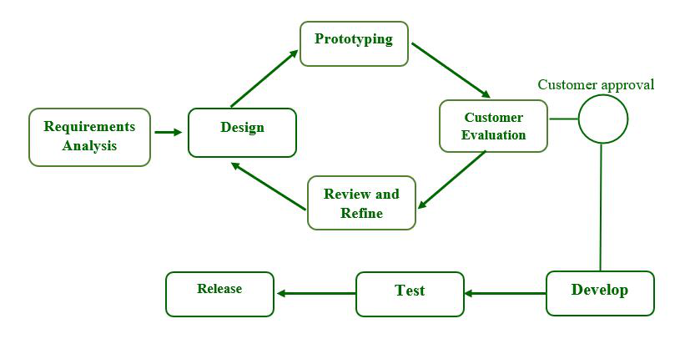

The Prototype Model is an iterative software development methodology that focuses on creating an initial version of the software, called a prototype, to better understand and refine the requirements and design. This approach allows stakeholders to visualize and interact with a working model of the software before the full development effort is undertaken. Here's a detailed overview of the Prototype Model, along with its advantages and disadvantages:

**Prototype Model Process:**

1. **Requirements Gathering**: The initial requirements are gathered from stakeholders, but they might not be fully clear or detailed.

2. **Quick Design:** A basic design or framework of the software is created, focusing on the core functionalities that need to be demonstrated.

3. **Prototype Development:** A prototype is developed based on the initial design. This prototype may not have all the features, but it should be functional and provide a tangible representation of the software's intended functionality.

4. **Prototype Evaluation:** The prototype is shared with stakeholders, including end-users and clients. Feedback is collected, and changes or improvements are identified.

5. **Refinement:** Based on the feedback, the prototype is refined, adding or modifying features, improving user interfaces, and addressing any concerns.

6. **Iterations**: Steps 3 to 5 are repeated in multiple iterations. Each iteration builds upon the previous one, incorporating feedback and making the prototype more comprehensive and closer to the final product.

7. **Final Implementation:** Once the prototype meets the requirements and gains stakeholder approval, the final version of the software is developed using the insights gained from the prototype iterations.

**Advantages of the Prototype Model:**

1. **Clearer Requirements:** By providing a visual and interactive representation of the software, the prototype helps stakeholders refine and clarify their requirements, reducing misunderstandings and ambiguities.

2. **Customer Involvement:** Regular interactions with prototypes allow customers and end-users to provide feedback early in the development process, leading to a product that better meets their needs.

3. **Early Detection of Issues:** Defects, design flaws, or usability problems are identified and addressed in the early stages, reducing the cost and effort required to fix them later.

4. **Risk Reduction:** The iterative nature of the model reduces the risk of developing a software product that doesn't align with user expectations or market needs.

5. **User-Centered Design:** Prototypes focus on user interfaces and interactions, ensuring that the user experience is considered from the start of the development process.

6. **Flexibility for Changes:** The model allows for flexible incorporation of changes and enhancements based on stakeholder feedback without the rigid constraints of the Waterfall model.

**Disadvantages of the Prototype Model:**

1. **Time and Effort:** Developing and refining prototypes can consume a significant amount of time and effort, particularly if multiple iterations are needed.

2**. Scope Creep:** Frequent changes based on feedback can lead to scope creep, where the project expands beyond its original scope, potentially affecting timelines and budgets.

3. **Documentation Challenges:** Due to the iterative nature, maintaining up-to-date documentation can be challenging, leading to potential confusion among team members.

4. **Not Suitable for All Projects:** The Prototype Model might not be suitable for projects with well-defined and stable requirements, as its strength lies in exploring and refining uncertain or evolving requirements.

5. **Lack of Complete Planning:** The model doesn't emphasize comprehensive upfront planning, which could lead to a lack of clarity regarding the final product's scope and features.

6. **Dependency on User Participation:** Effective user involvement and feedback are essential for the success of this model. If users are unavailable or not actively engaged, the benefits might not be fully realized.

The Prototype Model is particularly useful when dealing with projects where requirements are not fully clear, or when user feedback and involvement are crucial for a successful end product. It offers an approach that balances flexibility with structured development, allowing for better alignment with user needs and reducing the risks associated with developing software in isolation.

**V-MODEL**

The V-Model, also known as the Validation and Verification Model, is a software development methodology that emphasizes a systematic and structured approach to the development and testing of software. The V-Model is an extension of the Waterfall model, where each phase of development is followed by a corresponding testing phase, creating a visual representation that resembles the letter "V." This model ensures that each development phase is validated through testing, and it places a strong emphasis on the verification and validation processes. Here's an overview of the V-Model, along with its advantages and disadvantages:

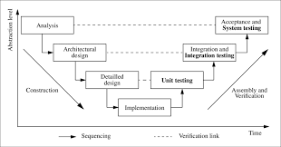

**V-Model Phases:**

1. **Requirements Specification Phase:** This phase involves gathering and documenting detailed requirements. The requirements are then used as the basis for creating a System Requirement Specification (SRS).

2. **System Design Phase:** Based on the SRS, a detailed system design is created, outlining the architecture, components, and interfaces of the software.

3. **Module Design Phase:** Detailed design documents are created for individual modules or components identified during the system design phase.

4. **Implementation Phase:** The actual coding and development of the software occur, based on the design specifications.

5**. Unit Testing Phase:** Each module's functionality is individually tested in isolation to ensure that it works as intended.

6. **Integration Testing Phase:** Modules are integrated and tested together to ensure that they interact correctly and function as part of the larger system.

7. **System Testing Phase:** The entire system is tested as a whole to verify that it meets the specified requirements and functions correctly.

8. **User Acceptance Testing (UAT) Phase:** The software is tested with real users to ensure it meets their needs and expectations.

**Advantages of the V-Model:**

1. **Structured Approach:** The V-Model provides a structured framework that clearly outlines the relationship between development and testing activities, ensuring thorough testing at every stage.

2. **Early Detection of Defects:** The testing phases are tightly integrated with development phases, which helps in identifying and addressing defects early in the development process.

3**. Clear Traceability:** The V-Model ensures clear traceability between requirements, design, development, and testing, making it easier to track and manage project progress.

4. **Higher Quality:** Rigorous testing and validation at each stage lead to higher software quality, as defects are detected and resolved before progressing to the next phase.

5. **Predictability:** The model offers a predictable and systematic approach, making it easier to estimate timelines, costs, and resource requirements.

**Disadvantages of the V-Model:**

1. **Rigidity:** Like the Waterfall model, the V-Model is relatively inflexible when it comes to accommodating changes after the development process has begun.

2. **Late Customer Feedback:** Customer involvement is more prominent in the later stages, which could lead to issues if user expectations are not met.

3. **High Dependency on Initial Requirements:** If the initial requirements are incorrect or incomplete, the entire development and testing process could be compromised.

4. **Sequential Nature:** The sequential nature of the model can lead to longer development cycles, delaying the delivery of working software to the end-users.

5. **Complexity:** The extensive documentation and thorough testing required at each stage can lead to increased complexity and administrative overhead.

6. **Limited Iterations:** While the model includes testing phases for each development phase, it might not allow for the same level of iterative development and feedback as Agile methodologies.

In summary, the V-Model is a structured approach that emphasizes the importance of validation and verification through rigorous testing. It's suitable for projects with well-defined requirements and a clear understanding of the system's architecture. However, its rigidity and sequential nature might not be ideal for projects with evolving requirements or where customer feedback is essential throughout the development process.

**SPIRAL MODEL**

The Spiral Model is an iterative and risk-driven software development methodology that combines elements of both the Waterfall model and iterative development. It was introduced by Barry Boehm in 1986 as a response to the limitations of traditional linear models like Waterfall. The Spiral Model focuses on addressing uncertainties and managing risks through a series of iterative cycles. Each cycle involves planning, designing, building, and testing, with an emphasis on risk assessment and mitigation. Here's a comprehensive overview of the Spiral Model, along with its advantages and disadvantages:

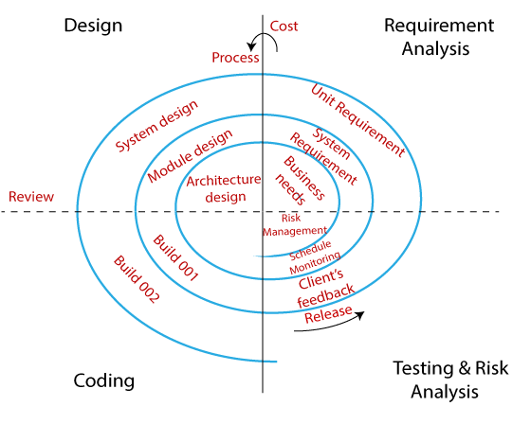

**Spiral Model Phases:**

1. **Planning:** In this phase, project objectives, constraints, and requirements are identified. Risks are assessed, and a development strategy is formulated.

2. **Risk Analysis:** The identified risks are analyzed in detail, and strategies are devised to mitigate them. This involves evaluating the potential impact of risks on the project's success.

3. **Engineering:** This phase involves actual development, where the software is designed, coded, and tested based on the strategies formulated in the previous phases.

4**. Evaluation:** The current iteration is evaluated through testing, validation, and customer feedback. This assessment determines whether the project is on track and whether any changes are required.

**Advantages of the Spiral Model:**

1. **Risk Management:** The Spiral Model places a strong emphasis on risk assessment and mitigation at every iteration, which helps in identifying and addressing potential issues early in the project.

2. **Flexibility and Iteration:** The iterative nature of the model allows for flexibility and continuous improvement based on feedback. This accommodates changing requirements and allows for enhancements in subsequent iterations.

3. **User Involvement:** The model encourages regular interactions with end-users and stakeholders, promoting better alignment with user needs and expectations.

4. **Gradual Development:** The incremental approach of the Spiral Model results in a gradual and controlled development process, reducing the likelihood of major defects in the final product.

5. **Adaptation to Change:** The model is well-suited for projects with evolving requirements, as changes can be incorporated in subsequent iterations.

6. **Well-Defined Milestones:** Each iteration ends with a well-defined milestone that includes assessment and evaluation, helping to track project progress effectively.

7. **Efficient Resource Allocation:** The model allows for adjustments in resource allocation based on the outcomes of each iteration, ensuring resources are used optimally.

**Disadvantages of the Spiral Model:**

1. **Complexity:** The Spiral Model can be more complex to manage than linear models due to its iterative and risk-driven nature.

2. **Resource Intensive:** Regular iterations require dedicated resources for each cycle, which might increase the overall project cost and effort.

3. **Time Consuming:** While iterations allow for continuous improvement, they can also extend the project timeline compared to more linear methodologies.

4. **Potential for Scope Creep:** Frequent iterations could lead to scope creep if changes are not managed effectively, impacting project schedules and budgets.

5**. Requires Skilled Personnel:** Effective risk assessment and mitigation demand experienced and skilled personnel, which might not be readily available.

6. **Documentation Overhead:** The need to document each iteration's decisions and outcomes can create documentation overhead.

7. **Not Suitable for Small Projects:** The Spiral Model's complexity and resource demands might make it less suitable for small projects with well-defined requirements.

In summary, the Spiral Model offers an effective approach for managing risks and uncertainties in software development while accommodating changes in requirements. It's particularly useful for larger projects with evolving requirements and significant risks that need to be managed carefully. However, its iterative nature and complexity might not be suitable for all projects, especially those with well-defined and stable requirements.

**RAPID APPLICATION DEVELOPMENT**

The Rapid Application Development (RAD) model is a software development methodology that prioritizes rapid prototyping and iterative development. It is designed to accelerate the software development process by focusing on quickly creating functional prototypes and involving users in the feedback and validation process. The RAD model is particularly suitable for projects with time constraints and evolving requirements. Here's an in-depth look at the RAD model, along with its advantages and disadvantages:

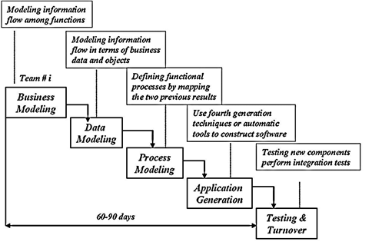

**RAD Model Phases:**

1. **Requirements Planning:** In this phase, the project scope and requirements are identified. The most critical and high-priority features are selected for rapid development.

2. **User Design:** User interfaces, user interactions, and overall system design are developed based on the requirements. This phase aims to create a mockup or prototype of the software's user interface.

3**. Construction:** Actual coding and development of the software take place during this phase. Rapid development tools and techniques are employed to quickly build functional components.

4. **Cutover:** In this phase, the final system is deployed, and data migration or system integration tasks are carried out.

**Advantages of the RAD Model:**

1. **Faster Development:** The RAD model's focus on rapid prototyping and iteration leads to quicker development cycles and faster time-to-market.

2. **User Involvement:** Regular user involvement and feedback help ensure that the software aligns well with user needs and expectations.

3. **Reduced Risk:** The iterative nature of the RAD model allows for early detection and mitigation of risks, leading to higher-quality software.

4. **Flexibility:** Changes in requirements can be incorporated more easily during the iterative development cycles, making the model suitable for projects with evolving specifications.

5. **Early Prototyping:** Rapid prototyping enables stakeholders to visualize and interact with the software early in the process, helping to identify any design flaws or misunderstandings.

6**. Higher User Satisfaction:** The model's emphasis on involving users and incorporating their feedback can result in a product that better meets their needs.

**Disadvantages of the RAD Model:**

1. **Dependency on User Availability:** The model requires active user involvement throughout the development process, which can be challenging if users are unavailable or too busy.

2. **Complexity and Integration Challenges:** Rapid development can lead to fragmented components that might be difficult to integrate into a cohesive system.

3. **Quality Control:** Rapid development might compromise proper testing and quality control practices, leading to the possibility of overlooking defects.

4. **Not Suitable for Large Systems:** The RAD model might not be well-suited for complex and large-scale projects due to the potential for chaos in managing various iterations.

5. **Limited Reusability:** Rapid development techniques might prioritize speed over code reusability and maintainability, which can have long-term consequences.

6. **Lack of Documentation:** Rapid iterations might lead to insufficient documentation, making it challenging for future maintenance and updates.

7**. Inadequate Scope Definition:** If the initial scope and requirements are not well-defined, the RAD model's flexibility might lead to scope creep.

In summary, the RAD model is an effective approach for projects where speed and user feedback are essential. Its iterative nature and focus on rapid prototyping make it suitable for projects with evolving requirements and constrained timelines. However, careful planning, coordination, and adequate quality assurance measures are required to ensure that the benefits of rapid development do not compromise the software's overall quality and maintainability.