ELECTRIC VEHICLE
BATTERY HEALTH PREDICTION
Exploratory Data Analysis & Data Preprocessing Report

Prepared by: Ansh Gupta and Anjali Jha
Group: Ember
Project scope: EDA and initial data preprocessing
Dataset file: ev_battery_data.csv

Abstract
This project examines an electric-vehicle battery dataset to understand its structure, data quality, battery-related measurements, State of Health (SOH), Remaining Useful Life (RUL), and high-risk labels. The work focuses on exploratory data analysis (EDA) and initial preprocessing only; no predictive model or dashboard is developed in this report. The supplied dataset contains 18,090 records and 17 columns. The initial inspection identified 90 exact duplicate rows and 1,172 missing cells, concentrated in four measurement columns. Duplicate rows were removed, missing values in selected numeric input features were filled with medians, and selected categorical features were filled with their modes. The resulting working dataset contained 18,000 rows and no missing cells in the validation output reported during the project.

1. Introduction
Electric vehicles rely on battery packs whose performance and usable capacity can change with operating conditions and charging history. Battery State of Health describes battery condition relative to an appropriate reference, while Remaining Useful Life estimates the remaining service or cycle life under a defined criterion. Exploring battery telemetry can help identify patterns, data-quality problems, and variables that may be useful for later analysis.
This stage of the project is limited to understanding and preparing the dataset. EDA can reveal associations and unusual observations, but it does not by itself establish causation or demonstrate predictive accuracy.

2. Problem Statement
The project aims to explore EV battery records and prepare a consistent dataset for later battery-health analysis. The immediate task is to inspect the dataset, visualize important variables, identify missing and duplicate records, check logical ranges, and create a cleaned CSV without training a machine-learning model.

3. Objectives
- Inspect the number of records, variables, data types, and descriptive statistics.
- Explore the distributions of SOH, RUL, and high-risk labels.
- Visualize relationships between SOH and selected battery measurements.
- Examine correlations among numerical variables and inspect timestamp-based trends.
- Identify missing values, exact duplicates, and potentially suspicious values.
- Apply transparent initial preprocessing and save a cleaned dataset.

4. Dataset Description
The supplied CSV has 18,090 rows and 17 columns before preprocessing. It contains 60 unique vehicle IDs and 60 unique battery IDs. The timestamp field supports chronological inspection. The dataset includes operational measurements, battery descriptors, two health-related numeric fields, and a binary high-risk flag.
Category | Columns
Identifiers / time | vehicle_id, battery_id, timestamp
Electrical / operating measurements | battery_voltage_V, battery_current_A, battery_temperature_C, state_of_charge_pct
Usage / charging | charge_cycle_count, charging_duration_min, fast_charging_frequency, driving_distance_km
Battery descriptors | battery_capacity_Ah, battery_chemistry, climate_zone
Health-related fields | state_of_health_pct, remaining_useful_life_cycles, high_risk_flag

5. Tools and Libraries
Python was used in Jupyter Notebook. The workflow uses pandas and NumPy for data inspection and processing, Matplotlib for plotting, and Seaborn for statistical visualizations.

6. Exploratory Data Analysis

6.1 Dataset structure and descriptive statistics
The dataset includes 18,090 records before cleaning. The SOH values range from 63.413% to 100.000%, while RUL values range from 0 to 5,795 cycles. These are observed ranges in this file, not guarantees about all EV batteries.

6.2 Missing values and duplicate records
Column | Missing count | Percent of rows
battery_voltage_V | 270 | 1.49%
battery_temperature_C | 361 | 2.00%
state_of_charge_pct | 181 | 1.00%
driving_distance_km | 360 | 1.99%

The initial dataset contained 1,172 missing cells and 90 exact duplicate rows. Missing values were reported in battery_voltage_V (270), battery_temperature_C (361), state_of_charge_pct (181), and driving_distance_km (360). The exact duplicate rows were removed before further preprocessing.

6.3 State of Health distribution
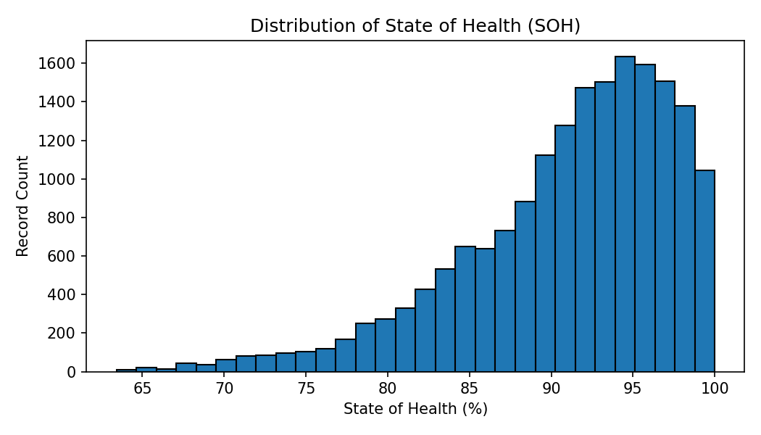
The histogram shows the distribution of SOH observations in the supplied data. The reported SOH range is 63.413% to 100.000%. Any claims about skewness or concentration should be based on the plotted histogram and descriptive statistics.

6.4 High-risk flag distribution
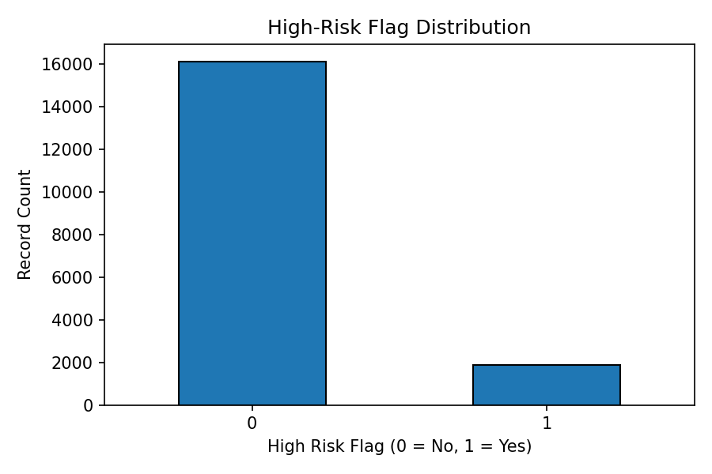
High-risk flag | Records | Percentage
0 | 16124 | 89.58%
1 | 1876 | 10.42%

The flag uses binary values 0 and 1. The count plot is included to inspect class prevalence; the flag's meaning and labelling rule should be confirmed from the dataset documentation before further use.

6.5 SOH vs. charge cycle count
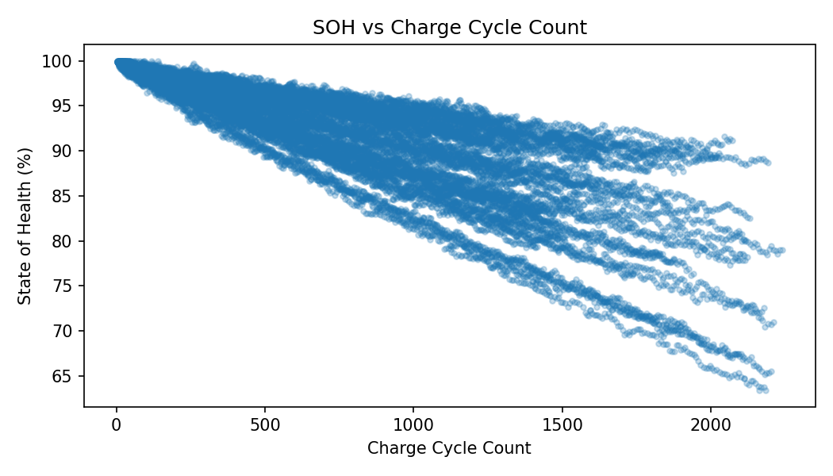
This scatter plot explores whether SOH varies with charge_cycle_count. The plot is descriptive and does not prove that cycle count alone causes a change in SOH.

6.6 SOH vs. battery temperature
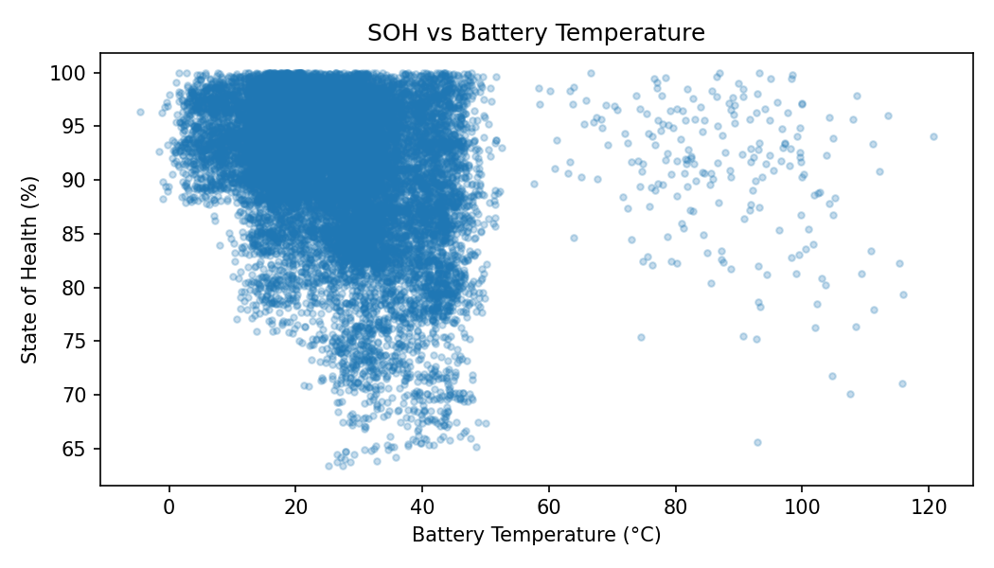
This plot explores the association between measured battery temperature and SOH. Missing temperature observations are naturally omitted from this particular visualization.

6.7 Correlation analysis
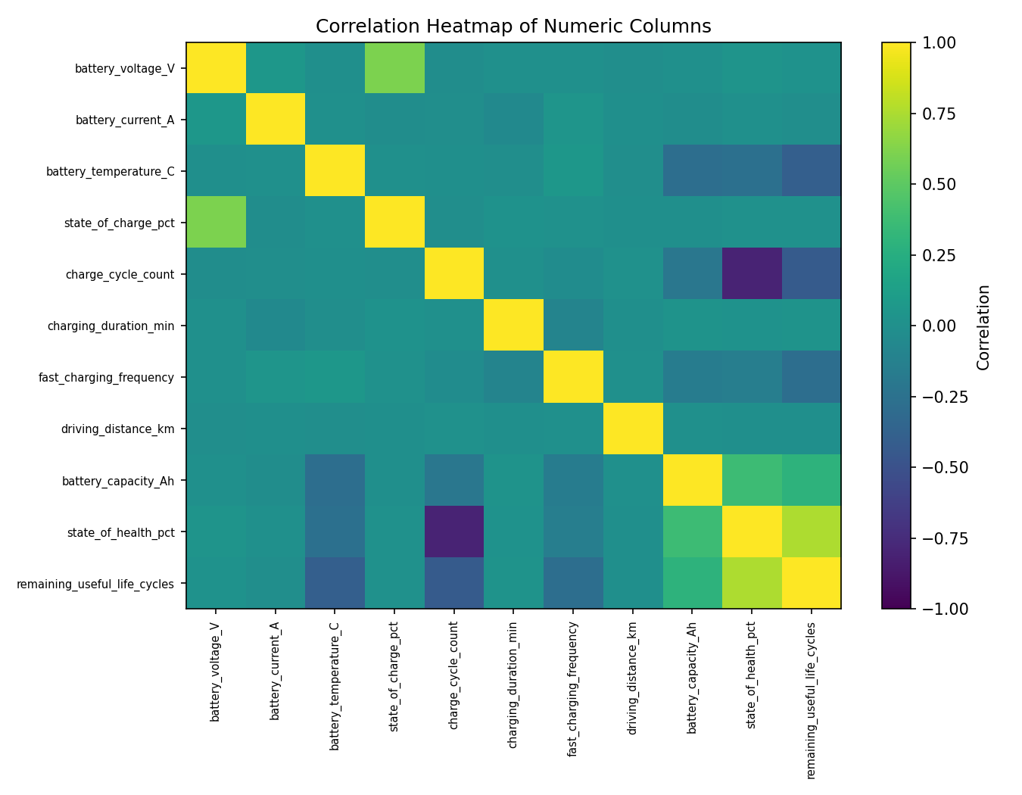
The heatmap summarizes pairwise linear correlations among numeric columns. Identifier fields and the binary high-risk label were excluded from this heatmap. Correlation does not establish causation, and relationships with health-related target columns require care in any future modelling workflow.

7. Data Quality Checks
- Exact duplicate rows were counted before cleaning and removed from the working dataset.
- Missing-value counts were inspected by column.
- Timestamp values were converted to datetime format, with invalid conversions represented as NaT for inspection.
- Logical range checks were applied to percentage, cycle, duration, distance, capacity, and RUL fields.
- Repeated battery-timestamp combinations should be investigated rather than automatically removed, since repeated readings may be legitimate.

8. Data Preprocessing Methodology
The working dataset was created as a copy so that the original CSV remained unchanged.
Step | Method
Duplicate handling | Removed exact duplicate rows only.
Numeric input features | Filled missing values with each column's median for selected input measurements.
Categorical input features | Filled missing values with the mode for battery_chemistry and climate_zone when needed.
Timestamp | Converted timestamp to datetime using errors='coerce' to make invalid values identifiable.
Target fields | Did not intentionally impute SOH, RUL, or high_risk_flag; missing target values were checked separately.
Export | Saved the processed working data as ev_battery_cleaned.csv.

Median and mode imputation are simple baseline choices. They may not preserve temporal patterns or battery-specific behaviour. A later modelling pipeline should fit imputation rules on training data only to avoid information leakage.

9. Validation Results
Validation item | Observed result
Original shape | 18,090 rows × 17 columns
Exact duplicates before cleaning | 90
Rows after duplicate removal | 18,000
SOH range | 63.413%–100.000%
RUL range | 0–5,795 cycles
High-risk flag values | 0, 1
Missing cells after preprocessing | 0 (based on the preprocessing procedure applied here)

The validation output shared during the notebook work reported zero remaining exact duplicates, zero missing cells, SOH from 63.413 to 100.0, RUL from 0 to 5795, and high_risk_flag values 0 and 1. The exact post-cleaning missing-cell result depends on rerunning the notebook cells in order; invalid timestamps and suspicious physical values still require review.

10. Limitations
- The data source and collection procedure have not been independently verified in this report.
- The report does not establish whether the dataset represents real-world telemetry or simulated records; conclusions should be limited to the supplied file.
- Some measurement values may be physically unusual and require domain-specific validation.
- Median imputation may obscure time-dependent or battery-specific patterns.
- No model was trained, so no predictive accuracy, generalization, or deployment readiness is claimed.
- A high-risk flag's definition and generation method should be documented before drawing operational conclusions.

11. Conclusion
This project stage completed an exploratory review and initial preprocessing of the supplied EV battery dataset. The workflow examined the dataset structure, missing values, duplicates, SOH and RUL ranges, high-risk label distribution, selected SOH relationships, correlations, and timestamp-based trends. Exact duplicates were removed, selected missing input measurements were imputed, categorical input gaps were handled where necessary, and the processed data was exported to CSV. The dataset is now prepared for further validation and, if required in a later project phase, a carefully designed modelling workflow. No predictive model or dashboard was built as part of this report.

Appendix A: Dataset columns
- vehicle_id
- battery_id
- timestamp
- battery_voltage_V
- battery_current_A
- battery_temperature_C
- state_of_charge_pct
- charge_cycle_count
- charging_duration_min
- fast_charging_frequency
- driving_distance_km
- battery_capacity_Ah
- state_of_health_pct
- battery_chemistry
- climate_zone
- remaining_useful_life_cycles
- high_risk_flag

Appendix B: Reproducibility note
Keep ev_battery_data.csv, ev_battery_cleaned.csv, and EV_Battery_EDA_From_Scratch.ipynb together in the project folder. Run the notebook from the first cell to the last cell. If the cleaned CSV is regenerated, re-check the final row count, missing-value summary, duplicate count, and target ranges before submission.

