1.

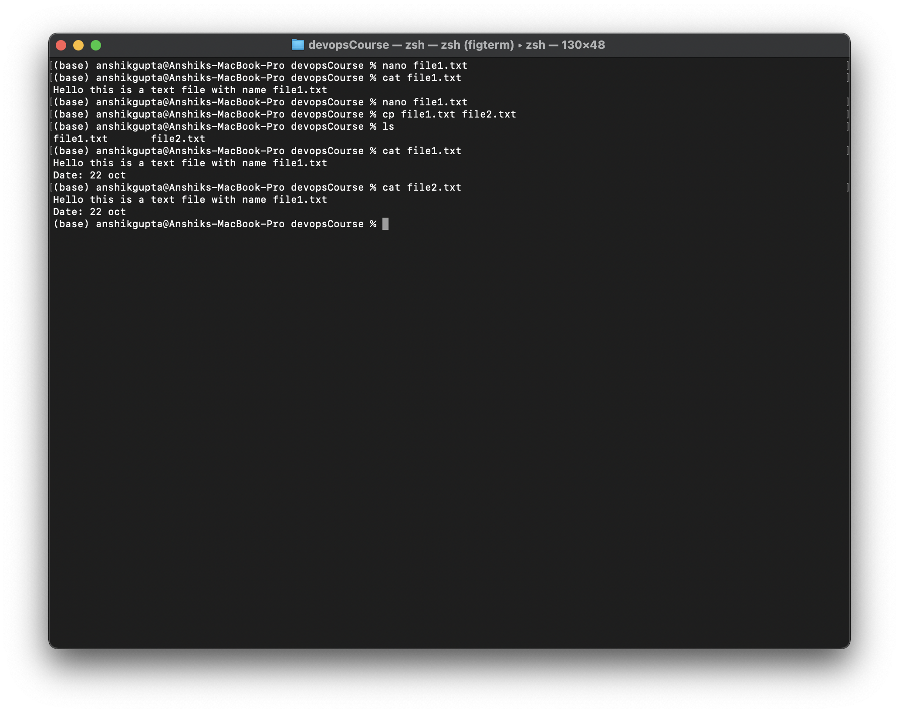

2.

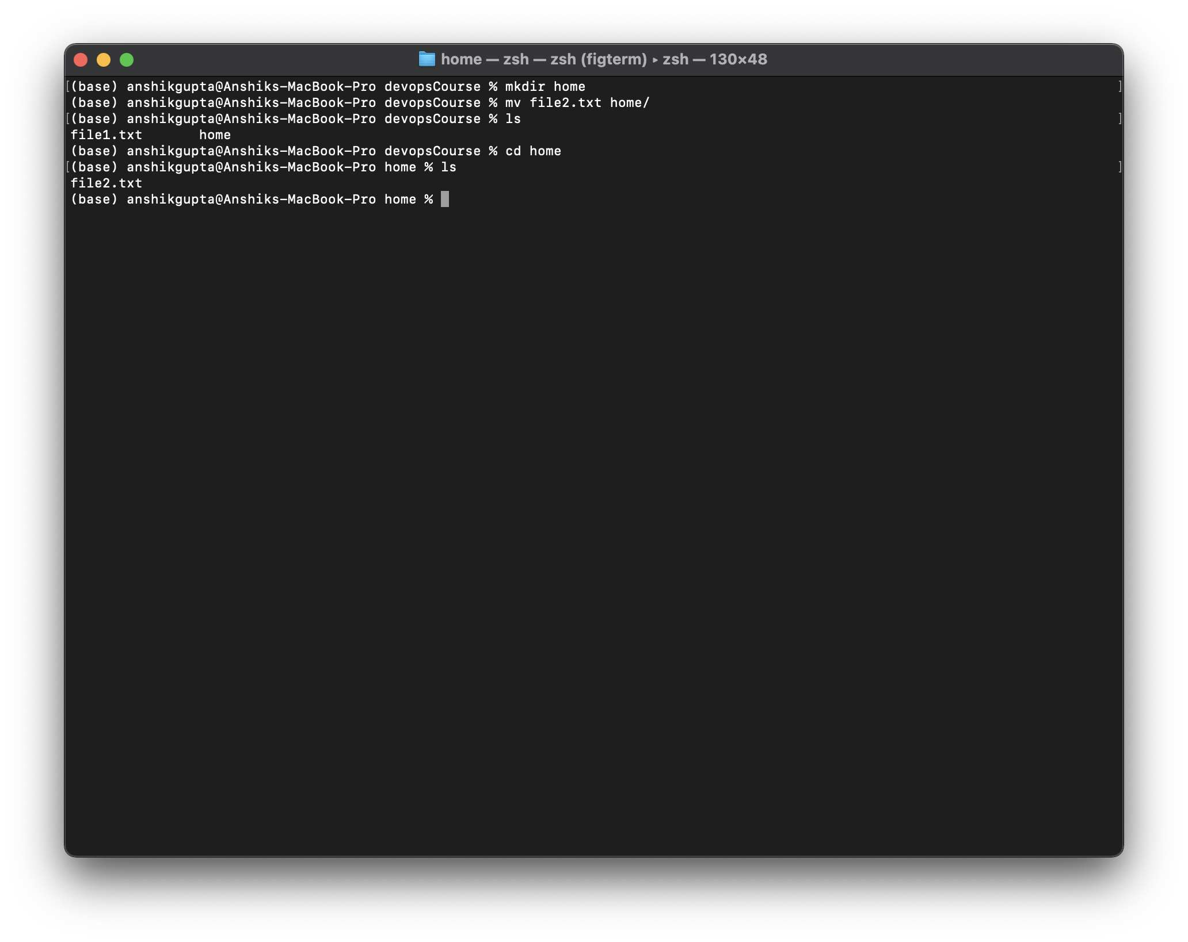

3.

**Output of file3.txt**

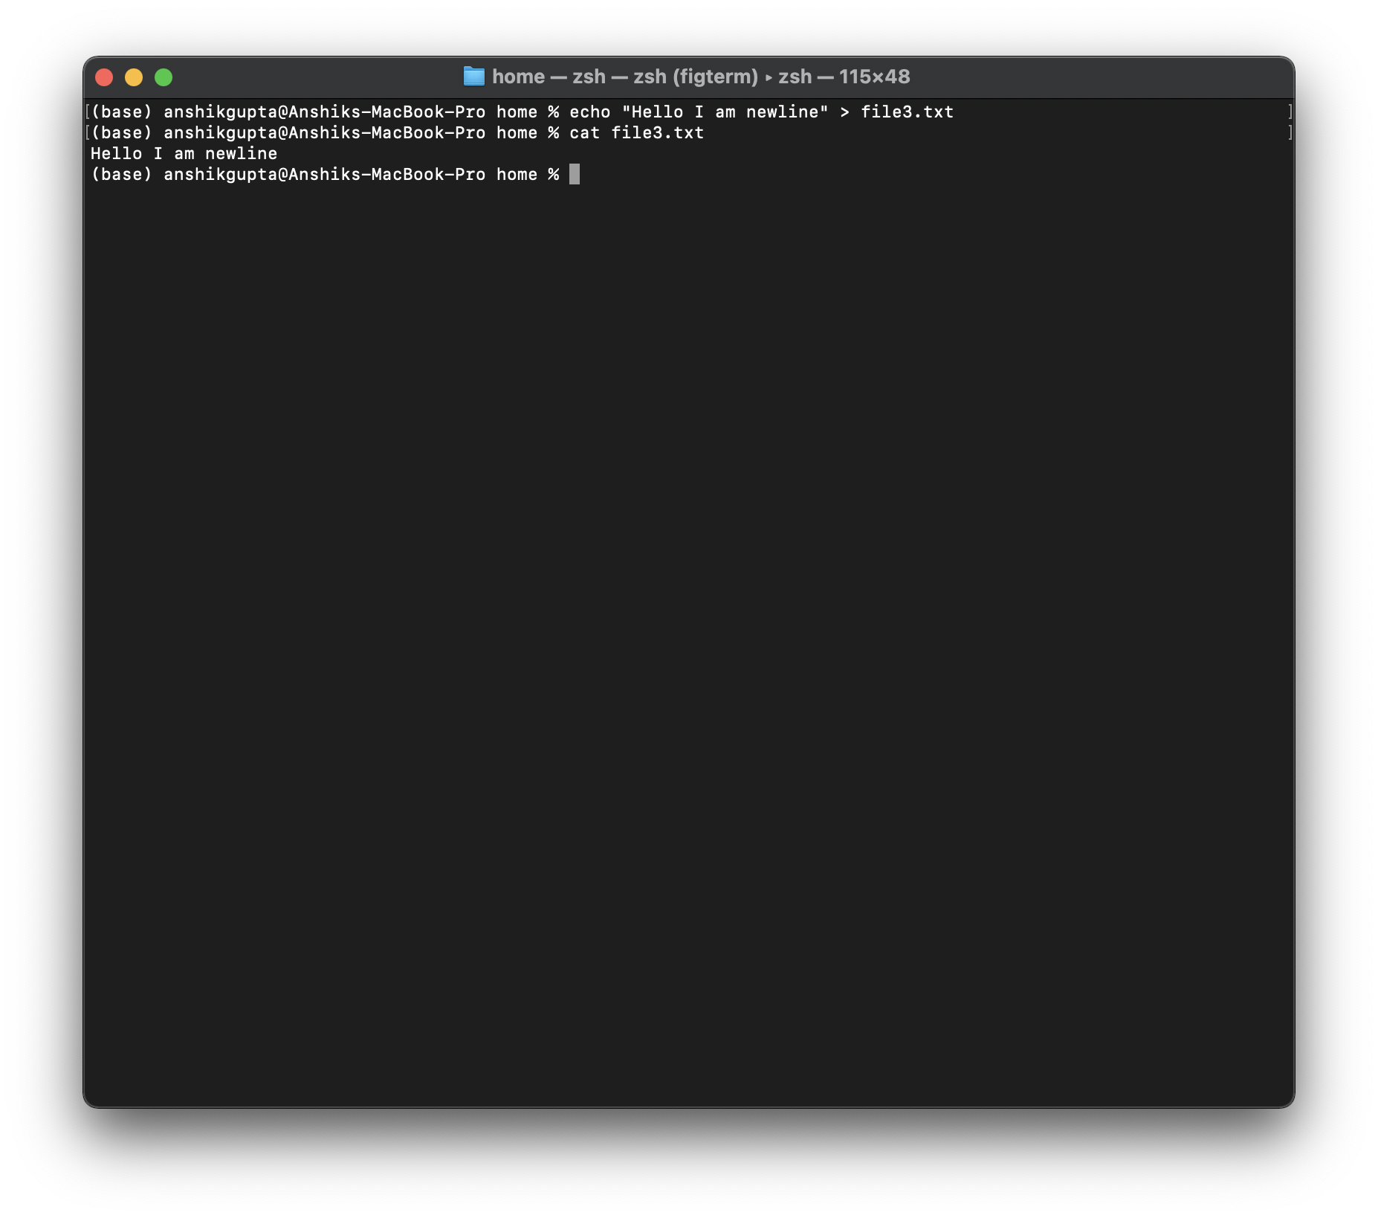

**Output of file4.txt**

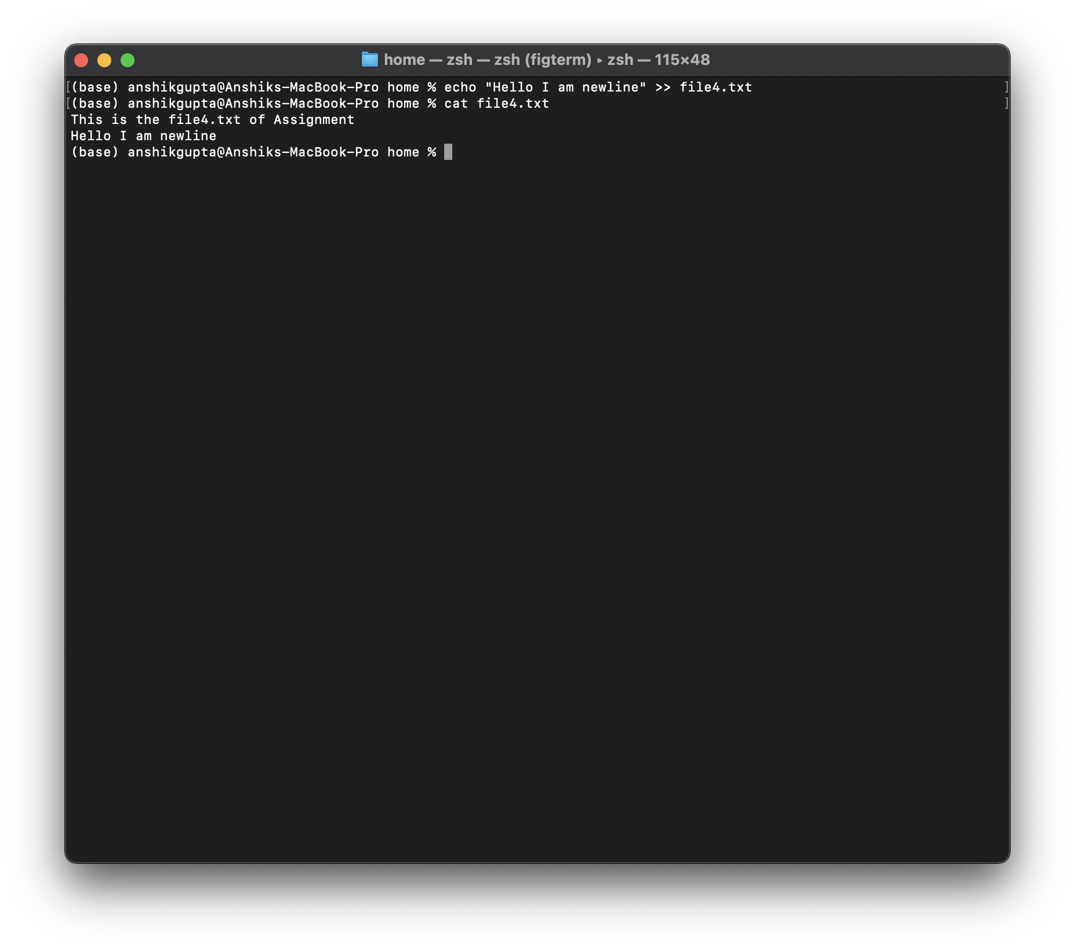

**Difference:** On using (>), the content of the file got overridden but when (>>) is used, the content of the file is not overriden but the new content is appended with the old content.