**Bubble Trouble**

**Anuj Gupta  
21D070014**

**Features in the game:**

**Basic Features:**

1. The bubble movement has been modified to incorporate vertical motion such that the bubbles travel in a parabolic path.

When the ball hits the horizontal ground, it bounces off the ground.

2. Since the game features the EXTRA FEATURE 1, the smallest bubble with threshold radius(10) disappears after a bullet hits it.

After the collision, bullet disappear too. When all the bubbles disappear, the game displays a "Congratulations!!" message while everything else freezes.

3. Since the game features the EXTRA FEATURE 2, collision between the bubble and the shooter decreases health by 1;

the shooter is dead when the health gets 0 and game gets over.

**Extra Features:**

1. The game involves bubbles of different sizes (maximum being 4*Threshold radius). When a bullet hits the larger bubble, it splits into smaller bubbles

(half the radius of the original larger bubble) and they starts moving in horizontally opposite directions.

The smallest bubble with threshold radius(10) disappears after a bullet hits it.

2. There is also a score, time(of app. 50 seconds) and a health counter. The score increases by 1 whenever a bullet hits a

bubble. Total health given is 3 and it decreases by 1 whenever a bubble hits the shooter, the shooter is dead when the health gets 0 .

The game gets over when we run out of time (measured in seconds) or if the health gets 0 and displays a "Game Over" message while everything else freezes.

Link for the Demo Video

<https://drive.google.com/file/d/1WDr4nJvu5DuUewoP7DOBXn8oCGAcpM_-/view?usp=sharing>  
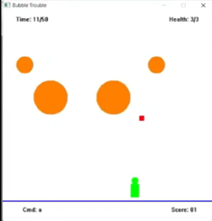 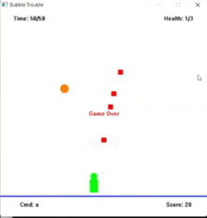  
 **Demo Images**