**Portable current indicator-cum-controller for panel mounting**

Harish Mokashi Mayank Gupta Anuj Gupta Vansh Aggarwal

[210070053@iitb.ac.in](mailto:210070053@iitb.ac.in) [210101002@iitb.ac.in](mailto:210101002@iitb.ac.in) [21d070014@iitb.ac.in](mailto:21d070014@iitb.ac.in) [210070091@iitb.ac.in](mailto:210070091@iitb.ac.in)

**Introduction**

This is a lightweight, easy-to-use, accurate, current controller and indicator for researchers experimenting with electronics to obtain and control current values accurately, set manually or using a computer (UART). The voltage rating is 5V, and the current can be varied in the range 0-3A.

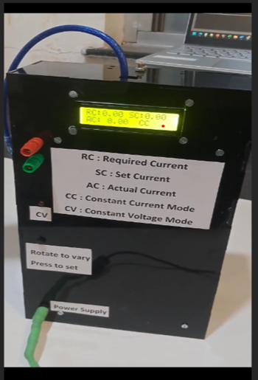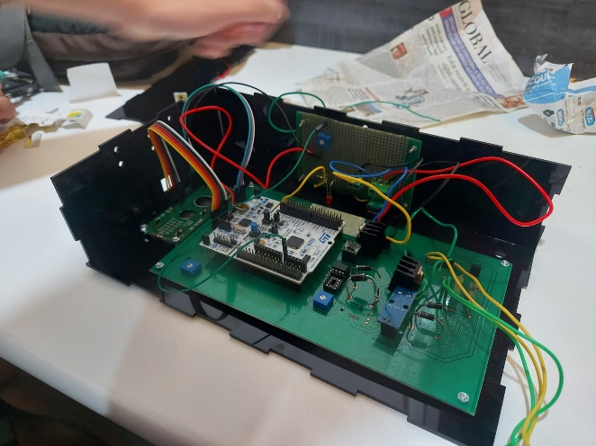

The components used:

* STM-32 microcontroller
* 2 TS912 opamps
* 2 TIP41C BJTs
* MCP4921 DAC
* ACS912 5A current sensor
* JHD162a 16 $×2$ LCD display
* Rotary Encoder (pec12r-2220f-s0024)
* Power Resistors

The basic idea is to change the input voltage of opamps using a Digital-to-Analog converter operated using an STM-32 microcontroller. The output of each opamp drives a BJT to regulate the current. These two Opamp-BJT systems are connected in parallel; therefore, the actual current is the sum of currents from each BJT.

The user can set the current using either a rotary encoder or through UART from the laptop. The resulting current is displayed on the LCD or the laptop screen. Moreover, depending on the mode being constant current or constant voltage, an LED would remain off or on.

Below is the overall block diagram of our device:

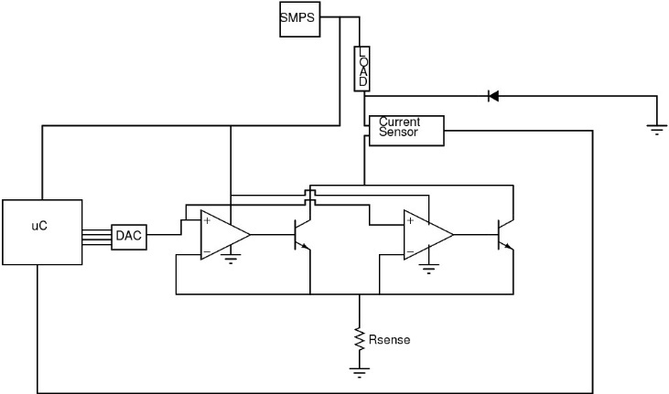

Below is the schematic of our circuit:

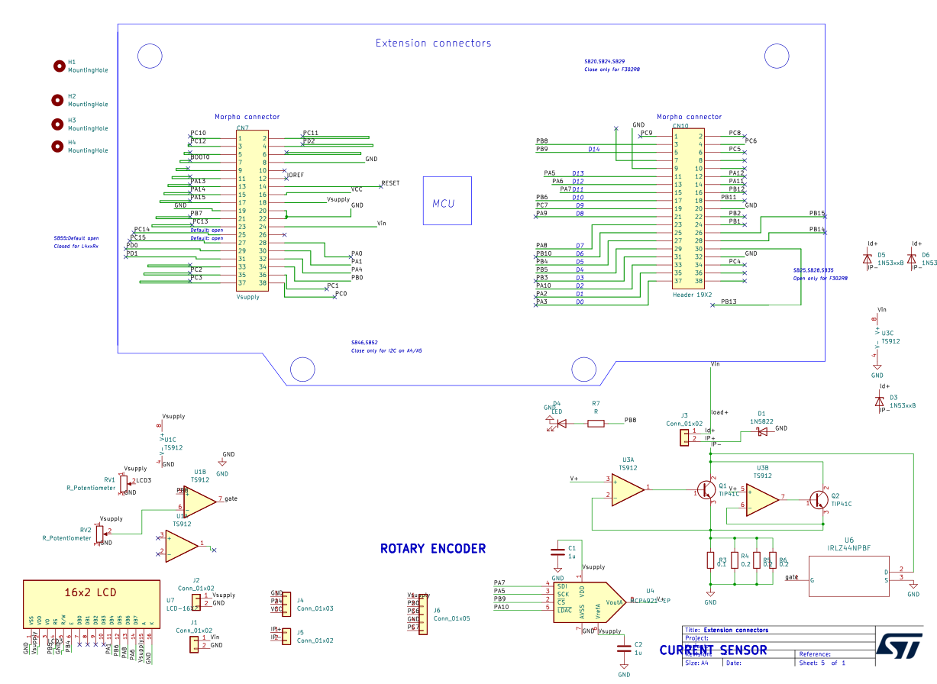

**Modes of Operation**

Our device has two modes of operation: constant voltage (CV) mode and constant current (CC) mode. Since the maximum voltage across the load is 5V, the maximum current the load can draw would be simply 5/R A, where R is the load resistance.  
After setting the current, the device goes into CV mode if the set current is greater than the maximum current that can be drawn by the load; otherwise, it goes into CC mode and draws a current equal to the set current.

**Control Mechanism**

After pressing the rotary set button, the device goes into a transition phase where it employs a PD mechanism to converge to the required current.   
When the device is in CV mode, the voltage across the load is also maintained at 5V using a PD control. The ADC of the STM32 reads the voltage value at the lower end of the load; the other end is connected to 9V input and tries to maintain it close to 4 V by varying the current across the load.