UX CASE STUDY
Zomato
Analyzing the food-delivery user journey, strengths and weaknesses, and three evidence-based improvements

UI/UX Design — Task 3
CodeAlpha Internship · codealpha.tech
August 2026

1. About the Product
Zomato is India's leading food-delivery app, part of Eternal Limited (renamed from Zomato Ltd in 2025), which also owns quick-commerce app Blinkit and B2B supply arm Hyperpure. Zomato began as a restaurant-discovery and review platform before expanding into delivery; in 2025 its dining-out, movies, and events booking features were spun off into a separate app, District, leaving the Zomato app focused specifically on food ordering and delivery. This case study evaluates that core food-delivery experience: browsing restaurants, ordering, paying, tracking, and resolving issues.

2. Methodology
This is a heuristic evaluation, not a moderated usability study. The journey map and pain points below are built from (a) a structured walkthrough of the current ordering flow, evaluated against Nielsen's usability heuristics, and (b) a synthesis of publicly posted user reviews from Trustpilot, PissedConsumer, G2, and Capterra dated across 2026, used to identify recurring, independently-reported friction points rather than one-off complaints. Where a weakness is cited from reviews, it reflects a pattern across many reviewers, not a single anecdote.

3. User Journey Map
Stage | User goal | Key touchpoints | Friction / emotion
1. Discover | Decide what/where to eat | App open, location detect, home feed, banners | Neutral–positive; feed is fast and visually appealing
2. Browse & choose | Compare restaurants/dishes | Search, filters, ratings, menu, photos | Positive; menus are described as accurate and easy to follow
3. Order & pay | Complete purchase with confidence | Cart, coupon field, fee summary, payment | Mixed; delivery/platform fees often only fully clear at final step
4. Track | Know when food will arrive | Live map, rider status, ETA | Mixed; ETA and tracking sync issues reported during peak hours
5. Receive | Get the correct, complete order | Handover, packaging, item check | Negative when items are missing/wrong — a recurring complaint
6. Post-order | Resolve issues / rate experience | Chat support, refund flow, rating prompt | Negative; refunds seen as slow, partial, or hard to escalate
Table 1 — the core ordering journey, from app open to post-order resolution.

4. Strengths
- Accurate, well-structured menus — menus were repeatedly described as accurate and easy to follow, reducing pre-order uncertainty.
- Low-friction browsing & ordering — reviewers highlight a friendly, easy-to-navigate interface and a fast path from search to order.
- Strong packaging quality — food is reported as arriving well packed, with sturdy containers — a detail several reviewers called out unprompted.
- Real-time restaurant-side tools — restaurant partners praise real-time menu and item-availability toggles, which keeps what customers see closer to what's actually sellable.
- Broad discovery — wide restaurant selection with ratings and filters makes discovery feel comprehensive rather than limited.

5. Weaknesses
- Slow, opaque refunds — PissedConsumer aggregates a 1.4/5 average across ~9,600 reviews, with refunds and billing as the top cited reason; multiple reviewers describe partial refunds with no visible breakdown of how the amount was calculated.
- Support is hard to escalate — several reviewers report support is chat-only, with listed phone numbers described as switched off or invalid — frustrating during time-sensitive delivery issues.
- Order accuracy issues — missing or substituted items (e.g., an order arriving without one dish) appear repeatedly, with the current recovery path requiring a multi-step chat conversation.
- Fee transparency — reviewers on G2 and Trustpilot describe delivery and platform fees as high and, in some cases, unclear until the final payment step.
- Inconsistent policy disclosure — a Trustpilot reviewer describes a restaurant time-limit policy that wasn't shown at booking — a smaller but related transparency gap outside pure delivery.

6. Three Proposed Improvements
Each improvement below targets a specific, review-backed pain point above, and is illustrated with a low-fidelity sketch showing the concept on the existing screen it would modify.

6.1 Self-Serve Refund & Dispute Tracker
Problem: refund status is currently opaque — communicated only through chat, with no visibility into stage or reasoning, which is the single most cited complaint in the reviews sampled.
Solution: a persistent 4-stage tracker (Reported → Under review → Refund approved → Credited) attached to the order, with a live status label, an itemized "refund breakdown" so the user sees exactly what was approved, and automatic escalation to a human agent if a stage exceeds its SLA.
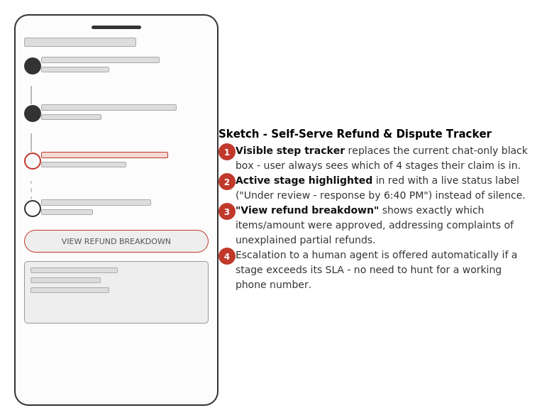
Fig. 1 — refund tracker concept, applied to the existing order-status screen.

6.2 Packing Checklist & Missing-Item Reporting
Problem: missing or wrong items are a recurring complaint, and today's recovery path (chat, re-explaining the order, waiting for a decision) is slow and inconsistent.
Solution: a restaurant-side packing checklist where staff confirm each item with a photo before handover, mirrored on the customer's tracking screen so any substitution is visible immediately — plus a one-tap "Report missing/wrong item" that pre-fills the order and photo evidence instead of starting a fresh chat.
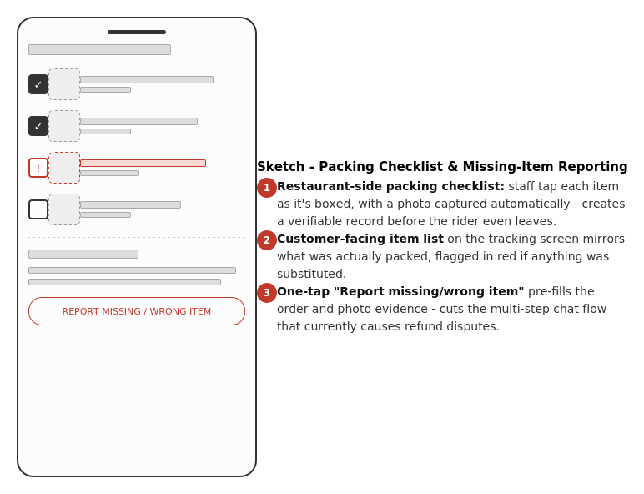
Fig. 2 — packing checklist concept, applied to the order-tracking screen.

6.3 Upfront, Itemized Fee Breakdown
Problem: delivery and platform fees are reported as high and, more importantly, not fully visible until the final payment screen — creating a "surprise charge" moment that erodes trust even when the fee itself is reasonable.
Solution: every fee line gets a tappable "i" explaining what it funds, the full breakdown is shown on the cart screen rather than only at payment, and a highlighted callout explains in plain language when and why a total has changed since a previous visit (e.g., surge demand).
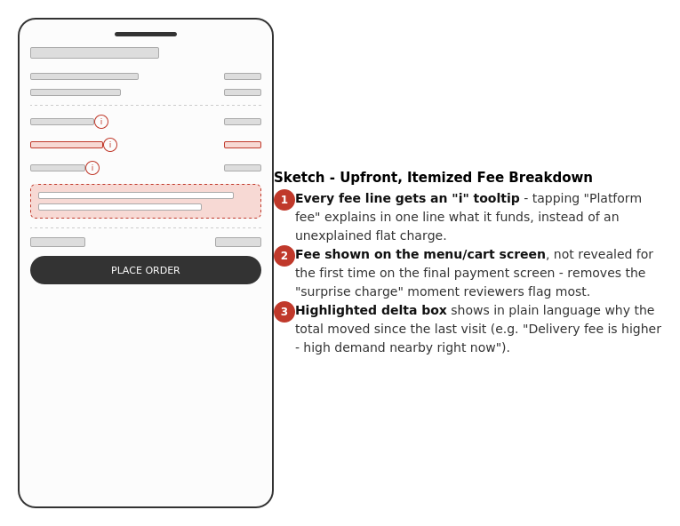
Fig. 3 — fee transparency concept, applied to the cart screen.

7. Conclusion
Zomato's core browsing-to-order flow is well regarded — accurate menus, an easy interface, and good packaging come through consistently in user feedback. The recurring friction sits after the order is placed: when something goes wrong, users can't see what's happening, can't easily prove what they received, and are often surprised by the final cost. The three improvements above don't change Zomato's visual design or core flow — they add visibility at exactly the three moments (refunds, order accuracy, and fees) where its own users say trust currently breaks down.

