
Dashboard Design

Date | 24 September 2024
Team ID | SKILLBRIDGE-01
Project Name | Global Olympic Performance Analysis
Maximum Marks | 5 Marks

Creating an effective dashboard involves thoughtful design to ensure that the presented information is clear, relevant, and easily understandable for the intended audience. Here are some key principles and best practices for dashboard design
Activity 1: Interactive and visually appealing dashboards
Creating interactive and visually appealing dashboards involves a combination of thoughtful design, effective use of visual elements, and the incorporation of interactive features. Here are some tips to help you design dashboards that are both visually appealing and engaging for users so take care of below points
- Clear and Intuitive Layout
- Use Appropriate Visualizations
- Colour and Theming
- Interactive Filters and Slicers
- Drill-Down Capabilities
- Responsive Design
- Custom Visuals and Icons
- Use of Infographics

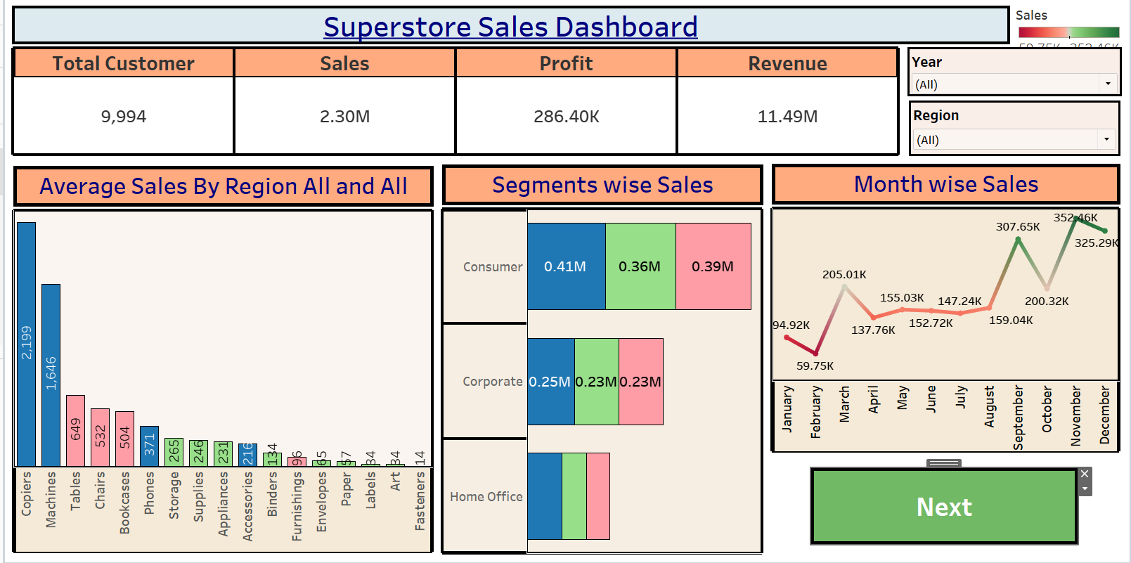
Note: Highlight the major outcomes in form of bullet points
Sample:
Here are five key analytical outcomes from the Global Olympic Performance dashboards:
- • Global Participation Scale: The historical dataset covers comprehensive participation across hundreds of nations, tracking thousands of athletes from inception to modern Olympic games.
- • Dominant Nations in Medal Counts: Leading countries such as the USA, Germany, France, and Russia consistently capture the highest share of total medals across Summer and Winter games.
- • Gender Equity Evolution: Historical trend analysis reveals a remarkable growth in female athlete participation over successive decades, reflecting significant strides in Olympic inclusivity.
- • Peak Age Demographics: Athlete age distribution analysis shows peak participation concentrated heavily in the 20 to 30 age bracket across major athletic disciplines.
- • Top Sports by Engagement: Athletics, Aquatics (Swimming), and Gymnastics represent the sports with the highest athlete participation and fan engagement globally.

Activity 2
Publish Dashboard on Tableau Public and Paste the Dashboard Public link below:
Example
https://public.tableau.com/app/profile/global.olympic.performance.analysis/viz/GlobalOlympicPerformanceAnalysis/Story1

