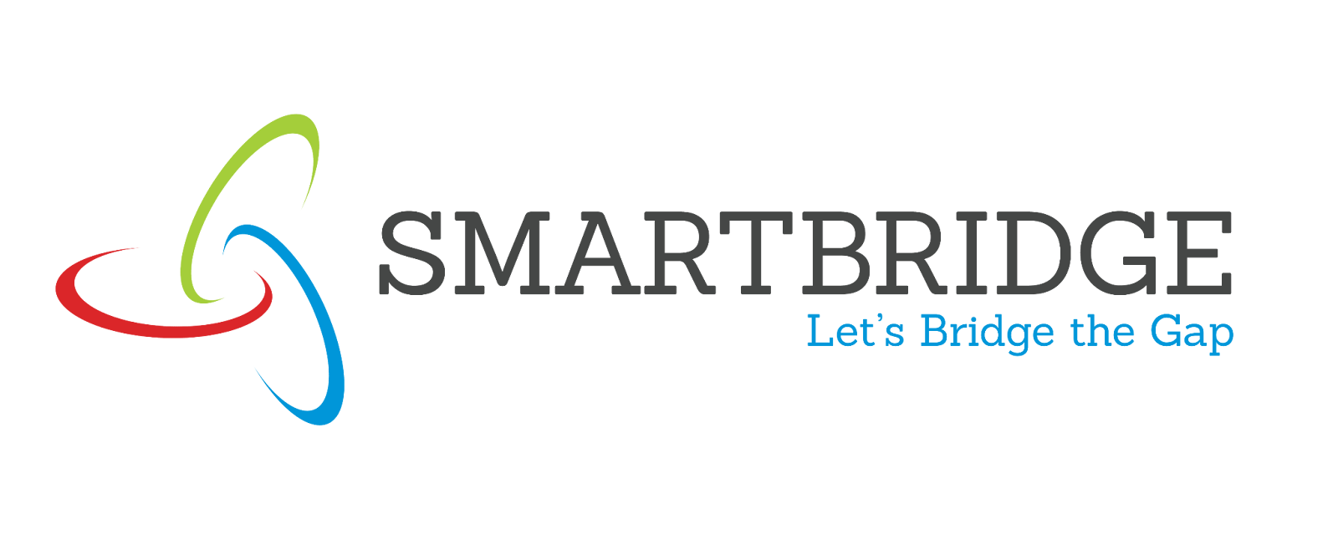
Story

Date | 24 September 2024
Team ID | SKILLBRIDGE-01
Project Name | Global Olympic Performance Analysis
Maximum Marks | 5 Marks

By using stories in Tableau, you can effectively communicate complex data in a way that is both interactive and engaging, making it easier for the audience to follow along and understand the insights. It’s a tool for data storytelling, allowing you to present insights in a cohesive, engaging way that takes viewers through a logical progression of findings or analyses.
In Tableau, Story is a feature that allows you to create a sequence of dashboards, visualizations, and text to present data insights in a cohesive and narrative-driven way. It's like a slideshow within Tableau that guides the audience through a series of data points, helping them understand key insights, trends, or outcomes of your analysis.

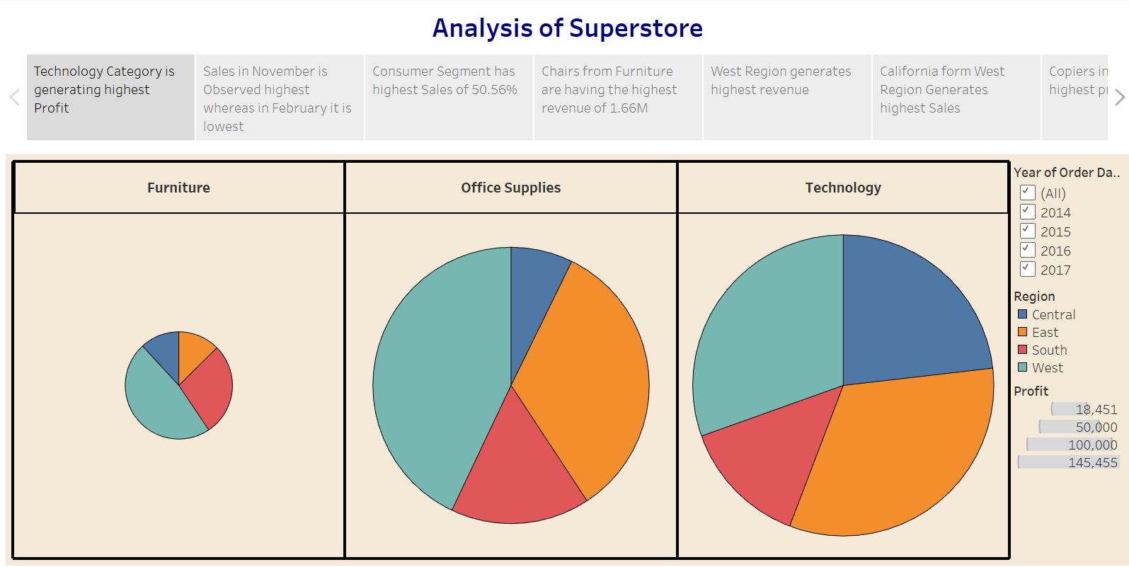

Observations:
- • Global Country Participation: The USA, Germany, France, and other major nations lead in overall athlete participation across historical Olympic games.
- • Medal Distribution Insights: Medal counts highlight the consistent dominance of top-tier nations in securing Gold, Silver, and Bronze medals.
- • Gender Inclusivity Growth: Historical trends show significant growth in female athlete representation over successive Olympic cycles.
- • Peak Athlete Age: Age distribution analysis indicates that peak athletic performance and participation are heavily concentrated between the ages of 20 and 30.

Activity 2:
Publish Story on Tableau Public and Paste Public link below
https://public.tableau.com/app/profile/global.olympic.performance.analysis/viz/GlobalOlympicPerformanceAnalysis/Story1

