DATA CLEANING & PREPARATION REPORT
DecodeLabs Industrial Training Program 2026
Project 1: Data Cleaning & Preparation
By: Bandana Gupta
Program: Data Analytics Internship
Organization: DecodeLabs
Dataset: Snitch Fashion Sales Dataset
1. Introduction
Data cleaning is one of the most important stages of the data analytics process. Real-world datasets often contain missing values, duplicate records, inconsistent formats, and invalid entries that can affect analysis and decision-making.
The objective of this project was to clean and prepare a raw e-commerce sales dataset so that it becomes reliable, consistent, and ready for further analysis.
2. Dataset Overview
The dataset used for this project was the Snitch Fashion Sales Dataset, containing sales transaction records from an e-commerce fashion business.
Dataset Columns
- Order_ID
- Customer_Name
- Product_Category
- Product_Name
- Units_Sold
- Unit_Price
- Discount_%
- Sales_Amount
- Order_Date
- City
- Segment
- Profit
The dataset contained missing values, inconsistent text formatting, invalid numeric values, and duplicate records which required cleaning before analysis.
3. Problems Identified
The following data quality issues were detected during the initial assessment:
Missing Values
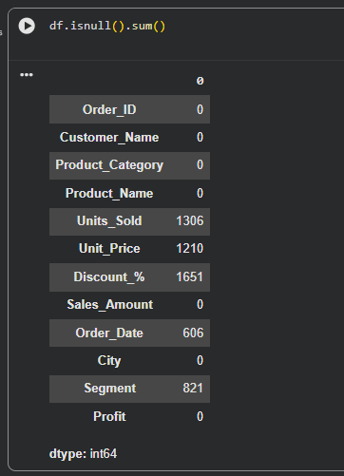
Additional Issues
- Duplicate records were present.
- Duplicate Order_ID values existed.
- Negative values were found in Units_Sold.
- Negative values were found in Sales_Amount.
- Discount values greater than 100% were detected.
- Date formats were inconsistent.
- City names contained formatting inconsistencies.
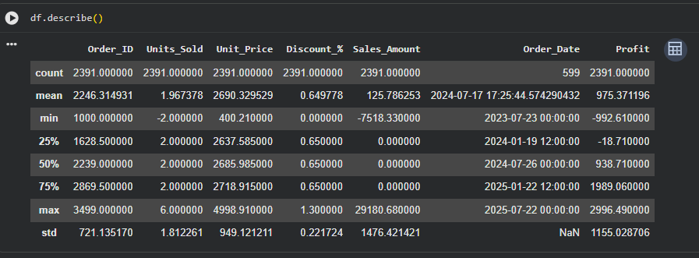
4. Data Cleaning Process
4.1 Handling Missing Values
Different imputation techniques were used depending on the type of data.
Numerical Columns
The following columns were filled using Median Imputation:
- Units_Sold
- Unit_Price
- Discount_%
Median was selected because it is less sensitive to outliers and provides a robust estimate of central tendency.
Categorical Columns
The following column was filled using Mode Imputation:
- Segment
Mode was selected because it represents the most frequently occurring category.
Date Column
Missing Order_Date values were converted into datetime format and replaced using the most frequently occurring valid date.
4.2 Removing Duplicate Records
Duplicate rows were identified and removed to ensure data uniqueness.
Additionally, duplicate Order_ID values were checked and removed to maintain transaction integrity.
4.3 Correcting Invalid Data
Several invalid values were detected and corrected:
Units Sold
Negative values were treated as invalid and replaced using the median value.
Sales Amount
Negative sales amounts were considered incorrect and replaced using the median sales amount.
Discount Percentage
Values exceeding 100% were considered unrealistic and replaced using the median discount value.
4.4 Data Standardization
The dataset was standardized to ensure consistency across all records.
Text Standardization
- Removed leading and trailing spaces.
- Converted text fields into proper title case.
- Standardized city names.
Date Standardization
All dates were converted into a consistent format:
YYYY-MM-DD
Numeric Standardization
Numeric columns were rounded to appropriate decimal precision.
5. Validation Results
After completing all cleaning operations, the dataset was validated.
Final Data Quality Checks
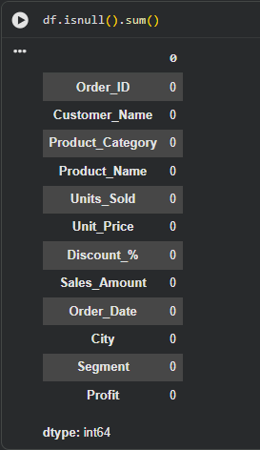
Standardized Cities 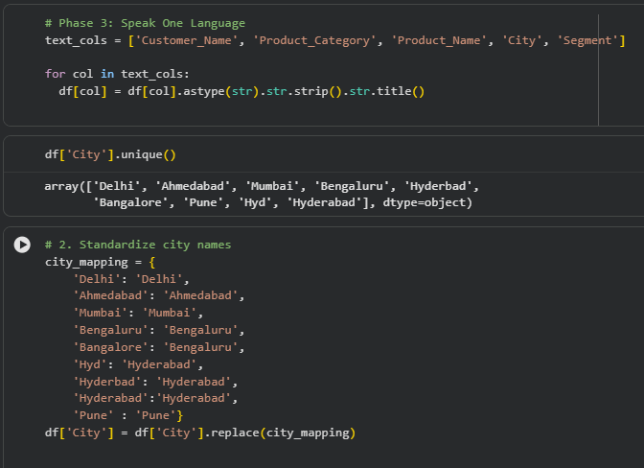
- Delhi
- Ahmedabad
- Mumbai
- Bengaluru
- Hyderabad
- Pune
The validation confirms that the dataset is clean, consistent, and ready for further analysis.
6. Conclusion
This project successfully transformed a raw and inconsistent sales dataset into a clean and analysis-ready dataset.
Key achievements include:
- Removal of missing values
- Elimination of duplicate records
- Correction of invalid numeric values
- Standardization of text and date formats
- Successful validation of data quality
The cleaned dataset can now be used confidently for exploratory data analysis, visualization, business intelligence reporting, and predictive analytics.

