AIM : To prepare a basic database for an e-wallet company using contraints like Primary key, Foreign key etc.
TABLES CREATED:

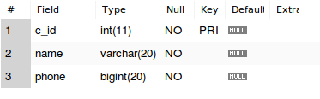
- Costumer

- Transactions

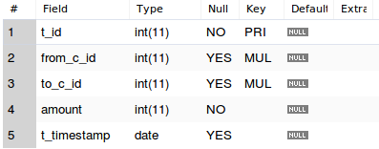

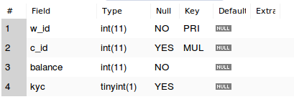
- Wallet

QUERIES RUN :

- SELECT * FROM costumer;
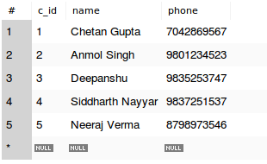

- SELECT * FROM transactions;
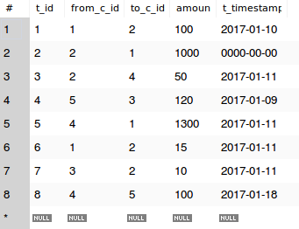

- SELECT * FROM wallet;

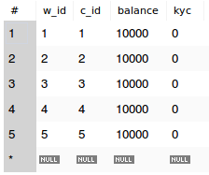

- INSERT INTO transactions VALUES(9, 12, 13, 100, "2017-01-12");

Error Code: 1452. Cannot add or update a child row: a foreign key constraint fails (`dbms_lab`.`transactions`, CONSTRAINT `transactions_ibfk_1` FOREIGN KEY (`from_c_id`) REFERENCES `costumer` (`c_id`))

