AIM : To use ALTER and UPDATE statements on the created database.

- ALTER TABLE costumer ADD age INTEGER;
- ALTER TABLE costumer ADD email VARCHAR(10);
- SELECT * FROM costumer;
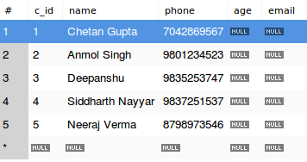

- ALTER TABLE costumer MODIFY email VARCHAR(50);
- UPDATE costumer SET age=20,email='abc@xyz.com' WHERE name='Chetan Gupta';
- UPDATE costumer SET age=21,email='abc123@xyz.com' WHERE name='Anmol Singh';
- UPDATE costumer SET age=21,email='qwerty@xyz.com' WHERE name='Deepanshu';
- UPDATE costumer SET age=21,email='asdfgh@xyz.com' WHERE name='Siddharth Nayyar';
- UPDATE costumer SET age=20,email='zxcvb@xyz.com' WHERE name='Neeraj Verma';
- SELECT * FROM costumer;

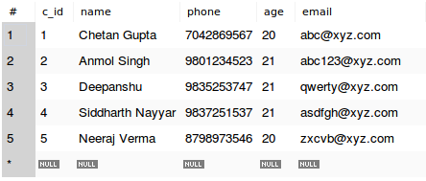

- SELECT name,amount,t_timestamp FROM costumer,transactions WHERE from_c_id=c_id AND amount<100;

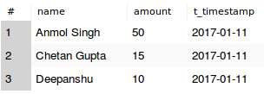

- UPDATE wallet SET balance=50000,kyc=1 WHERE w_id=1;
- UPDATE wallet SET balance=500 WHERE w_id=2;
- UPDATE wallet SET balance=1200,kyc=1 WHERE w_id=3;
- UPDATE wallet SET balance=1000 WHERE w_id=4;
- UPDATE wallet SET balance=3100 WHERE w_id=5;
- SELECT * FROM wallet;

