Ques1. .Create a directory "exercise" inside your home directory and create nested(dir1/dir2/dir3) directory structure inside "excerise" with single command.

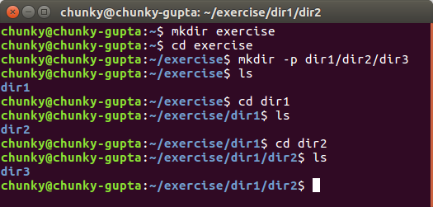

Ques2 Create two empty files inside dir2 directory: emptyFile1,emptyFile2 in single command and Remove the dir2 directory

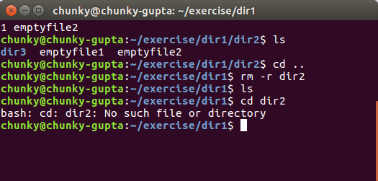

Ques 3 Create one file file.txt containing text "hello world" and save it.

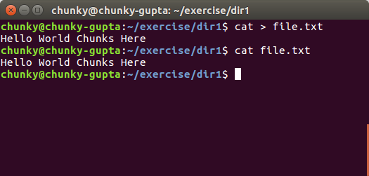

Ques 4.Find a "passwd" file using find command inside /etc. copy this files as passwd_copy and then rename this file as passwd_backup.

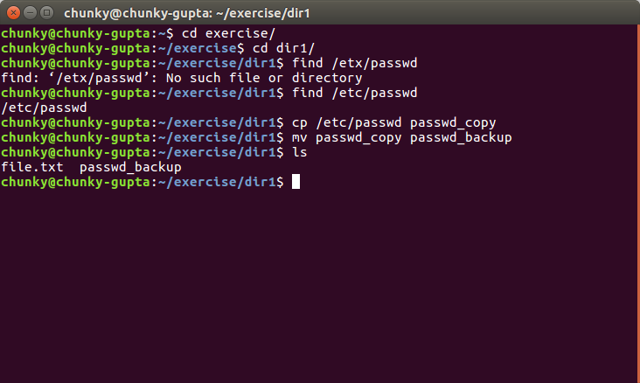

Ques5 Try reading passwd_backup file in multiple tools: less,more,cat,strings etc and find the difference in their usage.

Less : less is a terminal pager program on unix systems used to view (but not change) the contents of a text file one screen at a time. It is similar to more, but has the extended capability of allowing both forward and backward navigation through the file.

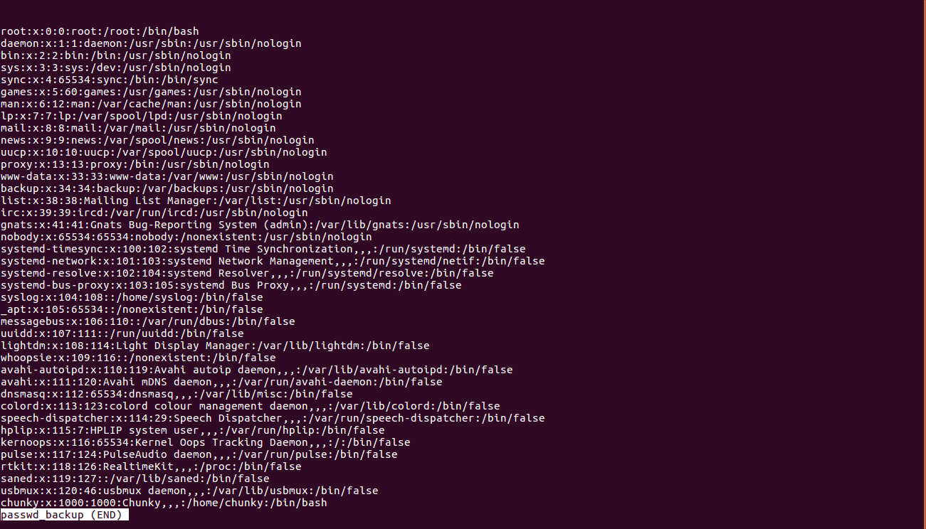

More:more is an old utility. When the text passed to it is too large to fit on one screen, it pages it. You can scroll down but not up.

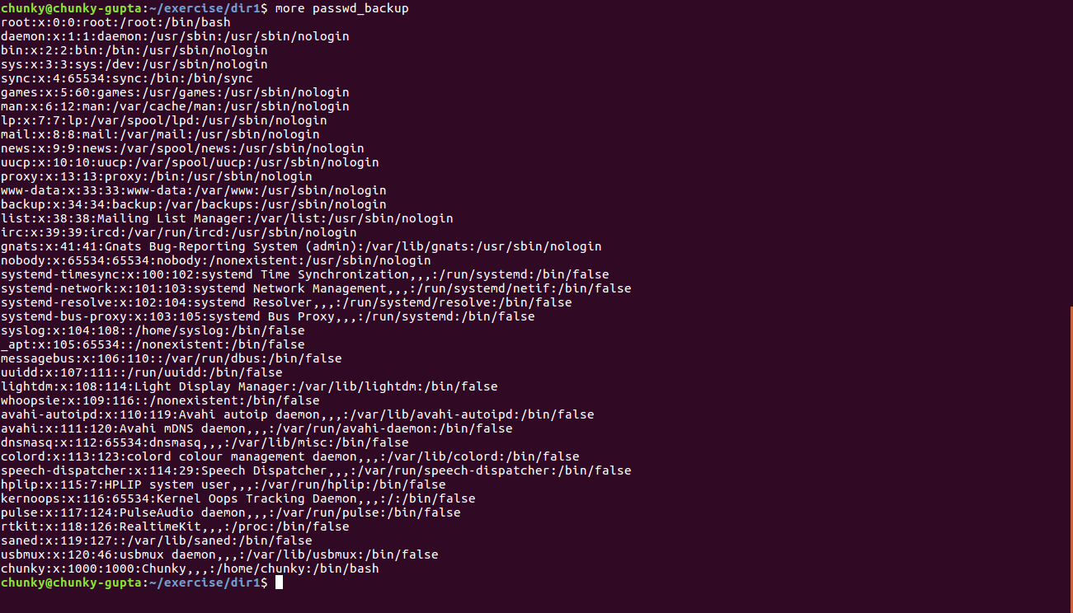

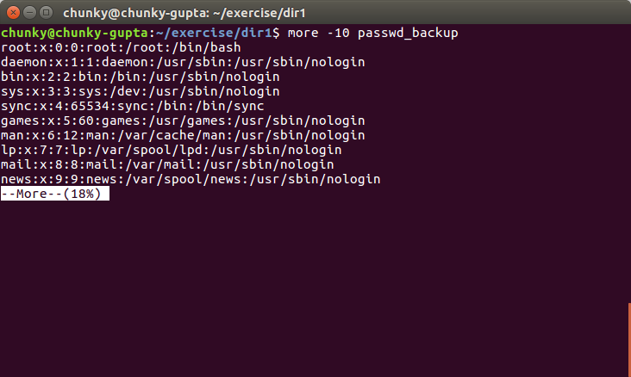

Cat : Stands for concatenation . Used to show the contencts in the file. Concatenate (join) two or more plain file and/or print contents of a file on standard output.
Cat passwd_backup

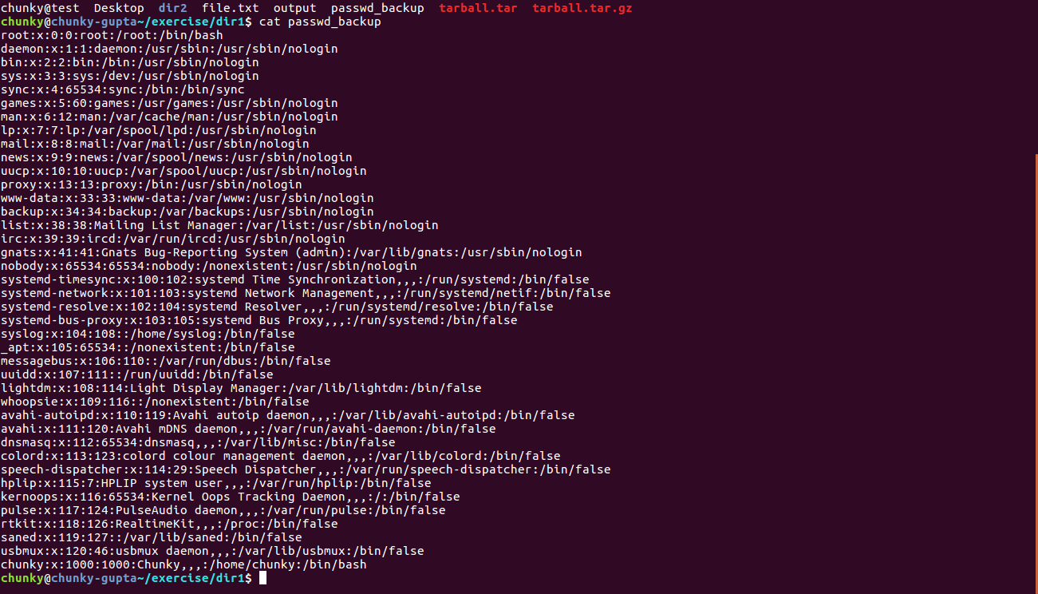
Strings: The strings command returns each string of printable characters in files. Its main uses are to determine the contents of and to extract text from binary files (i.e., non-text files).

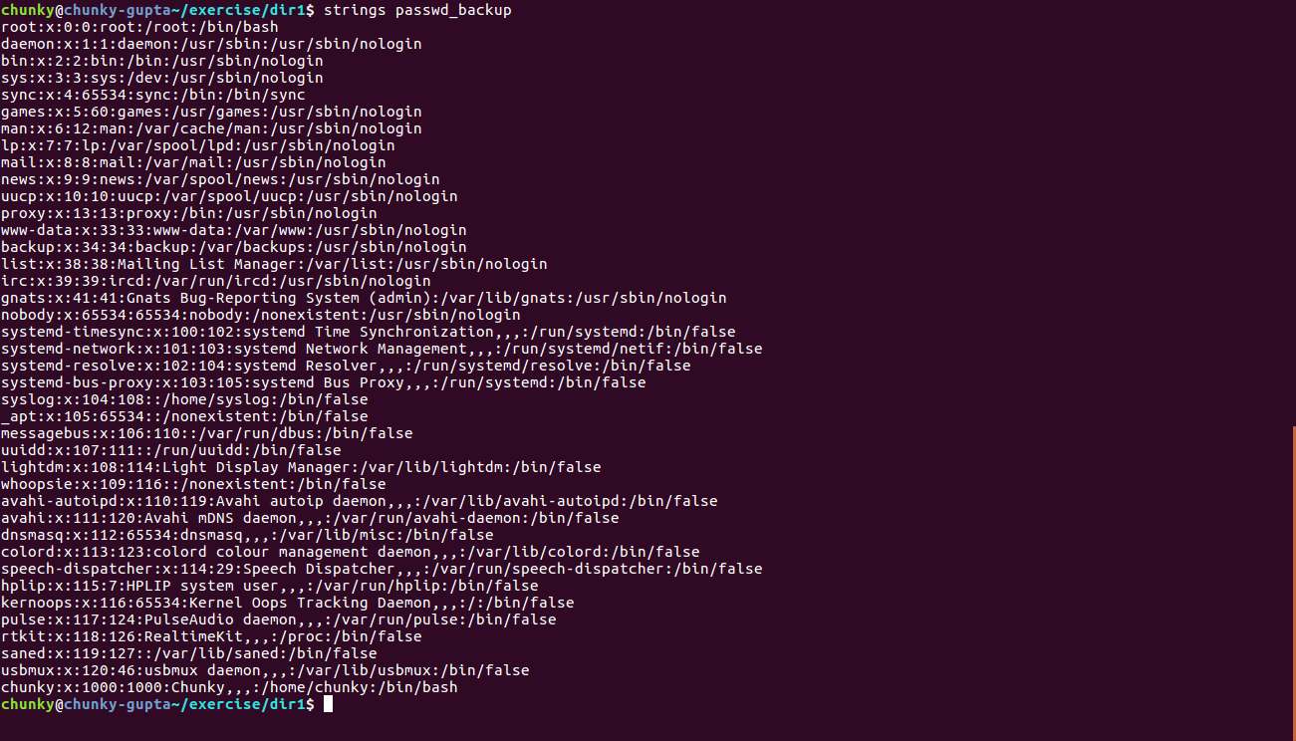

Ques 6 Find out the number of line in password_backup containing "/bin/false".

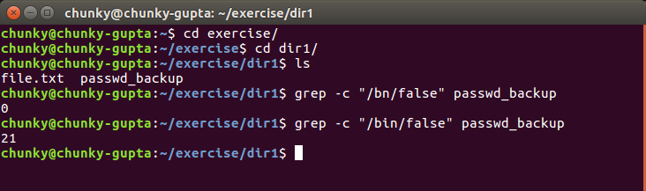
Ques7 . Redirect the output of the above command( in Ques 6) into file "output".

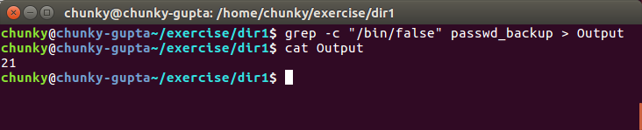

Ques8 Create a "test" user,create its password and find out its uid and gid.

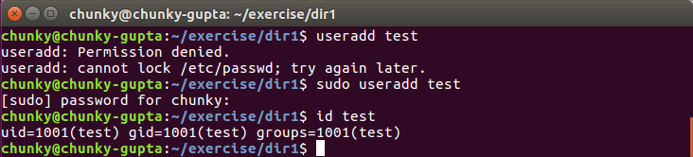
Ques9 .Login as test user and edit the "output" file created above. Since the permission wont allow you to save the changes.

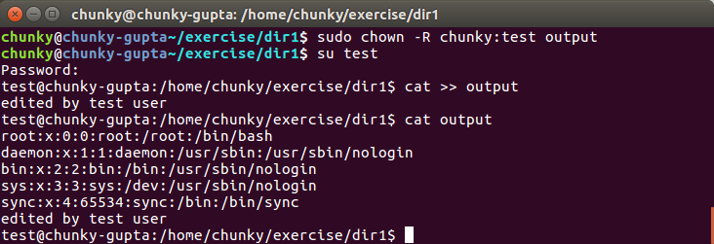

Ques10 Configure such that test user can edit it.
a. Add group owner of the "output" file as the secondary group of testuser and check/change the "output" file permission if it is editable by group. Once done revert the changes.
b. Make the file editable to the world so that test user can access it. Revert the changes after verification
c. Change the ownership to edit the file.

1 : Add group owner of the "output" file as the secondary group of testuser and check/change the "output" file permission if it is editable by group. Once done revert the changes

Solution
- sudo chgrp test1 output
- sudo groupadd mygroup
- sudo usermod -a -G mygroup
- sudo chmod 664 output
- sudo chmod 644 output
2 : Make the file editable to the world so that test user can access it. Revert the changes after verification.

Solution
sudo chmod 666 output
sudo chmod 644 output
3 : Change the ownership to edit the file.

Solution
sudo chmod 664 output

Ques11 Create alias with your name so that it creates a file as "/tmp/aliastesting".

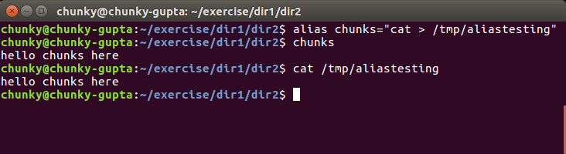

Ques12 .Edit ~/.bashrc file such that when you change to "test" user it should clear the screen and print "Welcome".

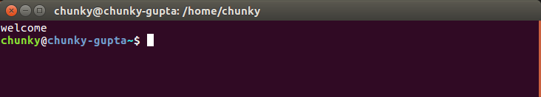
Ques13 Install zip package.

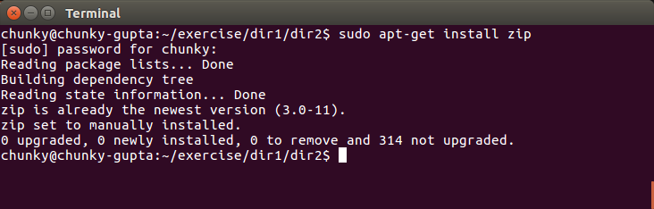

Ques14. Compress "output" and "password_backup" files into a tar ball. List the files present inside the tar created.

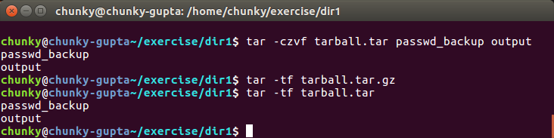

Ques15 . scp this file to test user

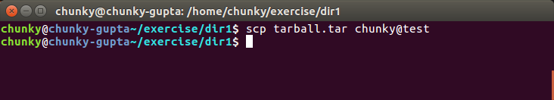

Ques16. Unzip this tar bar by logging into the remote server.

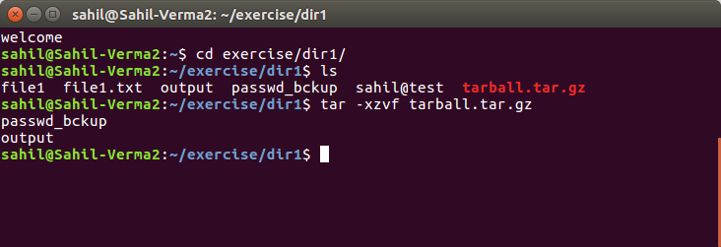

Ques17. Download any image from web and move to desktop

