Ques1.Create Database
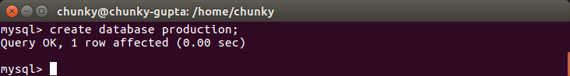
Ques2. Design schema

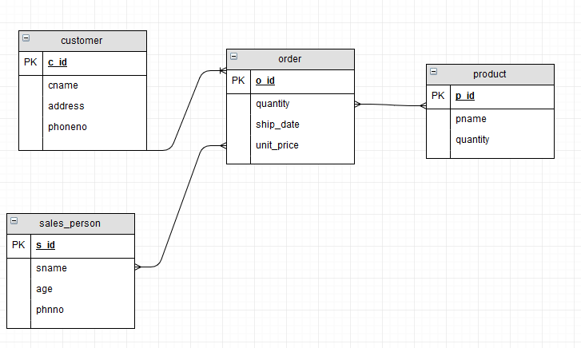

Ques3.Create tables
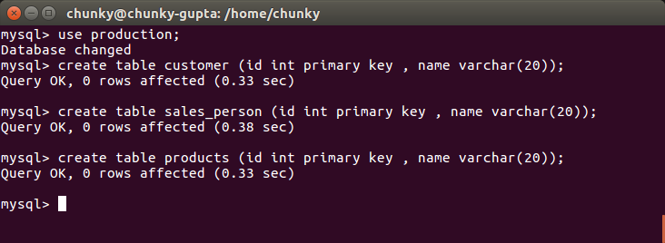
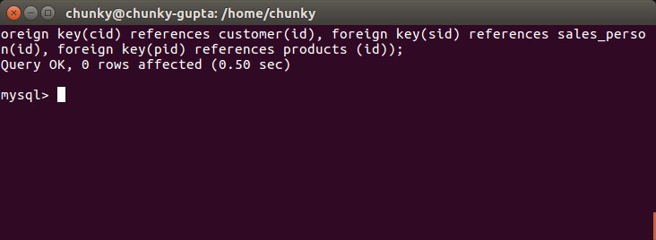
Ques4.Insert sample data

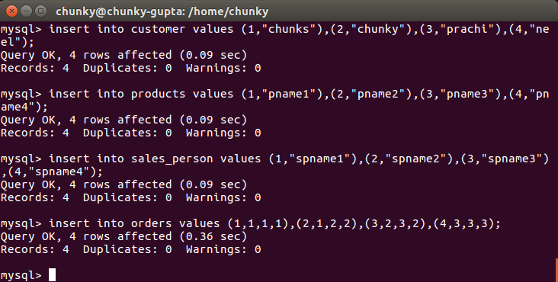
Ques5.Find the sales person have multiple orders.

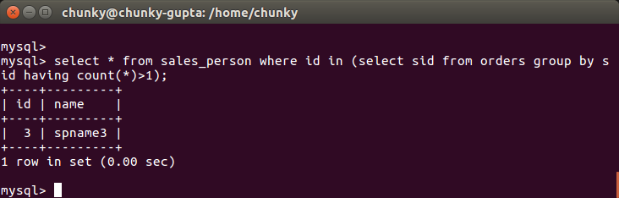
Ques 6. Find the all sales person details along with order details
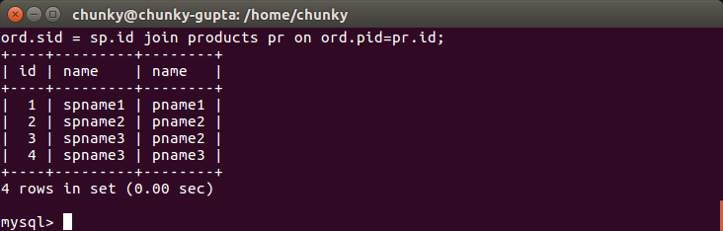

Ques7. Create index
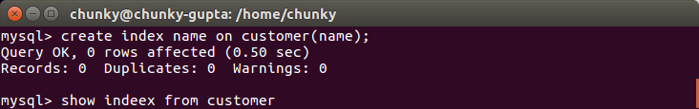
Ques 8.How to show index on a table
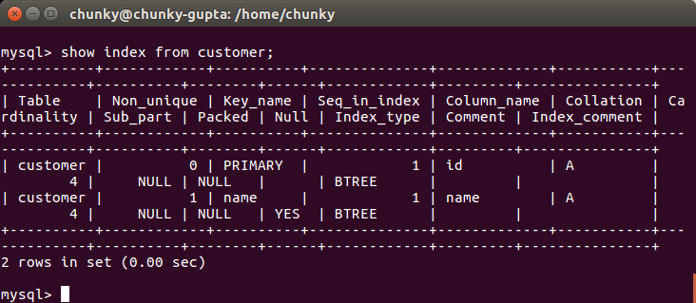
Ques9.Find the largest order amount for each salesperson and the associated order number, along with the customer to whom that order belongs to

