Ques1. Git Setup https://confluence.atlassian.com/bitbucket/set-up-git-744723531.html

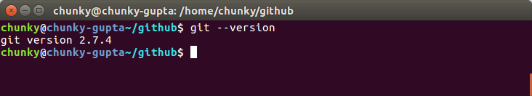

Ques2 .Initialize a Git Repository
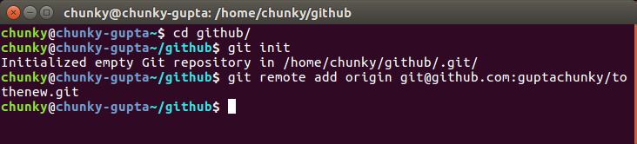

Ques3 . Add files to the repository

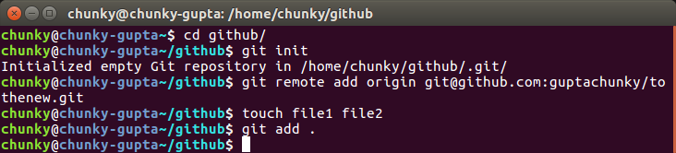
Ques4. Unstage 1 file

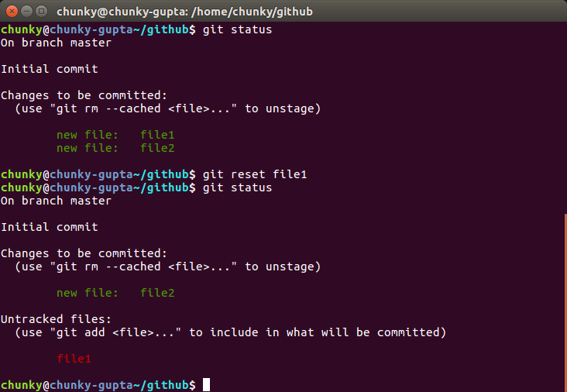
Ques5. Commit the file
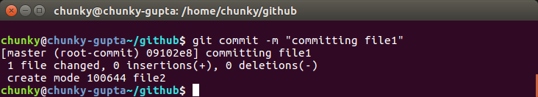

Ques6.Add a remote

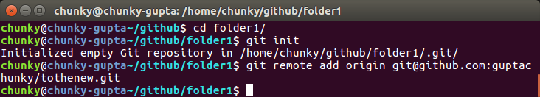
Ques7. Undo changes to a particular file

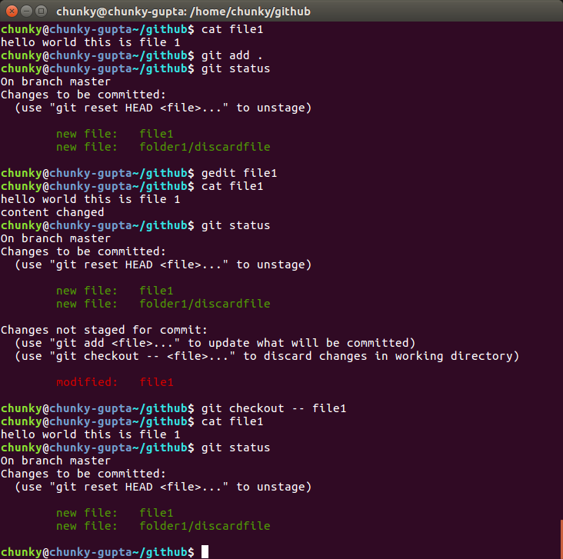
_{Ques8 .Push changes to Github}
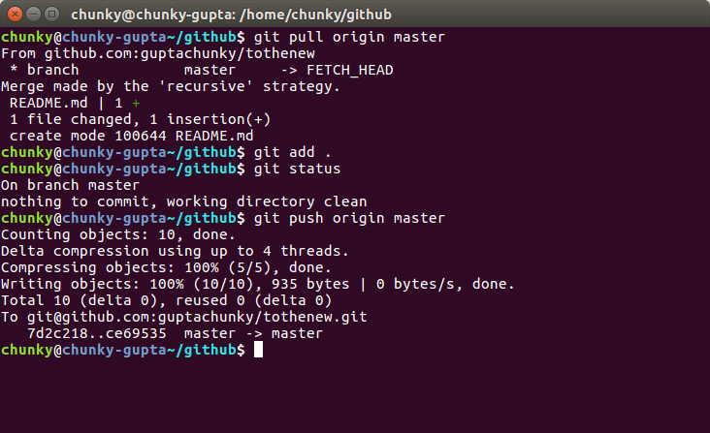
_{Ques9 Clone the repository}
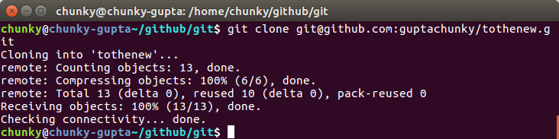
Ques10 Add changes to one of the copies and pull the changes in the other.
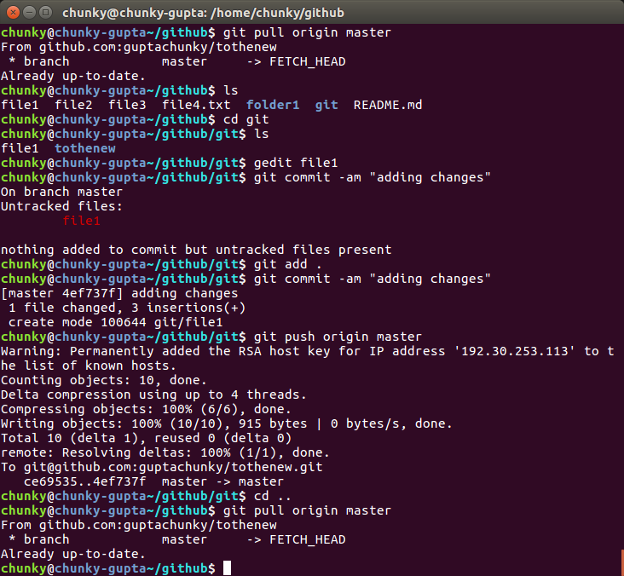
Ques11.Check differences between a file and its staged version
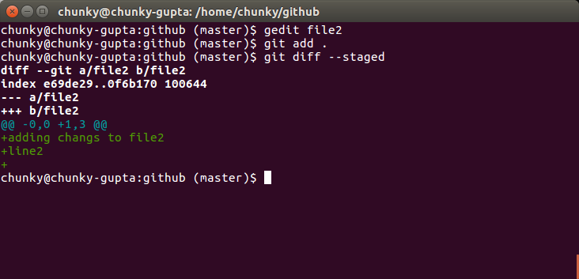
Ques12. Ignore a few files to be checked in
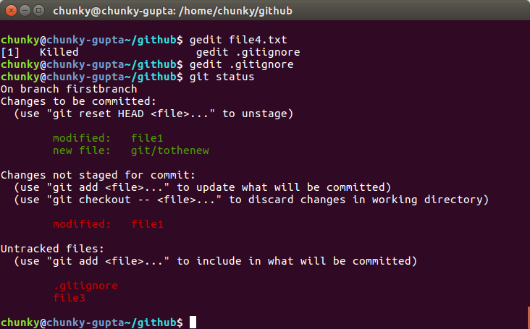
_{Ques13 .Create a new branch}
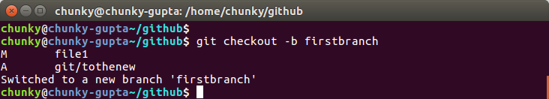
Ques14. Diverge them with commits
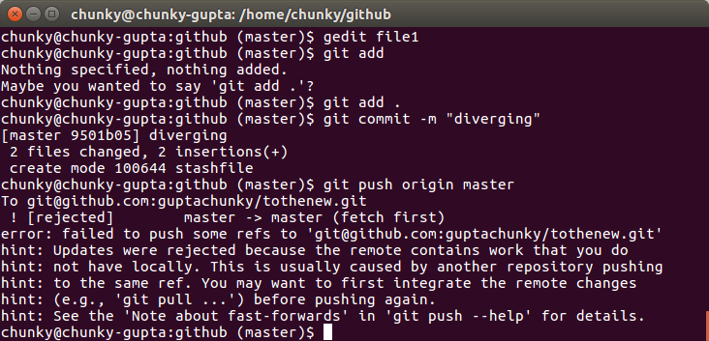
Ques15.Edit the same file at the same line on both branches and commit
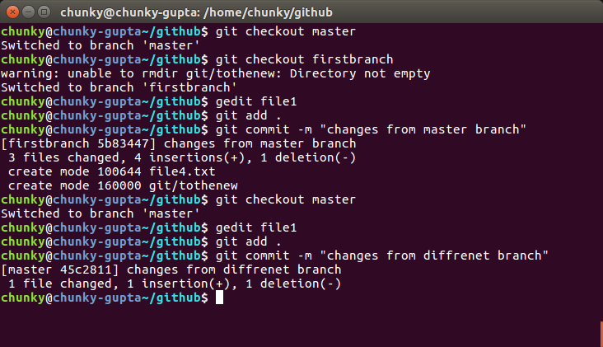
Ques16.Try merging and resolve merge conflicts
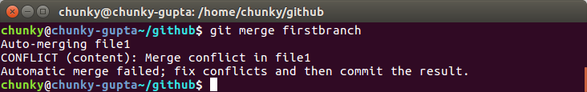
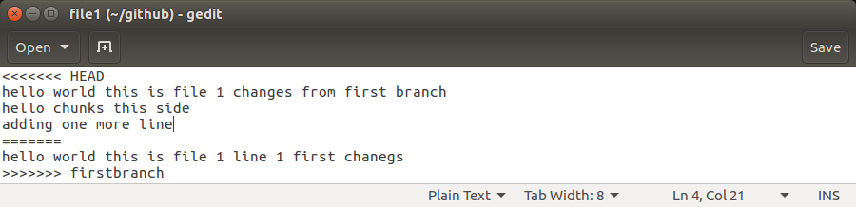
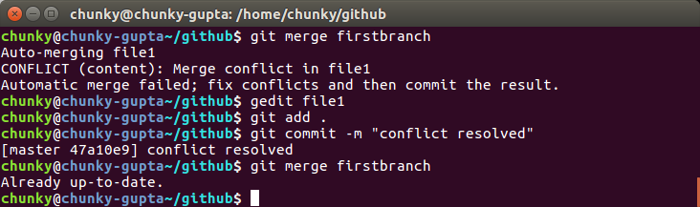

Ques17. Stash the changes and pop them
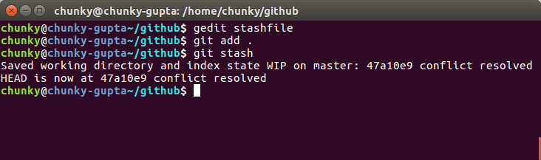
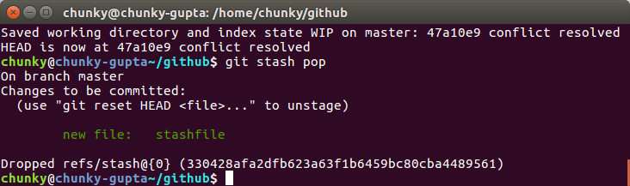

Ques18.Add the following code to your .bashrc file : color_prompt="yes"
_{parse_git_branch() {}
git branch 2> /dev/null | sed -e '/^[^*]/d' -e 's/* \(.*\)/(\1)/'
}
if [ "$color_prompt" = yes ]; then
PS1='\u@\h\[\033[00m\]:\[\033[01;34m\]\W\[\033[01;31m\] $(parse_git_branch)\[\033[00m\]\$ '
_{else}
PS1='\u@\h:\W $(parse_git_branch)\$ '
_{fi}
unset color_prompt force_color_prompt

