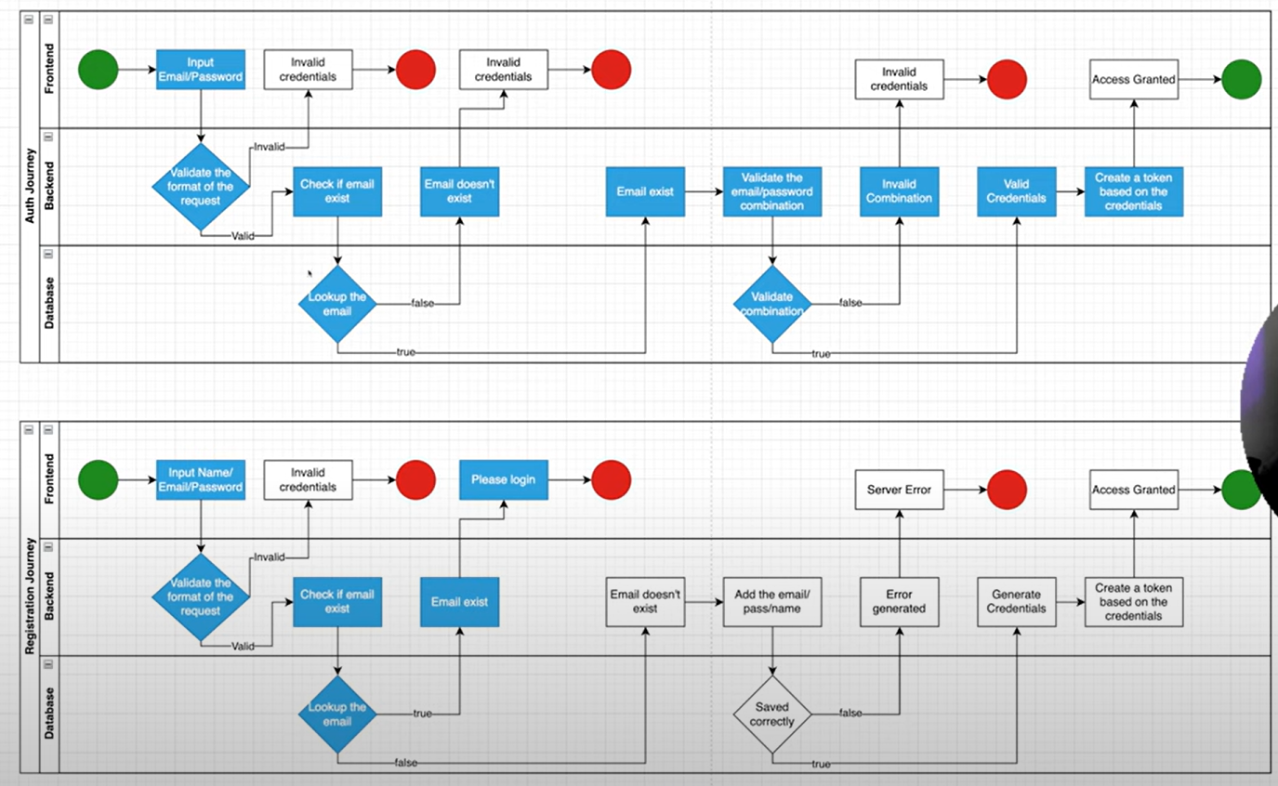

1. Login Register and generate token
2. Email Verification

