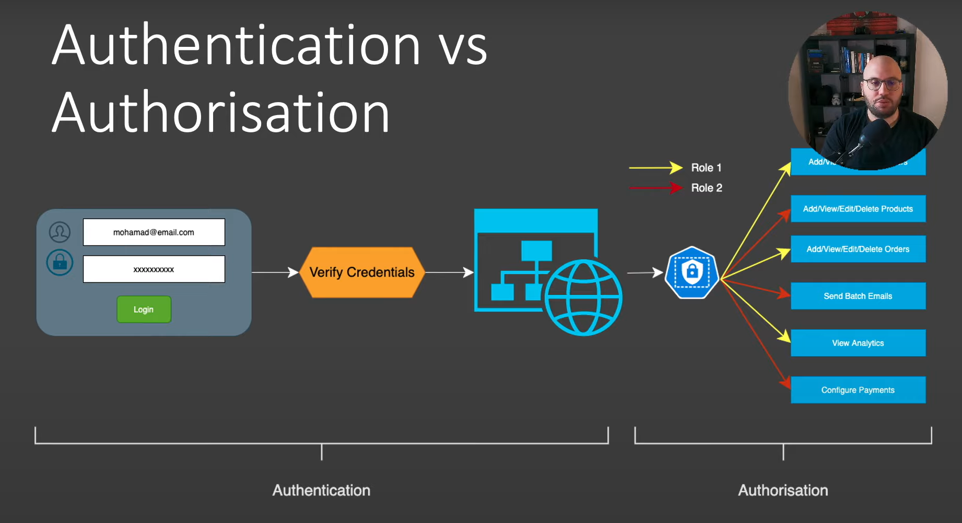

Authentication :

Verify if the user is someone they claim to be. Identify the person.

e.g : If I claim to be a teacher in school then I should have teacher Id to verify otherwise the claim will be rejected.

Authorization :

Process that determines what user is able to do and what user is not.

e.g : A marketing person do not have access to products source code but have access to marketing dashboard

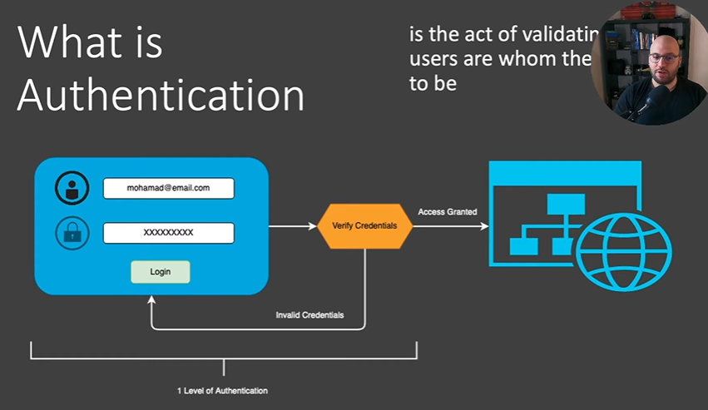

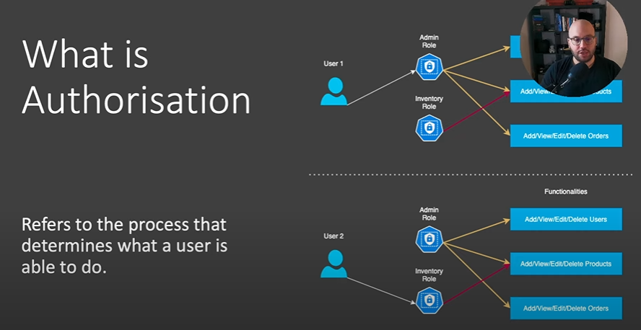

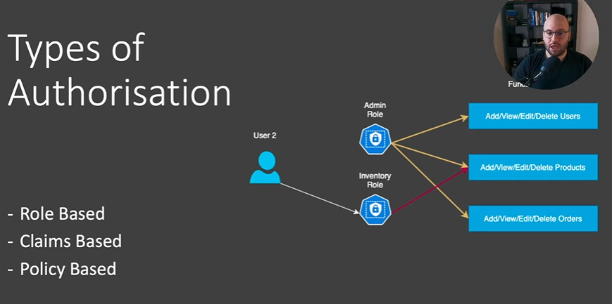

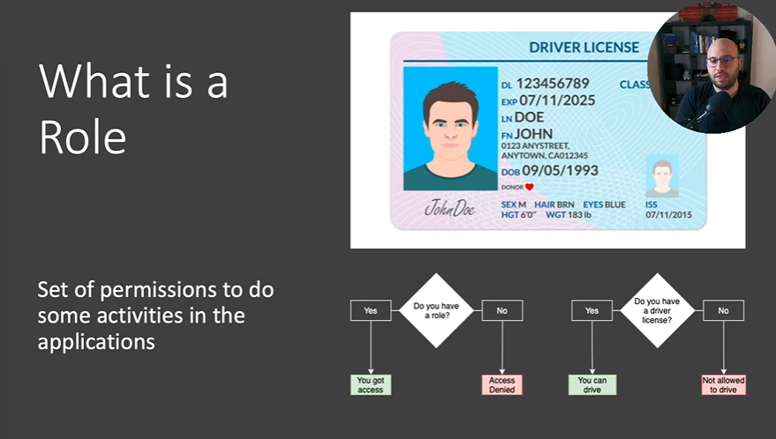

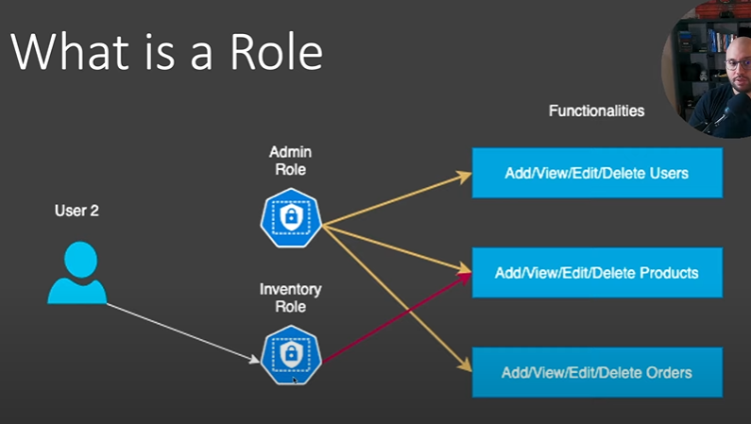

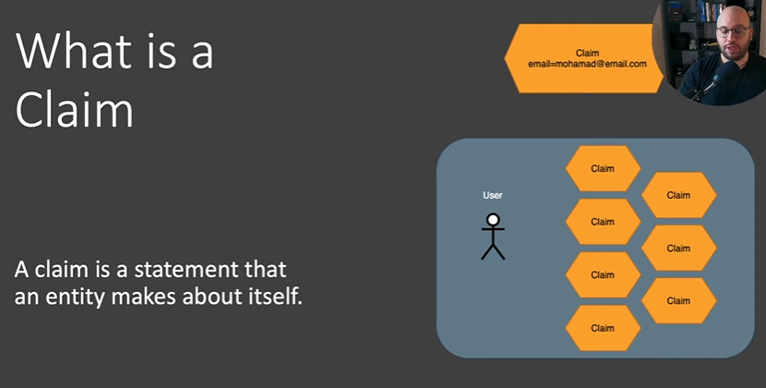

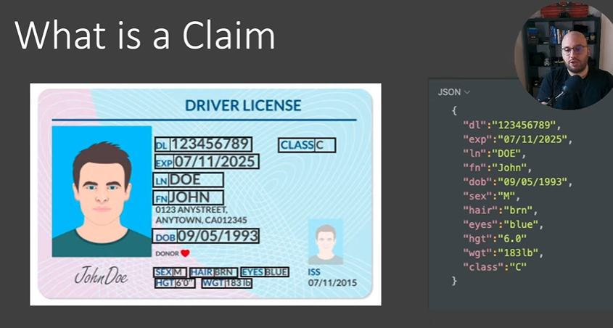

Claim : Provides more information about the user which can be used to provide additional functionality.

Here,

The Claim:

Class : C specifies that the user can drive cars. A different class number will specify that the user can drive Aeroplane,Tractor etc.

Claims and Roles work together to provide much more info about the user and help us to create robust authorization systems.

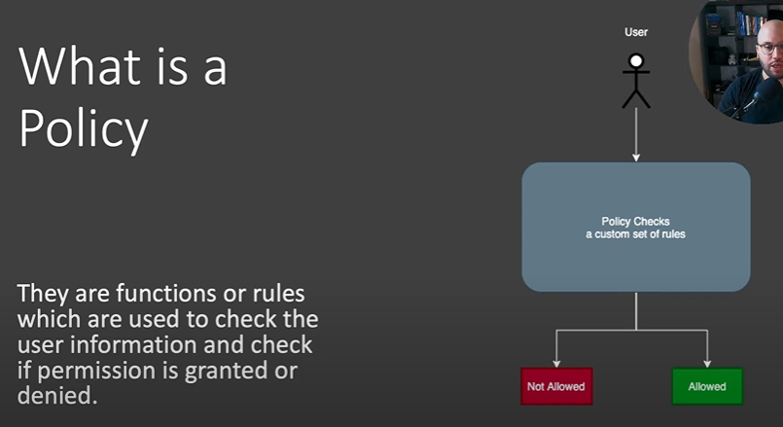

Policy : Set of rules that we need to check in order to grant user the access.

e.g A claim is a rule and a policy is a set of rule which when verified the user gets access to a particular resource.

