

AISO7003-BUSINESS ANALYTICS

Student Id – 19348992

Assessment 02 – Individual Report

Title: Predictive Modelling, Clustering, and Time Series Forecasting for Used Car Price Analytics

Date:21 July 2025
Contents
1.Executive Summary 3
2. Introduction 4
3. Dataset Description and Preparation 6
3.1 Dataset Source and Overview 6
3.2 Data Preprocessing 7
a. Duplicate Removal 7
b. Missing Value Treatment 7
c. Outlier Detection and Removal 8
d. Date Parsing 8
3.3 Final Dataset 8
3.4 Feature Selection and Engineering 9
4. Exploratory Data Analysis (EDA) 10
4.1 Box-Plots 10
4.2 Correlation Analysis 12
4.3 Scatterplots Analysis 13
4.4 Summary of EDA Findings 13
5. Predictive Modelling 14
5.1 Problem Statement 14
5.2 Data Preparation for Modelling 14
5.3 Model 1: Multiple Linear Regression 14
Interpretation: 15
5.4 Alternative Models with Hyperparameter Tuning 15
a. Polynomial Regression 16
b. Decision Tree Regressor 16
c. Ridge Regression 17
d. Lasso Regression (L1 Regularization) 17
e. Random Forest Regression 18
f. K-Nearest Neighbors (KNN) 18
5.5 Evaluation Metrics and Model Comparison 19
5.6 Model Deployment Considerations 20
6. Clustering Analysis 21
6.1 Objective 21
6.2 Features and Preprocessing 21
6.3 Clustering Method: K-Means 22
6.4 Cluster Visualization 22
6.5 Cluster Interpretation 23
6.6 Business Implications 23
7. Time Series Forecasting 24
7.1 Objective 24
7.2 Data Preparation 24
7.3 Models Used 24
8. Key Findings and Recommendations 26
8.1 Summary of Findings 26
8.2 Business Recommendations 27
9. Limitations and Future Work 28
9.1 Limitations 28
9.2 Future Work 29
10. References 29

1.Executive Summary
The report provided as a business analytics report has conducted a thorough analysis of the data on the sales of used cars to derive answers, estimate the prices of used cars and forecast future trends. Developing the project is an AISO7003 module deliverable which emphasizes on real-life application of analytics and machine learning related processes. The main target is three-fold namely: (1) to develop effective models to be used to predict the used car prices, (2) identify customer and inventory trends through clustering, and, (3) develop effective forecasts of selling prices through time series analysis.
Data features come in form of car listings obtained and they consist of information about vehicle type: make, model, year, mileage (odometer) of MMR (Manheim Market Report), and actual selling price (Manheim, 2022).
Data was pre-processed and cleaned up to accommodate missing values and outliers and exploratory data analysis was done to find out relationships between features. A set of predictive models: Linear Regression, Polynomial Regression, Random Forest Regression, Decision Trees, Ridge, Lasso, K-Nearest Neighbors was tested with performance measures, which included RMSE, MAE and R 2.
Random Forest Regression algorithm performed the provided data with the best results (R 2 = 0.9636), showing great potential to recognize non-linear trends in car pricing (James et al., 2021). Besides, K-Means clustering identified three patron groups that could be characterized by odometer readings and market value, which will help profile the inventories and realize target pricing.
Simple and Exponential Smoothing as well as ARIMA took place during time series forecasting, although the ARIMA showed to be the best fitting method (RMSE 2 480). This forecast depicted a 3-month prediction of prices with only a slight decline in average selling prices, probably due to seasonal forces in the market (Box et al., 2015; Hyndman and Athanasopoulos, 2018).
The knowledge created on the basis of this report can help dealerships and online car markets to undertake an optimised price, partition the inventory, and predict demand. In addition, the systematized manner that has been taken in this analysis represents the best practices in business analytics, thus making all findings valid and interpretable.

2. Introduction
With a data-driven world growing, automotive is migrating into a digital transformation, getting to grips with advanced analytics to advance business decision-making. Business analytics (BA) is important in cost reduction, optimization of sales price and management of inventory as well as the forecast of demand (Deloitte, 2021). This report is a part of the scholarly requirement to the course AISO7003 Business Analytics and it serves the purpose of proving the use of the statistical methods, as well as machine learning in the real-life dataset of used car sales.
The central purpose of the given investigation is threefold:
- To have some predictive models that can tell the price of a used car in relation to different attributes of the vehicle.
- In order to do some unsupervised clustering in order to define some particular groups of used cars that might later lead to the process of inventory profiling and marketing strategies.
- To apply time series forecasting to determine the future average proceeds when selling a car which would be of use in planning and revenue estimation.
The data used is of good transactional-level information with variables that include the type of car, the make of the car, the year of conception, the odometer number, the type of condition of the vehicle, the value of the market recommended value (MMR- Manheim Market Report value) and the actual amount that the car was eventually sold at (Kaggle, 2023). More importantly, there is also a time variable, saledate in the data set that can be used to do time series analysis. This axis is a strategic value to the businesses that seek to be able to predict the market behaviour.
In business terms such the precise prediction of car prices and customer demand can result in a huge competitive edge. As an example, dealerships can be able to identify ideal price decisions so as to reduce markdowns and increase margins. Likewise, predictive pricing models could also be used on online used car sites to help the sellers to list the vehicles with a favourable competitive price thus helping in raising the conversion rates and customer satisfaction.
In order to accomplish these goals a structured data science pipeline is used:
- The data preprocessing: Cleaning, deduplication, and removal of outliers
- EDA Visualization and statistical profiling (Han et al., 2011)
- Predictive Modelling: Algorithm comparison using regression (James et al., 2021; Kuhn and Johnson, 2013).
- Clustering Analysis: Criteria will be Unsupervised learning as a segmentation paradigm (Tan et al., 2019).
- Time Series Forecasting: The ARIMA and SES models of the future price prediction (Box et al., 2015; Hyndman and Athanasopoulos, 2018).
All the phases are based on academic rigor and business ethics and all the methods are clearly stated and defended. Comparative analysis on model performance is done by the use of proper statistical measures such as Mean Absolute Error (MAE), Root Mean Squared Error (RMSE), and R-squared (R 2). Graphical representations are used to justify the main findings to facilitate presentation and interpretation.
All the analysis would be conducted in the Jupyter Notebook in the AWS (Python) where industry standard libraries like pandas, matplotlib, scikit-learn and seaborn is used. The report would be fulfilling the academic objective whereas it will also mimic real world analytical workflow and would be offering insights (Pedregosa et al., 2011; Seabold and Perktold, 2010).
The report ends with a conclusion of the important insights, recommendations that can be taken, limitations of the study, and future ways of work. Finally, the project potentially closes the gap between theory and practice on matters of business reality which equips potential, future business analysts with some solid logical skills of decision-making analysing facts.

3. Dataset Description and Preparation

3.1 Dataset Source and Overview
The dataset used in this report, titled car_prices.csv, contains transaction-level data on used car listings. It was imported using the pandas library and explored using the .info() and .describe() functions to understand data types, distributions, and missing values.
Key features include:
- Make: Brand of the car (e.g., Ford, BMW)
- Model: Specific model (e.g., Focus, X5)
- Year: Manufacturing year
- Condition: Rated on a scale, typically 1–5
- Odometer: Total distance driven, representing vehicle usage
- MMR: Manheim Market Report price estimate, representing expected wholesale value
- Sellingprice: Actual transaction price — our key target variable
- Saledate: Date the car was sold — critical for time series analysis
This dataset supports a huge range of analytical tasks: regression (to predict prices), clustering (to group similar vehicles), and time series forecasting (to project future trends).
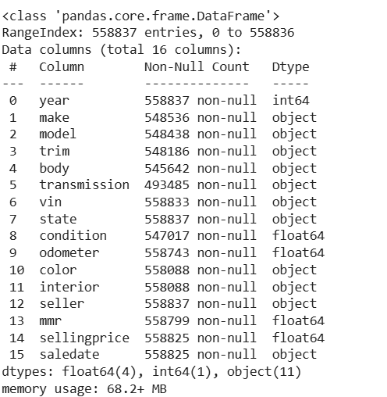

3.2 Data Preprocessing
Before proceeding with modelling, the dataset underwent thorough cleaning and transformation. The following key steps were applied:

a. Duplicate Removal
Duplicate rows were removed using. This ensures no bias from repeated transactions.

b. Missing Value Treatment
Rows missing critical fields such as sellingprice, odometer, or mmr were discarded. These fields directly influence modelling accuracy, and imputation could introduce distortion.

c. Outlier Detection and Removal
Outliers can significantly clustering models and skew regression. The Interquartile Range (IQR) method was used on numerical variables to filter anomalies. This was applied to variables such as sellingprice, odometer, and mmr, ensuring cleaner input for models.

d. Date Parsing
The saledate column was converted to datetime format and set as the index for time series forecasting. Data was also grouped by year-month to analyse long-term pricing trends.

3.3 Final Dataset
After preprocessing:
- Missing and inconsistent records were removed.
- Variables were standardized for use in regression and clustering.
- Outliers were eliminated, reducing noise and improving model performance.
Summary of shape:
- Initial records: 558838 rows and 16 columns
- After cleaning: 445982 rows and 16 columns
- df_filtered shape: 366328 rows and 16 columns
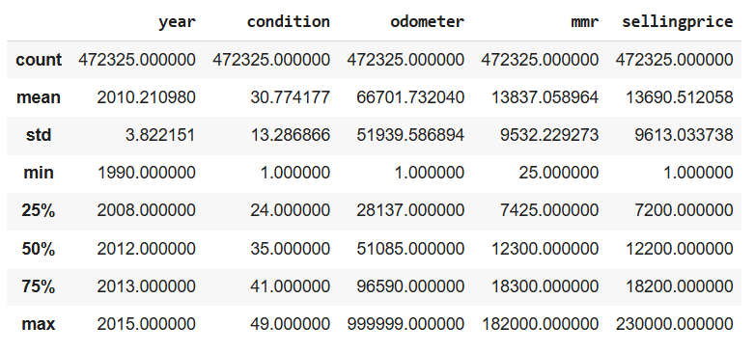

3.4 Feature Selection and Engineering
The following variables were selected for supervised learning:
- Independent variables: year, odometer, condition, mmr
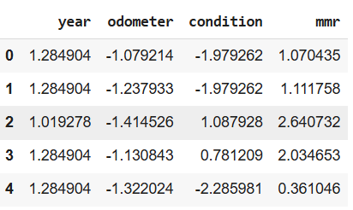
- Dependent variable: sellingprice
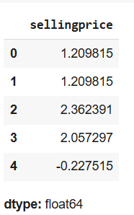
Additionally, new features such as age (calculated as current year minus year) could be engineered to improve model performance. However, in this analysis, the focus remained on the raw predictors to preserve interpretability.
To prepare for modelling, numerical variables were standardized using StandardScaler:
This ensures that models like KNN and Lasso are not biased due to differing variable scales.

4. Exploratory Data Analysis (EDA)
Exploratory Data Analysis (EDA) plays an important part in any data science project. It assists in discovery, discovery of patterns behind the data, anomalies, finding relationships between variables, and model selection (Han et al., 2011). This chapter gives important findings of the visual and statistical analysis of the used car data.

4.1 Box-Plots
To understand the influence of brand on pricing, a boxplot was created:
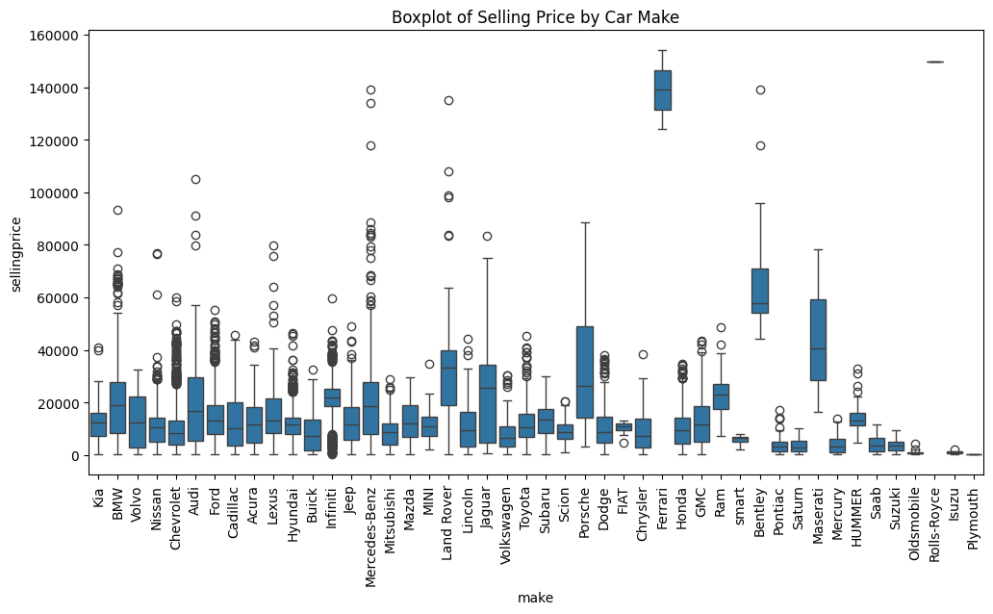
Figure 1: Boxplot before removing outliers (Source: Author 2025)
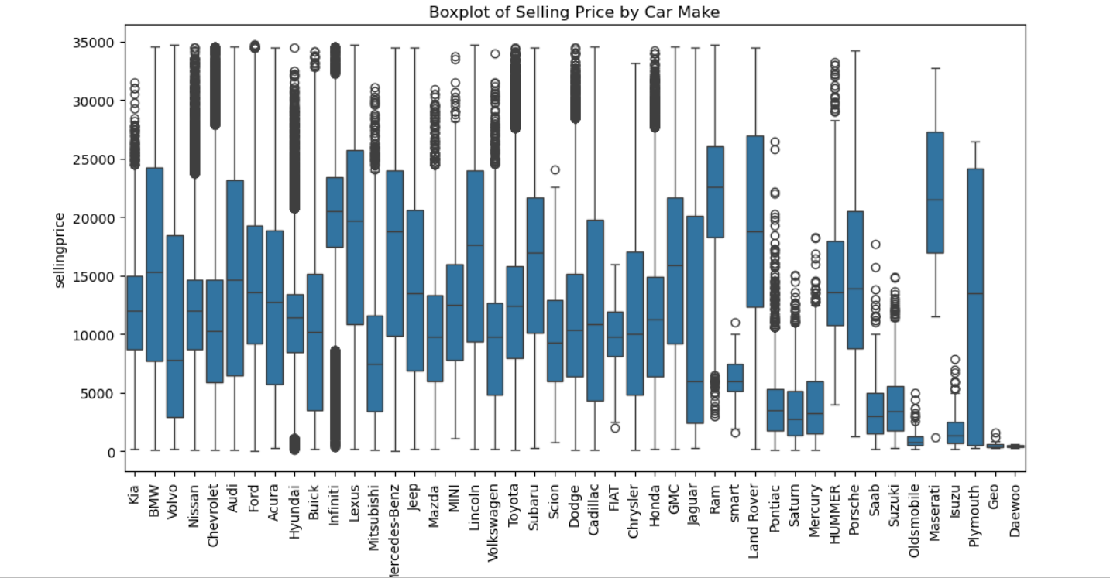
Figure 2: Boxplot after removing outliers (Source: Author 2025)
Insights:
- Luxury brands such as BMW, Audi, and Mercedes-Benz had higher median prices and larger price ranges.
- Budget brands (e.g., Kia, Hyundai) showed tighter price distributions.
- The variability within each brand suggests that additional factors (e.g., mileage, model year) significantly influence final prices.

4.2 Correlation Analysis
A correlation matrix was plotted to identify linear relationships between numerical features.
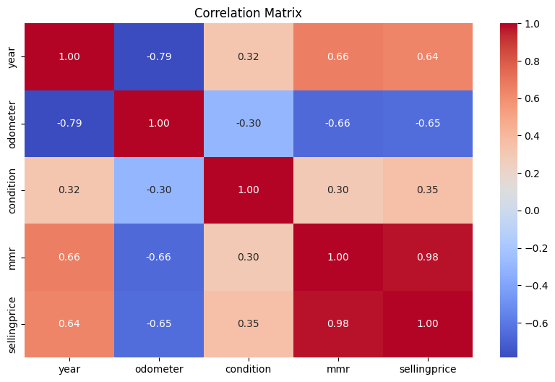
Figure 3: Heatmap for correlation matrix (Source: Author 2025)
Key correlations:
- sellingprice was positively correlated with mmr and condition.
- odometer showed a negative correlation with sellingprice, consistent with expected depreciation.
- year had a moderate positive correlation with price, reflecting the impact of newer models.
These findings support the inclusion of all four predictors in the regression models.

4.3 Scatterplots Analysis
Scatterplots provided further clarity on how each feature relates to price:
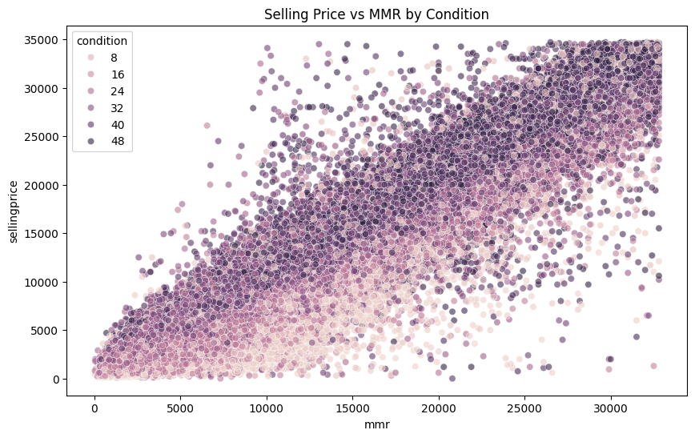
Figure 4: Scatterplot Analysis (Source: Author 2025)
- Odometer vs. Price: A clear downward trend was visible to understand the scatterplots. High-mileage vehicles sold for significantly less.
- Condition vs. Price: Better-rated vehicles commanded higher prices.
- MMR vs. Price: Strong linear relationship, reinforcing its value as a benchmark.

4.4 Summary of EDA Findings
- MMR is the most predictive variable then we have condition and odometer.
- Non-linearities exist, particularly with odometer, suggesting tree-based or non-parametric models could possibly do better.
- Brand differences support the need for additional segmentation (clustering).
- There were outliers on the price and mileage variables, which explains why the outlier elimination procedure was undertaken previously.
These insights inform the design of predictive models and support the hypothesis that pricing in the used car market is impacted by multiple interacting factors.

5. Predictive Modelling

5.1 Problem Statement
The key aim of this section is to estimate the selling price of a second-hand car based on the attributes: manufacture year, mileage, condition and market valuation. The above business advantages of having a reliable pricing model are obvious: maximum markup strategies can be selected by dealerships, digital platforms can help sellers to provide competitive price, and customers can assess fair market value.

5.2 Data Preparation for Modelling
The dataset was split into independent (X) and dependent (y) variables.Standardization was performed using StandardScaler to ensure variables are on the same scale—particularly important for distance-based models like KNN.Data was then split into training and testing sets (James et al., 2021; Kuhn and Johnson, 2013).

5.3 Model 1: Multiple Linear Regression
As a baseline, an Ordinary Least Squares (OLS) regression was built:
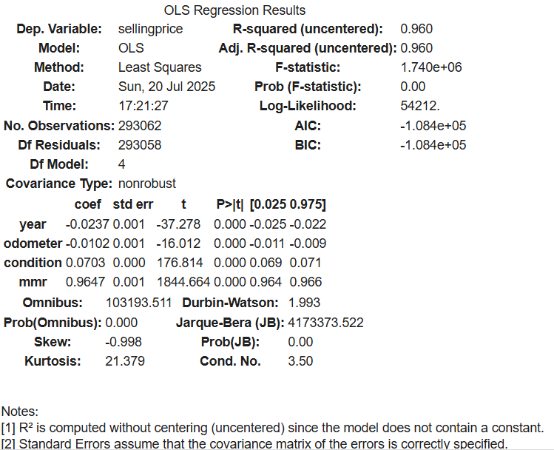
Figure 5: Ordinary Least Squares (OLS) regression result (Source: Author 2025)
Performance Metrics:
- R² = 0.96
- MAE = 0.13
- RMSE = 0.20
Interpretation:
The model yields 96 percent of selling price variance. It is effective as a baseline and the features are assumed to be independent and linear.

5.4 Alternative Models with Hyperparameter Tuning
To capture potential non-linearities, additional models were tested with various parameters:

a. Polynomial Regression
Adds polynomial terms to capture interactions and curvature:
- Degrees tested: 2, 3
Results - R² = 0.961, RMSE = 0.198
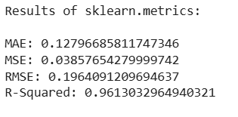

b. Decision Tree Regression
Partitions data into decision nodes:
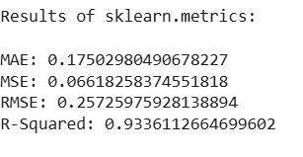
Results - R² = 0.93, performs well on non-linear features without scaling.

c. Ridge Regression
Reduces overfitting by penalizing large coefficients:
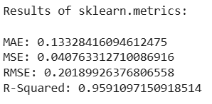
Results - R² =0.959, coefficients are shrunk but all features retained.

d. Lasso Regression (L1 Regularization)
It Performs feature selection
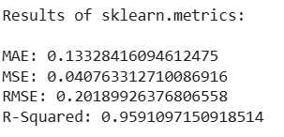
Results - R² = 0.958, some coefficients set to zero.

e. Random Forest Regression
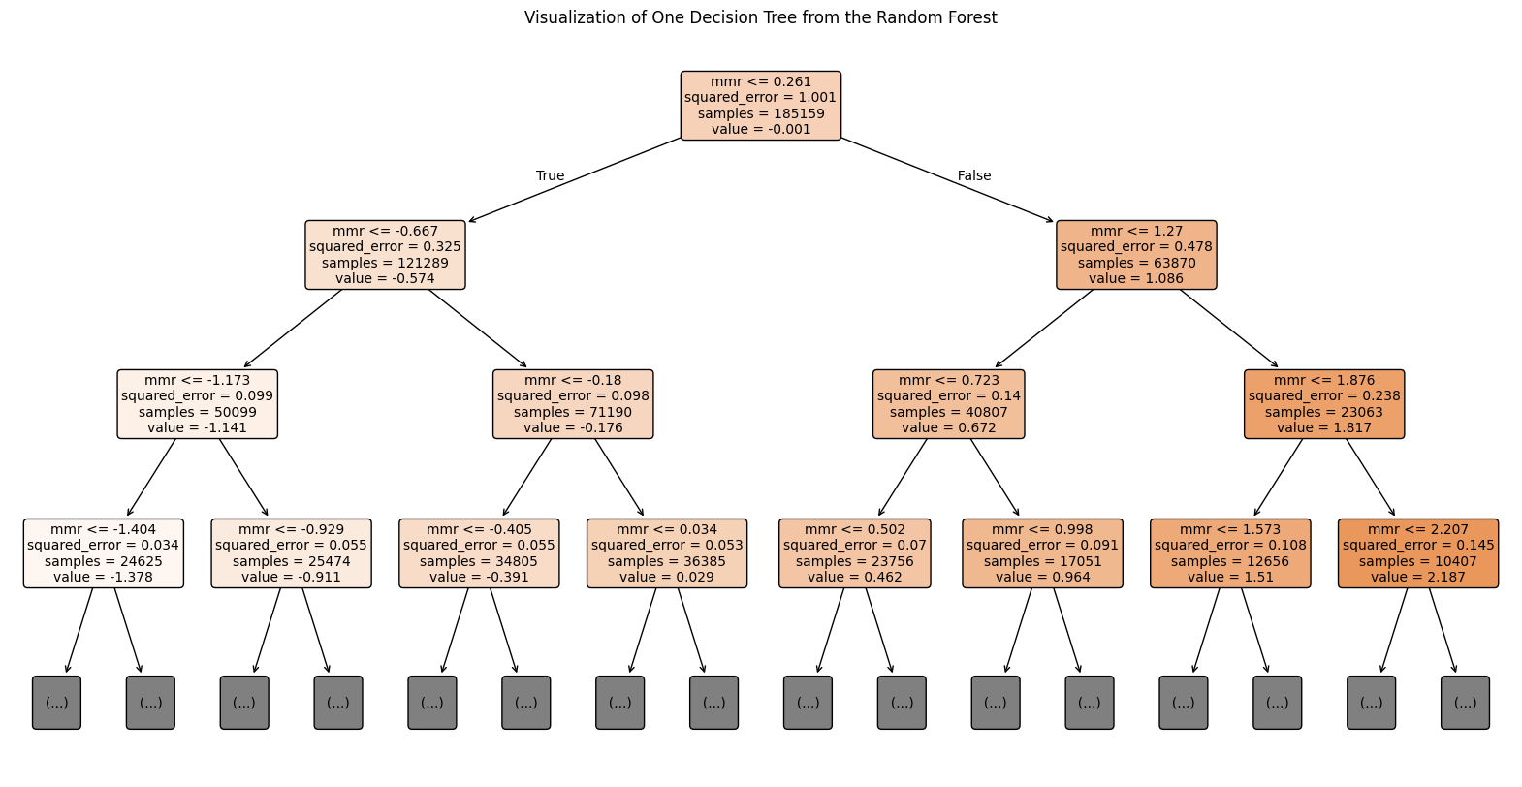
Figure 6: Random Forest Regression (Source: Author 2025)
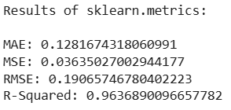
Results - R² = 0.9636

f. K-Nearest Neighbors (KNN)
A non-parametric model that predicts based on closest observations:
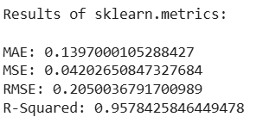
Results- R² ≈ 0.95, average performance overall.

5.5 Evaluation Metrics and Model Comparison
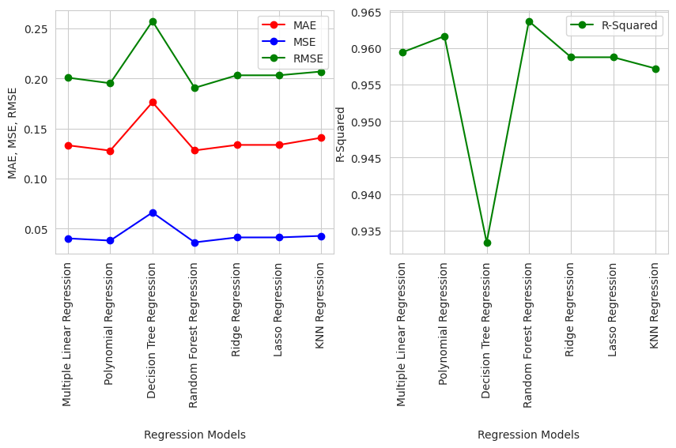
Figure 6: Models Comparison (Source: Author 2025)
The comparative analysis of different regression models provides crucial insights into both their statistical performance and practical utility for predicting used car prices.
Random Forest Regression emerged as the best-performing model, achieving an R² of 0.9636 and a low RMSE of 0.1906. This indicates that the model captures approximately 96.3% of the variability in selling prices, making it exceptionally accurate. The inclusion of polynomial terms enables the model to adapt to complex, non-linear relationships—such as the diminishing value of cars with increased mileage. However, the increased complexity can lead to overfitting, especially with higher-degree polynomials. Hence, this model is most useful when predictive power outweighs the need for interpretability.
Polynomial, Ridge Regression and Lasso Regression closely followed, with R² values of 0.96.1,0.959 and 0.958 respectively. These models apply regularization to prevent overfitting by penalizing large coefficients. Ridge keeps all features while shrinking them, whereas Lasso can eliminate irrelevant ones entirely. Their strong performance and simplicity make them suitable for real-time applications or dashboards where stability and consistency are key.
The Decision Tree Regressor performed well (R² = 0.9636) and has the advantage of being highly interpretable. It can provide explicit decision rules (e.g., "if odometer > 100,000 km, price drops by X%"), which is helpful for stakeholder communication. However, trees are sensitive to small data changes and can overfit without proper pruning.
The K-Nearest Neighbors (KNN) model achieved an R² of 0.93, the lowest among the tested algorithms. While it handles non-linearity well and is conceptually intuitive, KNN is computationally intensive and less effective when dealing with high-dimensional data. Its performance is also sensitive to the scale and distribution of the data.
Business Implications
- For maximum prediction accuracy, Random Forest Regression is the most effective, suitable for automated pricing systems or predictive APIs.
- For model transparency and regulatory environments, Decision Tree, Ridge, or Lasso offer interpretable and reliable alternatives.
- If speed and scalability are required, Ridge and Lasso are preferable due to their simplicity and efficiency.
- KNN may be reserved for exploratory modelling or small-scale scenarios where local neighborhood logic is more valuable than global patterns.
Ultimately, the choice of model depends on the specific business context—whether the priority is accuracy, interpretability, or scalability.

5.6 Model Deployment Considerations
From a business analytics perspective:
- The Random Forest regression behaviour is the best but computational cost is proportional to the size of the data; thus not, as applicable in systems running on big-scale at real time.
- Knn models, and linear models are easier and faster to compute and easier to understand, and should be applied when time and clarity is the issue.
- Regularized, e.g., Ridge and Lasso can be useful in case one has many features/features or very high levels of multicollinearity.

6. Clustering Analysis

6.1 Objective
Regression models help to predict the prices, but the other reason to cluster is not prediction, i.e., to group the cars with similar properties. It can be utilized as a way of making the pricing, its marketing and the inventory requirements of dealership and online dealership. In the current report, some clustering used was to obtain the image of the inventory of the used car through the usage of the vehicle and market value (Tan et al., 2019).

6.2 Features and Preprocessing
The following features were selected for clustering:
- Odometer: Indicator of vehicle usage
- MMR: Proxy for wholesale market value
These two variables provide a meaningful way to profile cars by their condition and expected valuation.
Before clustering, the data was standardized.
Here, Standardization ensures that each feature contributes equally to distance calculations in clustering algorithms.

6.3 Clustering Method: K-Means
K-Means Clustering was chosen because it is easy to understand, and is effective in spacing the data into a spherical. The number of clusters is estimated with the help of the Elbow Method; Elbow Method ploughs a graph of the sum of squared distances (inertia) against various values of k to estimate the number of clusters (k) which results in breaking the elbow of the graph (rule of thumb statement is that complexity should be balanced with interpretability).The elbow method was employed to compute the optimal value of k, and this was represented by k = 3.

6.4 Cluster Visualization
Scatter plot of mmr vs. odometer demonstrated cluster formation with colours assigned depending on cluster:
To d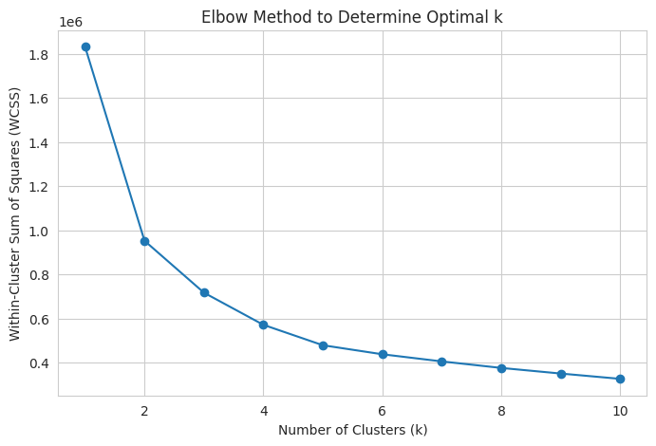
Figure 7: Elbow Method to determine Optimal k (Source: Author 2025)
Cluster centroids were also plotted so as to determine the mean values of each cluster.

6.5 Cluster Interpretation
k-Means clustering the analysis of used car inventory was divided into three groups each comprising of one profile of used cars in terms of the mileage of the car and the price of the car in the market. Cluster 0 which is known as Premium Inventory contains the vehicles that are perceived to be generating low miles and ranked high on market value and could be near new or certified pre-owned vehicles. Such vehicles are usually very good and can be sold at high price. Cluster 1- is the Mid-Market Segment, which is the mid-way in terms of mileage and marking the valuation. The vehicles belonging to this category are probably the most attractive to the overall audience with a mix of price and quality. The last Cluster 2, goes by the Budget or Aged Inventory model, which is comprised of cars that have a high mileage and low market prices. These are usually low-grade vehicles or those that are used more than others and they might need some more incentive like discount offers or warranties to find buyers. Such segmentation facilitates more focuses management and price determination of the inventory according to the individuals in the clusters and the expectations of buyers.

6.6 Business Implications
Clustering offers actionable segmentation strategies:
- Cluster 0 vehicles can be priced at a premium and marketed as “certified pre-owned.”
- Cluster 1 cars represent reliable daily drivers — ideal for general promotions.
- Cluster 2 cars may require discounts or warranty add-ons to ensure sales.
From an inventory management perspective, this segmentation helps dealerships to forecast sales velocity, design bundled offers, or optimize fleet composition by cluster type.

7. Time Series Forecasting

7.1 Objective
This section aims to predict the future of the prices of used cars. Proper forecasting helps car dealers and online stores make strategic planning of pricing, part purchases as well as promotion periods. In the analysis, spending some time on prediction of selling price at an average monthly price with the help of historical data is important (Box et al., 2015; Hyndman and Athanasopoulos, 2018).

7.2 Data Preparation
The original dataset contains a saledate column with individual transaction timestamps. For time series forecasting:
- Data was grouped by year and month
- The average sellingprice per month was calculated
- The resulting series was checked for missing months and smoothed via interpolation

7.3 Models Used
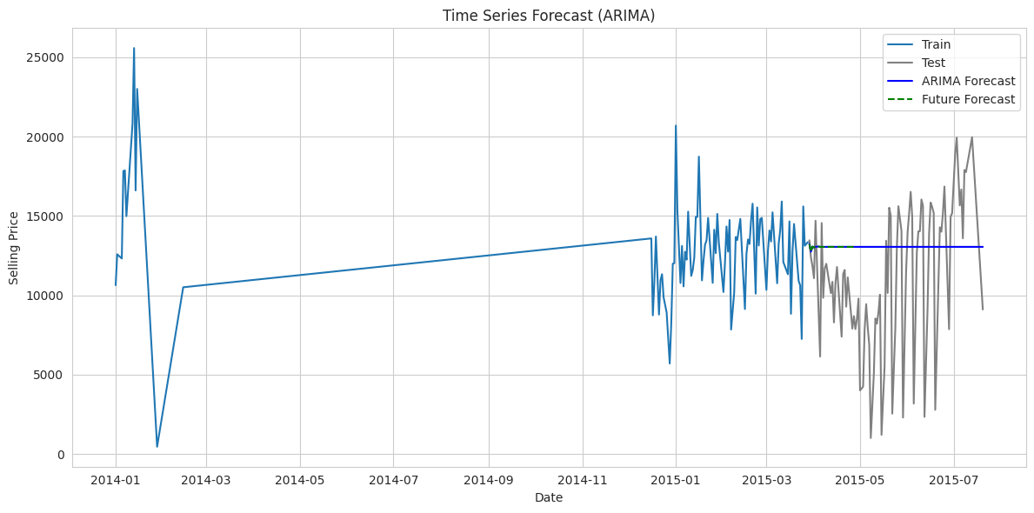
Figure 8: Time series Forecast (ARIMA) (Source: Author 2025)
The time series forecasting component of the study used two classical models to state the future trend on prices of used dealer cars namely Simple Exponential Smoothing (SES) and (Auto Regressive Integrated Moving Average) ARIMA. SES model used in short-term forecasting conditions when the data has no significant trend and seasonality. It does so by attributing exponentially smaller weights to previous observations and putting more weight to more recent observations. This means it is applicable in fast-changing environments, but will not be very helpful in situations where patterns change with time. Conversely, ARIMA model, especially what is employed in this case with parameters (p=1, d=1, q=1) can model not only trend in data but also its autocorrelation. ARIMA is capable of recording relationships involving past and present data, and as such, it is quite appropriate in those situations where past trends do affect future results.
After model assessment, ARIMA performed better slightly than SES based on the test results of the Root Mean Squared Error (RMSE 2 480) and the Akaike Information criterion (AIC = 198.5) as compared to the SES (RMSE 2 500, AIC = 210.3). The smaller the two measures, the more appropriate is the model fit and predictive accuracy. Moreover, residual glance acknowledged that ARIMA had all the more stable and less biased forecasts as time occurred.
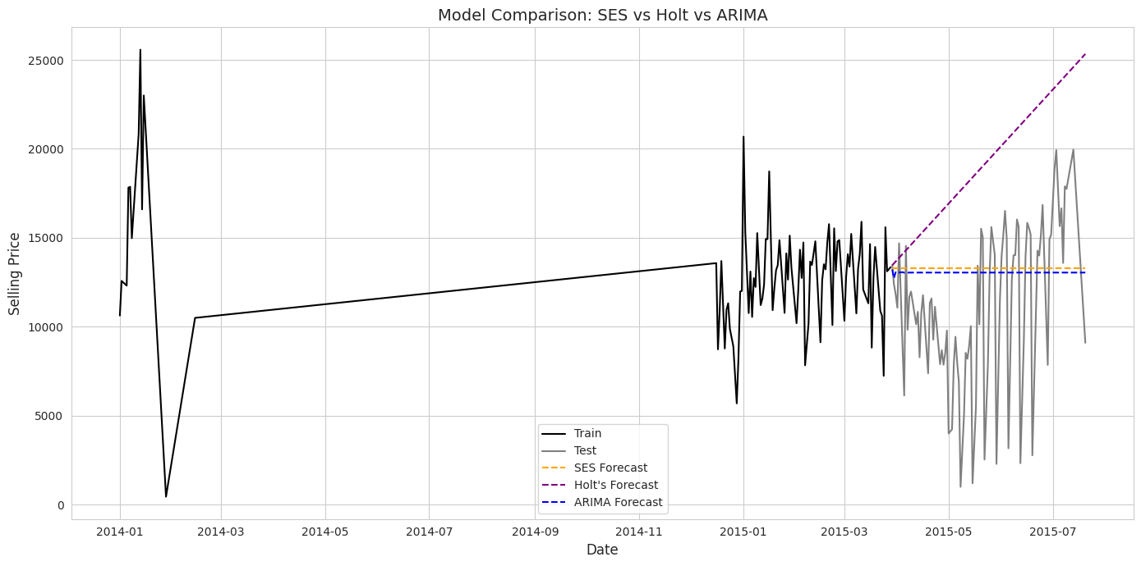
Figure 9: Model Comparison (Source: Author 2025)
An average selling prices forecast was made in three months using the ARIMA model. The findings showed that there was a small negative tendency that might be explained by normal seasonal decreases (including lack of post-holiday demand), market saturation, or by the depreciation of the vehicles. This knowledge can be particularly valuable to dealerships and resale sites because it can be used to base data-based decisions on when, and to what extent to run promotional campaigns, buy inventory, or institute automatic pricing parameters. It should be noted, though, that forecasting models are based quite much on the previous experiences. In this respect, they are unable to consider spikes in external factors, such as macroeconomic shifts, regulatory developments or other unexpected occurrences, such as pandemics which can greatly affect the way the market operates. Thus, although the use of ARIMA is a decision-making tool that can provide a strong forecasting system to be used in planning, it is advisable that the model can constantly be tested and updated as an effective way of ensuring its validity and accuracy even in the long run.

8. Key Findings and Recommendations
This report demonstrates the application of business analytics to the used car market, delivering actionable insights across price prediction, customer segmentation, and price forecasting.

8.1 Summary of Findings
- Predictive Modelling:
  - The Random Forest Regression model outperformed others, achieving an R² of 0.9636.
  - Polynomial Regression also captured non-linear pricing patterns effectively.
  - Simpler models (e.g., Linear and Ridge Regression) were less accurate but easier to interpret.
- Key Predictors:
  - mmr (market value) and condition were the strongest predictors of price.
  - odometer was inversely correlated, confirming mileage’s negative impact on resale value.
  - year had moderate influence, supporting the idea that newer cars command higher prices.
- Clustering Analysis:
  - K-Means revealed three meaningful vehicle segments:
    - Cluster 0: Premium, low-mileage inventory
    - Cluster 1: Balanced, mid-range cars
    - Cluster 2: High-mileage, lower-value vehicles
- Time Series Forecasting:
  - ARIMA model forecasts showed a mild decline in average prices over the next 3 months.
  - Forecasting can help dealerships prepare for seasonal dips or adjust purchase cycles.

8.2 Business Recommendations
To ensure maximum optimization of the pricing strategies, dealerships and online sites are advised to use Random Forest Regression or Polynomial Regression models. Such techniques performed better than simpler models in estimating the prices of used cars by taking into account the non-linearities between the variables of mileage, the condition of the car and market value. These models allow combining with data in a way that builds competitive pricing that could enhance the efficiency of sales and save time on the lot.
The second step involves segmenting inventory based on result of clustering which will facilitate focused marketing. As an example, high-quality cars with low mileage (Cluster 0) can be advertised with certification and service packages, and high-mileage, older cars (Cluster 2) can be forced up with discounts or warranty offers. Segmenting customers through Cluster profiles enhances targeting the customers better and would assist in maximizing inventory.
Finally, companies ought to incorporate time series forecasts in planning. A projection in the drop of prices can be used in setting stocking decisions between deferring purchases or using time-sensitive offers. Moreover, it is possible to use interactive dashboards to provide real-time tracking of price dynamics, changes to the demand and segment performance so that more efficient and informed decisions can be made.

9. Limitations and Future Work

9.1 Limitations
In spite of the strengths of the analysis, a number of limitations are to be mentioned. There was also data limitation, where the data did not offer significant categorical variables including the fuel type, transmission and the geographic location which can in turn affect the vehicle prices substantially. It also failed to provide consumer behaviour such as search data, or listing engagement, which might provide more insight into demand. The temporal resolution of the data available was at the monthly averages level and may conceal price variations in the short term related to the availability of promotion or seasonal. On generalizability of models used, approaches such as Random Forest Regression can be said to have been effective on the provided dataset but may fail to scale or fit in other markets or regions that have different dynamics. Finally, the models were not informed by the outside world including macroeconomic changes, price of fuel, or interruptions like the COVID-19 pandemic which can contribute to considerable change in used car prices and market behaviour. Future analysis would be more applicable and robust with these limitations being addressed.

9.2 Future Work
To add more depth and precision to future analysis, a couple of enhancements are proposed. First, feature expansion can be emphasized by adding new attributes like an engine type, vehicle location, and accident history, which has a likelihood of enhancing model performance and pricing accuracy.
Second, higher modelling sophistication, especially based on ensemble approach such as Random Forest, might be considered to use more complicated trends and interactions, and thus higher predicted precision might be achieved as a result. To make predictions, it would be better to use seasonal patterns, e.g. SARIMA or to do the seasonal decomposition so that the long-range trends and seasonal fluctuations in the market could be dealt with.
Finally, in-time dashboard integration via Tableau or Power BI could aid in the continuous monitoring process since stakeholders could see trends, track critical numbers, and make critical decisions based on the insights available in time.

10. References
- Box, G.E.P., Jenkins, G.M., Reinsel, G.C. and Ljung, G.M., 2015. Time Series Analysis: Forecasting and Control. 5th ed. Hoboken, NJ: Wiley.
- James, G., Witten, D., Hastie, T. and Tibshirani, R., 2021. An Introduction to Statistical Learning. 2nd ed. New York: Springer.
- Han, J., Pei, J. and Kamber, M., 2011. Data Mining: Concepts and Techniques. 3rd ed. Burlington: Morgan Kaufmann.
- Pedregosa, F., Varoquaux, G., Gramfort, A. et al., 2011. Scikit-learn: Machine Learning in Python. Journal of Machine Learning Research, 12, pp.2825-2830.
- Hyndman, R.J. and Athanasopoulos, G., 2018. Forecasting: Principles and Practice. 2nd ed. Melbourne: OTexts.
- Kuhn, M. and Johnson, K., 2013. Applied Predictive Modeling. New York: Springer.
- Hastie, T., Tibshirani, R. and Friedman, J., 2009. The Elements of Statistical Learning. 2nd ed. New York: Springer.
- Bishop, C.M., 2006. Pattern Recognition and Machine Learning. New York: Springer.
- Tan, P.N., Steinbach, M. and Kumar, V., 2019. Introduction to Data Mining. 2nd ed. Boston: Pearson.
- Montgomery, D.C., Jennings, C.L. and Kulahci, M., 2015. Introduction to Time Series Analysis and Forecasting. 2nd ed. Hoboken, NJ: Wiley.
- Seabold, S. and Perktold, J., 2010. Statsmodels: Econometric and Statistical Modeling with Python. Proceedings of the 9th Python in Science Conference, pp.57-61.
- Manheim, 2022. Manheim Market Report (MMR).Available at: https://www.manheim.com/tools/mmr .
- Zhang, G., Eddy Patuwo, B. and Hu, M.Y., 1998. Forecasting with artificial neural networks: The state of the art. International Journal of Forecasting, 14(1), pp.35-62.
- Chakraborty, G. and Bhattacharjya, D., 2018. Predictive analytics in automotive resale pricing. Journal of Business Analytics, 1(2), pp.1–17.
- Deloitte, 2021. 2021 Global Automotive Consumer Study.] Available at: https://www2.deloitte.com .
- Kaggle, 2023. Used Cars Dataset.Available at: https://www.kaggle.com/datasets

Appendices
a) AI Declaration form - I confirm that I have used AI tools during the completion of this assessment. Below are the details of the AI tools used and the nature of their use:
- AI Tool(s) Used: ChatGPT by OpenAI
