

**GAVI – iSupplier Outbound | zDoc**

**Low Level Design Document**

|  |  |
| --- | --- |
| **Low Level Design Document** | |
| **Customer Name** | Gavi |
| **Document Name** | LLD_Gavi_iSupplier_Outbound_1.0 |
| **Document Summary** | Low Level Design Document addresses various aspects of integration in detail that are associated with successful functioning of the integrated systems. The allocated requirements and functions are the basis for the synthesis of the technical solution.  This document gives an overview of the derived requirements, system interfaces and system attributes. This document must be under change control to incorporate any changes to the system requirements that may arise in the future. |

|  |  |  |  |  |  |  |
| --- | --- | --- | --- | --- | --- | --- |
| **Document Revision History** | | | | | | |
| **Version** | **Created/Updated By** | **Reviewed By** | **Update Comment** | **Creation/ Modification Date** | **Sign Off By** | **Sign off Date** |
| 1.0 | Neeraj Jahagirdar |  |  | 10 Oct 2024 |  |  |
| 1.0 |  | Dave Terpstra |  | 28 Oct 2024 |  |  |
|  |  |  |  |  |  |  |
|  |  |  |  |  |  |  |
|  |  |  |  |  |  |  |
|  |  |  |  |  |  |  |

**Gavi Endorsement**

The following people are responsible for endorsement of the content of this document. Physical (wet)/Digital (eSign) signatures are not required and the email endorsement/sign-off will be considered as the official sign-off for this document.

|  |  |  |  |  |  |
| --- | --- | --- | --- | --- | --- |
| **Version** | **Date** | **Business Function** | **Endorsing Section** | **Endorser Name** | **Endorser Sign-Off  E-Mail** |
|  |  | SAP Functional Architect |  | Ravi Nanduri |  |
|  |  | Technical Architect |  | Bhaskar Das |  |
|  |  | Workata/ Integration Architect |  | Dmitry Kuzmin |  |
|  |  | Zycus Functional Architect |  | Yogesh Sarda |  |
|  |  | SAP functional Analyst |  | Priyanka Gupta/ Shaikh Shareef |  |
|  |  |  |  |  |  |

|  |  |
| --- | --- |
| **PROJECT ONBOARDING DETAILS** | |
| **Type of Suite** | S2P |
| **Customer’s ERP** | SAP S4 HANA |
| **Customer’s Middleware** | Workato |
| **Product in scope** | iSupplier |
| **Type of Implementation** | zDoc |
| **Direction w.r.t. Zycus** | Outbound |
| **Type of Integration** | API Based Integration |

Contents

1. As IS Landscape 1

2. To Be Landscape 1

4. Interface Details 1

4.1 Supplier Integration 1

3.1.1 Descriptive Diagram 1

3.1.2 Events 1

3.1.3 Low Level Details 1

3.1.4 Endpoints – Staging 1

3.1.5 Endpoints – Production 1

3.1.6 Interface Limitation 1

5. Authentication 1

6. Mapping Sheet 1

6.1 Supplier Control Block 1

6.2 Sample Payloads 1

7. Non- Functional Requirements 1

8. Error Handling 1

# As IS Landscape

Gavi is currently using SAP S4 HANA ERP to maintain the entire vendor/supplier repository. This system will be integrated with Zycus for vendor/supplier management.

# To Be Landscape

Zycus iSupplier will be used as the primary solution to create and maintain the vendor information and will facilitate the Create, Edit, Deactivate, Reactivate and On-Hold of vendors via iSupplier UI. Gavi will integrate the Vendor information from iSupplier into SAP through Workato as their middleware and the same information will be integrated from Workato to Safesforce.

An API based Integration approach has been chosen to be implemented to maintain real time synchronization between Gavi and Zycus systems, which will use oAuth 2.0 to authenticate with Gavi APIs and 2-factor Auth to authenticate with Zycus APIs.

Zycus iSupplier will allow all applicable actions on UI for the authorized users. The Implementation type will be zDoc for Zycus, that is, no data transformation will be done in Zycus and the payloads to and from Zycus will follow the standard Zycus data structure.

Zycus iConsole acts as the gateway for all transactions with Zycus and will communicate with Gavi’s middleware solution, Workato, which will then communicate with the Gavi ERP SAP S4 HANA.

**Note**:

1. The data exchange between Gavi and Zycus in API Based Integration approach will be as per zDoc standard shared by Zycus in JSON format.
2. Zycus Suppliers would have 1system-1 facility configuration.

# Interface Details

# Supplier Integration

# Descriptive Diagram

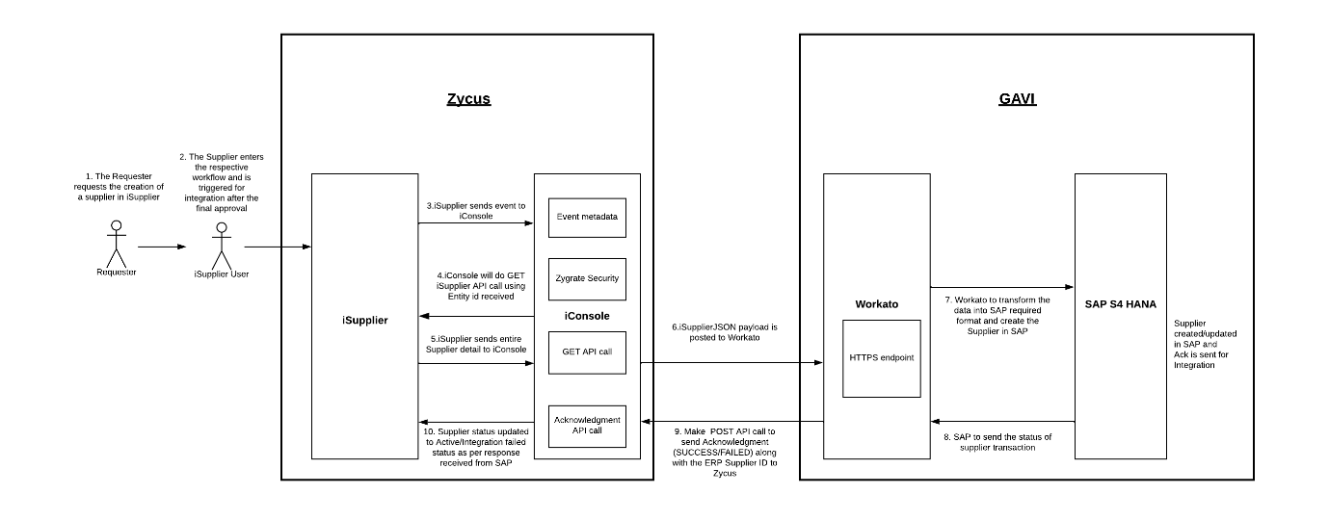

Figure 1 Low Level Design Diagram

# Events

|  |  |  |  |  |  |  |
| --- | --- | --- | --- | --- | --- | --- |
| **SL No.** | **Interface Name** | **Source** | **Target** | **Direction (w.r.t Zycus)** | **Event Name** | **Ack Needed** |
| 1 | SUPPLIER | Zycus | SAP S4 HANA | Outbound | CREATE/Onboarding | Yes |
| 2 | SUPPLIER | Zycus | SAP S4 HANA | Outbound | EDIT | Yes |
| 3 | SUPPLIER | Zycus | SAP S4 HANA | Outbound | DEACTIVATE | Yes |
| 3 | SUPPLIER | Zycus | SAP S4 HANA | Outbound | REACTIVATE | Yes |
| 3 | SUPPLIER | Zycus | SAP S4 HANA | Outbound | ON-HOLD | Yes |
| 4 | SUPPLIER_ACK | SAP S4 HANA | Zycus | Inbound | ACK | - |

An API based Integration approach has been chosen to be implemented to maintain real time synchronization between Gavi and Zycus systems.

This communication will be done with the authentications below.

1. Zycus will use oAuth 2.0 to authenticate with Gavi APIs.
2. Gavi will use 2-Factor Auth to authenticate with Zycus APIs

# Low Level Details

A supplier can either be created directly as operational supplier on Zycus iSupplier or it can be registered as a potential supplier via ZSN which can then be onboarded as an operational supplier. Whenever a supplier is created/modified in Zycus iSupplier, it goes through a workflow. There can be same or different workflows configured for different events. The last node in a workflow is an external agent which initiates the integration process and pushes the supplier into a pending integration state. As it is acknowledgement dependent flow, it is mandatory to send acknowledgement back to Zycus, as when in a pending integration state, **no action can be performed on that supplier unless acknowledged**.

Integration flow will be as follows:

**Outbound Supplier from Zycus**

1. When the supplier reaches the pending integration status, iConsole will post the data to Gavi’s HTTPS endpoint after authenticating using oAuth2.0 Authentication.
2. Workato should provide a 200 response for every API call made by Zycus to ensure data has been posted to the endpoint.
3. After receiving the data, Workato will make the necessary data transformation that is required as per the mapping sheet and post the supplier data to SAP S4 HANA.
4. Once the supplier information is successfully processed at Gavi’s end, the supplier will be created/updated in SAP S4 HANA.
5. Supplier payload contains a Control block to identify the delta changes done on a supplier. It describes the mode of the supplier whether it is created / edited. In the case of edit, it captures all the edits that are carried out on a supplier.
6. When a potential supplier is onboarded and converted to Operational supplier, then the event from Zycus will be ‘Create’ and the payload will contain the action as **Onboard**.
7. There are two types of Supplier Status in Zycus iSupplier which is at Global Level and Facility Level.

**Inbound Supplier Acknowledgement to Zycus**

1. SAP S4 HANA must send an acknowledgement back to Zycus with ERP supplier number in case of Success. In case of Failure in creating or updating the supplier in SAP S4 HANA, a failure message should be sent so that proper actions can be taken by the user.
2. Once the acknowledgement is received by iSupplier, the mentioned request id is deleted from product side, so retriggering the same entity will result in GET call failure.
3. If supplier data is successfully processed at Gavi’s end, response with “SUCCESS” status will be sent in the acknowledgement payload to Zycus.
4. Once Supplier is successfully acknowledged in Zycus, the potential supplier request will be completed.

*Success ACK* should contain the details mentioned below:

* **integrationTrackingNumber**: The tracking number should be same as that was sent in supplier JSON payload.
* **referenceCodeForEntity**: The reference code for entity should be same as that was sent in supplier JSON payload.
* **id**: Id should be same as supplier id sent in JSON payload.
* **requestid**: Requestid should be same as requestId sent in supplier JSON payload.
* **displayGSID**: displayGSID should be same as displayGSID sent in supplier JSON payload.
* **Status**: “SUCCESS”.
* **externalId:** Supplier ERP ID (ERP generated ID for a Supplier) against “externalId” tag.
* **Forms:** Address and Contact ERP ids to be sent along with respective internal Ids, refer sample ACK with form fields. ERP ids of custom add to list can be updated as well.

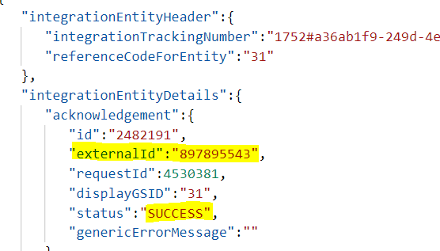

Once a supplier is successfully acknowledged in Zycus, the supplier status will change from “Pending Integration” to “Active”.

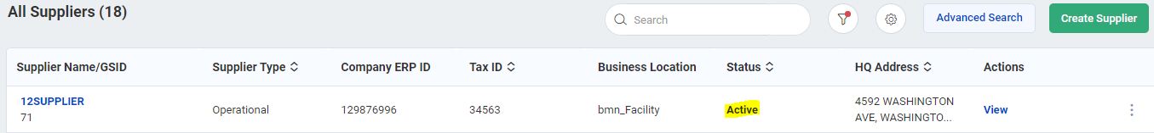

1. If supplier data is not successfully processed at Gavi’s end, response with “FAILED” status along with an error message will be sent to Zycus.
2. After the failure, Business user will have to take appropriate action to resolve as per error description.

*Failed ACK* should contain the details mentioned below:

* **integrationTrackingNumber**: The tracking number should be same as that was sent in supplier JSON payload.
* **referenceCodeForEntity**: The reference code for entity should be same as that was sent in supplier JSON payload.
* **id**: Id should be same as supplier id sent in supplier JSON payload.
* **requestId**: requestId should be same as requestId sent in supplier JSON payload.
* **displayGSID**: displayGSID should be same as displayGSID sent in supplier JSON payload.
* **status**: “FAILED”.
* **externalId:** NA against “externalId” tag.
* **genericErrorMessage:** Error message should also be mentioned with the reason of failure against “genericErrorMessage” tag in the JSON.

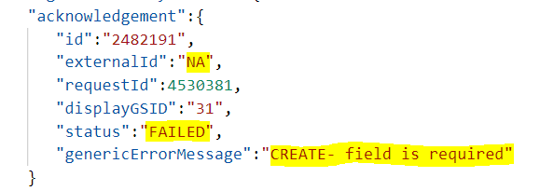

The error description will be displayed on UI and the status of the supplier will be Integration Failed.



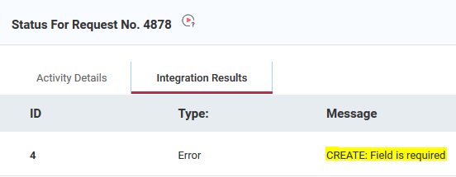

# Endpoints – Staging

|  |  |  |  |  |
| --- | --- | --- | --- | --- |
| SL No. | Interface Name | Direction (w.r.t Zycus) | Method | Endpoint |
| 1 | Gavi’s HTTP(s) endpoint for posting data | Outbound | POST | Resource URL : <https://apim.eu.workato.com/gavi-dev/zycus-integration/post_test>  Auth URL: <https://apim.eu.workato.com/oauth2/token> |
| 2 | SUPPLIER_ACK (Zycus endpoint to post ACK) | Inbound | POST | https://api-ausyut.zycus.com/Zygrate/rest/v2/sim/endpoint/supplier/externalIntegrationAcknowledgement |

# Endpoints – Production

|  |  |  |  |  |
| --- | --- | --- | --- | --- |
| SL No. | Interface Name | Direction (w.r.t Zycus) | Method | Endpoint |
| 1 | Gavi’s HTTP(s) endpoint for posting event metadata | Outbound | POST | TBD |
| 2 | Supplier Acknowledgement (Zycus endpoint to post ACK) | Inbound | POST | https://api1.zycus.com/Zygrate/rest/v2/sim/endpoint/supplier/externalIntegrationAcknowledgement |

# Interface Limitation

1. Integration payload will contain only 1 supplier for each entity ID.
2. Entity id for iSupplier is the Request ID for the supplier.
3. Once the Supplier acknowledgement is received by the product. The respective request id is deleted by the product. So, retriggering the same entity id will result in GET call failure.
4. Gavi users are required to always maintain an HQ address in Zycus.

# Authentication

|  |  |  |  |
| --- | --- | --- | --- |
| **Environment** | **Authentication Method** | **Username** | **Application ID** |
| Staging | 2-factor Auth | Integration.Gavi@zycus.com | t9MyGcVlPJrzshXtsMiSGg== |
| Production | 2-factor Auth | TBD | TBD |

**Authentication in Zycus**

|  |  |  |  |  |  |
| --- | --- | --- | --- | --- | --- |
| **Environment** | **Authentication Method** | **Client Id** | **Client secret** | **Scope** | **Grant Type** |
| Staging | oAuth 2.0 | <Shared separately> | <Shared separately> | WRITE | Client credentials |
| Production | oAuth 2.0 | <Shared separately> | <Shared separately> | WRITE | Client credentials |

**Authentication in Gavi**

Zycus Authentication Mechanism Documentation:

# Mapping Sheet

The mapping sheet shall contain a detailed description of all the fields with possible values and data transformation information between Zycus zDoc format and Gavi data format.

# Supplier Control Block

The attached excel spreadsheet gives detailed explanation of keys and values that are part of control block.

# Sample Payloads

|  |  |  |
| --- | --- | --- |
| **SR No.** | **Supplier Events/Actions** | **Sample Payload** |
| 1 | Supplier Create Payload |  |
| 2 | Supplier Edit Payload |  |
| 3 | Supplier Deactivate Payload - Global |  |
| 4 | Supplier Reactivate Payload - Global |  |
| 5 | Supplier On-Hold Payload - Global | <<To be added>> |
| 6 | Supplier Deactivate Payload - Facility | <<To be added>> |
| 7 | Supplier Reactivate Payload - Facility | <<To be added>> |
| 8 | Supplier On-Hold Payload - Facility | <<To be added>> |
| 9 | Supplier Acknowledgement Success |  |
| 10 | Supplier Acknowledgement Failed |  |

**NOTE: The above payloads are for reference only, values are subject to change.**

# Non- Functional Requirements

This section will capture the Non-Functional Requirement for integration. This should be captured with proper approximations and foresight since efficiency of integration and solution building depends also on this.

|  |  |  |  |  |  |
| --- | --- | --- | --- | --- | --- |
| **SL. No.** | **Interface Name** | **Direction (w.r.t Zycus)** | **Event Name** | **Avg. Volume (per day/week/month)** | **Frequency (Real Time/ Scheduled)** |
| 1 | Supplier | Outbound | Create | 40/month | Real Time |
| 2 | Supplier | Outbound | Edit | 80/month | Real Time |
| 3 | Supplier | Outbound | Deactivate | 300/year | Real Time |
| 4 | Supplier | Outbound | Reactivate | 50/year | Real Time |
| 5 | Supplier | Outbound | On-Hold | 100/year | Real Time |

# Error Handling

Zycus iConsole is used to log Integration failures between Zycus and Gavi.

|  |  |  |
| --- | --- | --- |
| **Sr No.** | **Description** | **Actionable** |
| 1 | If there is any business data issue for Outbound files (e.g., mandatory field value not present in supplier JSON), it needs to be handled by Business users by editing the supplier data in UI and resubmit the same. For example, if the Address information is not entered while creating a supplier in UI which causes failure in creating supplier in ERP, Business user needs to edit that supplier by adding the required information which would trigger new request to ERP. | Gavi |
| 2 | While making a request to the Gavi Middleware for pushing a Transaction if it is not reachable or there are any technical issues related to the Server it should be notified to the Zycus tech support team at tech-support@zycus.com (E.g.: If the production environment is down.) | Gavi/Zycus |
| 3 | In case wherein particular records of Supplier fails for some reason, necessary re-triggering for those requests should be done. If the problem persists, it should be notified to Zycus tech-support team on tech-support@zycus.com | Zycus |

All Event posting failures can be monitored under the ‘Track Events’ tab in Zycus iConsole. All other GET/POST failures can be viewed in the ‘Integration Dashboard’ and ‘Audit trail’. *Zycus iConsole Guide* provides detailed explanation of each of these tabs in iConsole.

In case of failures, events can be retriggered from Integration Dashboard, however, if the issue persists from Gavi side and the transaction is crucial from business standpoint, the transaction can be manually acknowledged to remove the supplier from Pending Integration status to be used by Business. This activity can be processed by Workato team as they already have Zycus endpoints.

All event failures can be configured to trigger ‘*Event Failure Notification*’ email and Gavi can share an email distribution list (ZycusEventFailure@Gavi.com) involving relevant personnel from Gavi IT for preliminary checks and analysis in iConsole.

Zycus has a shared support team for resolving production issues. An email once sent to Zycus tech support team (tech-support@zycus.com) creates a ticket which has pre-defined SLAs based on severity which is actioned upon by Zycus support team.

|  |  |
| --- | --- |
| **ABOUT US:**  Zycus is the pioneer in Cognitive Procurement software and has been a trusted partner of choice for large global enterprises for two decades.  Zycus has been consistently recognized by Gartner, Forrester, and other analysts for its Source to Pay integrated suite.   Zycus powers its S2P software with the revolutionary Merlin AI Suite. Merlin AI takes over the tactical tasks and empowers procurement and AP officers to focus on strategic projects; offers data-driven actionable insights for quicker and smarter decisions, and its conversational AI offers a B2C type user-experience to the end-users.   Zycus helps enterprises drive real savings, reduce risks, and boost compliance, and its seamless, intuitive, and easy-to-use user interface ensures high adoption and value across the organization.   Start your #CognitiveProcurement journey with us, as you are #MeantforMore. |  |
|  | |
| **USA** **Princeton:** 103 Carnegie Center, Suite 321, Princeton, New Jersey, United States, 08540 | Ph: 609-799-5664  **Chicago:** 5600 N River Road, Suite 800 Rosemont, IL 60018 Ph: 847-993-3180  **Atlanta:** 555 North Point Center East; 4th Floor, Alpharetta, GA 30022 Ph: 678-366-5000  **UK** **London:** Regus - Reading, Office No 335, 400 Thames Valley Park Drive Reading, Berkshire, England, United Kingdom, RG6 1PT +44 (0)808 189 0327 | +44 (0)808 189 1423  **NETHERLANDS** **Amsterdam:** Zycus Infotech Netherlands B.V, REGUS, Herengracht 282, 1016BX Amsterdam, The Netherlands  **ASIA** **Mumbai**: Plot No. GJ-07, Seepz++, Seepz SEZ, Andheri (East), Mumbai - 400 096 Ph: +91-22-66407676 | Plot No. GJ – 03, Seepz++, Seepz SEZ Andheri (East), Mumbai 400 096 | Ph: +91-22-66407676  **Pune:** Pride Purple Accord, 2nd Floor 205/208, Above Vijay Sales, Next to Hotel Mahableshwar, Baner Road, Pune - 411045 Ph: +91-22-66407676  **Bangalore:** 6th floor, Garnet Building, Bagmane Developers Pvt Ltd-SEZ II, Bagmane World Technology Centre, Mahadevapura, KR Puram Hobli, Marathahalli Outer Ring Road, Bengaluru (Bangalore), Karnataka, Bengaluru, 560048  **AUSTRALIA** **Melbourne**: Level 9, 440 Collins Street, Melbourne VIC 3000  **MIDDLE EAST** **Dubai:** Unit EX – 20 , Building No 12 , Dubai Internet City, Dubai , UAE , PO BOX No. 73000  **SOUTH EAST** **Singapore:** 101 Cecil Street, #20-11, Tong ENG Building - 069533 | |