**Task 1**

1. **Task Description:**   
   Build Quiz app in Django which have dynamic no. of options, E.g., few questions have 2 options, few may have 6 options, and must return the no. of right and wrong answers.
2. **Task Output Screenshot:**

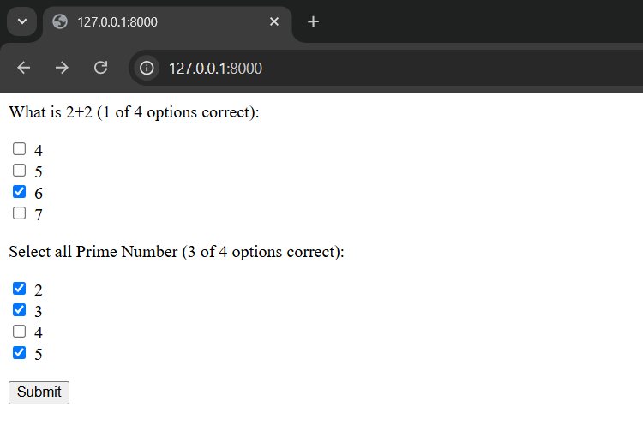

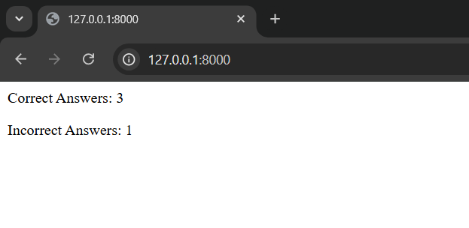

1. **Algorithm Used in Task:**

Data Model:

1. The Question model stores the text of each quiz question.
2. The Option model stores the possible options for each question, including whether the option is correct.
3. The foreign key relationship between Question and Option allows dynamic number of options per question.

Form Generation:

1. The QuizForm dynamically generates form fields based on the questions and options fetched from the database.
2. For each question, it creates a MultipleChoiceField with the available options as choices.
3. The form label includes the number of correct options out of the total options for that question.

Form Handling:

1. In the view, the form is initialized with the questions fetched from the database.
2. When the form is submitted, the view checks the selected options against the correct options.
3. It calculates the number of correct and incorrect answers and returns the results.

This algorithm allows for a dynamic number of options per question, while tracking the correctness of the user's selections. It provides a flexible and extensible way to create quizzes with varying difficulty levels.

**Note to tester:**

The project does not have a front-end to add new questions and options. These must be added manually in the Django admin panel. (http://127.0.0.1:8000/admin/Quiz/)

A Boolean variable is_correct (in Options table) should be selected if the option is correct answer.

The username and password to access the admin panel are:

* Username: Admin
* Password: password

The app awards 1 point for each correct option selected, and 1 point for each incorrect option selected, regardless of how many options are actually correct for that question.