**Task 4**

1. **Task Description:**

Build a function which returns all cities of India and saves in a .csv (USE API).

1. **Task Output Screenshot:**

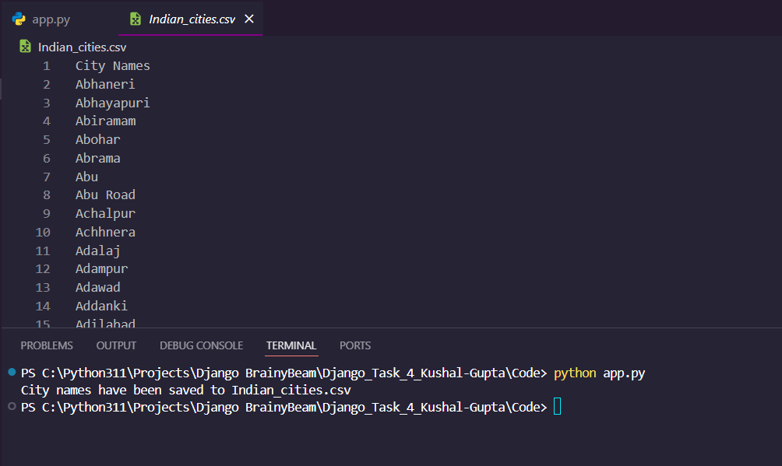

1. **Algorithm Used in Task:**

The algorithm used in the provided code is a simple API call to fetch city names from a country code. Specifically:

1. The algorithm constructs an API URL to retrieve city data for the given country code ("in" for India).
2. It sets up the necessary headers for the API request, including an API key.
3. It sends a GET request to the API endpoint with the country code as a parameter.
4. If the API response contains city data, the algorithm saves the city names to a CSV file named "Indian_cities.csv".
5. If there is an error during the API request, the algorithm prints an error message.

This algorithm is a straightforward way to fetch and save city data for a given country using an external API.

**API Used:**

Country State City API (https://countrystatecity.in/docs)