**Task 5**

1. **Task Description:**

Build a python program which can display advantages of the polymorphism and encapsulation in same program.

1. **Task Output Screenshot:**

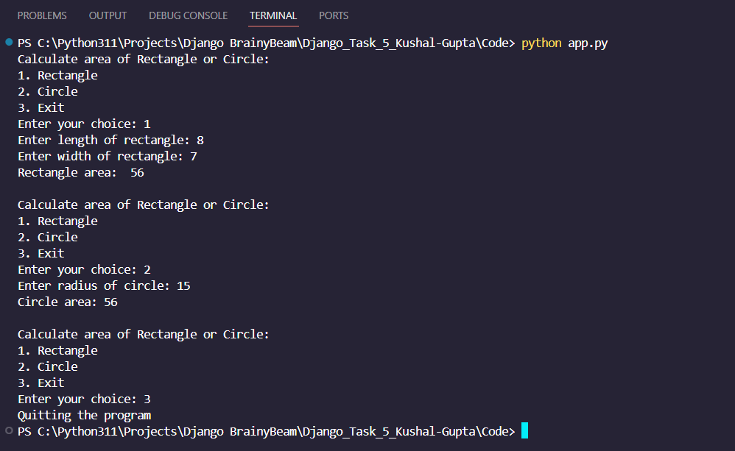

1. **Algorithm Used in Task:**

The algorithm implements an Object-Oriented Shape Calculator that uses polymorphism and encapsulation to handle different geometric shapes. The program provides a menu-driven interface allowing users to calculate areas of different shapes while maintaining data integrity and code reusability.

1. Encapsulation Implementation:

a. Private attributes for dimensions (__length, __width, __radius)

b. Public setter methods with validation logic

c. Protected access to internal data through controlled methods

1. Polymorphic Structure:

a. Different shapes inherit from base Shape class

b. Each shape provides its own area calculation logic

c. Common interface allows uniform handling of different shapes

This algorithm provides a robust and extensible way to handle geometric calculations while maintaining object-oriented principles. It demonstrates how encapsulation and polymorphism can be used to create a maintainable and scalable program structure that can be easily extended to include additional shapes.